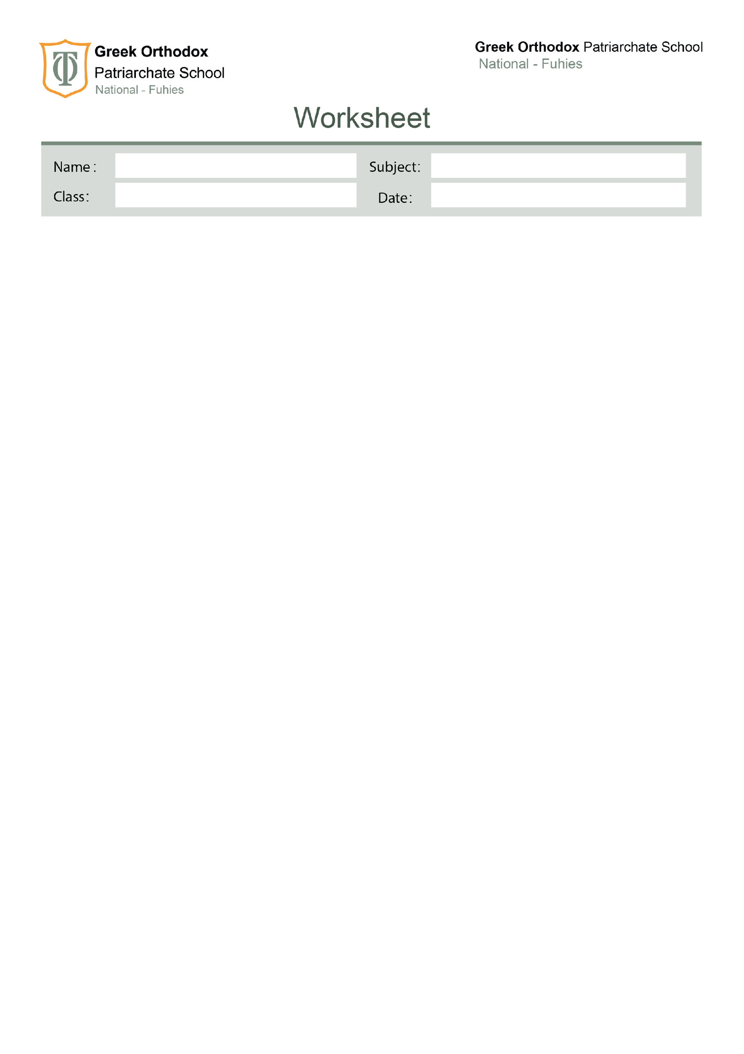

Science

Fifth grade ( A , B ).

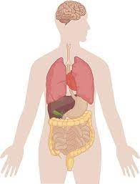
( small intestine , anus , large intestine , mouth , food pipe , stomach ).

Your teacher : Jessica Khoury.

