

No. (3 )

Science : Theme 3: Plants
Four

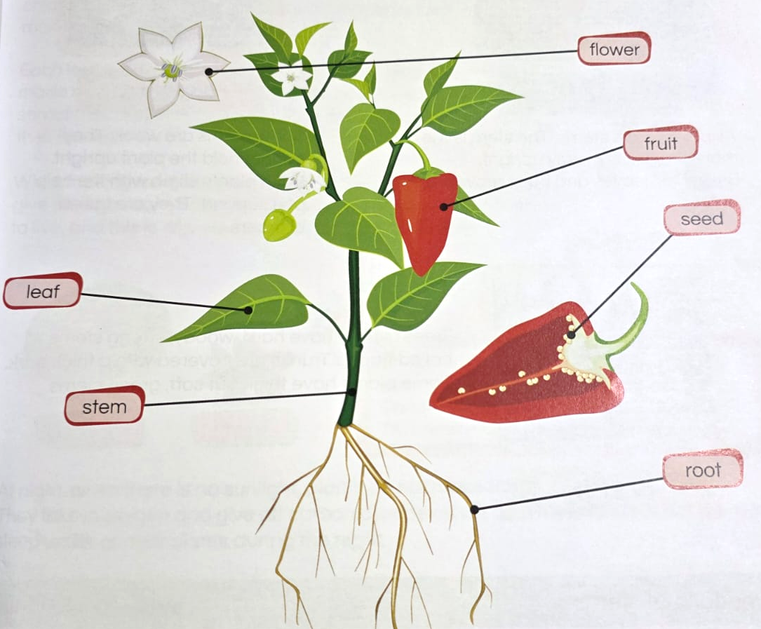
Theme 3: Investigating Plants
- The stem:
-It supports the plant above the ground.
-It takes water to the leaves and food to all parts of the plant.

- The green leaves:
- They make food using water, sunlight and carbon dioxide.
- They also help the plant to breathe.

- The flowers:
-Some flowers grow into fruits which have seeds inside them.

- The seed:
It starts growing into a new plant, when it gets water, air and warmth.
Some flowers makes fruits and fruits have seeds inside them.
Some fruits, such as a mango, have only one seed.
Some fruits, such as an orange, have a few seeds.
A papaya has many seeds inside it.

- The Roots:
There are of two kinds of roots: tap roots and fibrous roots.
They grip a plant in the soil.
They take in water and salts from the soil.
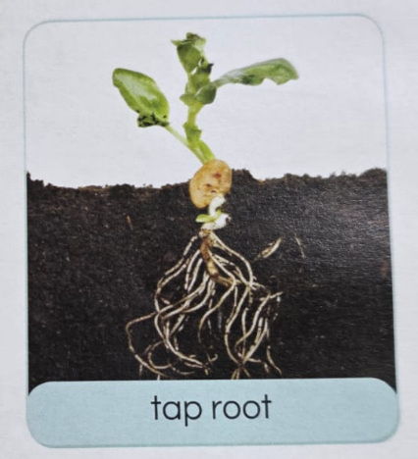
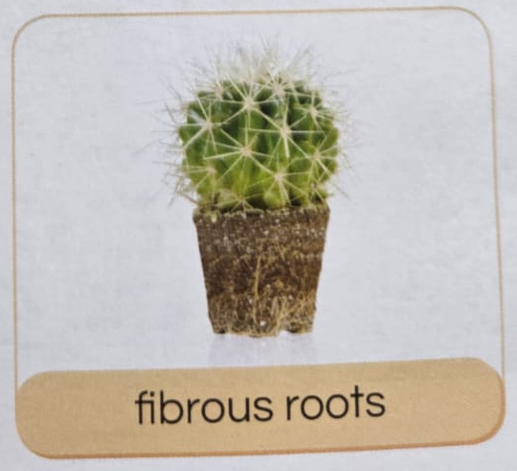

Exercises
A. Match the part of the plant with its job:
1. The stem | a. helps the plant to breathe and make food
2. The leave | b. grows into a new plant
3. The flower | c. supports the plant and carries water and food
4. The seed | d. has seeds inside
5. The root | e. takes water and salts from the soil

B. Fill in the blanks:
(water – sunlight – carbon dioxide – fruits – one – soil)
- The stem takes _________________ to the leaves.
- Green leaves make food using water, sunlight, and _________________ , ______________
- Some flowers grow into _________________.
- A mango has only _________________ seed.
- Roots grip the plant in the _________________.

Best Wishes
Your Teacher Jameela

