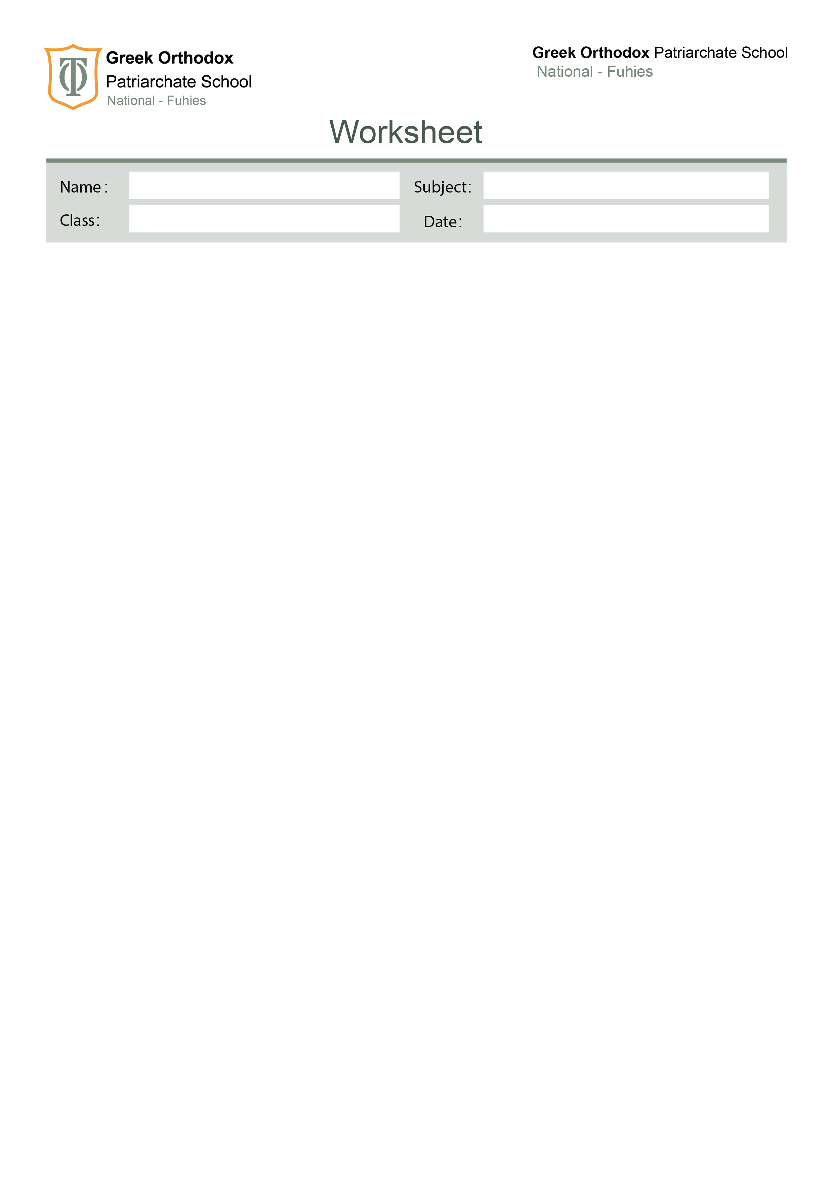

No. ( )

Present tenses
Nine
1.The Present Simple & the Present Continuous

Simple Present Tense | Present Continuous Tense
Uses:  We use the simple present tense when:  · the action is general  · the action happens all the time, or habitually, in the past, present and future  · the action is not only happening now  · the statement is always true  Form:  1. For positive sentences, we use the base form of the verb with(I-we you-they).  2. For the 3rd person singular (he, she, it), we add s to the main verb or es to the auxiliary.  3.For negative sentences, we use:don't/doesn't  4.For interrogative sentences,we use:do/does  Indicators:  Always-usually-sometimes-often-seldom-rarely-  never……  every day/week/month/year….. | Uses:  We use the present continuous tense to talk about:  an action happening around now and it is not permanent or habitual.  Form:  1. For positive sentences, we use:  Subject + be + (base verb+ing).  2.For negative sentences, we use:  Subject + be + not + (base verb+ing).  3.For interrogative sentences,we use:  Be+ subject + (base verb+ing).  Indicators:  At the moment-now- right now-nowadays- today-tonight-this-these-currently-listen-look-be careful-be quiet……….

Look at the following present simple examples: | Look at the following present continuous examples:
I live in New York.  The Moon goes round the Earth.  John drives a taxi.  He does not drive a bus.  We do not work at night.  Do you play football?  Does she work in a bank? | I am living in New York.  The cat is going round the street.  John is driving a taxi.  He isn't driving a taxi.  We aren't working tonight.  Are you playing football?  Is she working in a bank?
Stative Verbs
Some verbs are only (or mostly) used in simple tenses, and are not used in continuous tenses.
An example of a simple tense is the present simple, or the past simple. An example of a continuous tense is the present continuous or past continuous. These verbs are called stative, or state verbs. A verb which isn’t stative is called a dynamic verb, and is usually an action. Often stative verbs are about liking or disliking something, or about a mental state, not about an action.

verb | Correct | not correct
agree | Sarah agrees with us. | Sarah isn’t agreeing with us.
believe | I don’t believe the news. | I am not believing the news.
cost | This car costs a lot of money. | This car is costing a lot of money.
disagree | I disagree with you. | I am disagreeing with you.
dislike | He dislikes mushrooms. | He is disliking mushrooms.
hate | Julie hates dogs. | Julie is hating dogs.
hear | Do you hear music? | Are you hearing music?
know | We know the answers. | We are knowing the answers.
like | I like reading detective stories. | I am liking reading detective stories.
love | I love chocolate. | I’m loving chocolate.
mean | ‘Enormous’ means ‘very big’. | ‘Enormous’ is meaning ‘very big’.
need | I needed a taxi to go to the airport. | I am needing a taxi to go to the airport.
own | She owns two cars. | She is owning two cars.
prefer | I prefer chocolate ice cream. | I am preferring chocolate ice cream.
promise | I promise to help you tomorrow. | I am promising to help you tomorrow.
remember | He doesn’t remember my name. | He isn’t remembering my name.
surprise | The noise surprises me. | The noise is surprising me.
understand | I don’t understand this question. | I’m not understanding this question.
want | I want to go to the cinema tonight. | I am wanting to go to the cinema tonight.
Some verbs can be both stative and dynamic:
be | be is usually a stative verb, but when it is used in the continuous it means ‘behaving’ or ‘acting’  you are stupid = it’s part of your personality  you are being stupid = behaving now, not usually
have | have (stative) = own: I have a car have  (dynamic) = taking :I’m having a party / a picnic / a bath / a good time / a break
see | see (stative) = see with your eyes / understand  I see what you mean/ I see her now, she’s just coming along the road  see (dynamic) = meet / have a date or an appointment with  My mother is seeing her dentist next Sunday./ I’m seeing Robert tomorrow
taste , smell | taste/ smell (stative) = has a certain taste/ smell  This soup tastes great. This flower smells beautiful.  taste/ smell (dynamic) = the action of tasting/ smelling  The chef is tasting the soup. The girl is smelling the flower.
think | think (stative) = have an opinion  I think that coffee is great.  think (dynamic) = consider, have in my head  What are you thinking about? I’m thinking about my next holiday.
weigh | weigh(stative)=have the weight  This bag weighs 5 kilograms.  weigh(dynamic)=measuring the weight of  The shop keeper is weighing the vegetables.
fit | fit (stative)= perfect size  This shirt fits me well.  Fit (dynamic)= placing or putting  The carpenter is fitting the new cupboards in the kitchen.
measure | measure (stative)= be that long  This door measures two metres.  measure (dynamic)= taking the length of  The carpenter is measuring the kitchen cupboards.
feel | feel (stative)= have an opinion  I feel this is a good idea.  feel(dynamic)= touch  The doctor is feeling the child's body.  feel (dynamic)=have the sense of feeling  I'm feeling sick/ She's feeling better
look | look (stative)= have the appearance of  She looks tired.  Look (dynamic)= must be followed by a preposition and the meaning changes according to the preposition  I’m looking for a new job.  She’s looking at the painting.

Exercises 1. Choose the present simple or present continuous (these verbs are sometimes stative):
- She _____________ (have) a bath every evening.
- My husband __________________________ ( taste) the food while I’m cooking! It’s very annoying.
- A: Where’s Luke? B: He __________________________ (see) the doctor now.
- I _________________________________ (not / think) that’s a good idea.
- He ____________________________ (have) a party at the weekend.
- This coffee _________________________ (not / taste) right.
- We ___________________________ (see) John and Susie next weekend.
- What ____________________________ (you / think) about ?
- She ______________________________ (have) a headache.
- It ______________________ (be) cold today.
- They ___________________________ (not / have) a car.
- The waiter _______________________________ (taste) the wine now.
- She _______________________________ (not / be) a doctor.
- A: What ________________________ (that child / do)? B: He _______________________ (be) silly.
- He (think) _______________________________ that we are studying now 16. These flowers (smell) __________________________ terrific. 17. Henry (understand) ________________________________ Italian well. 18. This milk (taste) ______________________________ funny. I won’t drink it. 19. Diana (want) ___________________ to come over now. Is that all right? 20. There’s a spider in the corner. I (hate) ________________________ them. 21. I (hear) _______________________ you, but I can’t understand what you are saying. 22. Mark (believe) _______________ you, but I know that you are lying. 23. I (think) _______________ that we will get a discount because Talia (know) _______________ the manager. 24. Although Tom is very ill, he (know) _______________ what (happen) _______________ around him.
- Of course I (understand) _______________ you, I (listen) _______________, aren’t I? 26. Why don’t you comb your hair? It (look) _______________ awful. 27. I (tell) _______________ the truth. Why (you/not believe) ______________________ me? 28. Why are you so angry? You (look) ______________________ awful when you (be) _______________ angry.
29. I (wait) ____________________ for David. We (want) ________________________ to go swimming.
30.He_________________________(own) the biggest company in the country.
2. Present Perfect Tenses
The Present Perfect Simple | The Present Perfect Continuous
Usage : 1 –actions that happened at an indefinite time.  I have swum in the Dead Sea. 2 –experiences in the past.  She has been in England for two weeks once before.  3 –past actions with present signs.  I have broken my leg. How to form the Present Perfect  1-Present Perfect Positive  subject+ have / has + past participle  e.g. I / you / we / they have written he / she / it has written  2-Present Perfect Negative  Subject + has/have +not + past participle e.g.* I / you / we / they haven’t seen  *he / she / it hasn’t seen  3-Present Perfect Questions  Have / Has + subject + past participle ?  e.g.Have I / you / we / they finished? Has he / she / it finished?  Indicators of this tense:  1-since:It's used with definite time.  e.g.We have been at this school since 2012.  2-for:It's used with indefinite time.  e.g.We have been at this school for three years.  3-just: It means something happened a short time ago.  e.g.I have just eaten chocolate. 4-already:It means something happened before you expected. e.g. A:Don’t forget to water the flowers,Jane?  B:Oh,mum.I’ve already watered them.  5-yet:It means “until now”.It is used in negative sentences or questions.  e.g.A:Have you finished your homework yet? B:No.I haven’t finished it yet.  6-ever:It's used in questions. e.g. Have you ever been to China?  7-never:It's used to show that the action was not done before.  e.g. I have never been to China.  8. so far-recently- lately | Usage:  1 –actions that started in the past and continued until now. I have been reading a book about history.  2 –actions that took a period of time in the past with present signs.  I’ve been painting the house. That’s why I have some paint on my clothes. 3-actions that started in the past and will not probably end.  Nadia has been writing the letter all morning.  How to form the Present Perfect Continuous  1-Present Perfect Continuous Positive  subject+ have / has + been+ v+ing  e.g. I / you / we / they have been writing he / she / it has been writing  2-Present Perfect Continuous Negative  Subject + has/have +not + been + v+ing e.g.* I / you / we / they haven’t been eating  *he / she / it hasn’t been eating  3-Present Perfect Questions  Have / Has + subject + been + v+ing?  e.g.Have I / you / we / they been playing? Has he / she / it been playing?  Indicators of this tense:  how long /all day / all night / all morning……./ again/ for a long time/ since/ for..now
Exercises 1. Put the words in the correct order using the present perfect tense.
1. you / ever / go / skiing / ?
______________________________________________ 2. you / finish / your homework / yet / ?
______________________________________________ 3. she / just / visit / her friends / .
______________________________________________ 4. I / already / meet / a famous person /.
______________________________________________ 5. you / ever / write / a poem / ?
______________________________________________ 6. I / never / go / bungee-jumping / .
______________________________________________ 7. I / not / be / on TV / yet / .
______________________________________________ 8. you / ever / win / a competition/?
_________________________________________________________________
2-Fill in the blanks with ( just , already or yet )
1. "Would you like something to eat?" "No thanks, I've ________________ had lunch." 2. "Have you finished your homework _______________________?" 3. "What time is Pilar leaving?" "She's _______________________ left." 4. Are you going to make dinner?" "No, I've ___________________ made it. It's in the oven!" 5. "Are we too late to see the film?". "No, it hasn't started ___________________." 6. I need to take the Intermediate exam because I've _________________ taken the Elementary.
3. "Do you know where Mauricio is?" "Yes, I've _________________ seen him in the Library."
4. "Why isn't Simone coming to the cinema with us?" "She's ______________________ seen the film."
5. "Have you tidied your room ______________?" "No, not _______________. I'll do it in a minute."
6. You have _______________________ completed the first nine questions.
3. Fill in the blanks with ( since or for )
1- Nobody has come to see us ___________ we bought this small house. 2- She has been a doctor ___________ 1998. 3- Nobody has seen her ___________ then. 4- They have all been ill ___________ last week. 5- Peter went to the library. He has studied there ___________ a long time. 6- It has been very foggy ___________ early morning. 7- I’ve worked with you ___________ nine years. 8- He has been in prison ___________ two years. 9- She has worked in that office ___________ a month. 10- He hasn’t eaten anything ___________ twenty-four hours. 11- He hasn’t eaten anything ___________ yesterday. 12- They haven’t spoken to us ___________ we were at school. 13- I haven’t talked to her ___________ my birthday. 14- She’s been ill ___________ years. 15- I’ve been very patient with you ___________ several years 10. They haven't come together ____________ they graduated from the university. 11. We haven't seen Mr.Parker ____________ this morning. 12. David hasn't telephoned ____________he left school at three o'clock. 13.We have been working_____________ ages. 14. The singer has sung seven songs ________ the concert began.
- Complete the sentences with the verb in brackets in the present perfect simple or the present perfect continuous.
1.She loves Paris. She __________________ (be) there many times.
2.Bill ________________________ (work) in that company for 3 years. 3. They ______________________ (just/ go) to London on holiday. 4. I ________________________ ( never/read) that book.
5. They __________________________ ( talk) for two hours now. 6. I _________________________ ( already/have) my coffee.
7. He ____________________ (live) in Rome since he was a teenager. 8. The house looks different. ___________ you _______________ (paint) it? 9. I ________________________ (not see) your new car yet.
10. The detectives ____________________________people all week. ( interview) 11._____________ Tim_______________ (finish) his work yet? 12. They __________________________ (just / go) out.
13. The child ___________________________all night. ( sleep) 14. ____________ you________________ (send) the letters yet? 15. The train ____________________________ (just / arrive). 16. _____________ you _____________________ (ever / be) in a TV studio?
13. I think the waiter has forgotten us. We _____________________________ here for over half an hour and no body has taken our order yet. (wait) 14. How long ______________________ ( she/ live ) in this house? 15. His hair looks short. He _____________(have) a haircut.
16.James ___________________( teach) at the university since June.He is still working there.
5.Rewrite the sentences adding the words in brackets.
1. I have eaten sushi before. (already)
______________________________________________________
2. She hasn’t visited Germany. (yet)
______________________________________________________
3. They have seen this movie. (already)
______________________________________________________
4. We have met your teacher. (just)
______________________________________________________
5. Daniel has fixed a broken pipe. (never)
______________________________________________________
6. Have you eaten snails?. (ever)
______________________________________________________
7. He has finished three assignments. (so far)
______________________________________________________
8. My son has bought a new car. (lately)
______________________________________________

Your English teachers: Nayfeh Abu Hanna & Lara Bajjali

Education is the passport to the future, for tomorrow belongs to those who prepare for it today

