English/Unit 4/lesson 1/vocabulary p.38 in the student’s book
1(A+B)
Q1.Fill in the missing letters then match them with their pictures.
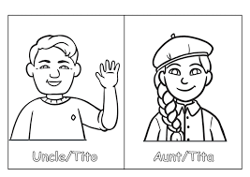
- m _ m

- co_ sin
- uncl _
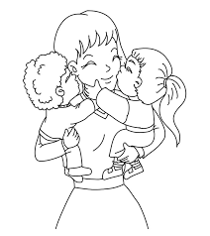
- _a _ _
- _ unt



Q2. Circle the correct word in each sentence.
- This is my mum / dad. She takes care of me every day.
- My cousin / aunt is my mum’s sister.
- I love to play with my baby / cousin.
- My dad / teacher drives me to school every day.
- My mum buys me/ dad the school uniform
- My dad / grandpa is very old.
Q3.Draw your family and write (dad/mum/me).

“Don’t stop until you’re proud”

