Enzyme
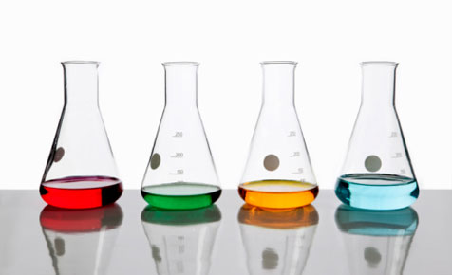
Experiments

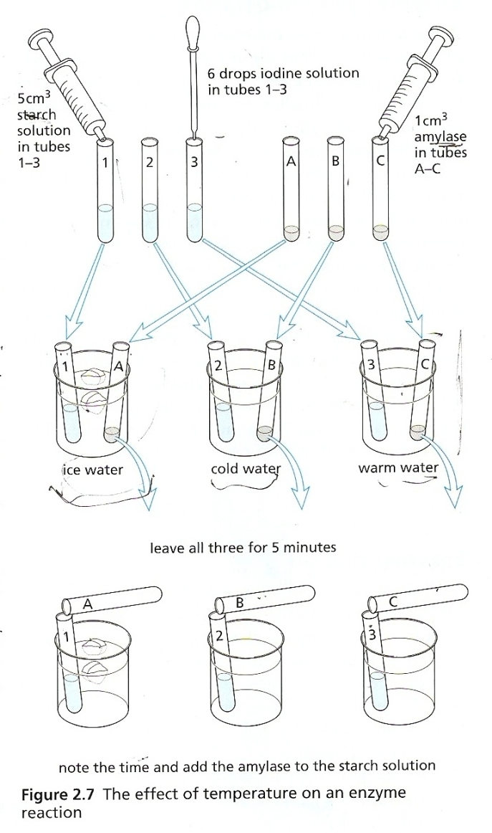
Experiment 1
The effect of temperature on the activity of enzymes
Enzymes are very sensitive to temperature, increasing temperature will increase the activity of the enzyme but if we keep increasing the temperature above the optimum temperature the enzyme will become denatured (due to breaking of the bonds that hold the protein structure) and the shape of the active site will be lost, As a result, the enzyme will no longer be able to carry out its former function substrate no longer fits into the active site of the enzyme
How can we test this experimentally?
1) Label 3 test tubes 1, 2, 3 and fill them with 5cm³ starch with 6 drops of iodine, as mentioned previously, if starch is present and Iodine was added a bluish black colour will form.
2) Label another 3 test tubes A, B, C then add the enzyme Amylase to the three. (Amylase is the enzyme that breaks down starch into maltose).
3) Place test tubes 1 and A in iced water.
Test Tubes 2 and B in cold water.
Test tubes 3 and C in warm water.
Leave for few minutes then mix the components.
5) Set up a timer and see which tube changes colour first.
- If amylase is active , it will catalyze the breakdown of starch into Maltose, Maltose will not react with Iodine and so the bluish black colour will change into the original colour of Iodine which is yellowish brown because there is no starch left to react with Iodine.
Results:
- Test Tube 3 and C will turn yellowish orange first.
This is because in warm water, the activity of the enzyme will be the greatest (optimum temperature) so the starch will be broken down into maltose and iodine will quickly restore its original colour since all starch is broken down.
- Test Tubes 2 and B will change colour but it will take much more time than test tubes 3 and C lower temperature Lower kinetic energy slower reaction rate!
Test tubes 1 and A may not change colour at all because the temp is too low and the enzyme will be inactive.

Go back to page 40 Human Biology book – Activity 4
Keep in mind!
Low temperatures inactivate enzymes whereas high temperatures denature them!
Experiment 2 :
The Effect of pH on Enzyme:
As you studied before, enzymes are also sensitive to the pH. Each enzyme has an optimum pH at which it works the best, for example: Amylase; the enzyme responsible for the digestion of starch in the mouth (saliva) , works optimally at the pH of
6-7, whereas proteases(e. in the stomach require the highly acidic pH of 2. Most Enzymes working in cells require a neutral pH.
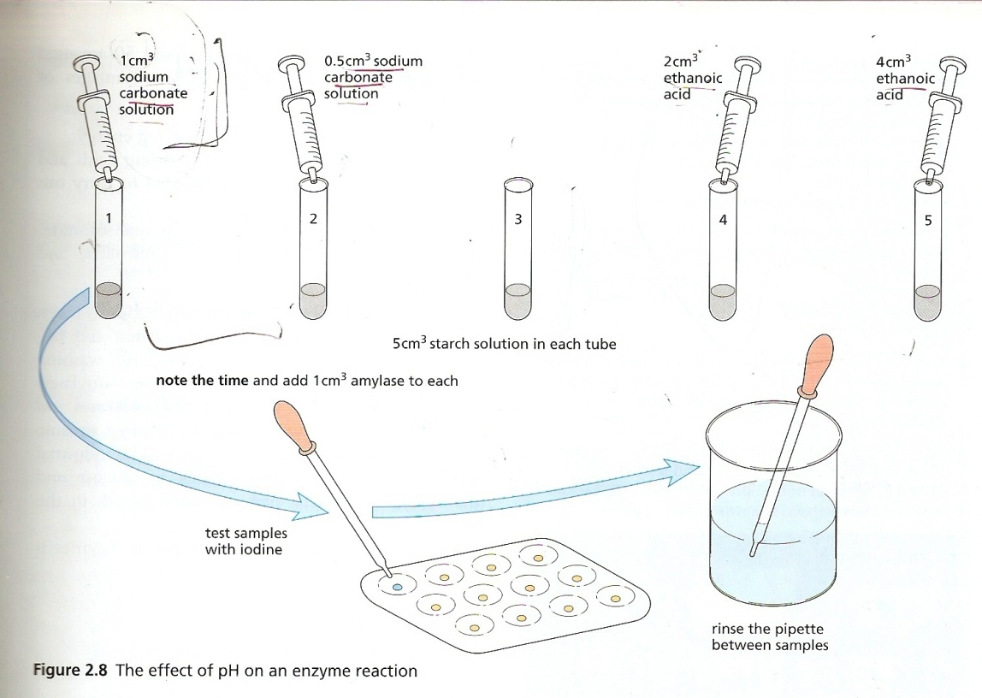

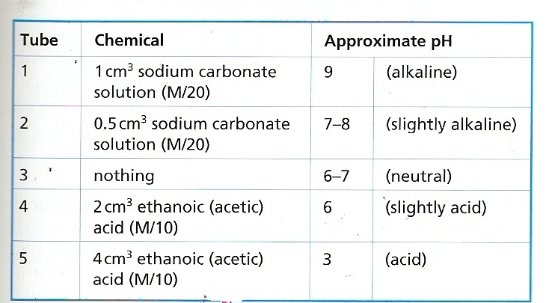
1) Label 5 test tubes 1-5 and use a plastic syringe and place 5cm³ starch solution in each using a pipette.
2) Add acid or alkali to each tube as indicated in the table
3) Add amylase enzyme.

*Rinse the syringe when changing from sodium carbonate to acid
4) Place several rows of Iodine in the cavity tile as shown in the figure above.
5) use a clean dropping pipette to remove a small sample from each tube in turn and let 1 drop fall on to one of the iodine drops in the cavity tile .
* Rinse the pipette in a beaker of water between each sample , and keep on sampling this way.
When one of the samples fail to give a blue colour , this means that the starch in that tube has been completely broken down to maltose by amylase .
Write down the time when this happens for each tube and stop taking samples from that tube .
Questions :
- At which pH did the enzyme , amylase , work most rapidly ?
- Is this its optimum pH ?
- Explain why might you have expected the results which you got?
- Your stomach pH is about 2 .Would you expect starch digestion to take place in the stomach ?
Go back to page 42 Human Biology Book – Activity 5
The effect of enzyme concentration on the rate of enzyme catalyzed reactions

A student carried out an experiment to find out if the concentration of protease enzyme affected the time taken to digest protein.
He used a protein jelly, which became liquid as the enzyme digested the protein.
He carried out five separate tests
He used the same mass of protein jelly for each test
He used a different concentration of enzyme solution for each test.
For each test, he mixed the protein jelly and the enzyme solution together to make a paste , and the he poured the paste into a funnel
Results :
Test | Concentration of enzyme solution (%) | Time for paste to flow out in seconds
1 | 0.00 | 32
2 | 0.25 | 29
3 | 0.50 | 25
4 | 0.75 | 19
5 | 1.00 | 11

Conclusion :
Description of results:
The greater the concentration increases the time taken for the paste to flow out decreases
Explanation of results :
More enzymes more collisions between enzyme and substrate more digestion of proteins takes place.

Experiment 3:
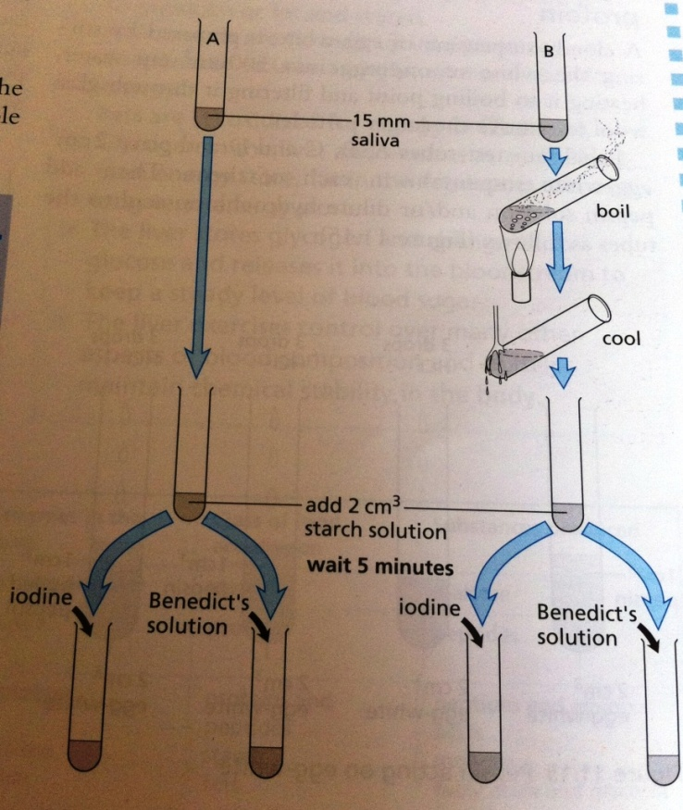
Digestive enzymes
The action of salivary Amylase on starch:
Amylase is an enzyme that digests starch into maltose (reducing Sugar), in the mouth. The optimum pH of amylase is 7.
-Rinse the mouth with water to remove traces of food.
-Collect saliva in two test tubes labeled A and B to a depth of 15mm.
-Heat Test tube B over a small flame until it boils for about 30 seconds.
-Add about 2cm³ of 2 % starch solution to each tube and leave them for 5 minutes.
-Share the contents of tube A between two clean test tubes. To one of these add some Iodine solution. To the other one, add some Benedict's Solution and heat in a water bath.

Results: The contents of A fail to give a blue colour with Iodine showing that starch is broken down. When starch breaks down, it produces Maltose which is a reducing sugar, so when we add it to Benedict's solution it will change the colour of the solution from blue Brown.
The contents of tube B which was boiled, gives a blue colour with Iodine but fails to change the colour of Benedict's solution.
This indicates that Amylase is denatured, so it couldn’t catalyze the breakdown of starch into Maltose , as a result, starch changed the colour of Iodine. The colour of Benedict's solution will not change due to the absence of maltose (no reducing sugar is present).

- The Action of pepsin on egg white (albumen):
Notes:
- Pepsin is an enzyme present in the stomach
- Pepsin digests proteins
- Pepsin will only work in acidic solutions
- It is pepsin and not the hydrochloric acid which does the digestion.
A cloudy solution of egg white is prepared by stirring the white of one egg into 500 cm³ of tap water and heating it to boiling point.
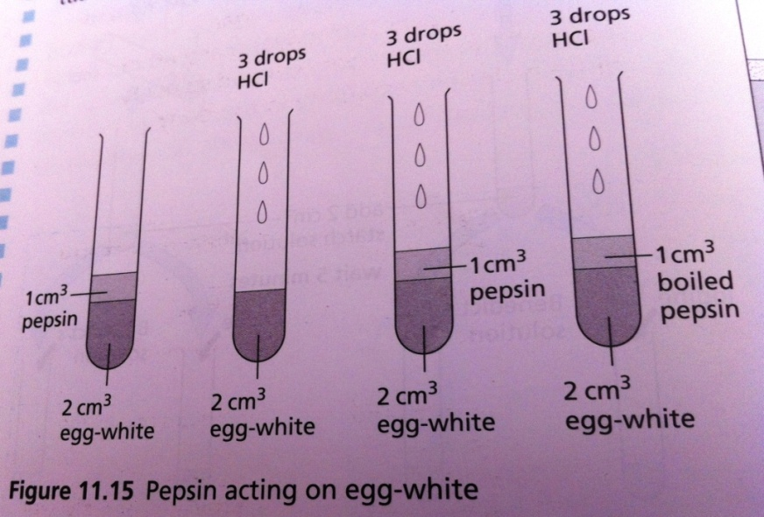
Label four test tubes A, B, C and D and place 2cm³ egg white suspension in each of them. Then add pepsin solution and/ or dilute hydrochloric acid as shown in the figure:
A: Egg white suspension + 1 cm3 pepsin solution (1%)
B.Egg white suspension + 3 drops dilute hydrochloric acid
C. Egg White suspension + 1 Cm3 pepsin + 3 drops HCl
D. Egg white suspension + 1cm3 boiled pepsin + 3 drops HCl

Place all four tubes in beaker of warm water at 35^{O} C for 10-15 minutes.
Results: the contents of tube C go clear, the rest will remain cloudy. The change from cloudy suspension to a clear solution indicates that proteins have been digested (Proteins are insoluble in water).

The action of Lipase:
Place 5cm³ milk and 7 cm³ dilute sodium carbonate solution in each of three test tubes. Add 6 drops of phenolphthalein (indicator) to each to turn the contents pink. Add 1 cm³ of 3 percent bile salt solution to tubes 2 and 3. Add 1 cm3 of 5 percent lipase solution to tubes 1 and 3, and an equal volume of boiled lipase to tube 2.
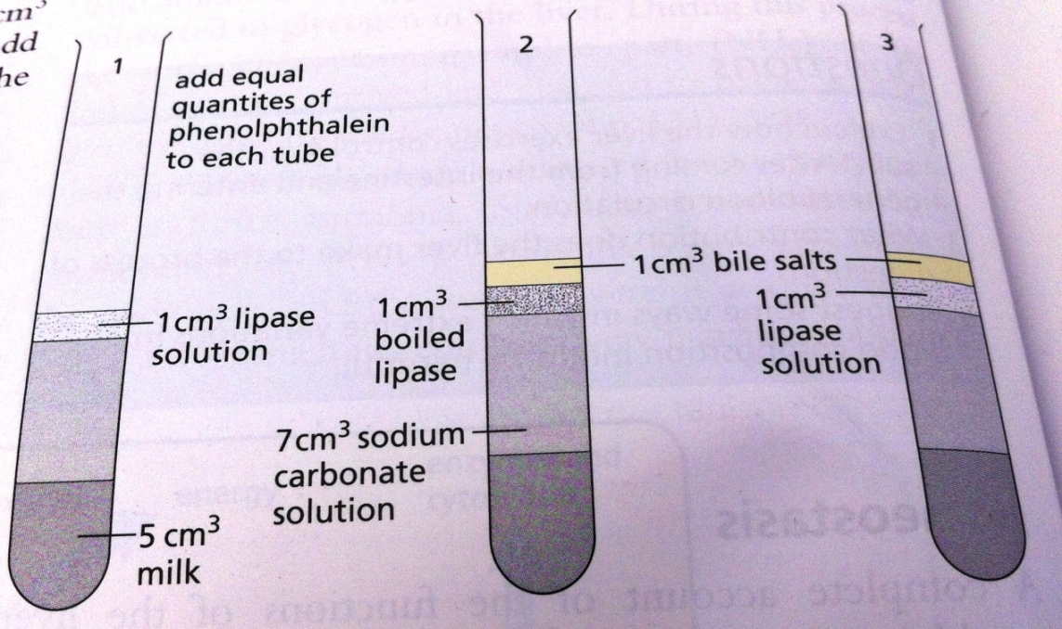
Result:
In 10 minutes or less, the colour of the liquids in test tube 1 and 3 will change to white, test tube 3 changes first. The liquid in tube 2 will remain pink.

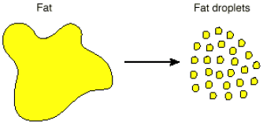
- The role of bile :
- Bile is produced by the liver , it has a role in digestion of fats in the small intestines
- Bile emulsifies fats
- Converts fats into small fat droplets speeds up its breakdown by the enzyme lipase by increasing the surface area.

- Lipase is an enzyme that digests fats to fatty acids and glycerol. When lipase acts on milk fats the fatty acids produced will react with the alkaline sodium carbonate and make the solution more acidic. In acid conditions the pH indicator, phenolphthalein changes from pink to colorless. The presence of the bile salt in tube 3 seems to accelerate the reaction although bile salts with the denatured enzyme in tube 2 cannot bring about the change on their own.
Past paper skills:
Notes that you need to keep in mind:
You’re going to encounter a lot of questions in the past papers that ask you to plan an experiment to study the effect of pH of enzyme activity or the effect of temperature on enzyme activity.
Keep in mind, that the rate of an enzyme catalyzed reaction depends on 4 factors

WHEN YOU ARE STUDYING THE EFFECT OF ONE FACTOR ON THE RATE OF REACTION YOU HAVE TO MAKE SURE THAT THE OTHER FACTORS ARE KEPT CONSTANT this ensures that the factor you are changing is the ONLY factor that is affecting the results !

Planning experiments
So if you’re planning an experiment that studies the effect of pH on enzyme activity my goal is to study the effect of this factor alone, so the other factors MUST be kept constant i.e. Temperature must be constant, and in each case you must be using the same concentration of substrate and the same concentration of enzyme, otherwise, these will also affect my results and the pH will not be the sole factor that is affecting the enzyme activity Not accurate results
A FAIR TEST is achieved when you are changing one factor at a time
Remember that reliability depends on how close you’re results are to each other
Reliability is improved by repeating the experiment!
- For that reason whenever you’re asked to plan an experiment always mention repeating the experiment to obtain more reliable results
- To maintain a constant temperature : use a water bath
- To maintain a constant pH use a buffer
- The use of burette , pipette or syringe allows for a greater accuracy in measuring volumes than a flask
What is a controlled experiment ( control) ?
In most biological experiments, a second experiment called a control is set up. What is a control?
It is an experiment which is set up to ensure that only the condition that is being investigated has affected the result.
When you’re a drawing graph make sure that you
- Determine the dependent and the independent variable

- Label the axes Independent variable on the x-axis Dependent Y-axis

