Enzymes
Life of living organisms depends on chemical reactions called metabolic reactions that occur within cells.Metabolic reactions include digestion, respiration, photosynthesis and many others. These reactions require ages to reach completion but in our bodies they take less than a second to be complete.
How is this so?
The answer lies in substances called enzymes.
All biological reactions within human cells depend on enzymes. Their power as catalysts enables biological reactions to occur usually in milliseconds.
Without enzymes, there would be no life at all, from microorganisms to humans
So what are Enzymes?
Enzymes are biological catalysts, made up of protein molecules used to speed up the rate of reactions, without being consumed.
All Enzymes are made of proteins, but not all proteins are enzymes
Enzyme VS catalyst
What is the difference?!
Catalyst: Substances that speed up the rate of chemical reactions, without being changed by the reaction or used up . These are used in the lab to speed up chemical reactions e.g. Iron , Copper, manganese (IV) oxide ..etc.
Enzymes are proteins that function as biological catalysts that speed up the rate of chemical reactions :
Enzymes are called biological catalysts because they work in living cells
The shape of an enzyme
Remember that proteins can be different from each other by having different
sequences of amino acids in the chain.
The different sequences of amino acids give different shapes to protein molecules
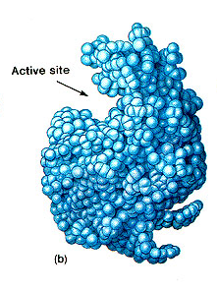
This is because the amino acids interact with other nearby amino acids in the chain causing the amino acid chain to fold up in a particular way which gives each protein a unique three-dimensional shape (3D).
Enzymes are proteins and like all proteins they have a three dimensional shape.
Different enzymes are considered different proteins that have different sequences of amino acids.
That’s why each enzyme folds up in a particular way. Enzymes are unusual proteins because they have a space in the molecule with a particular 3D shape
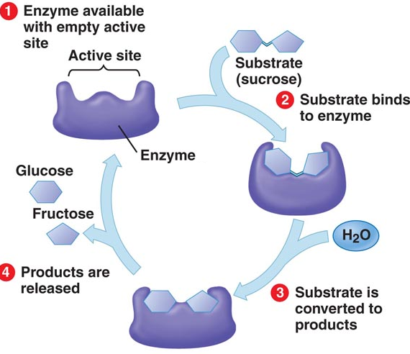
Consider this reaction :
Sucrose Glucose and fructose
This metabolic reaction takes place in our digestive system during the process of digestion .
This reaction is catalyzed by an enzyme .
The enzyme catalyses the breaking down of sucrose into the monosaccharides glucose and fructose.
The substance which the enzymes works on in a chemical reaction is called the substrate ( in this example it is sucrose) and the substances which are formed at the end of the reaction are called the products ( in this case they are glucose and fructose).
Enzymes are specific
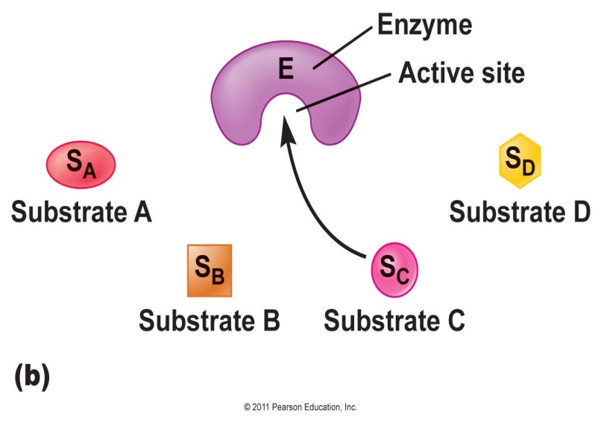
The substrate binds to a region in the enzyme called the active site forming an enzyme-substrate complex.
The active site matches the shape of the substrate molecule “they are complementary “ because the substrate fits into this space in the enzyme
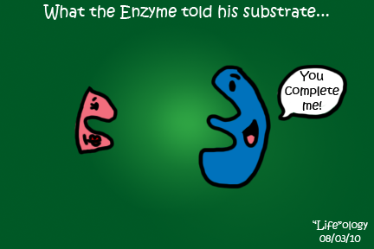
- The active site of each enzyme has a specific shape, and only substrates that have a shape complementary to the shape of the active site will be able to bind to the enzyme.

Each enzyme can catalyze only one particular kind of reaction. And because we have many different chemical reactions occurring in our bodies, there many different enzymes are found , one for each of the many different metabolic reactions that must take place for us to stay alive.
This feature resembles the Lock and Key model.
Just as a key must exactly fit the shape of a door lock, so must a substrate exactly fit the shape the active site of the enzyme!
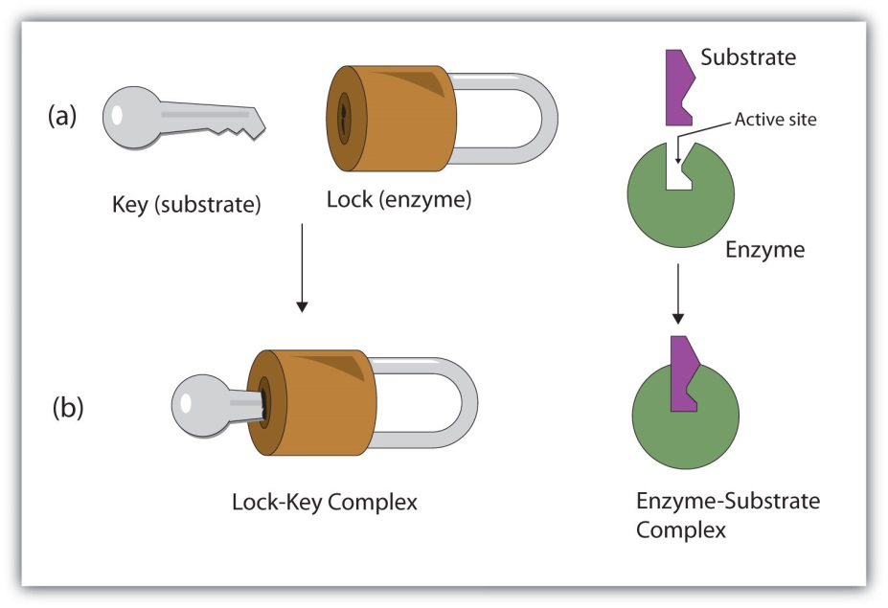
- If the substrate fits into the active site of the enzyme, then the enzyme will be able to catalyze the reaction , if does not the reaction won't be catalyzed. That’s why enzymes are said to be "specific".
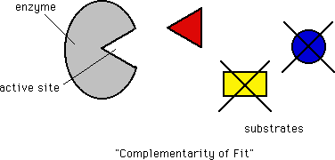
- Enzymes are not used during reactions, once the reaction that the enzyme is catalyzing is over, the enzyme will be free to catalyze a new reaction. A single enzyme can carry out many reaction of the same type (with the same substrates or those that are structurally similar to each other) because enzymes are specific.

How does the nucleus control the chemical reactions that take place in the cell ?
Enzymes are proteins so they must be produced on ribosomes (site of protein synthesis) ribosomes get instructions for synthesizing proteins from the genes that the nucleus of the cell contains the genes control the types and quantities of enzymes produced inside the cell so it controls the type of chemical reactions that take place inside the cell

Since different cells have different types of chemical reactions (specialization) nucleus controls what the cell will be e.g. Blood cell, Muscle cell, nerve cell.. Etc.
Genes proteins (enzymes) catalyze reactions
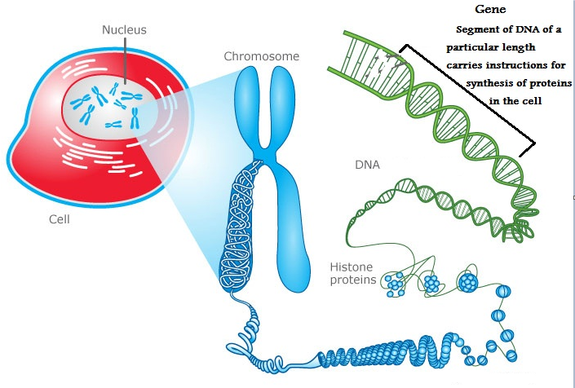
The Effect of High temperature on enzymes
Proteins are affected by high temperatures. High temperatures ruin the shape of the protein and it causes the protein to lose its function.
Why ? Because high temperatures break the bonds between the amino acids that hold the protein , as a result the protein loses its 3D shape Denatured
Since all enzymes are proteins they are too affected by high temperatures.
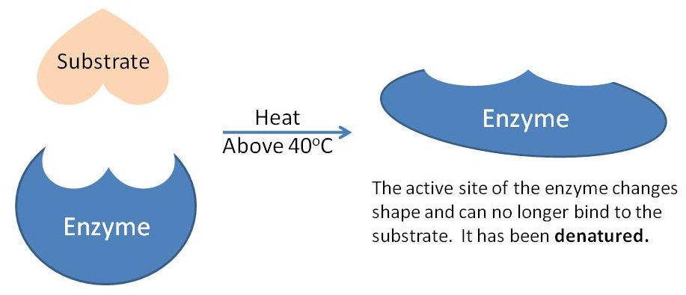
High temperatures changes the shape of the active site of the enzyme, as a result, the substrate won't be able to fit to the shape of the active site and form an enzyme-substrate complex anymore, as a result, the enzyme loses the ability to catalyze reactions and is said to be "Denatured".
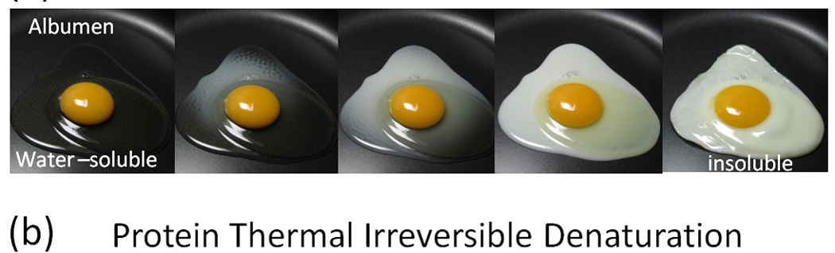
Do you know?
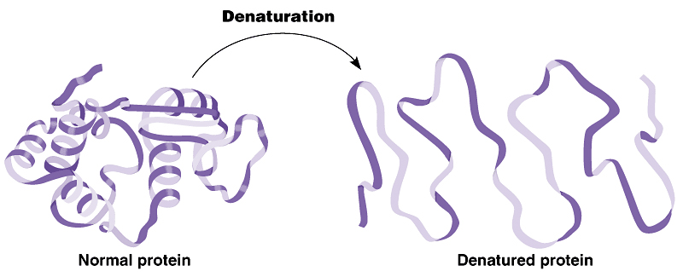
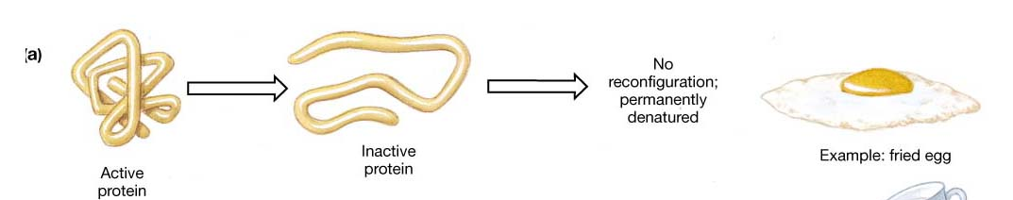
You can see the effects of denaturation when boil an egg. The egg white is made of a protein called albumin that changes from a clear runny liquid into a white solid as the heat denatures the protein
DENATURATION

The difference between chemical and biological catalysts:
Hydrogen peroxide (H₂O₂), is a waste product of some chemical reactions in the cell. This waste product is very toxic so it needs to be broken down immediately.
Our Body breaks hydrogen peroxide down with an enzyme called catalase (a common enzyme found in the cells living organisms both animals and plants e.g. liver cells and potato cells) according to this equation:
H₂O₂ H₂O +O₂
If you want to carry out the same reaction in the lab you would need MnO₂ as a catalyst
Catalase is an enzyme that functions inside living cells, and is sensitive to high temperature (becomes denatured), while MnO₂ is a catalyst made up of chemical substances and is not sensitive to high temperatures.
Naming enzymes
Typically, to generate the name of an enzyme, the suffix -ase is added to the name of its substrate or the reaction they promote
For example:
Enzymes that catalyze the breakdown of carbohydrates are called Carbohydrases
Enzymes that catalyze the breakdown of proteins are called Proteases
Enzymes that catalyze the breakdown of Fats (lipids) Lipases
Exceptions: Trypsin , pepsin
An enzyme that acts on sucrose as it’s substrate is called Surcrase and it is considered a carbohydrase
An enzyme that removes hydrogen from its substrate is called dehydrogenase

Amylase

1) Starch Maltose Step 1

Maltase
Maltose Glucose Step 2

Proteases
2- Protein amino acids
Protease is a large group of enzymes (including pepsin, trypsin)

3- Fats (lipids) 3 fattyacids + glycerol
Lipase

Types of enzymes:
Since metabolic reactions are either catabolic or anabolic , the enzymes that catalyze these are also classified into catabolic enzymes and anabolic enzymes
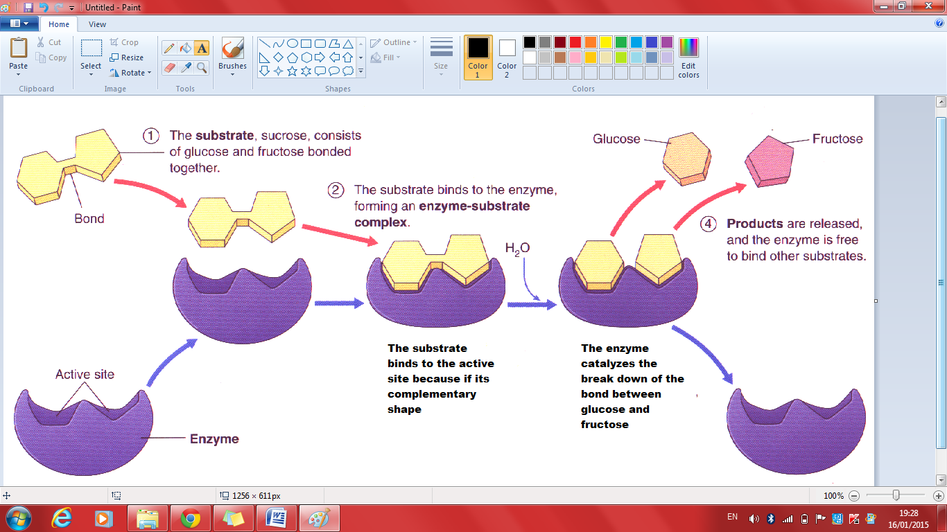
Catabolic enzymes: enzymes that speed up catabolic reactions by breaking down large molecules into smaller ones.

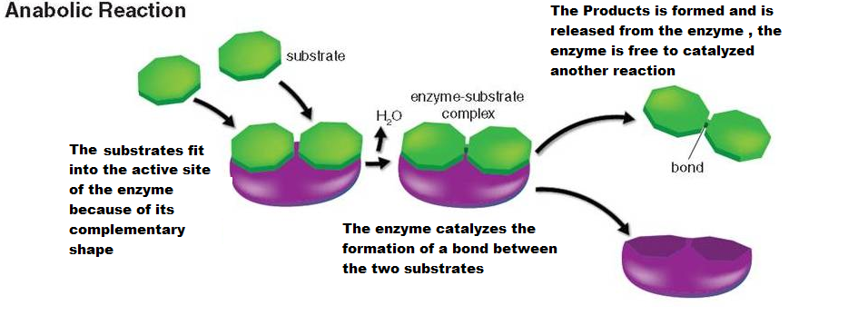
Anabolic enzymes: enzymes that speed up anabolic reaction by building up large molecules from smaller ones

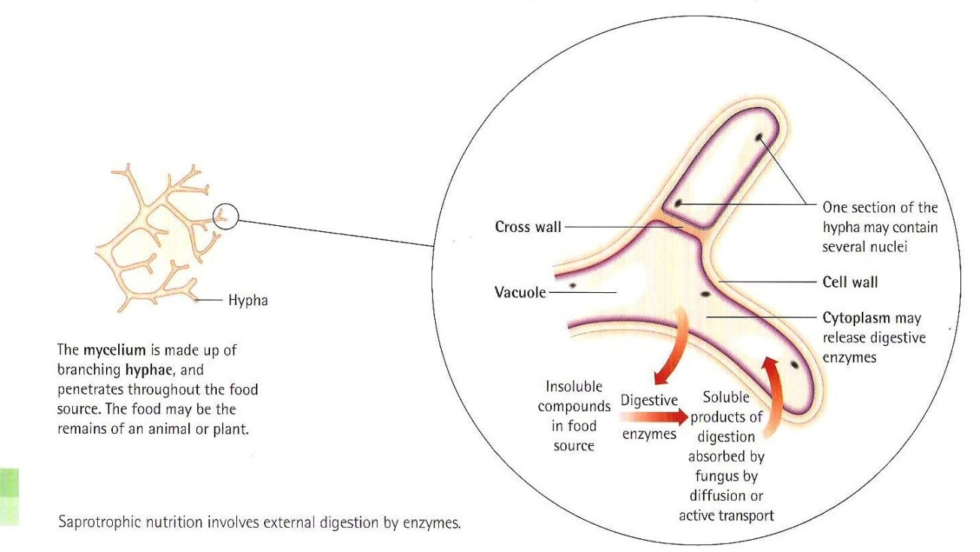
Hyphae secrete digestive enzymes:
Amylase breaks starch into maltose
Proteases breaks proteins to amino acids
The soluble products are then reabsorbed

1-Temperature:
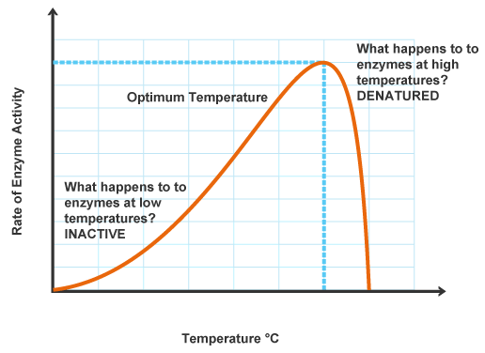
As the temperature increases, the activity of the enzyme increases, this happens because the kinetic energy of molecules increases with increasing temperature ( they move faster) , so more effective collisions take place between enzymes and substrates, so more enzyme-substrate complexes will form so the activity of the enzyme increases. The temperature at which the activity reaches its maximum is called "The Optimum Temperature". If the temperature increases too much above the optimum temperature, the bonds holding the shape of the enzyme will start to break, changing the shape of the active site permanently and denaturing the enzyme the rate of reaction drops sharply
Enzyme is inactive at low temperatures
At low temperatures , the enzyme and the substrate molecules move slowly , so they take longer time to collide ( less effective collisions ) with enough force to start the reaction.
Optimum Temperature: is the temperature at which the activity of the enzyme is the maximum. “The enzyme works best at this temperature”
The optimum temperature for enzymes that work in organs at the center of the human body is 37 ºC denaturation of human enzymes begins to happen at 40 ⁰C and above
- The optimum temperature for plant enzymes is 28 -30 ⁰C
- Note : Enzymes from bacteria that live in hot springs may have optimums as high as 75⁰C
2- The Effect of pH on the activity of Enzymes:
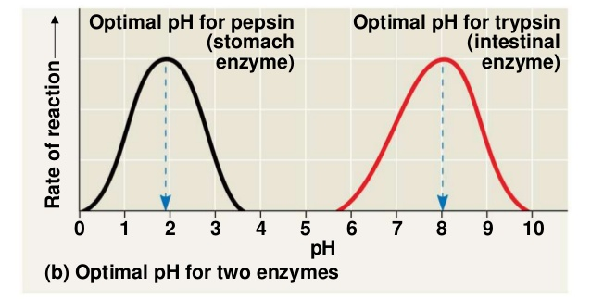
pH is the measure of H⁺ ions in the solution
The greater the number of H⁺ ions in a solution the greater it's acidity and the lower its pH

Different enzymes work best in different degrees of acidity. The best pH for each enzyme to work is called optimum pH
Extremes of pH (very high very alkaline or very low very acidic) can slow down the rate of action of the enzyme by causing the enzyme to lose its shape and denature , this means that the active site will no longer fit to the substrate and so the enzyme can no longer catalyze the reaction.
Activity here drops gradually unlike the previous graph (Temp Vs Enzyme activity), where the activity drops sharply. This is because an increase in temperature has a greater effect on the shape of the active site than an increase or decrease in pH.
Examples on enzymes and their optimal pH
-Proteases: work in the stomach at optimum pH=2 HCl in the stomach provides the optimum pH for Pepsin
-Salivary amylase: in the saliva optimum PH= 7
- Enzymes secreted by the pancreas : Lipase , trypsin and pancreatic amylase works at pH =9
Most Enzymes work best at neutral conditions PH= 7
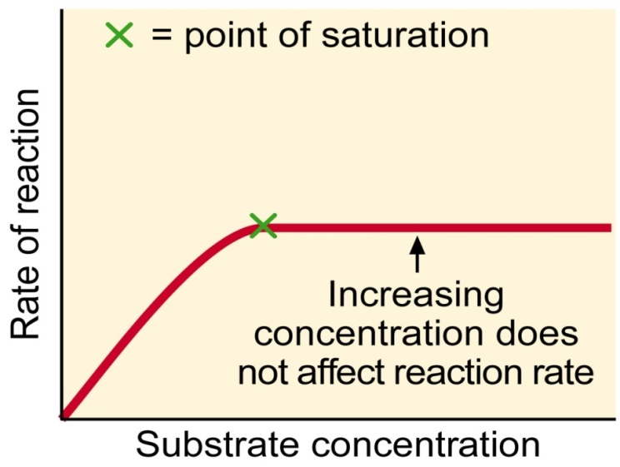
3- Concentration of the substrate:
As the concentration of the substrate increases , the rate of the enzyme catalyzed reaction will increase , until it reaches the optimum concentration after which the activity of the enzyme remains constant ( levels off ) because all the active site are occupied by the available substrates there is no room for more substrates, as a result , the rate become constant.--> the enzyme concentration is now limiting the rate at which the reaction can take place the enzyme concentration is now the limiting factor
4) Concentration of enzyme:
The rate of enzyme catalyzed reactions depends on the concentration of the enzyme, the more enzyme molecules the faster the reaction will proceed, provided there are enough substrate molecules available.
This is because, the more enzyme present the more collisions will take place between the enzyme and the available substrates

- The presence of inhibitors go back to 38,39
The role of enzymes in seed germination
Later in the book, you will study the plant kingdom in more details and explore the process of seed germination. Enzymes have an important role in seed germination which is defined as the growing of the seed as an embryo into a plant. When water enters the seed, enzymes become activated and begin breaking down the starch stored in the seeds and converting it into glucose which can be used by the seed to generate energy (by respiration) required for the process of growth.
You will explore this later in more details.
Summary:
Enzymes have the following properties :
All enzymes are proteins
Enzymes are catalysts
Enzymes are inactive at low temperatures and are denatured at high temperatures
Enzymes work best at a particular temperature Optimum temperature
Enzymes work best at a particular pH optimum pH
Enzymes are specific

