Chapter 2 (Cell structure)
Name: --------------------

2. Organization of the organism Cell structure
→ Cell: The smallest basic unit of structure and function of all living things.
→ All living things are made of cells
→ Function: it is the place where all vital activities take place
A cell undergoes the following processes:
- Reproduction for cell repair and growth ( by Cell division)
- Digestion
- Excretion
- Respiration

Cells are very tiny and small; we need a microscope to see them

Microscopes:

Electron Microscopes:
- More magnification and resolution.
- Use a beam of electrons.

Light Microscopes
- Less magnification and resolution
- Uses a beam of light

Animal Cell:

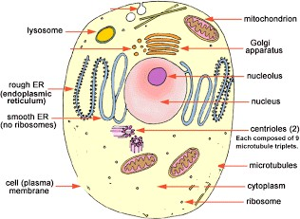

Plant cell :

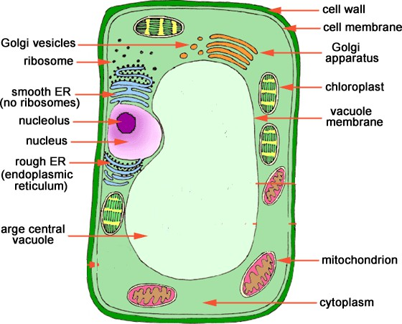

Cell Membrane:
→ The cell membrane is the outermost boundary of animal cells;
→ It is made up of 2 layers of phospholipids with protein molecules embedded between them.
→ It contains small openings (pores) that allow some substances to pass through and prevent others (semi-permeable).

→ It allows some substances to pass according to the size of the molecule: Large molecules (like starch) cannot pass.
Small molecules O₂ can pass.

Functions of the cell membrane
→ Controls movement of substances in and out of the cell (semi permeable membrane).

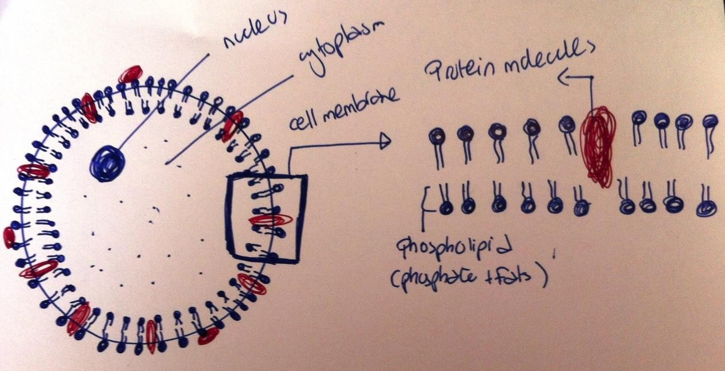
Cell Membrane as seen with a light microscope

Cell membrane as seen with an electron microscope

Cytoplasm:
→ It is a Jelly-like, made up of 90 per cent water (with many salts and sugars dissolved in it) with suspended proteins and fats
→ It carries the cell organelles e.g. Nucleus, mitochondria, ribosomes, vacuoles
→ It contains energy stores in the form of glycogen, oil droplets ( in animals ) and starch granules ( in plants).

Functions of Cytoplasm:

It is the place where all the metabolic reactions take place to keep the cell alive by providing energy and making substances that the cell needs

Anabolic : in these reactions we build up large molecules from smaller ones.
This reaction requires energy
e.g. Photosynthesis
Catabolic : In these reaction , we break down large molecules to form smaller ones . This reaction generates energy
e.g. Respiration
Metabolic Reactions can be

Organelle: a specialized structure within a cell that has a specific function and is usually separately enclosed within its own membrane.

Nucleus

- Center of the cell that controls the cell's activities.
- Controls cell division.
- It contains chromosomes (genetic material) which are made up of a substance called DNA (Deoxyribonucleic acid).
- Segments of DNA are called genes , genes are responsible for the characteristics of organisms , e.g. Eye colour , skin colour , etc
- Most cells contain only 1 nucleus
- Some cells don’t have a nucleus
Ex: Red Blood Cells (RBC)
- It has a spherical / oval shape
  - Only cells that contain a nucleus are capable of dividing
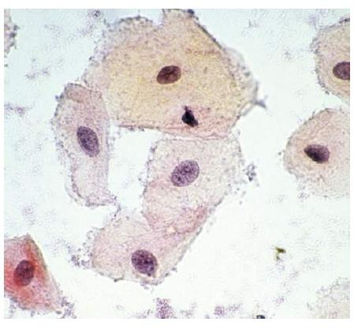
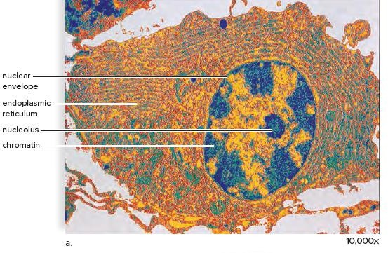
The Nucleus as seen with a light microscope
The Nucleus as seen with an electron microscope

Functions of the nucleus
- Controls the cell's activities.

- Responsible for cell division, because it contains chromosomes. Without a nucleus, the cell cannot reproduce.

What is the difference between Chromosomes and DNA? Chromosomes:
Chromosomes are thread-like structures made of a chemical called DNA (Deoxyribonucleic acid) coiled around proteins called histones.

The function of chromosomes

The most important function of chromosomes is to carry genes which are small segments of DNA that carries instructions for making proteins which in turn are responsible for the controlling the cell’s activities

Chromosomes as seen using an electron microscope
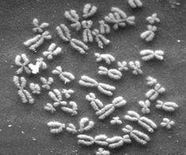
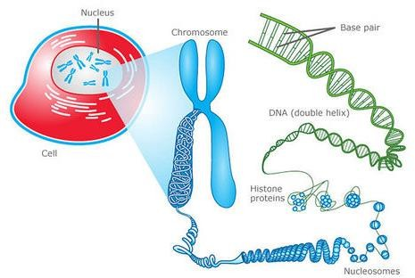

Ribosomes
Protein Factory of the Cell
→ In a cell, ribosomes can either free in the cytoplasm, or attached to the Rough endoplasmic reticulum.
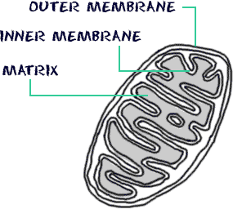
→ Ribosomes are the protein factory of the cell they are responsible for the protein synthesis in the cell.
Function:
Synthesis of proteins in the cell.

Mitochondria:
Energy Factory of the cell
Singular: mitochondrion
It is a rod-shaped organelle with a double membrane. The Mitochondrion is the site of aerobic respiration in the cell.

Functions:
The production of energy for the cell by respiration: Breaking down of glucose molecule in the presence of O₂ to release energy.
* any cell which carries out an energy-demanding job , such as muscle cells will contain large numbers of mitochondria.

Note: all cells except prokaryotic cells (like bacteria) contain mitochondria .

Glucose + Oxygen → Carbon dioxide +water+ energy C₆ H₁₂ O₆ + 6O₂→6CO₂ +6H₂O+energy
The Mitochondrion as seen with an electron microscope (TEM)
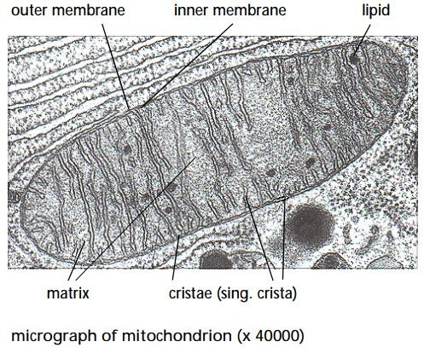

Vacuoles:
- It is a Space filled with fluid surrounded by a membrane called tonoplast Comparison between animal and plant vacuole
- Stores organic and inorganic substances.
- Stores waste products and gets rid of them later.

In animals | In plants
Many small temporary vacuoles | One large central permanent vacuole
The vacuole is formed to perform a certain job | It contains a watery  substance called (cell Sap) which contain (Water, sugar, salts, Pigments)

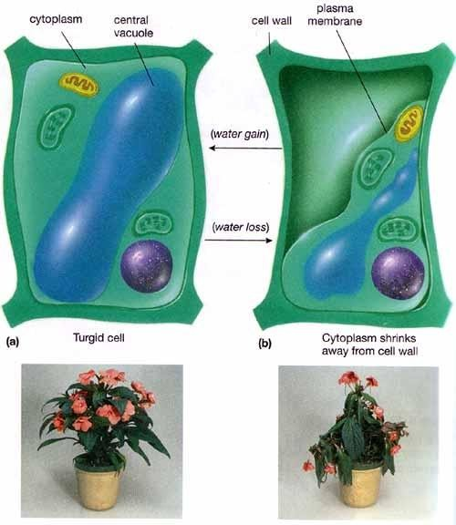
Functions in Plant cells:
- It exerts on outward pressure on the cytoplasm and makes it firm.
Note:
The vacuole pushes against the cell wall, this creates pressure, this pressure is called turgor pressure and the plant is said to be turgid → healthy state.

Chloroplasts:
Chloroplasts are a member of a larger group of organelles called plastids found in many plant cells but never in animal cells.
Chloroplasts are found in (green plants, algae, blue-green bacteria)
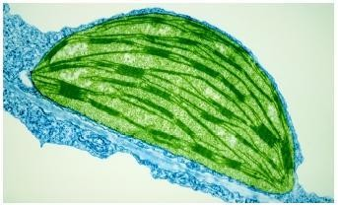
Contain a green pigment called chlorophyll, which plays a role during photosynthesis
Chlorophyll absorbs sunlight from the sun needed for the reaction.
During photosynthesis, plants make their own food in the form of glucose:

6 CO₂ + 6 H₂O →C₆ H₁₂ O₆ + 6O₂

Cell Wall:
- It is found in Plant cells but not in animal cells
- The cell wall is made up of cellulose and other supporting material called lignin.
- The cell wall is thicker than the cell membrane.
- The cell wall is a fully permeable membrane it allows all the substances to pass through it.
- Protect and give the shape of the cell.

Function:
Prevent plant cell from bursting out (because of pressure from vacuole).

Levels of organization of living organisms

Organelles

cell parts in the cytoplasm

Cells

smallest basic unit of living things (blood cell/ nerve cell).

Tissues

group of the same cells working together to do a certain shared function (blood tissue / nerve tissue).

Organ

group of different tissues working together to do a shared function ( kidney /
heart)

Organ system

a group of organs with related functiona working together to perform a certain body functions e.g respiratory system / digestive system

Group of Organ systems to form an organism e.g Human Body
Body Organism

Cell Specialization

The changes in shape and chemical reactions enable the cell to carry out its specific function.

guard
cells
Sperm
and egg cells
Xylem
Cells
Root Hair
Cells
White
Blood Cells
Red
Blood Cells
Muscle
cells.
Nerve
Cells
Ciliated
epithelial cells
Examples of specialized cells :

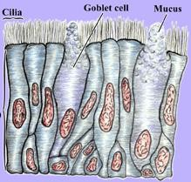
Ciliated Epithelial Cells
- This type of cells contains tiny cytoplasmic hairs called cilia.
- Ciliated cells form the lining of the nose, nasal passages, and trachea.
- ​
Function: the movement of the cilia backward and forwards keep the mucus in a continuous movement to trap bacteria and dust that enter during breathing
- The movement of cilia will lead the mucus away from the lungs to the top of the trachea to be expelled out by the mouth or swallowed into the stomach where the bacteria will be digested by HCl acid found in the stomach.
Type of specialization: is the presence of cilia

Red blood cells:
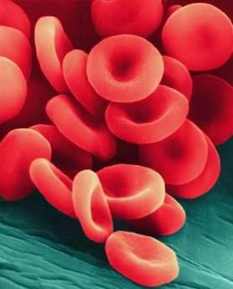
- They are small cells with no nucleus (they are incapable of dividing or repairing themselves and must be continually produced and removed)
- They are made in the bone marrow , and last only for 120 days before they are destroyed in the liver or spleen.
- They are the most numerous cells in blood (That's why your blood appears red in colour).
- They contain an oxygen-carrying protein called haemoglobin which contains iron and proteins.
- Haemoglobin is responsible for the red color of Red blood cells.
- Function: they contain Haemoglobin which carries oxygen around the body

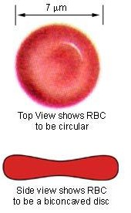
Specialization:
- They have a biconcave shape (disc-like shape) the advantage of red blood cells' biconcave shape is that membrane has a large surface area. Larger surface area means there is a larger area over which diffusion of oxygen can occur thus making the transfer of gas more efficient than if they had a flatter

- Red blood cells have no nucleus so that it can use all of its volume for hemoglobin, so can carry as much oxygen as possible.

- They are smaller than most other cells with an elastic cell membrane to be able to squeeze through blood capillaries to the body cells to supply them with oxygen and take away the carbon dioxide

- Hemoglobin combines with oxygen in areas with high oxygen concentration(Lungs), and it breaks down and releases its oxygen in areas with low oxygen concentration ( cells).
- Red blood cells don't have mitochondria
→ This is because mitochondria is the site of aerobic respiration which uses oxygen,if red blood cells have mitochondria they will consume the oxygen they carry , that’s why they can only respire anaerobically .

White blood cells:
  - They are larger than RBC's.
  - They have a nucleus
  - Function: fight infections in the body. WBC's perform this job in 2 different ways:
    - Producing antibodies against foreign bodies.
    - Engulfing and digesting bacteria

Specialization:
→ Some WBC's produce antibodies against foreign bodies, they are called lymphocytes. Lymphocytes were specialized into T-cells and B-cells which produce antibodies.
→ Other WBC's can change their shape to be able to engulf foreign bodies.

Nerve cells
  - Nerve Cells are called neurons that contain a cell body, axon, and a dendron and dendrites



There are three Types of Neurons
Sensory
Neuron
Motor
Neuron
Relay
Neuron

Function :
Conduction of electrical impulses

Specialization:
The presence of the axon and dendrites that makes a passage to the signals through them.
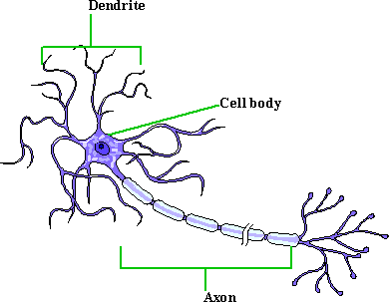

Root hair cells:
  - They are tiny tube-like projections that are produced by an outer layer of cells in plants.
  - They are found in the region above the root tip.

Functions:
  - They help in supporting the plant in the soil.
  - They absorb water and mineral salts from the soil (the cell membrane controls what substances enter the cell).
  - ​

Specialization :
    - The cell wall of the root hair cells is highly permeable.
    - The projections in their shape help in increasing the surface area for absorption of nutrients from the soil. In addition, the huge number of root hairs increases overall the rate of absorption.
    - They have the ability to penetrate between the particles of the soil to be able to fix and anchor the plant in specific regions.

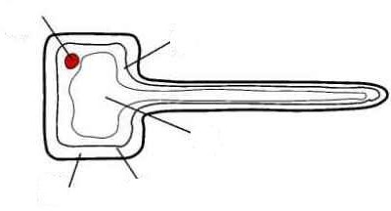
Cell membrane
Cell Wall
Large vacuole
cytoplasm
Nucleus

Xylem vessels:
  - They are found in roots, stems leaf stalks and leaf veins.
  - They have no cytoplasm
  - They have very thick cell walls to prevent the leakage of water from them
  - They are dead cells

Function:
-They are cells that carry water and dissolved minerals from the root of the plant upward the plant (unidirectional transport).
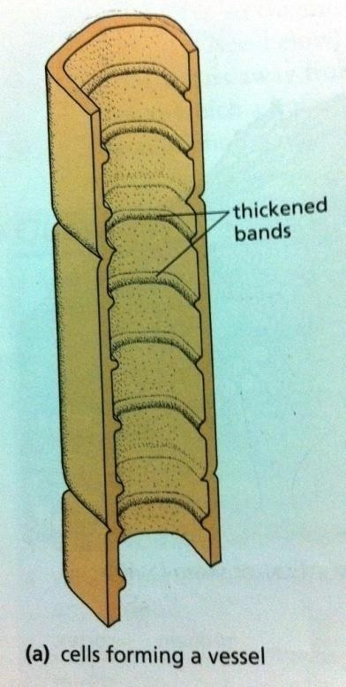
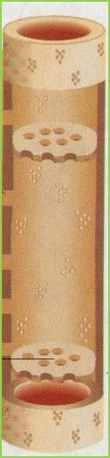
-They help in supporting the plant.

Specialization :
- They are made up of dead cells joined end to end to be able to transport water and minerals.
- They have a thick cell wall to prevent the leakage of water and minerals from it. The substance that gives the strength to the wall is called (lignin) and makes it impermeable.

- They also contain many elongated, lignified supporting cells called (fibres) to add the hardness to the xylem vessels

Phloem cells:
  - They are found in roots, stems, and leaves.
  - They are not dead cells; they remain alive unlike xylem cells with no organelles or cytoplasm to allow the easy passage of water

Function:
  - They transport food up or down the stem (not unidirectional as xylem), from the leaves where it is made, to any part of the plant which needs the food or even stores it.

Specialization:
Sieve

- The shape helps in the function because they are made up of series of long cells joined at ends.
- The end walls of the phloem cells are called (sieve plates) because they contain holes like a sieve to be able to pass the food from one cell to the next.
- Their walls are not lignified, to allow the entrance and exit of food.

Guard cells:
  - They are structures in the epidermis of the leaf called stomata.
  - In most dicotyledons the stomata occur only in the lower epidermis.
  - In monocotyledons the stomata are equally distributed on both sides of the leaf.
  - The singular of stomata is "stoma".
  - A stoma consists of a pair of guard cells surrounding an opening called stomatal pore.
    - When the stomatal pore opens, it allows CO₂ to diffuse into the leaf where it is used during photosynthesis.
    - When the stomatal pore closes, it prevents excessive loss of water vapor when photosynthesis cease.

Function:
Controls the opening and closing of stomata.

Specialization :

    - Guard cells have large vacuoles which control the size of the stoma. When water enters the cell, the turgor pressure increases inside leading to swelling and bending.
    - Although the increase in turgor pressure tends to expand the whole guard cell, the inner wall cannot expand because it is thicker and less elastic than the outer wall this causes the guard cell to bend in such a way that the stomatal pore between them is opened.
    - Guard cells are sensitive to the amounts and concentration of CO₂ so any change affects the amount of water being lost or gained. When the concentration of CO₂ increases the stomatal pore closes, but when the amount of CO₂ decreases it opens.
