Respiration
Many people think that respiration and breathing are the same although the two terms have different biological meanings.
What is Respiration?
It is the process of breaking down chemical bonds in food molecules such as glucose to release energy in a form that can be used in cells.
We usually refer to glucose as the food molecule, this is because it is the molecule that is most commonly used in this reaction. If glucose is in short supply our body may breakdown fats or proteins instead. Every cell in a living organism requires energy, and this energy comes from respiration.
Aerobic respiration needs oxygen, and to obtain oxygen we need to take in it into our lungs by breathing.
What is breathing?
It is the action of inhaling (getting oxygen into the lungs) and exhaling (getting air particles, mainly, CO₂ out of the lungs).
Why do we need energy?
- Muscle contraction
- Protein synthesis
- For Cell division and growth of cells
- For the transmission of nerve impulses along nerve cells (neurons)
- Maintenance of a constant body temperature.

Aerobic respiration:
It is defined as the chemical reactions in cells that use oxygen to break down nutrient molecules to release energy.
Aerobic respiration takes place in the mitochondria.

Word equation :
Glucose + oxygen carbon dioxide + water +energy
The carbon dioxide is released into air, and the water is either used in the body or excreted through the kidneys
Balanced symbolic equation
C₆H₁₂O₆ +6O₂ 6CO₂+6H₂O+38ATP

* It is important to realize that this equation is just a summary of the process (Starting reactants and the end products). It is in fact a series of almost 50 reactions each catalyzed by a different enzyme.
Because the chemical reactions of respiration are catalyzed by enzymes any change in temperature and/or pH will affect the rate of respiration

Anaerobic respiration:
Aerobic respiration supplies most of the energy that plant and animal cells need most of the time, but sometimes not enough oxygen will be available for aerobic respiration to be carried out fast enough to release the energy that is needed.

So what is anaerobic respiration?

It is defined as the chemical reactions in cells that break down nutrient molecules to release energy without using oxygen.

Note: anaerobic respiration is sometimes called fermentation

Fermentation in yeast:
Glucose Ethanol + Carbon dioxide + energy
C₆H₁₂O₆ 2C₂H₅OH + 2CO₂ + 2ATP
How can we make use of this reaction?
- Brewing (making beer and wine); the ethanol is produced when sugars in barley or grapes is broken down
- Bread-making
- Biofuel
In Muscles during vigorous exercise
Glucose Lactic acid + energy
C₆H₁₂O₆2C₃H₆O₃ + 2ATP
Note: Energy produced during respiration is stored in the bonds of a compound called ATP (Adenosine triphosphate).

Aerobic respiration | Anaerobic respiration
Uses oxygen | Doesn’t use oxygen
Doesn’t produce ethanol or lactic acid | Produces ethanol or lactic acid
Takes place in mitochondria | Takes place in the cytoplasm
Carbon dioxide is always produced | Carbon dioxide is sometimes produced
Releases more energy than anaerobic respiration | releases much less energy per glucose molecule than aerobic respiration

The amount of energy produced by anaerobic respiration is very small compared to aerobic respiration, this is because the glucose molecule is only partly broken down so less energy is released (part of the energy is still stored in ethanol or lactic acid). Anaerobic respiration provides smaller amount of energy than aerobic respiration but in a shorter time (faster than aerobic respiration)
Energy from respiration is stored in phosphate bonds of Adenosine Triphosphate (ATP)
ATP is formed during respiration from a substance called Adenosine diphosphate (ADP) consists of adenosine plus two phosphate groups. The energy released during respiration is used to add a phosphate group (make a bond) to ADP forming ATP (adenosine triphosphate).
When energy is required the bond between the phosphates is broken and the same amount of energy that was stored from respiration is released changing ATP back into ADP.

* Some of the energy released during respiration is not used to make ATP, but instead is lost as heat. Mammals use this to keep their bodies warm and maintain a constant temperature.
Respiration and Exercise
During exercise, the demand for energy increases because the body is doing extra activities (movement). Therefore, the body needs more energy, which can be obtained by increasing the breathing rate and by increasing the heart beat rate to deliver oxygen faster.
If the exercise that you’re doing is vigorous, like running a sprint, lifting a very heavy weight or running a race, the volume of oxygen delivered to the muscles is still very small compared to the volume required to completely break down glucose to carbon dioxide and water (aerobic respiration). Your heart beats faster to get oxygen to the muscles as fast as possible but eventually the muscle demand for oxygen becomes greater than the oxygen supply that’s when the muscles start respiring anaerobically (in the absence of oxygen) producing lactic acid, which causes muscular fatigue and stiffness.
Recovery period (after exercise)
Breathing and heart rates remain high after exercise but what is the reason for that?
After exercise has stopped, your body would still have a lot of lactic acid in your muscles and blood. The fast heart rate is maintained for a while to help transport lactic acid from muscles to the liver.
The fast and deep breathing rate after exercise supplies additional oxygen for breaking down lactic acid by aerobic respiration in the liver into carbon dioxide and water.
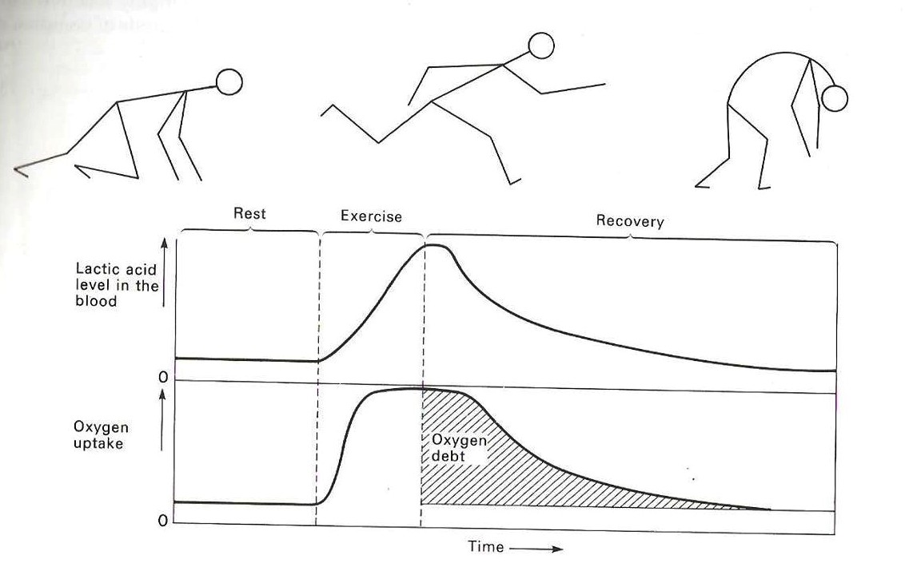
The additional oxygen that is needed after exercise to completely oxidize the lactic acid, is called oxygen debt.
In other words during strenuous\vigorous exercise the body produces energy first, and obtains oxygen to pay for it later.
Basal metabolism: is the amount of energy expended daily by humans and other animals at rest, this energy is required only for the functioning of
vital organs such as heart, lungs, nervous system, kidneys, liver, intestine, sex organs, muscles, and skin.

Vital activities must keep on going all the time to stay alive. We need a minimum amount of energy to maintain such activities e.g.:
- Heart beats.
- breathing
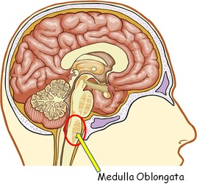
How does your breathing rate and breathing depth increase during exercise?
During exercise, CO₂ levels increase in blood causing the pH of the blood to be lowered. The decrease in the pH of blood will be detected by a sensor in the brain called medulla oblongata which will send impulses to the lungs and breathing muscles to increase the breathing rate and depth to replace CO₂ with O₂ and lower CO₂ levels and return the pH of blood back to normal.

Respiration Experiments

Experiment 1:
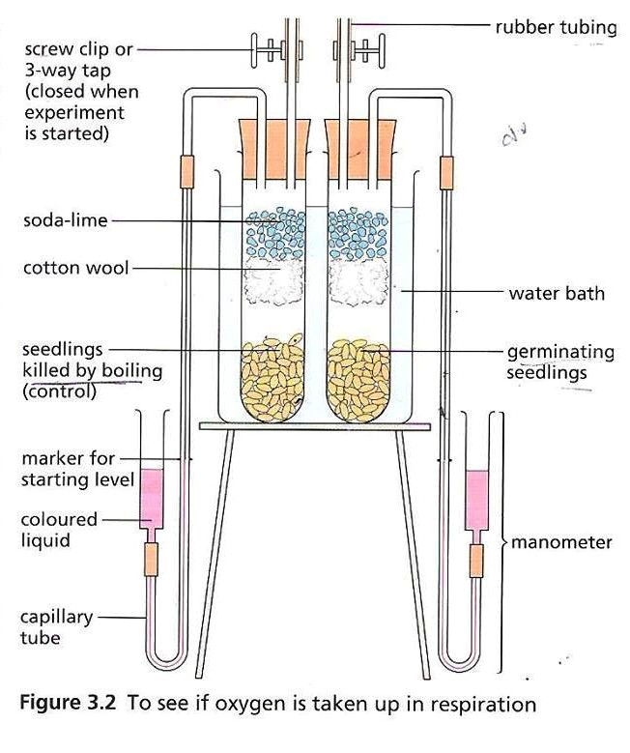
Using oxygen in respiration
- This experiment is performed using an apparatus called respirometer which is used to measure the rate of respiration by monitoring how quickly oxygen is used up The level of the liquid in the delivery tubing will go up.
There are two drawbacks (problems) to this experiment:
First drawback: Organisms usually give out as much carbon dioxide as they take in oxygen so there will be no change in the total amount of air in the test tube and the liquid level will not move. To overcome this problem we add soda lime which is used to absorb carbon dioxide as fast as it is produced.
The seeds will consume oxygen and release carbon dioxide. The soda lime in the apparatus will absorb the CO₂ that is produced and the amount of air in the test tube will decrease. As a result the pressure inside the tube will decrease and the level of the colored liquid in the capillary tube will increase (suction).
To better explain this, it is the exact same thing that happens when you're drinking a juice using a straw. When you suck in air you reduce the pressure inside the straw and the level of the juice rises.
The second drawback is that quite small changes in temperature will make the air in test tube expand or contract and so the liquid will rise or fall whether or not respiration is taking place. To overcome this, the test tube is kept in a beaker of water (water bath) to keep the temperature constant.
Control: A second experiment is done to make sure that the results of the first experiment are due to the conditions being studied and not to some other cause which has been overlooked. In this example, a similar respirometer is prepared containing an equal quantity of germinating seeds which have been killed by boiling to show that it is respiration (which is a process carried out ONLY by living things) that uses up oxygen. This proves that without respiration no oxygen will be consumed and no carbon dioxide will be produced and absorbed and as a result no change in pressure will occur.
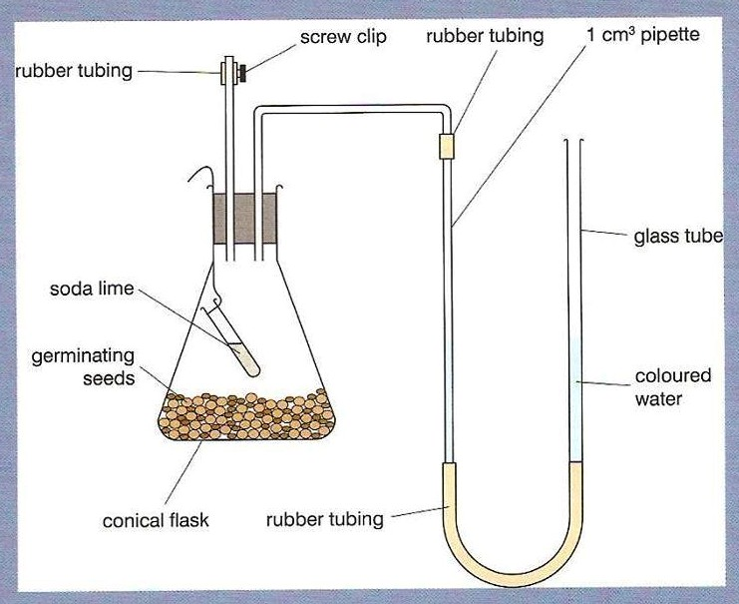
- One might argue that a gas other than oxygen is used up during respiration
Your answer should be:
There is only 0.03% CO₂ in the air and the other gas is nitrogen which is known to be less active than oxygen so oxygen seems to be the most likely gas to be consumed.
The Effect of temperature on the rate of respiration:
The effect of temperature on the rate of respiration can be investigated by placing identical sets of the apparatus in water baths of different temperatures. Note : living organisms are killed at temperatures above 40 ⁰C

Experiment 2:
Carbon dioxide from germinating seeds
It should be clear now that respiration consumes oxygen and releases carbon dioxide.
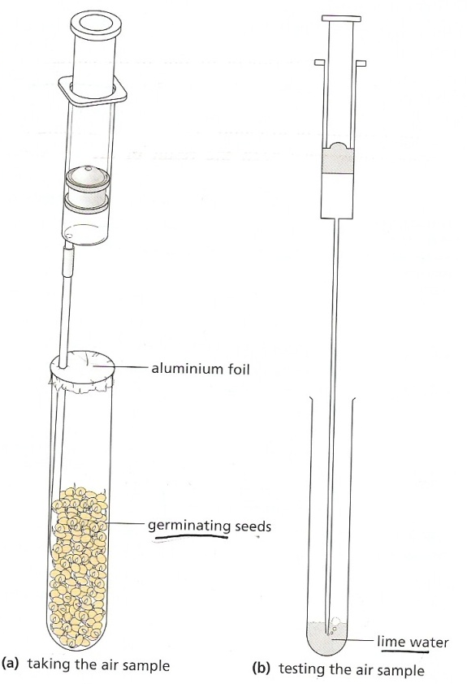
In this experiment we want to prove that carbon dioxide is produced.
Before we start the experiment, you should be familiar with the test that is used to prove the presence of carbon dioxide.
How do we test for carbon dioxide:
This is done by pumping the gas produced through lime water if it is carbon dioxide, lime water will turn milky.
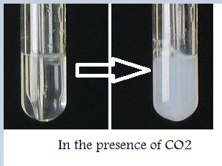
- The experiment is done by placing living seeds in a test tube which is closed using an aluminum foil as shown in the figure, these seeds are living seeds so they will respire, consume the oxygen found in the test tube and release carbon dioxide. By using the gas syringe we can collect the gas in the test tube and then release into another test tube containing lime water. Lime water will turn milky indicating the presence of carbon dioxide which proves that carbon dioxide is produced during respiration.
Control Experiment:
Boil some seeds of the same type/amount and place them in the same apparatus described above. Carry out the exact same experiment. The final result will be different; lime water will not become milky which proves that ONLY living seeds are able to respire.

Experiment 3 :
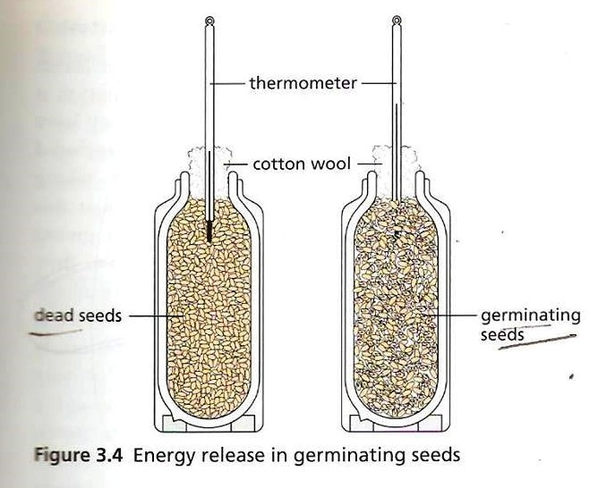
Releasing energy in respiration:
As learned before respiration is a process that produces heat energy.
How can we test for heat energy?
Easy! Thermometer!
Steps:
1) Wash the seeds with formalin. This is done to kill any bacteria or fungi on the surface of the seeds because these can interfere with the results.
2) Place the seeds in the flask and insert a thermometer.
3) Check the results
Control: As done in the previous experiments, a second experiment is done using dead seeds to prove that respiration is the reason for this temperature rise since ONLY living seeds can respire.
Result: Temperature of the living seeds will be 5-10 ºC higher.

Experiment 4:
- Anaerobic respiration in yeast:
Anaerobic occurs without oxygen.
As we learned before anaerobic respiration occurs in muscles and in yeast:
In Muscles:
C6H12O6C3H6O3 (lactic Acid) +2ATP
No Carbon dioxide is produced
In Yeast
C6H12O6 CO2 + C2H5OH (Ethanol) + 2ATP
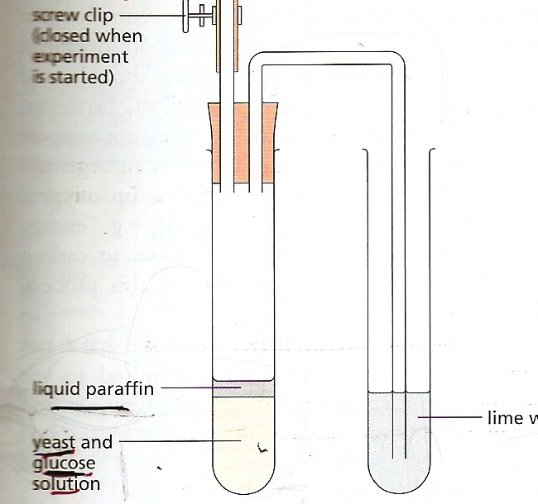
Carbon dioxide is produced
Steps:
- Boil a measured amount of water to expel all the dissolved oxygen (Because we are testing anaerobic respiration).
- Place 5 cm³ of the glucose solution and 1 cm³of the yeast suspension in a test tube
- Cover the mixture with a thin layer of liquid paraffin (this is used to exclude all atmospheric oxygen and to prevent it from entering into the mixture). As you’ve learned previously anaerobic respiration in yeast produces carbon dioxide, so this CO₂ will exit through the delivery tube into the test tube containing lime water and will turn it milky indicating that the process took place.

Control:
It might be suggested that carbon dioxide came from a chemical reaction that took place between yeast and glucose which has nothing to do with respiration. The only way to disprove this is to use killed yeast. When the yeast is killed it will no longer be able to carry out anaerobic respiration and will no longer produce CO₂, as a result, the color of lime water will not change. This proves that it is NOT a chemical process that took place, it is a living one.
We can use other indicators to test for the presence of carbon dioxide such as hydrogencarbonate indicator.
