
Chemistry (0620)
Chemical reactions

Acids and bases – part 2

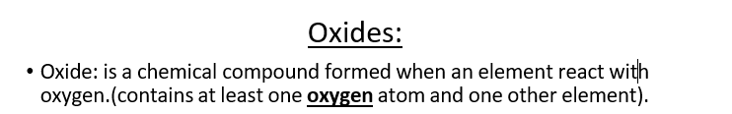

oxides

Metal oxide Non metal oxide
Neutral oxides PH = 7
Acidic oxides PH less than 7 dissolved in water
Amphoteric oxides
Basic oxides PH greater than 7 when dissolves in water

Examples of oxides:
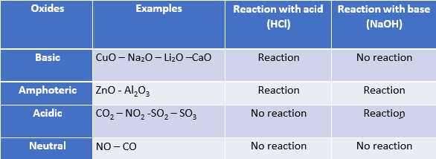

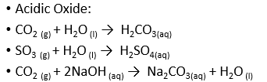

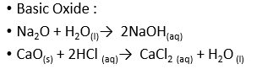

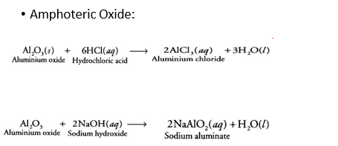

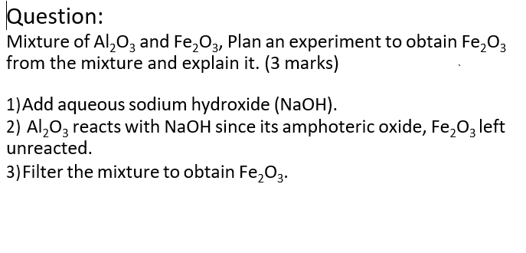

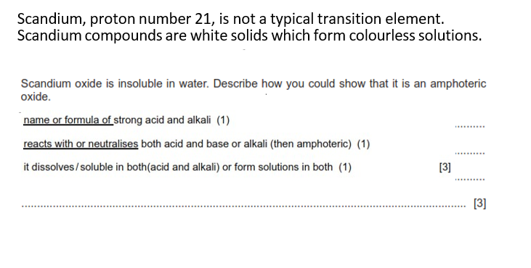

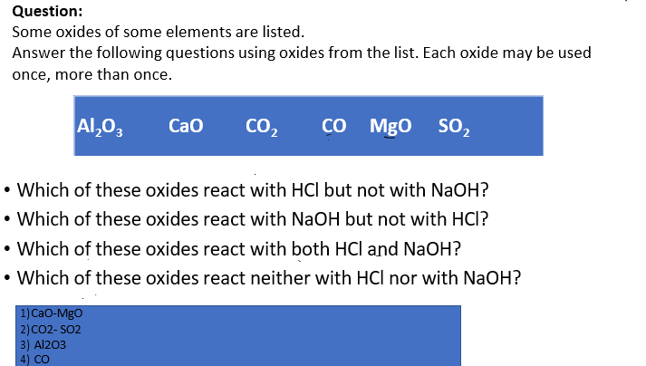

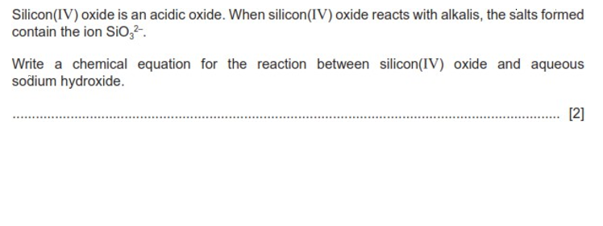

- Rules of solubility:

Solubility
Soluble compounds | Insoluble compounds
Al group 1 Li, Na, K, Rb, Cs, Fr ammonium ion NH4^{+,} Nitrate NO3⁻Hydrogen carbonate HCO ⁻ | All carbonate hydroxides
Most Halides Cl⁻, Br⁻, I⁻, Sulfates SO4 -2
Except: Ag, Pb, Ca and Ba | Except: With group 1 and NH4⁺

- Decide whether the following compounds are soluble or not:
Compounds | Soluble | Insoluble
NaCl
Na2SO4
K2CO3
AgNO3
Ca(HCO3)2
CaCO3
Fe(OH)₃
NaOH
KCl
PbI2
FeSO4
(NH4)2SO4

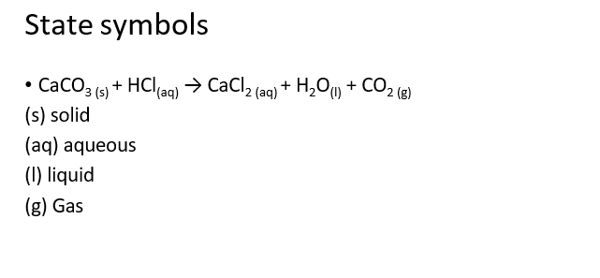

*Preparation of salts:
Is the salt soluble?
Yes, it is soluble | No, it is insoluble
Titration (Prepared  when alkali reacts with an acid (Salt from group 1 or ammonium) | Precipitation (prepared  when metal nitrates react with acids)
Neutralization (excess of
the solid) prepared when base(insoluble) reacts with an acid)

Metal + Acids
(Displacement reaction

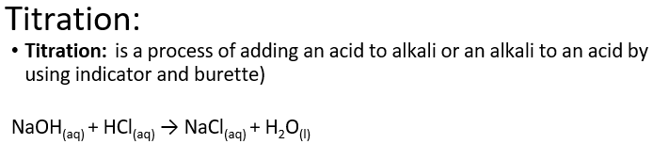

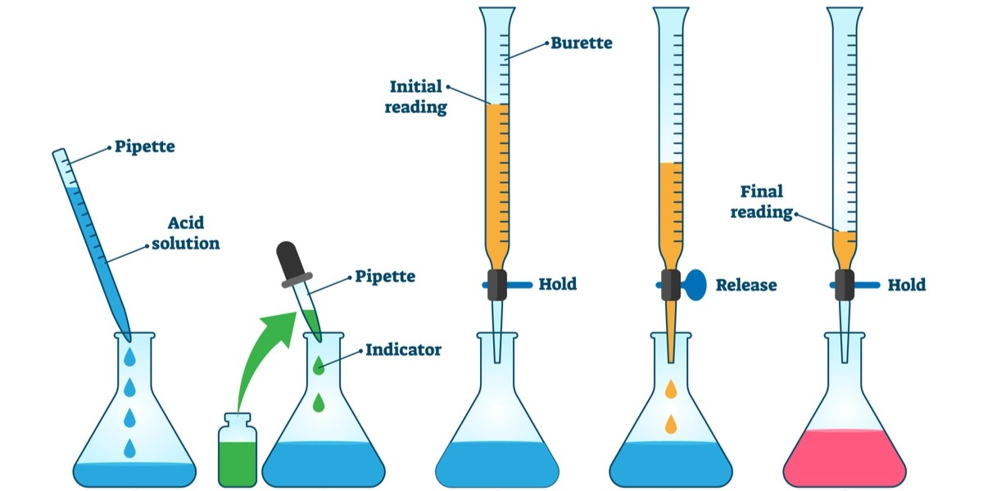

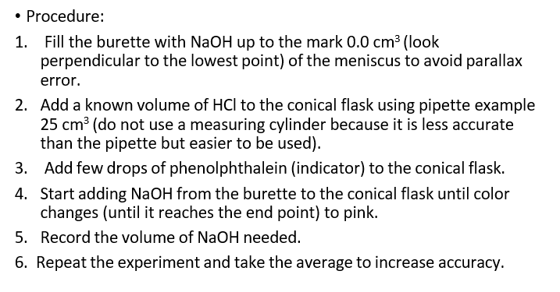

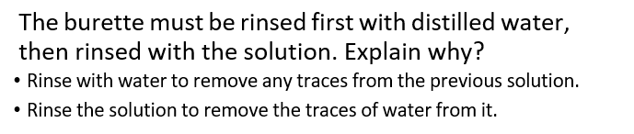

Acid HA | Salt MA
HCl | Chloride salt
HNO₃ | Nitrate salt
H₂SO₄ | Sulfate salt
H₂CO₃ | Carbonate salt
H₃PO₄ | Phosphate salt
CH₃COOH | Ethanoate salt

