
Booklet (2nd grade)
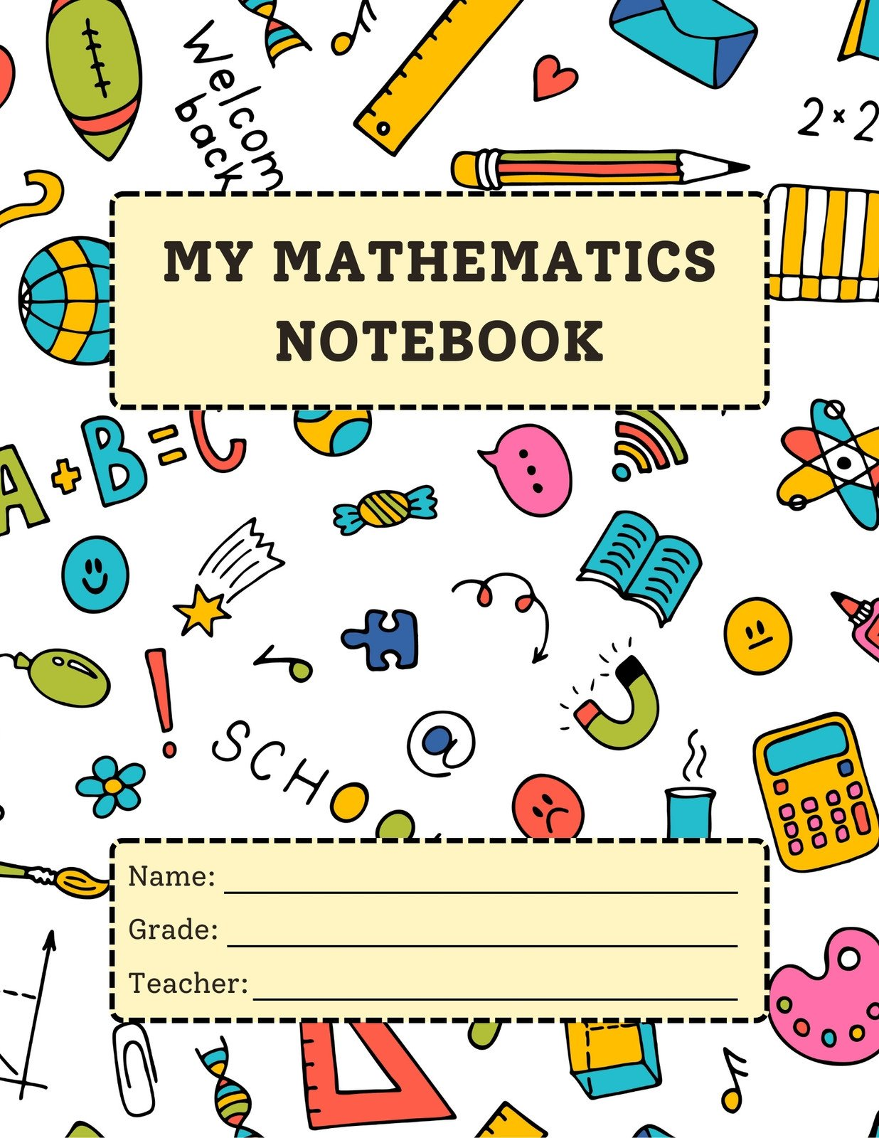

Teachers: Nancy Alfarah& konouz Hussien

Counting forwards and backwards
Objective: the student should be able to count on or back by 1’s, 2’s, 5’s, 10’s, 100’s.
Complete each of the following patterns.
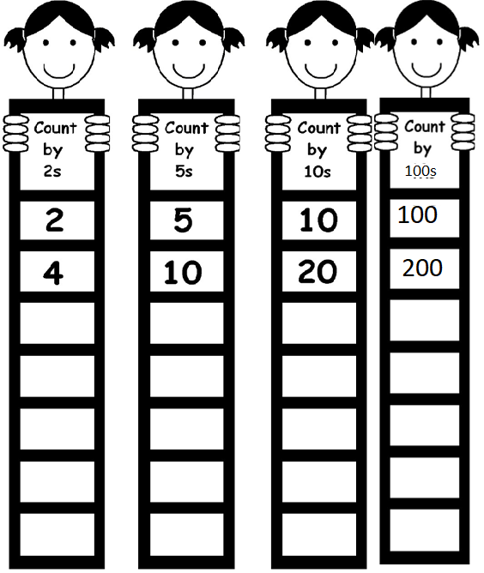

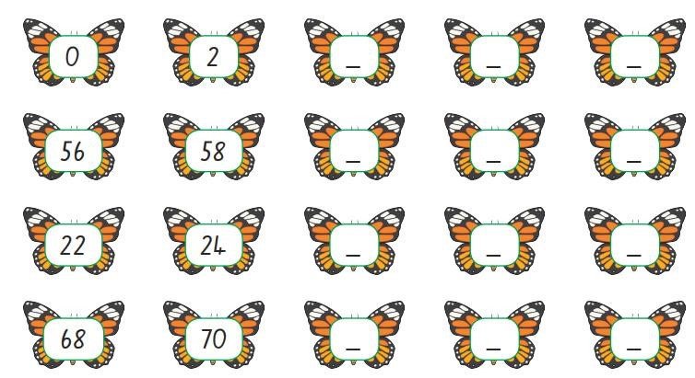
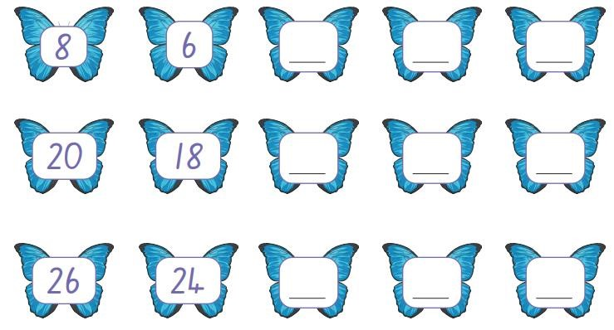
is counting forward or backward.

(
We are counting by
2
’s
)

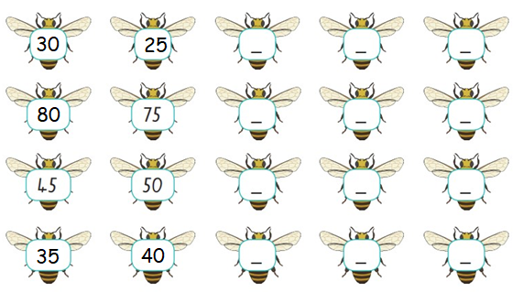
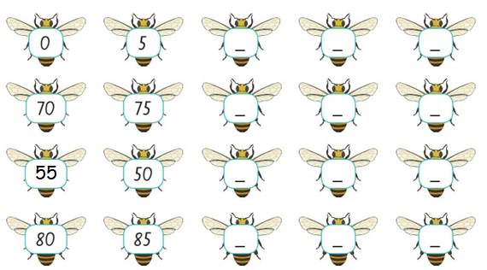
is counting forward or backward.
(
We are counting by
5
’s
)

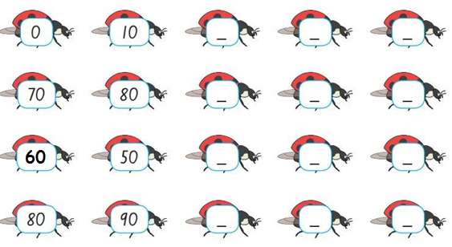
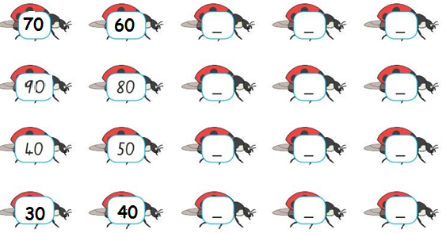
is counting forward or backward.
(
We are counting by
10
’
s
)

Count on by 2’s
124 | 126

Count on by 5’s
335 | 340

Count back by 5’s
625 | 620

Count on by 10’s

914 | 924

Count back by 10’s
401 | 411

Count on by 100:

128 | 228
Count back by 100:

1085 | 985

- Here is part of a sequence.
The sequence continues in the same way.

Write down the next two terms in the sequence.

545 535 525 515

- Here is a sequence of patterns in a table.

1st pattern | 2nd pattern | 3rd pattern | 4th pattern

One pattern is missing.
Draw the 3rd pattern in the table.

- Here are the first four numbers in a sequence.

2, 7, 12, 17, …

Write down the 12th term in the sequence.

- Here is part of a number sequence.

125 135
95 105

The sequence continues in the same way.

Write the correct number in each box.

- Write the next two numbers in this sequence.

47 44 41 38

Find the missing numbers in the following number bonds of 100.

35 + = 100 45 + = 100

55 + = 100 75 + = 100

25 + = 100 85 + = 100

33 + = 100 28 + = 100

63 + = 100 52 + = 100

46 + = 100 71 + = 100

24 + = 100 87 + = 100
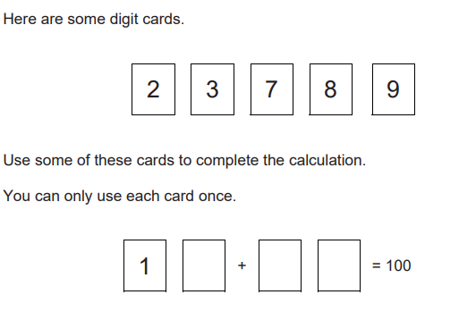

Multiplication
Fill with the missing numbers, the first one has been done for you.
Addition sentence | Groups | Multiplication sentence | Answer
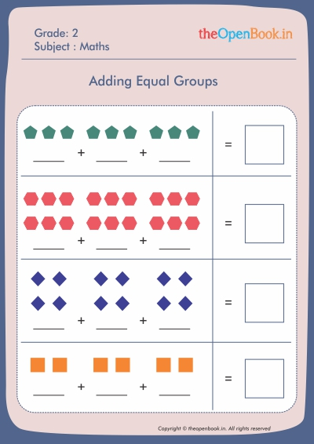  2  2  2 | _3_groups of_2__ | 3 x 2 | = 6
 | ___groups of____ | ___ x ___ | =___
 | ___groups of____ | ___ x ___ | =___
 | ___groups of____ | ___ x ___ | =___

Fill with the missing numbers.
Addition sentence | Groups | Multiplication sentence | Answer
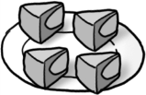 | _4__groups of__4__ | 4 x 4 | = 16
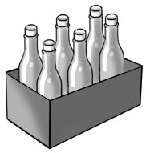 | ___groups of____ | ___ x ___ | =___
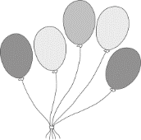  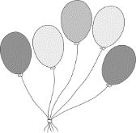  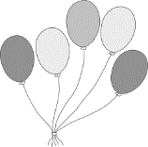 | ___groups of____ | ___ x ___ | =___
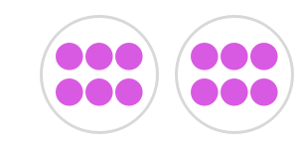 | ___groups of____ | ___ x ___ | =___

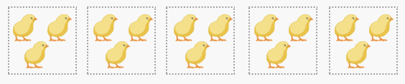
Fill with the missing numbers.
How many chicks in all?

Repeated addition: ____+____+____+____+____= ______
Means: ______ groups of ______
Multiplication: ____ x ____ = ____


How many stars in all?
Repeated addition: ____+____+____= ______
Means: ______ groups of ______
Multiplication: ____ x ____ = ____

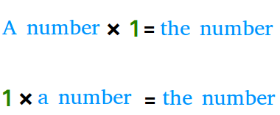
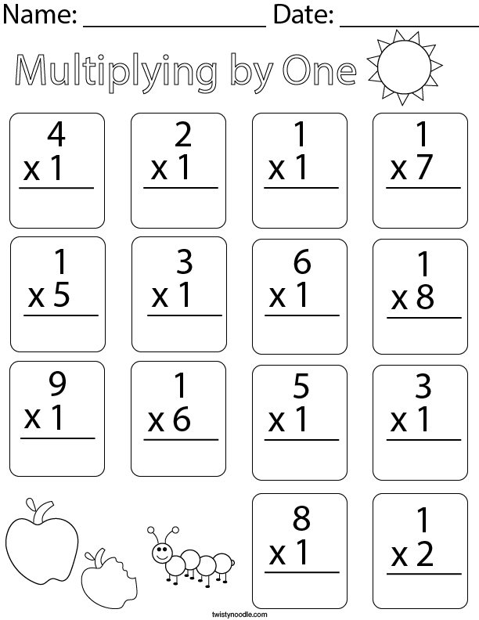

Note: any number times zero equals zero.
9×0=0
0×14=0
645×0=0
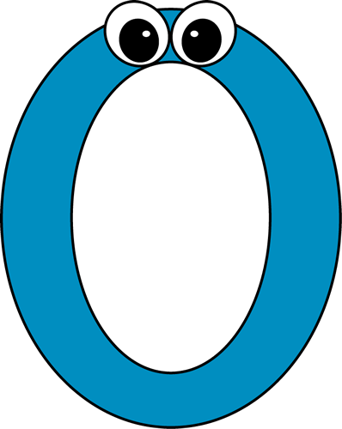
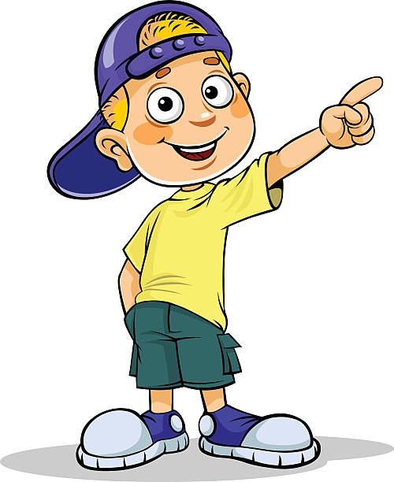

Find the answer for each of the following.
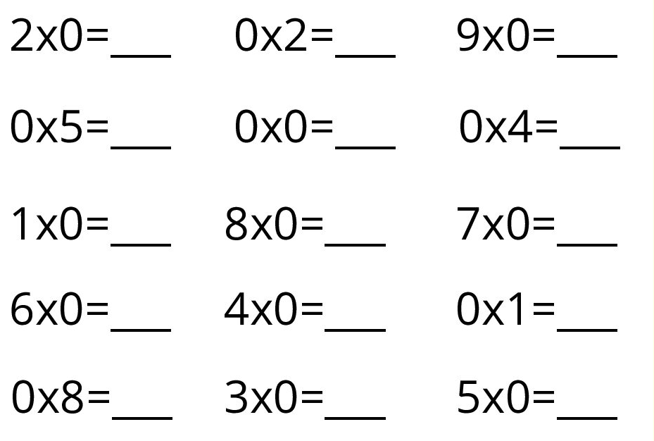

Predict what is the answer of the following.
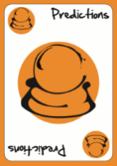
567,678 x 0 = ________
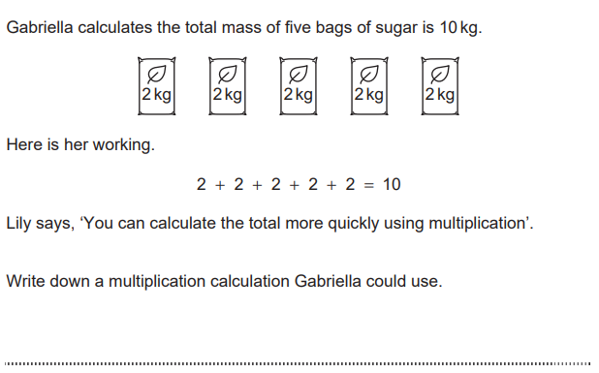
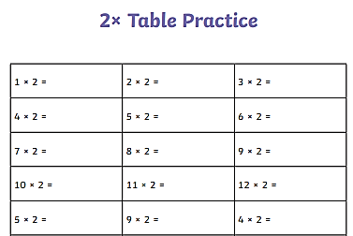
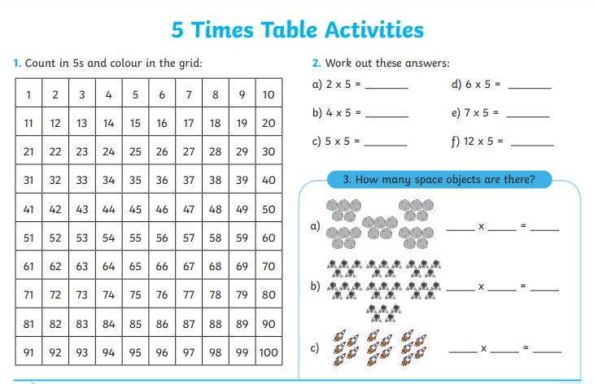

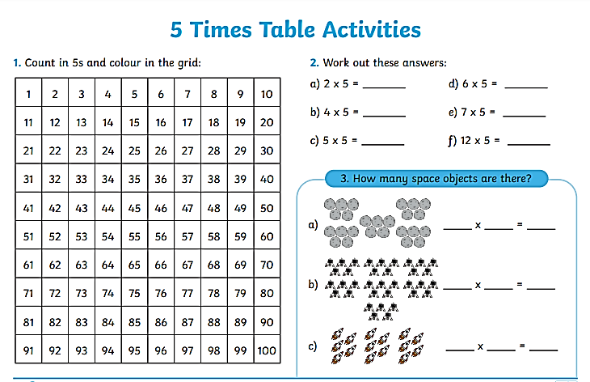

Note that we are counting by 5's
* when you multiply any number by 5, all the numbers will end with 0 or 5 .

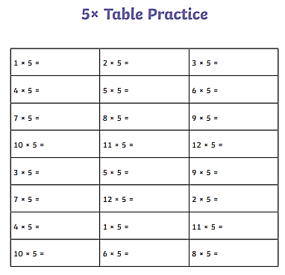
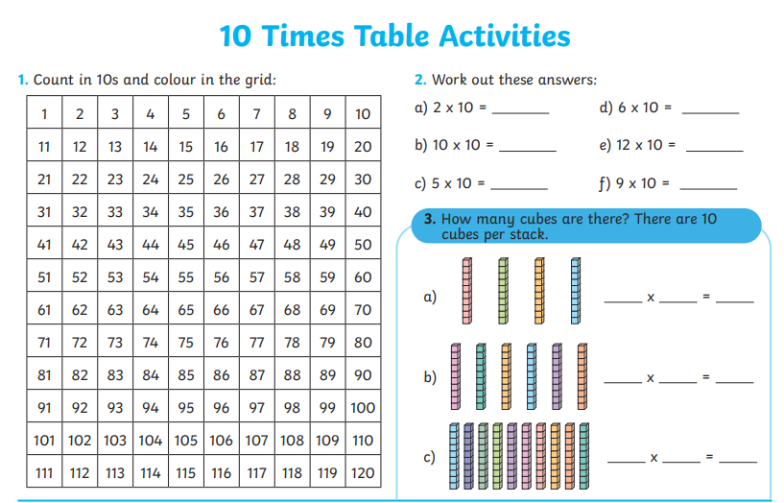

Find the product of the following.
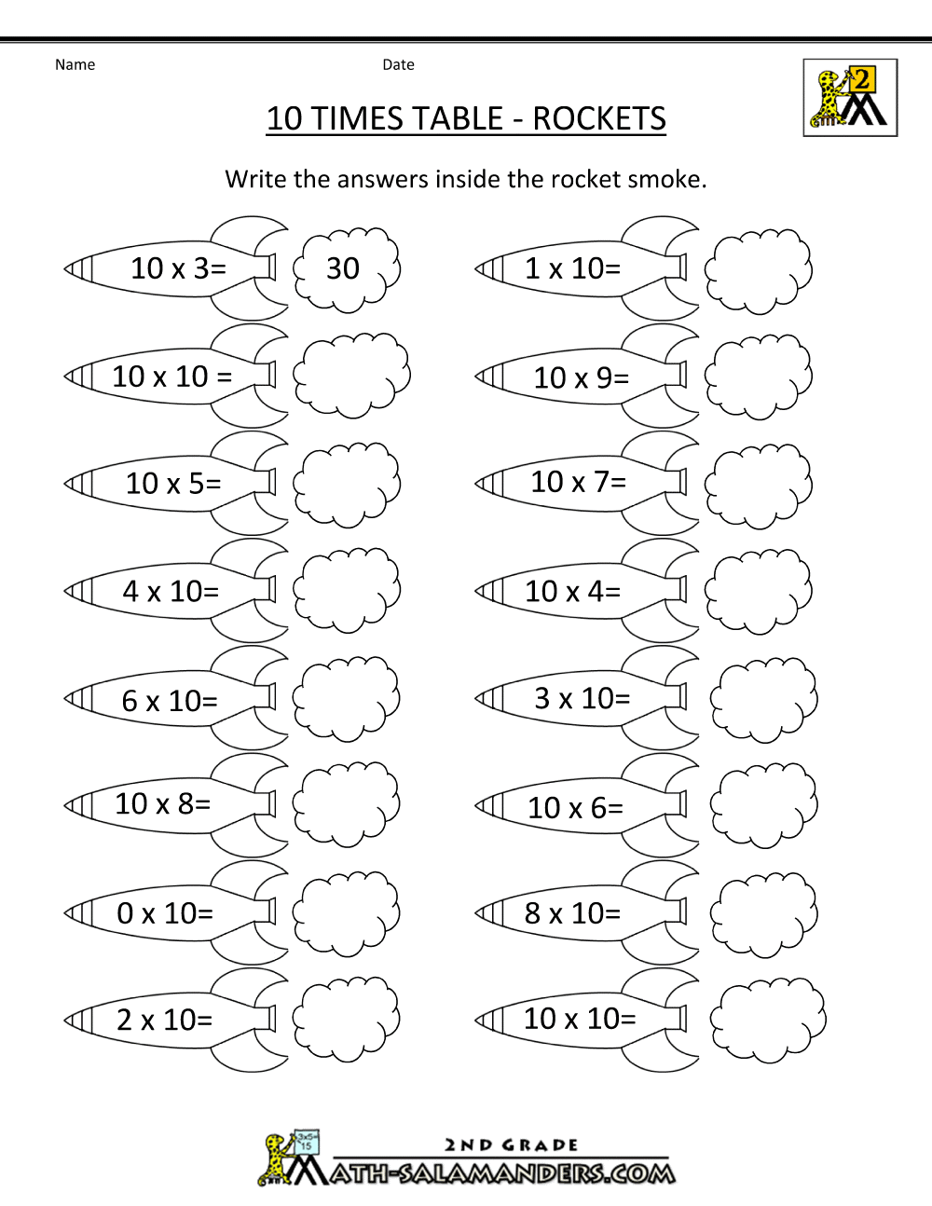
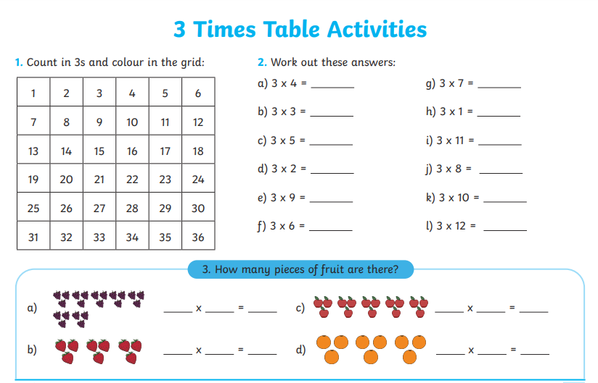
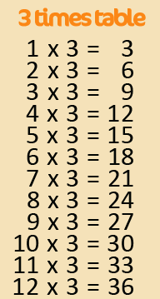
Note that we are counting by 3's

Find the product of the following.
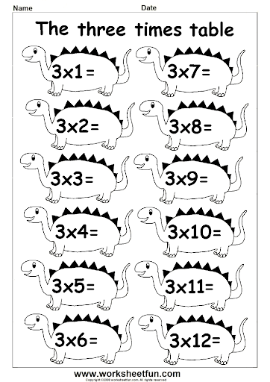
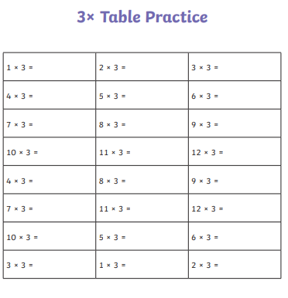
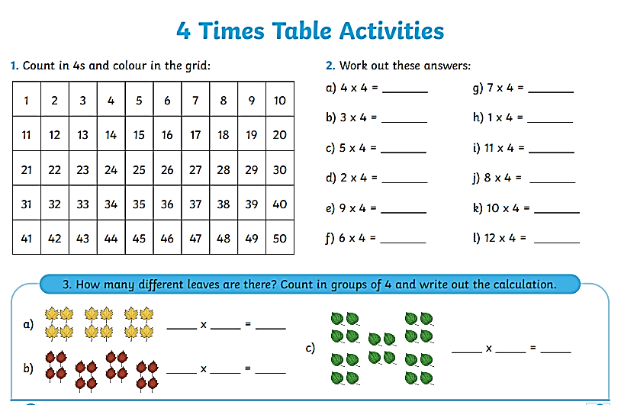
Find the product of the following.

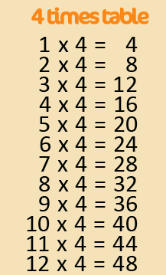
Note that we are counting by 4's

Find the product of the following. 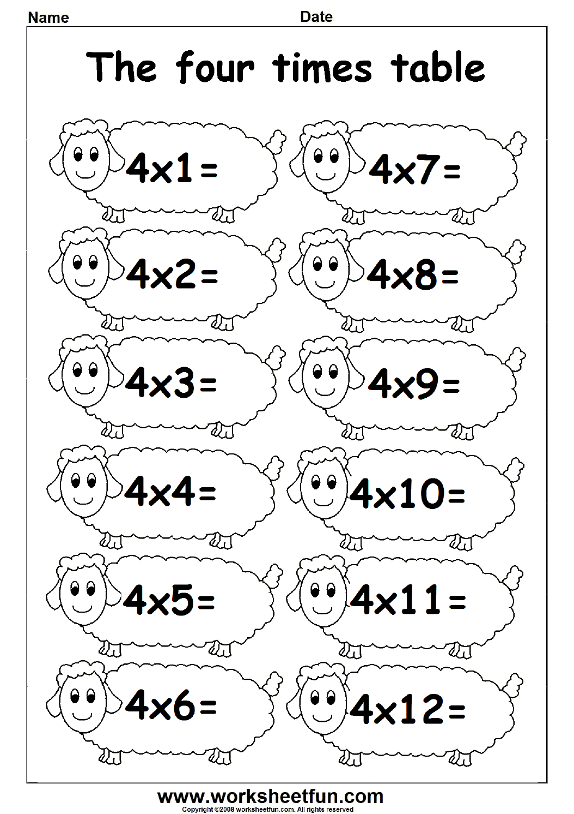
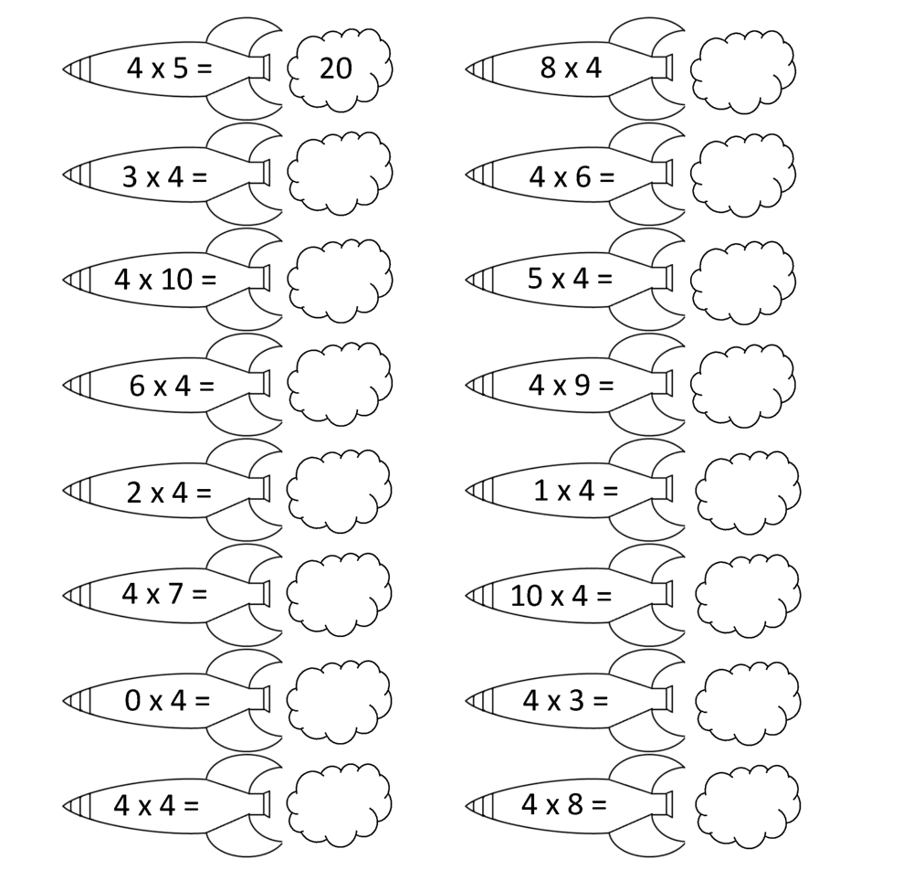
4
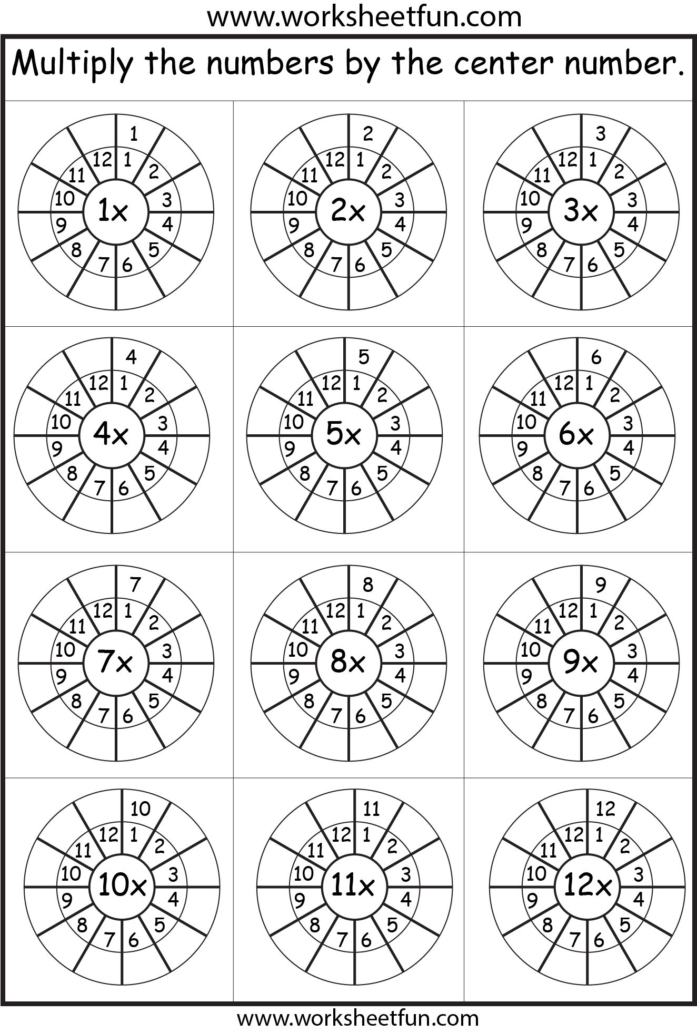
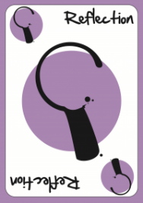
Multiply the numbers by the center number then use the reflection key to check your answers
10x

Multiplication using Arrays

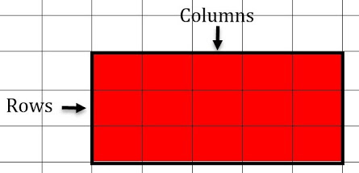
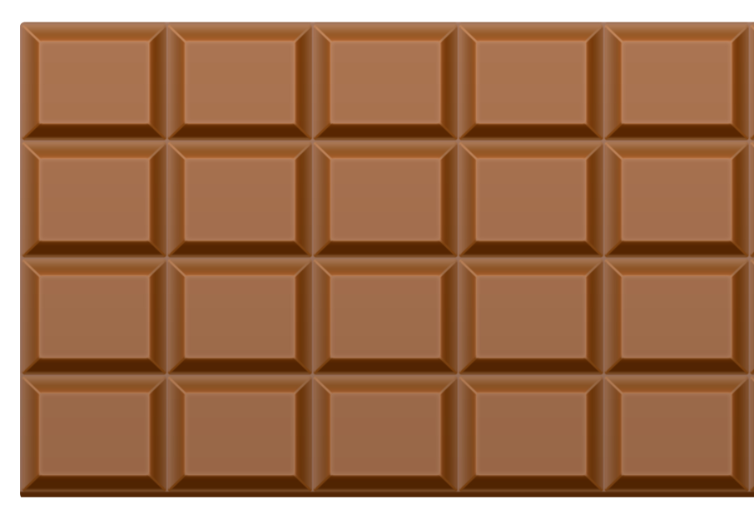
How many columns does it have? _______
How many rows does it have? _______
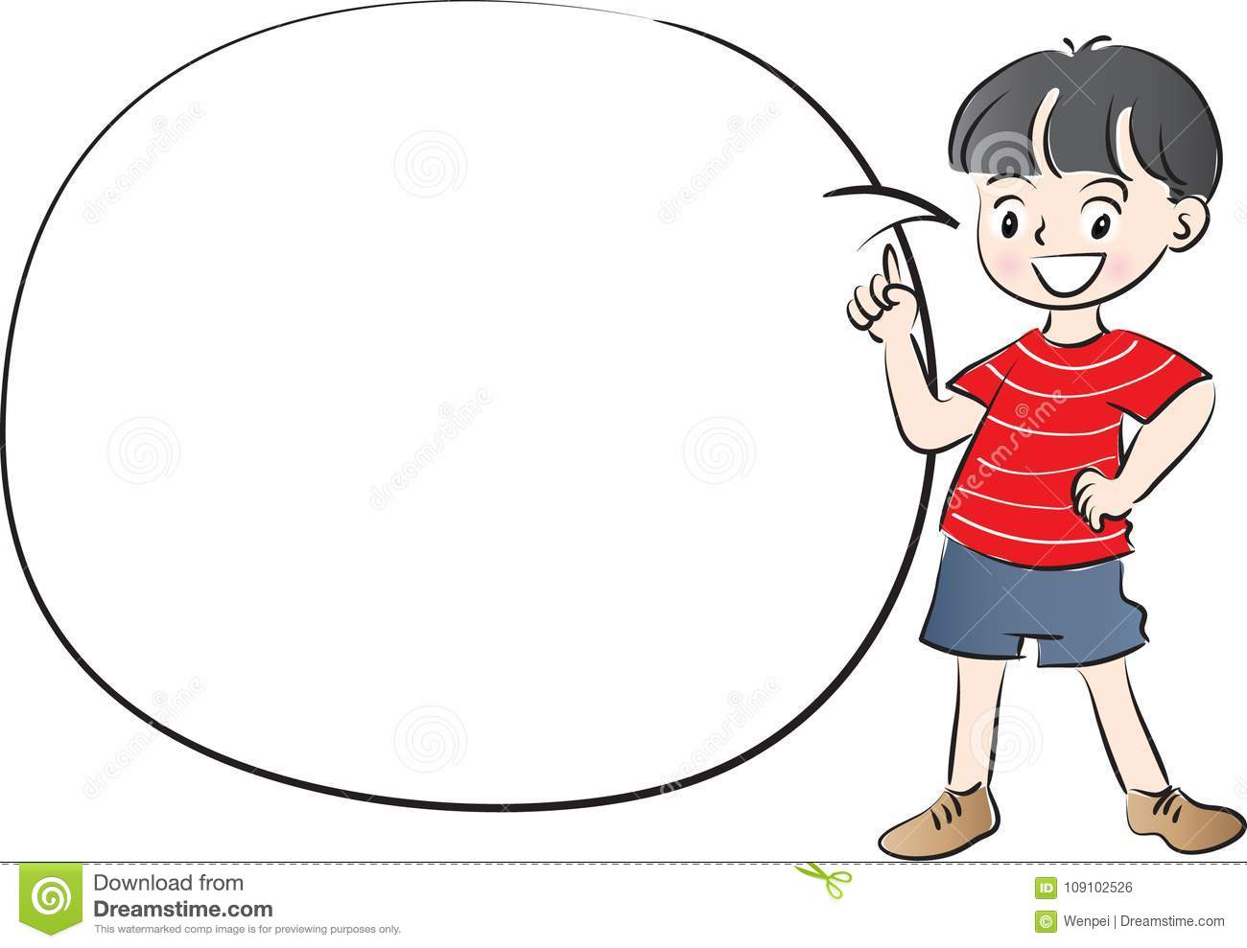
Look at this chocolate bar, how many pieces of chocolate do we have here? ____________________
Look at this chocolate bar, how many pieces of chocolate do we have here? ____________________

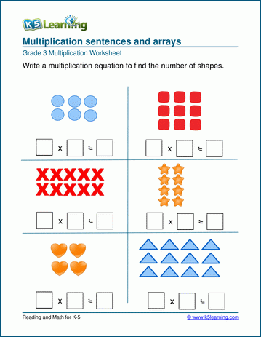
Write the multiplication sentences that represent the following arrays.
=
=
=
=
=
=
Write a multiplication sentence to find how many dots in the following array.
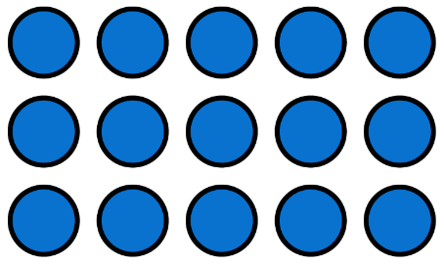 ______________
Write the multiplication sentence for each of the following arrays.

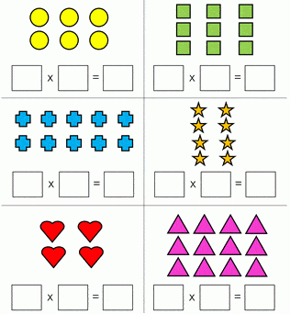

Grid multiplication
Fill in the missing numbers.
x | 5 | 2
3
5

x | 2 | 10
3
4

x | 1 | 4
4
10
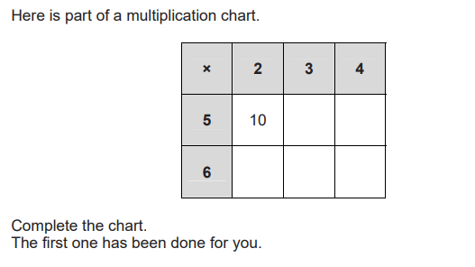

- Here is her working.
2 + 2 + 2 + 2 + 2 = 10

Lily says, ‘You can calculate the total more quickly using multiplication’.

Write down a multiplication calculation Gabriella could use.

- Draw a ring around all the numbers that are multiples of 2

112 121 398 500 889 | 945

- Samira wants to calculate 2 × 18 × 5
She rearranges the numbers to simplify the calculation.
Write the numbers 2, 18 and 5 in the boxes to show how she could do this.

 | × |  | ×

Division
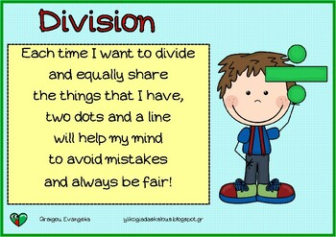
Objectives: The student should be able to divide 2-digit number by 1-digit number.

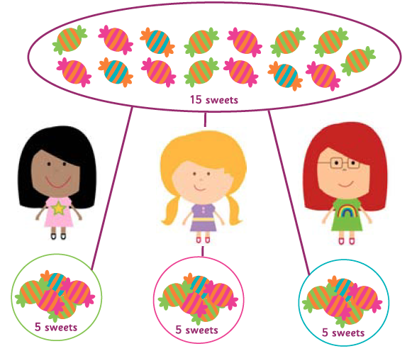
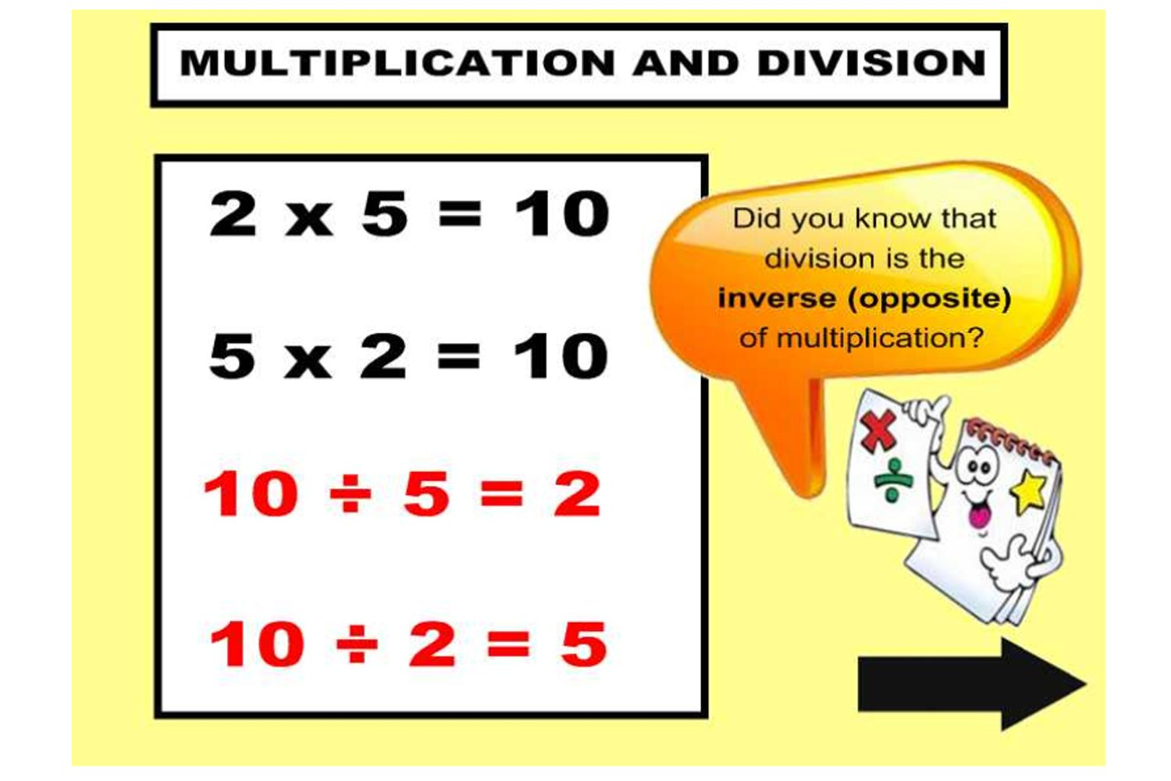

Complete the following.
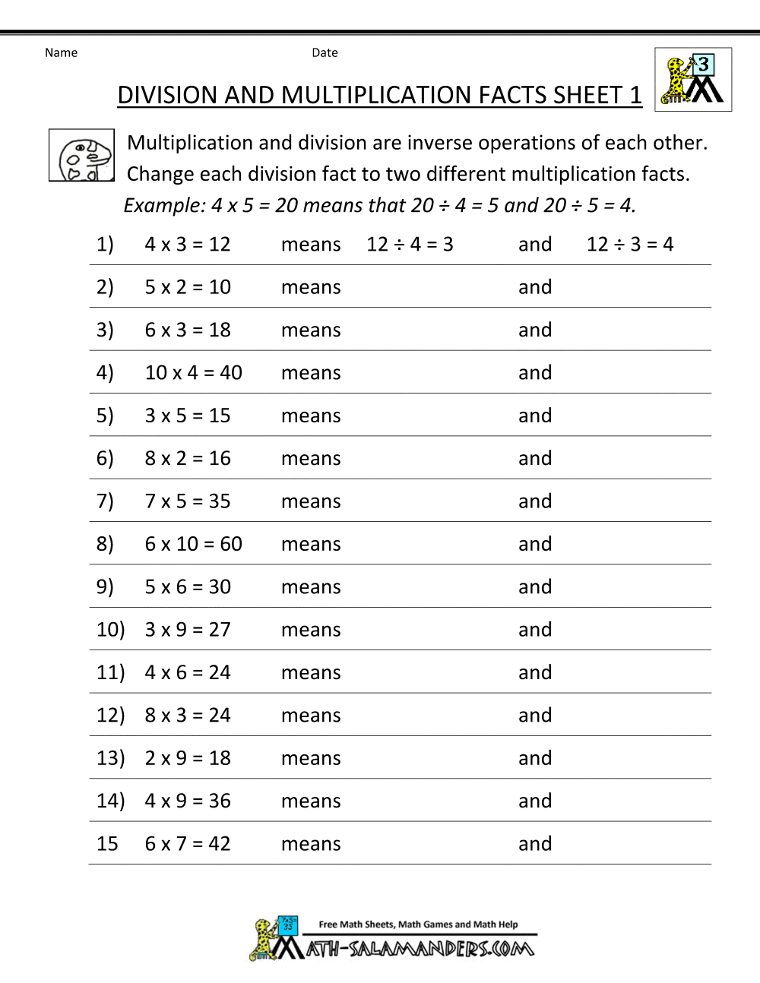
Fill in the missing numbers the first one has been done for you.

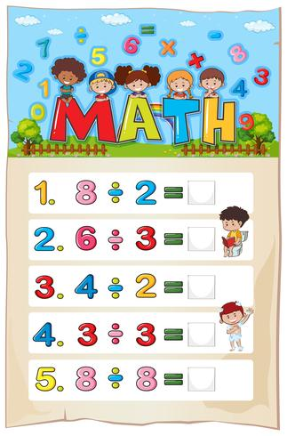
4
Note that:
6 ÷ 3 it means how many 3's in 6? The answer is 2
28 ÷ 4 it means how many 4's in 28? The answer is 7
60 ÷ 5 it means how many 5's in 60? The answer is 12

Find the quotient of the following.
25 ÷ 5 = | 27 ÷ 3 =
12 ÷ 4 = | 16 ÷ 2 =
40 ÷ 10 = | 60 ÷10 =
20 ÷ 2 = | 30 ÷ 3 =
9 ÷ 3 = | 45 ÷ 5 =
16 ÷2 = | 35 ÷ 5 =
8 ÷ 4 = | 15 ÷ 3 =
18 ÷ 3 = | 10 ÷ 2 =

Fill in the missing numbers.
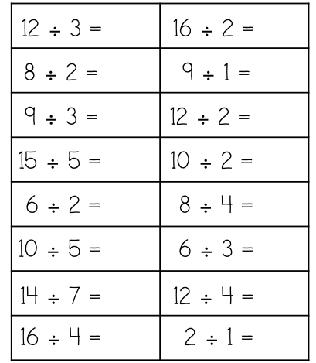

Find the quotient of the following
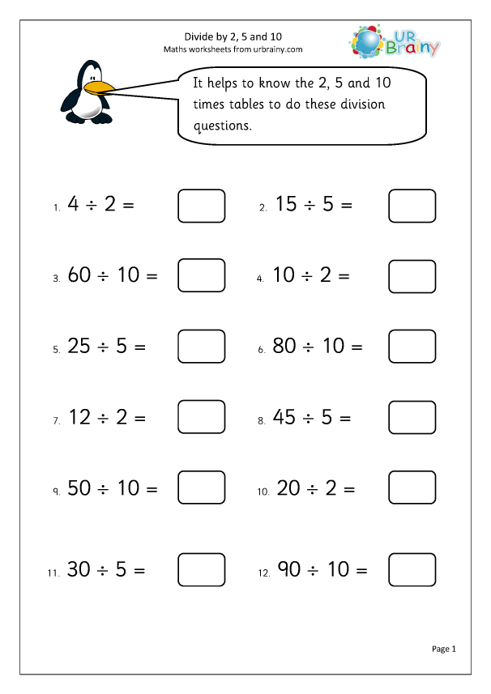

- Here are five digit cards.

2 |  | 3 |  | 4 |  | 6 |  | 8

Use four of the cards to complete this calculation.
Use each card once only.

 |  | ÷ |  | =

Multiplication and division facts (family facts)
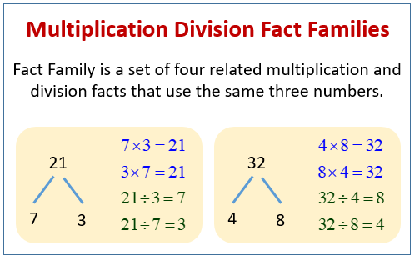
Write the missing numbers.

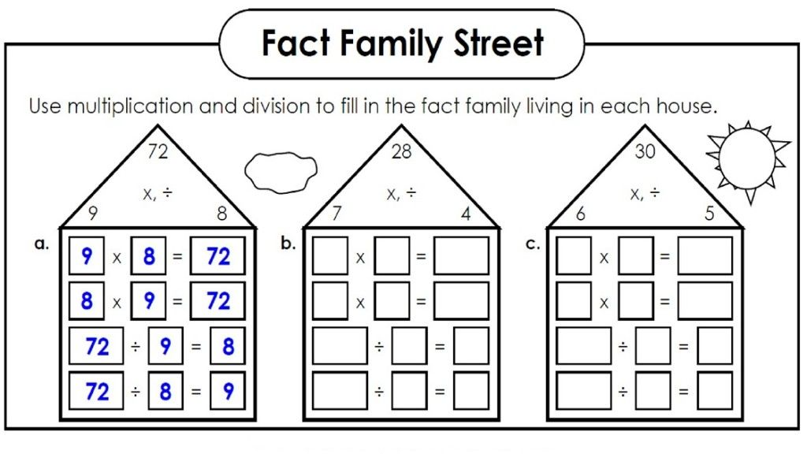

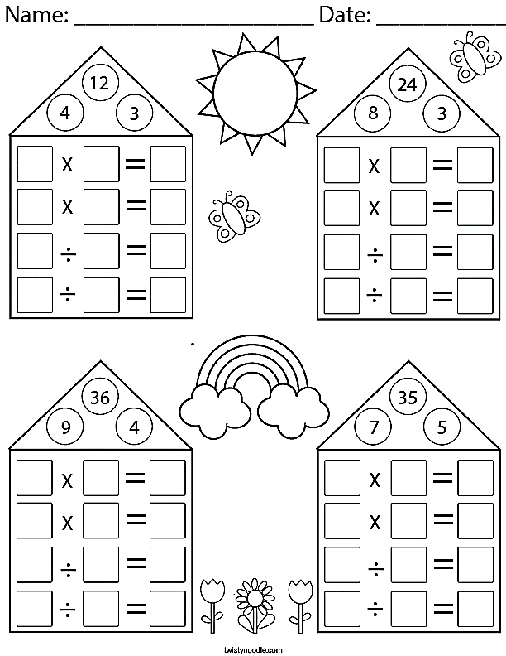
Complete the following facts family.

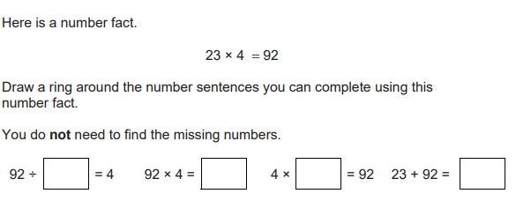
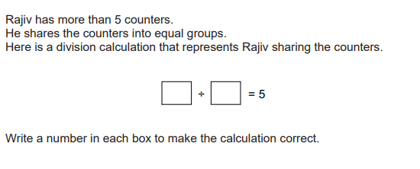

Multiplying and dividing numbers by 10
Find the missing numbers:
53 x 10 = 42 x 10 = 25 x 10 =

14 x 10 = 30 x 10 = 90 x 10 =

12 x 10 = 36 x 10 = 62 x 10 =

75 x 10 = 64 x 10 = 54 x 10 =
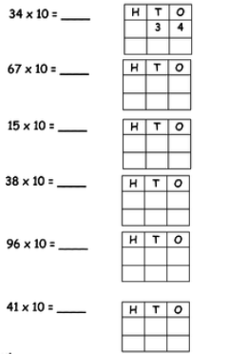
Multiply by 10 then find out what happens to the place value of each digit when you multiply by 10.

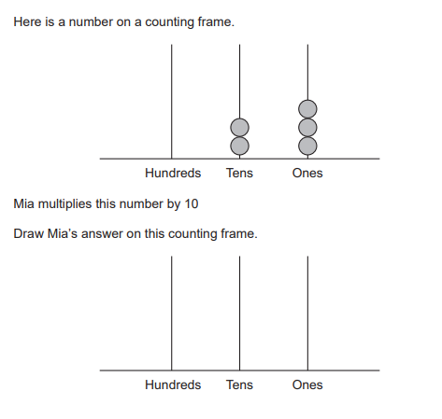

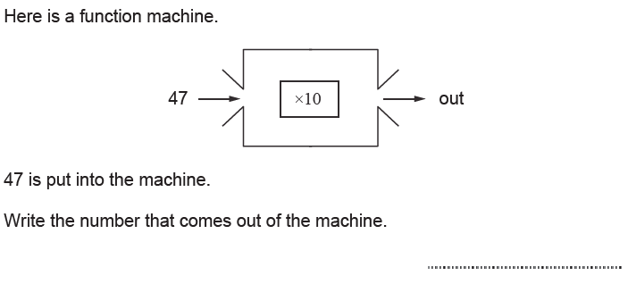

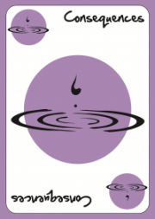
What are the consequences of multiplying any digit number by 10?
______________________________________

Find the quotient of the following:
920 ÷ 10 = 300 ÷ 10 = 500 ÷ 10 =

360 ÷ 10 = 580 ÷ 10 = 250 ÷ 10 =

200 ÷ 10 = 450 ÷ 10 = 120 ÷ 10 =

900 ÷ 10 = 150 ÷ 10 = 740 ÷ 10 =
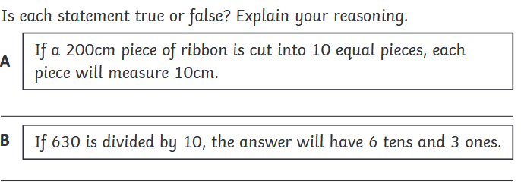

Solve the following problems.
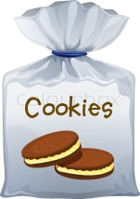
a) There are 12 cookies in a packet. Sam wants to share it with 4 of his friends. How many cookies each one will have?

………………………cookies
- Pooh shares 10 pencils equally into 5 baskets. How many pencils are in each basket?

................................ Pencils
- Pooh shares 50 apples equally into 5 baskets. How many apples are in each basket?

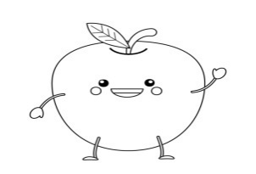
................................ Apples

- Pooh shares 12 bananas equally into 4 baskets. How many bananas are in each basket?

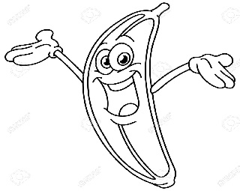
................................ Bananas
Note: share means division ÷

Doubling and Halving
Objectives: - Understand the relationship between halving and doubling.

Double the following numbers.
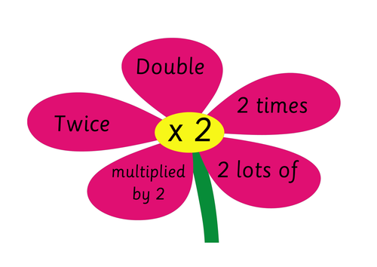
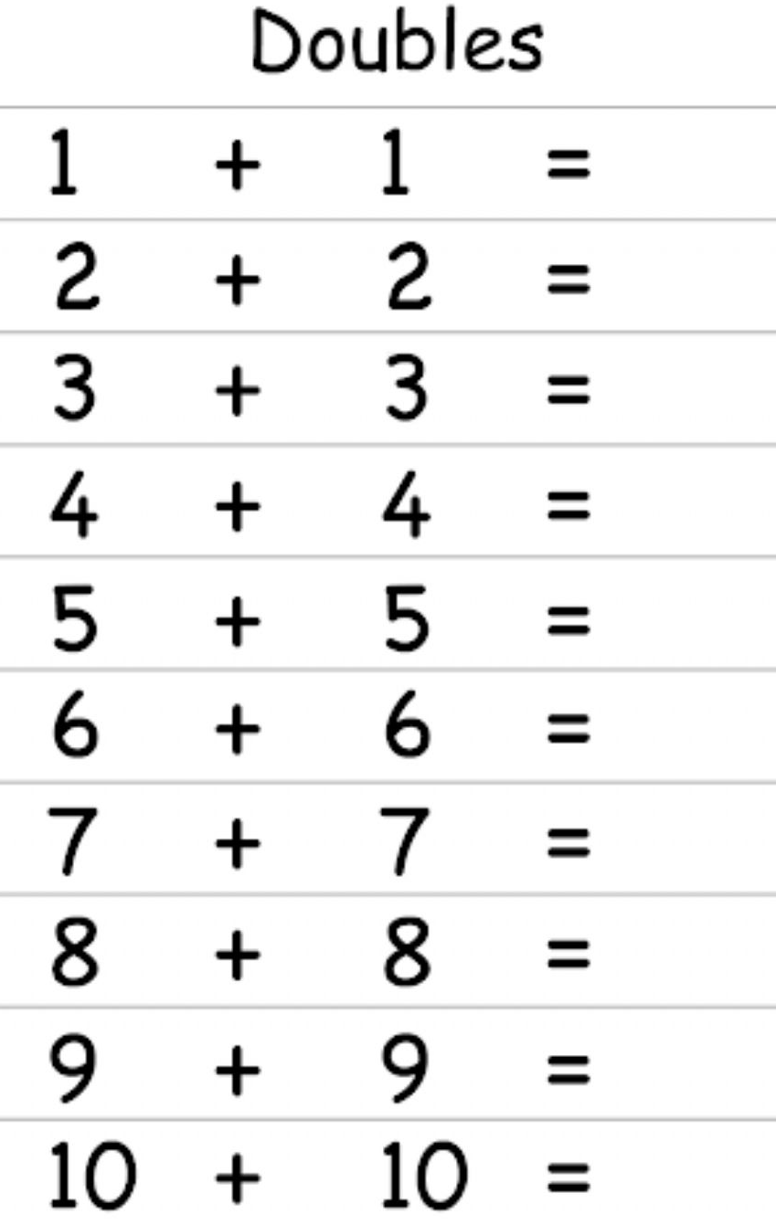

Find the answer of each of the following.

a) Double 4 = b) Double 10 =

c) Double 12 = d) Double 100 =

e) Double 240 = f) Double 50 =
Note that:
***To find Double any number, you should add the number twice.
Example: Double 12 it means 12+12=24
Double 15 it means 15+15=30
Double 240 it means 240+240=480

Fill in with the missing numbers.
(finding the half means divide the number by 2)
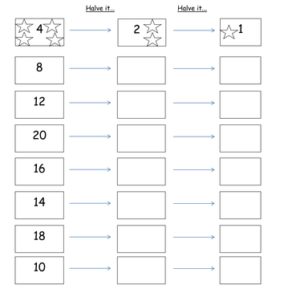

Find the half of the following numbers:
Half of 40
Half of 22
Half of 24

half half half

+ + +

= =
Half of 28
Half of 16

half half

+ +

= =
Solve the following word problems
Yamen has 8 apples. Half of the apples are red. How many apples are red?
................................ Apples

Qais has 24 pens. Half of the pens are blue. How many pens are blue?

................................ Pens

Sanad has 12 lollipops. Half of the lollipops are green. How many lollipops are green?

................................ Lollipops
Sophia bought 48 candy bars; she gave half of them to Elaina. How many cany bars she gave to Elaina?

……………………….. Candy bars

Sorting numbers
Objective: The student should be able to sort numbers into groups. (Recognize 2- and 3- digit multiples of 2, 5, 10.

Multiples of 2: 2, 4, 6, 8, 10, 12, 14, 16, 18, 20,…..
Multiples of 3: 3, 6, 9, 12, 15, 18, 21, 24, 27, 30, ….
Multiples of 5: 5, 10, 15, 20, 25, 30, 35, 40, 45, 50,.
Multiples of 10: 10, 20, 30, 40, 50, 60, 70, 80,….
All multiples of 2 end in 0, 2, 4, 6 or 8 (even numbers).
All numbers end in 1, 3, 5, 7 or 9 (odd numbers).
All multiples of 5 end in 0 or 5.
All multiples of 10 end in 0.

Date: / /

Multiples of 2:
2 | 4

Multiples of 3:
3 | 6

Multiples of 4:
4 | 8

Multiples of 5:
5 | 10

Multiples of 10:
10 | 20
Multiples of 100:
100 | 200

Here is part of a number grid. Draw a ring around all the multiples of 5.
492 493 494 495 496 497 498 499 500 501 502 503 504 505 506 507 508 509 510 511
Put each number in the correct bucket.
90 18 20 22 23 25 45
Multiples of 10 bucket

Multiples of 5 bucket

Even numbers bucket

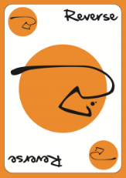
Which of the following is NOT a multiple of 2?
35 26 18 100

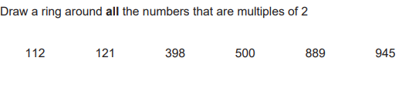

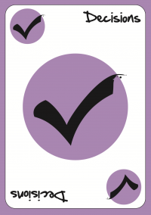
Here are 5 numbers.
18 20 22 23 25
Decide number in correct place of each on the Venn diagram. One has been done for you.
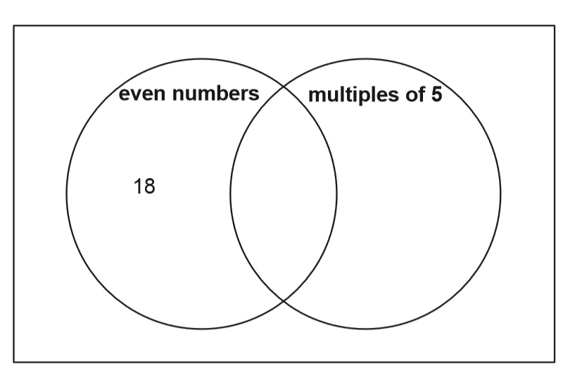
Put here the common numbers.

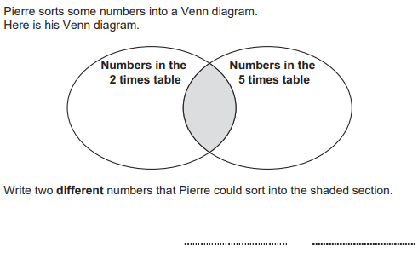

Here are 7 numbers.
16 20 45 8 17 75 90
Write each number in the correct place on the Venn diagram.
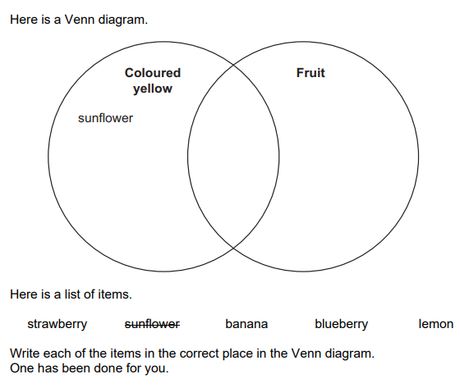

Pictogram, Carroll diagram, Bar Charts and Tally charts
Objective: The students should be able to
1- Answer a real-life question by collecting, organizing and interpreting data.
2- Use tally charts, frequency tables, pictograms (symbol representing one or two units) and bar charts (intervals labelled in ones
or twos)
3- Use Venn or Carroll diagrams to sort data and objects using two criteria

Here is a pictogram. It shows the number of minibeasts found by Class 2
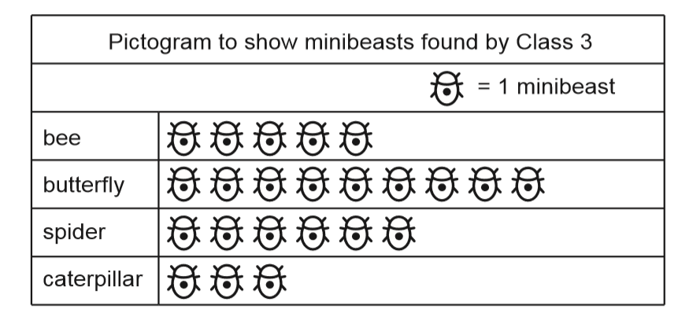
2
a- How many spiders did Class 2 find? .........
b- How many Caterpillars did Class 2 find? ........
c- How many butterflies did Class 2 find? ………….
d- How many bees and butterflies did class 2 find together ?..............
e- How many minibeasts did class 2 find in all?..............
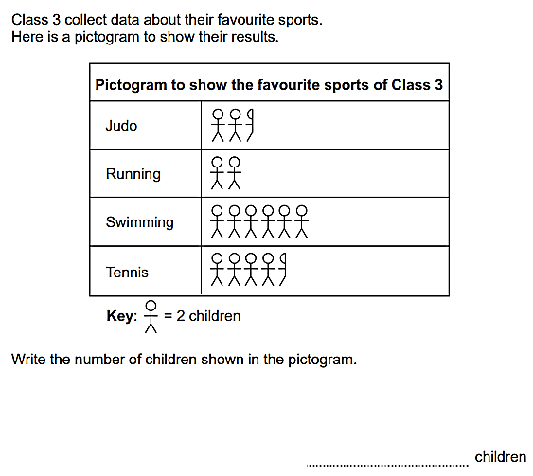
Murad asks the students in his class if they can sing. Here are his results.
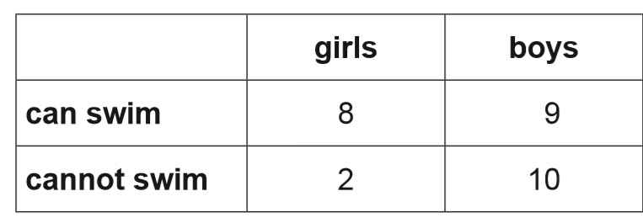
Cannot sing
Can sing
4
2
5
7
(a) How many boys can sing? ................. Boys
(b) How many boys cannot sing? ................. Boys
(c) How many girls can sing? ................. Girls
(d) How many girls cannot sing? ................. Girls
(f) How many students were asked? …………………Students
(E) Jawad says,
‘More students can sing than cannot.’ Explain why Jawad is correct. .......................................................................................................................................
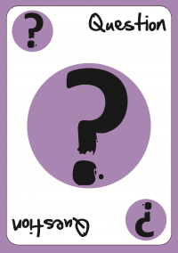
Write a question that you can answer using the above carol diagram.
________________________________

A sports magazine ran a poll asking readers which sport they liked the best. They published their results in the graph below. Use the graph to answer the questions.
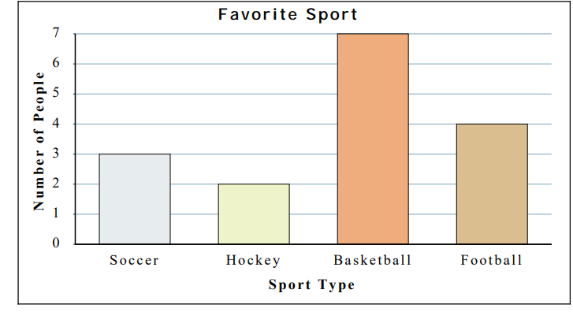
a) How many people said Football was their favorite sport? ………
b) Did more people like Soccer or Football? …………
c) Which sport did exactly 7 people say was their favorite? ………….
d) Which sport was liked by the largest number of people? ………….
e) Which sport was liked by the fewest number of people? …………….
f) How many people were asked in all ?.................................

Tally Chart
For my birthday party I made a fruit punch. I counted the number of fruits and put It in a tally chart. Use the information to answer the questions.
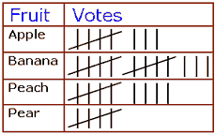
Number
a- How many apples did I use in my punch? …………………
b- How many Pears did I use in my punch? …………………
c- How many fruits did I use altogether? …………………
The following tally chart shows the favorite sports of a group of school kids. Use the chart to complete the table and answer the questions. 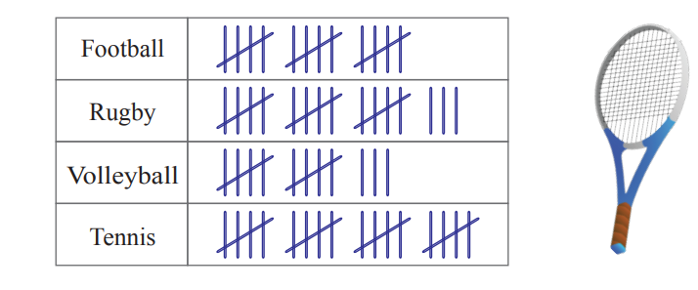
- Use the tally data to complete the following data table.
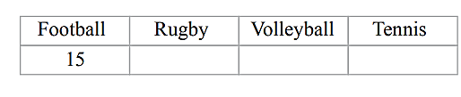
b) How many kids were asked about their favorite sport?
_________________________________________
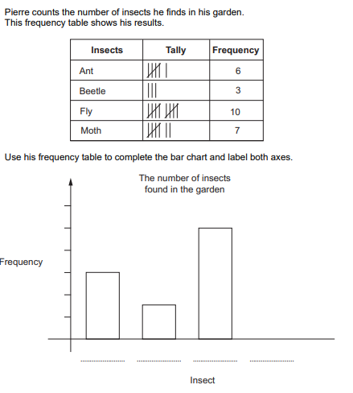

Anastasia draws a bar chart showing the favourite lessons of the children in her class.
Science
Maths
English
Favourite lesson
Favourite lessons of children
in Anastasia’s class
Art
Sport
0
1
2
3
4
5
6
7
8
9
10
Number of
children

  - Write the name of the lesson the greatest number of children chose as their favourite.
  - Write the number of children whose favourite lesson is science.

Favourite fruits of Class
3
Number of
children
Apple
Banana
Fruit
Orange
Pear

Lily says, ‘The graph does not show all of the data.’

Write one reason why Lily is correct.

Fractions
Objectives:
1- Understand and use fraction notation recognizing that fractions are several parts of one whole.
2- Recognize equivalence between 1 half, 2 quarters, 4 eighths, and 5 tenths using diagrams.
3- Recognize simple mixed fractions.

A fraction is a part of a whole.
The top number represents the part. (Numerator)
The bottom number represents the whole. (Denominator)

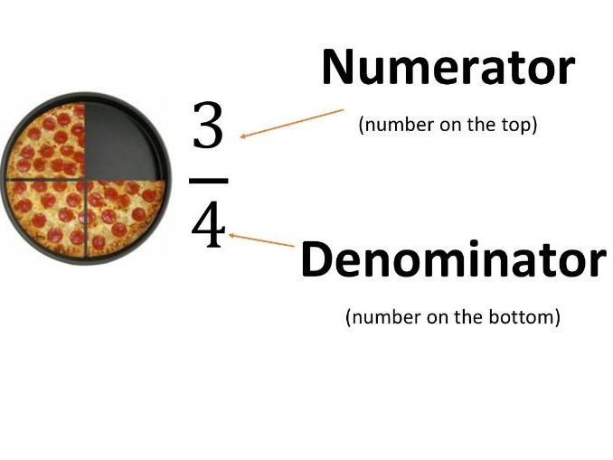
Proper fractions

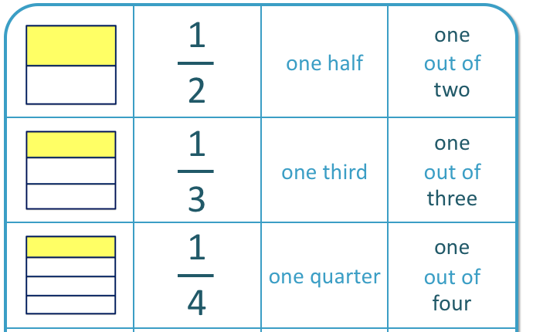

Write the fraction represented by each shape?
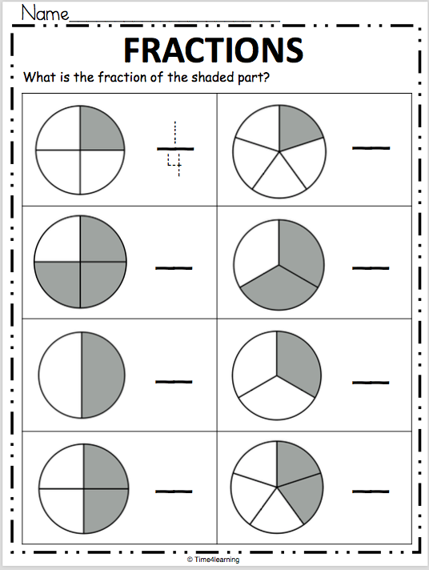
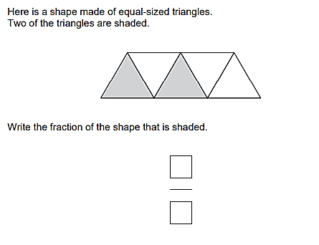

Circle the correct fraction that each shape represents.
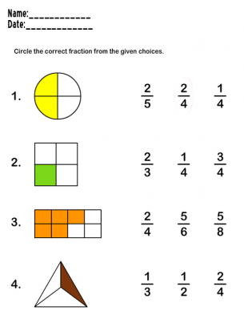
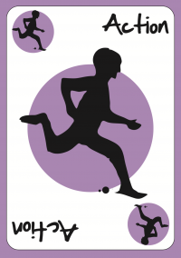
Plan to make a shape that represents a certain fraction then write the fraction that is representing by drawing It on A4 cartoon and shading some parts.

Color the correct number of parts to represent each fraction.
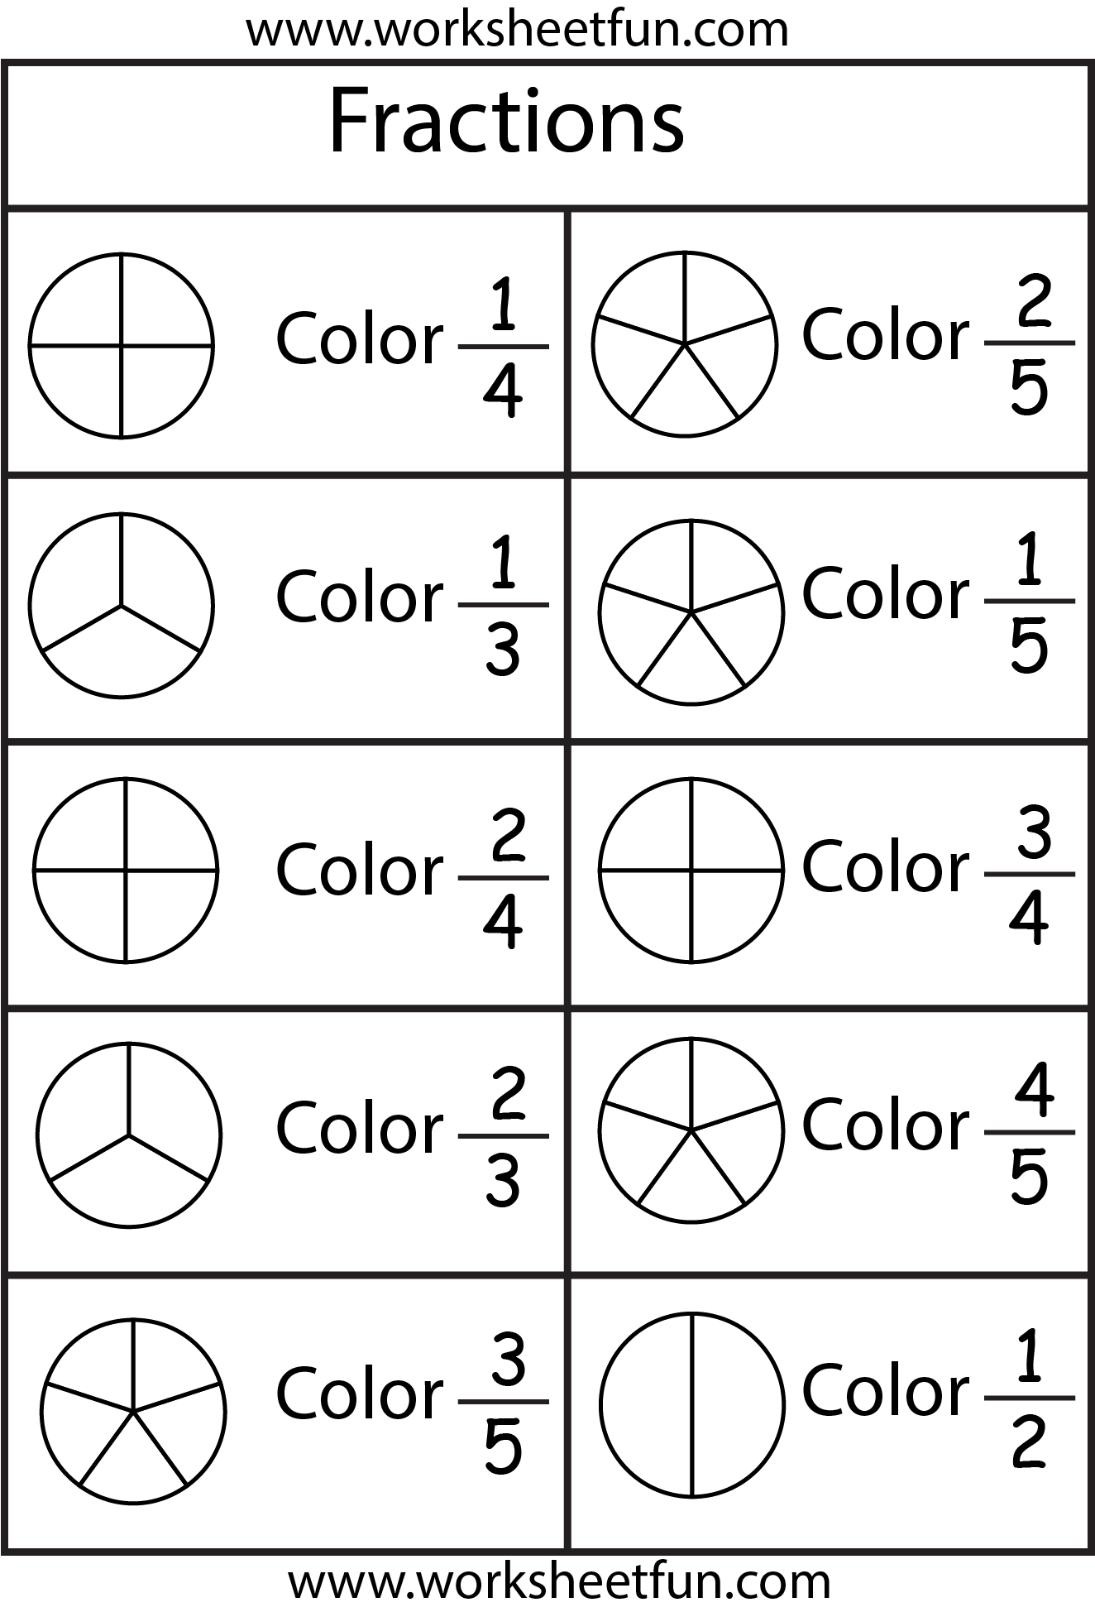

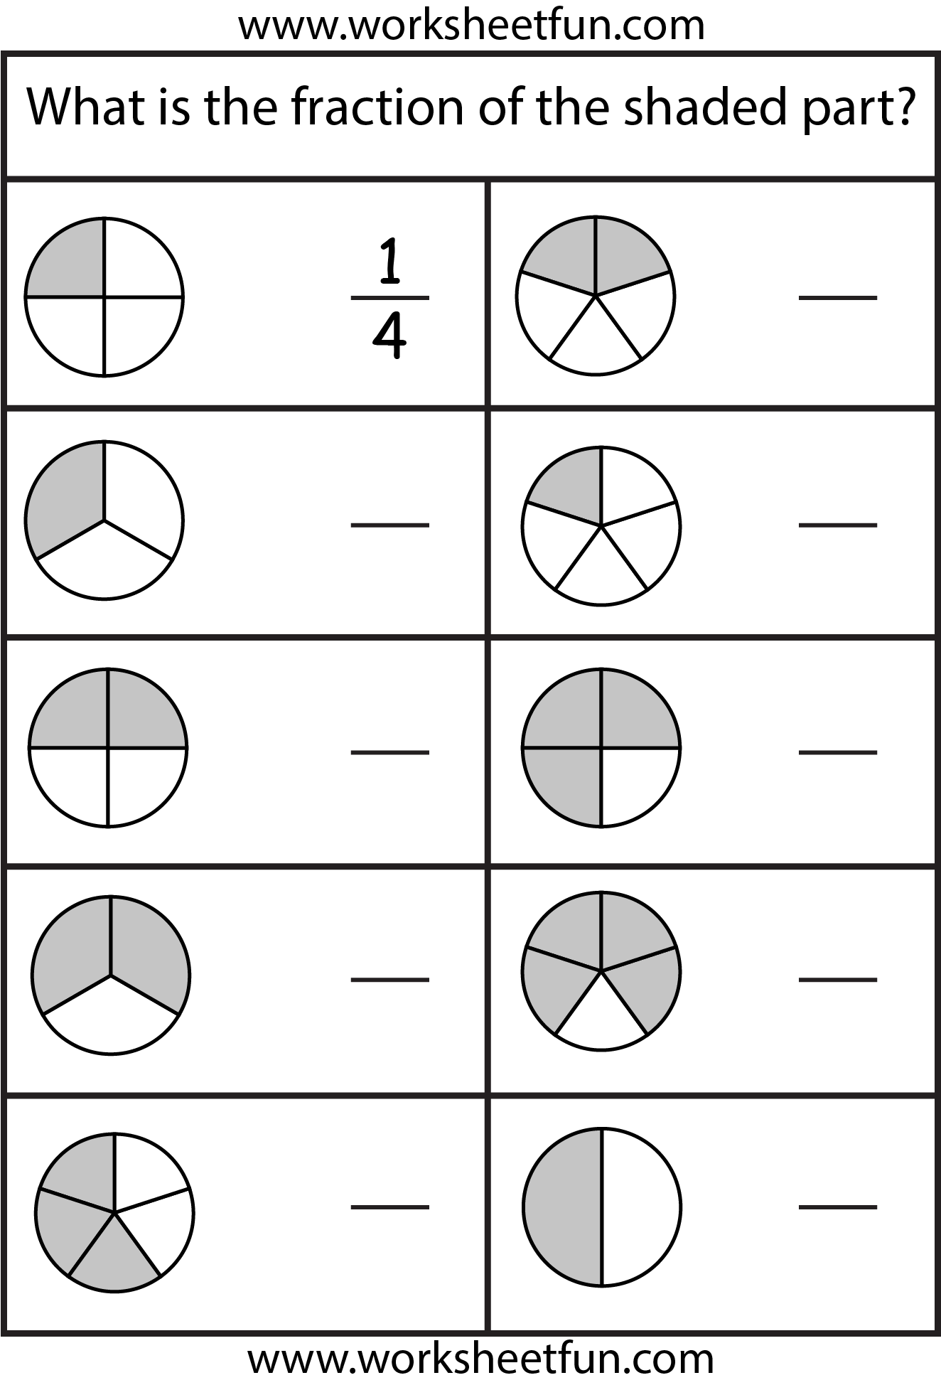
What is the fraction represented by each shap

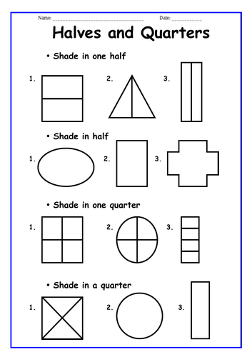
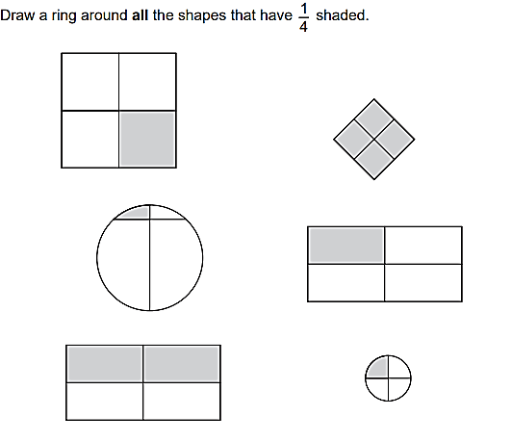

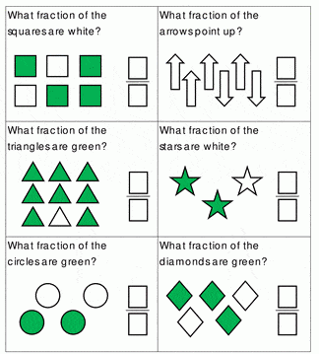
Fraction as part of a set

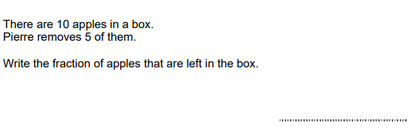

Mixed fraction
A mixed number is formed by combining three parts: a whole number, a numerator, and a denominator. The numerator and denominator are part of the proper fraction that makes the mixed number.
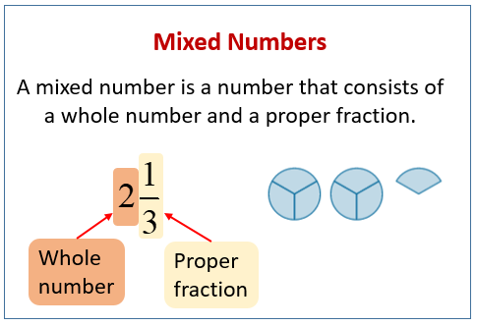

Write the mixed number these diagrams represent.
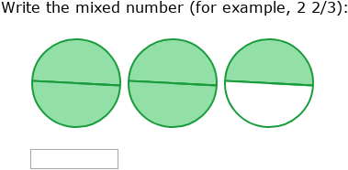

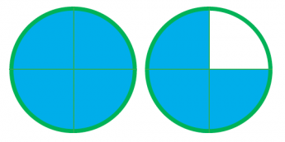
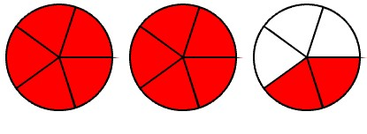
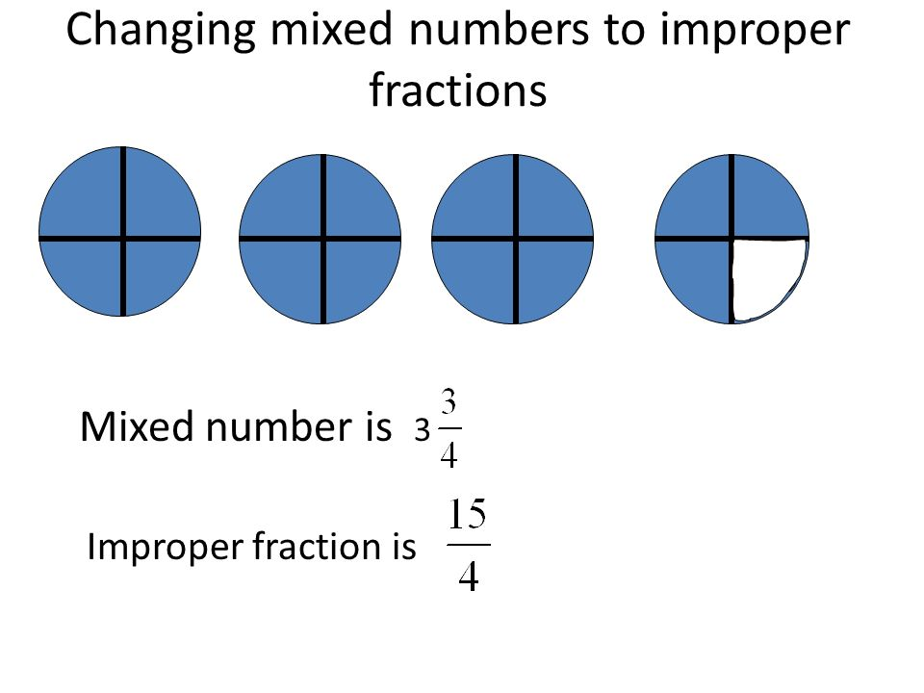

Write the mixed number these diagrams represent.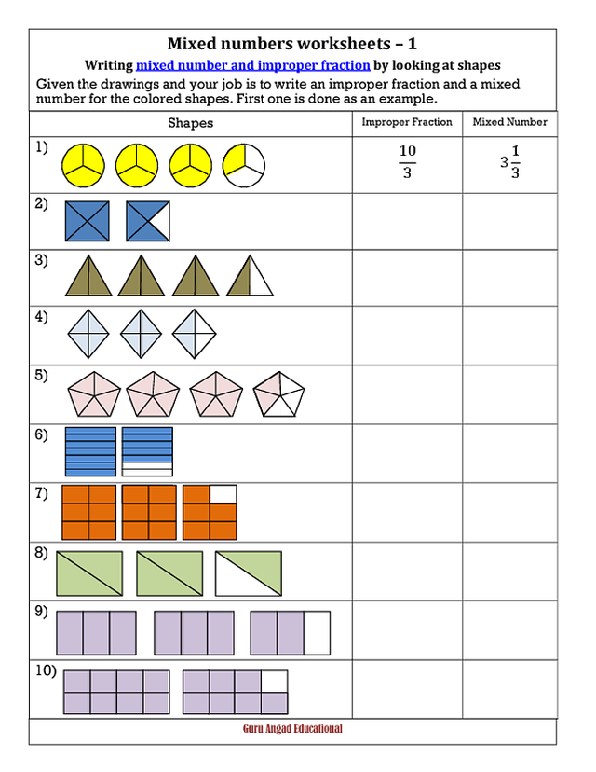
3 $\frac{1}{3}$

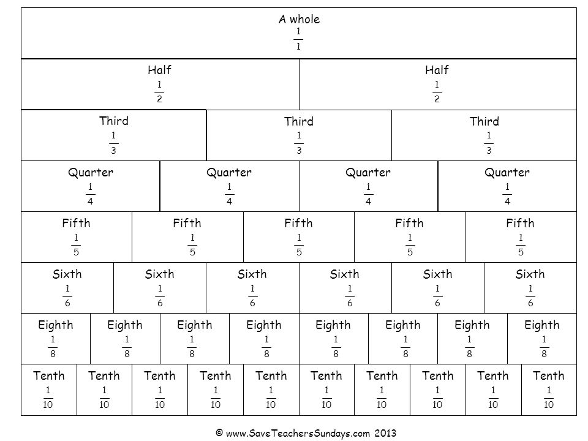

Equivalent fractions
Equivalent fractions are fractions that represent the same value, even though they look different.
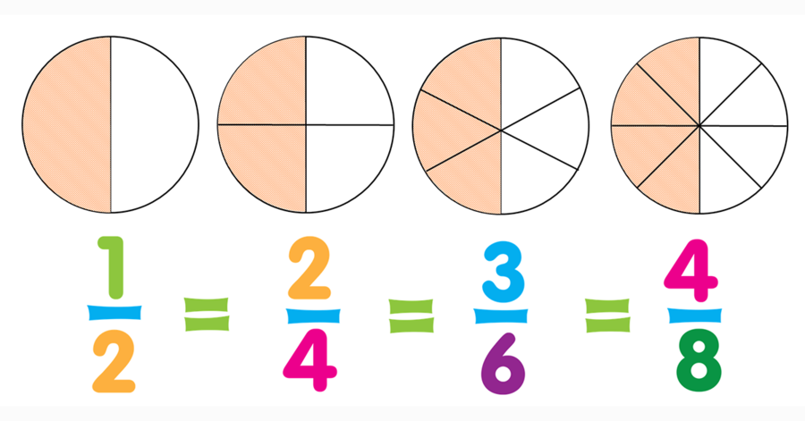

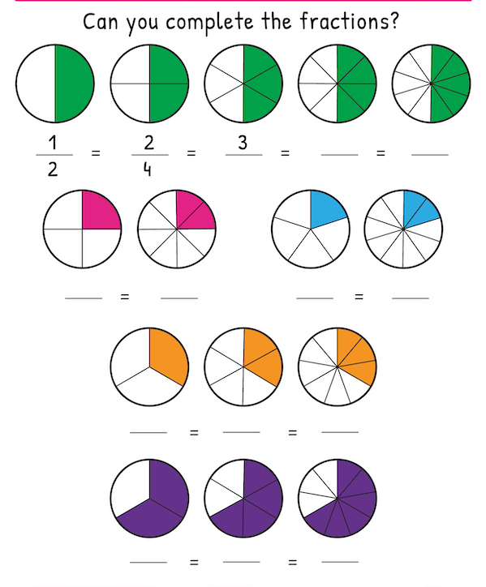

- Eva collects 24 eggs.
She sells 6 of these eggs.
Write the fraction of the eggs that she sells.

- Oliver says, ‘The value of  is the same as the value of  ’

Tick (✓) to show if Oliver is correct.

No
Yes

Explain how you know.

Time
Objectives: -1- Suggest and use suitable units to measure time and know the relationships between them (second, minute, hour, day, week, month, year)
2- Read the time on analogue and digital clocks, to the nearest 5 minutes on an analogue clock and to the nearest minute on a digital clock

The are 7 days in a week
There are 12 months in a year

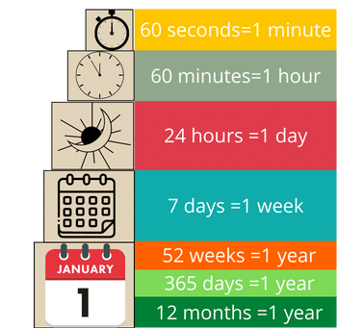
Units of time

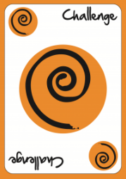
Challenge yourself to write the months in order by singing the song we learned.

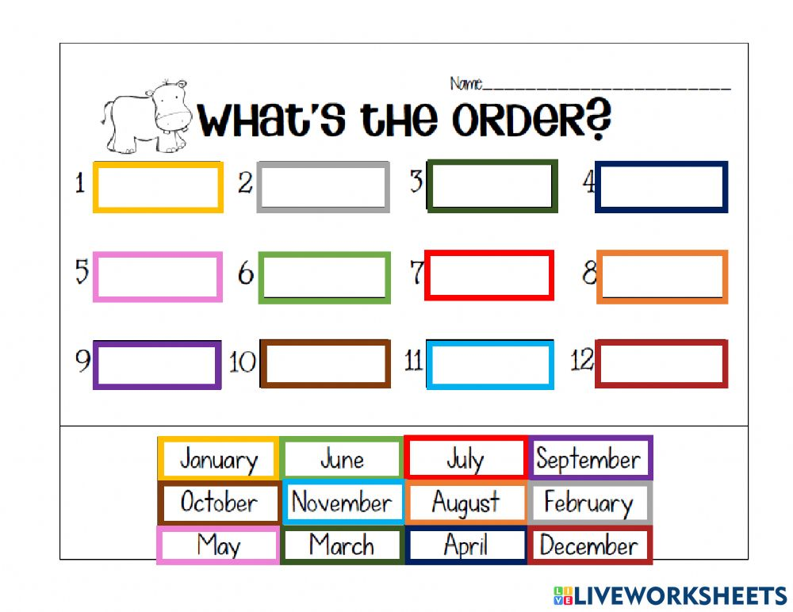

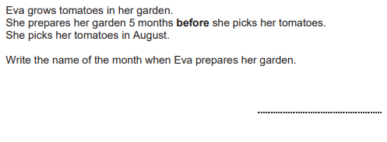

Write the days of the week in order start from Monday:
Monday ______________ _____________ _____________
_____________ _____________ ______________

Fill in the blanks with the correct days (yesterday and tomorrow)
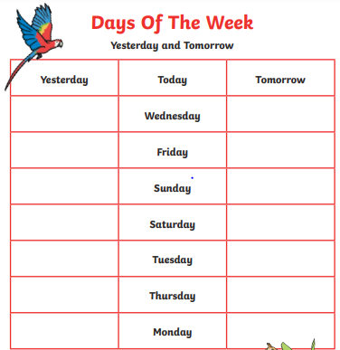

Write the time shown by each clock using the analogue form.
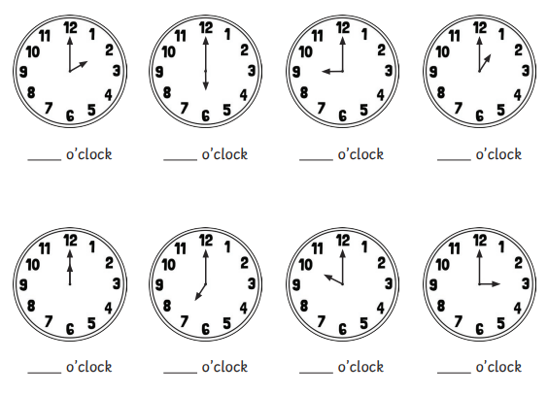
Write the time shown by each clock using the analogue form.
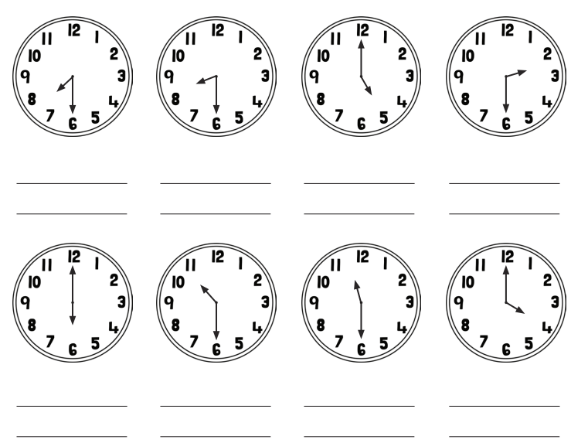

Write the time shown by each clock in the digital form.
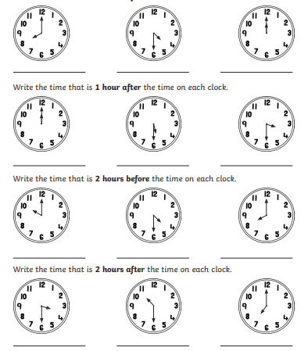

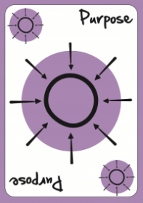
What is the purpose of using time and clocks?

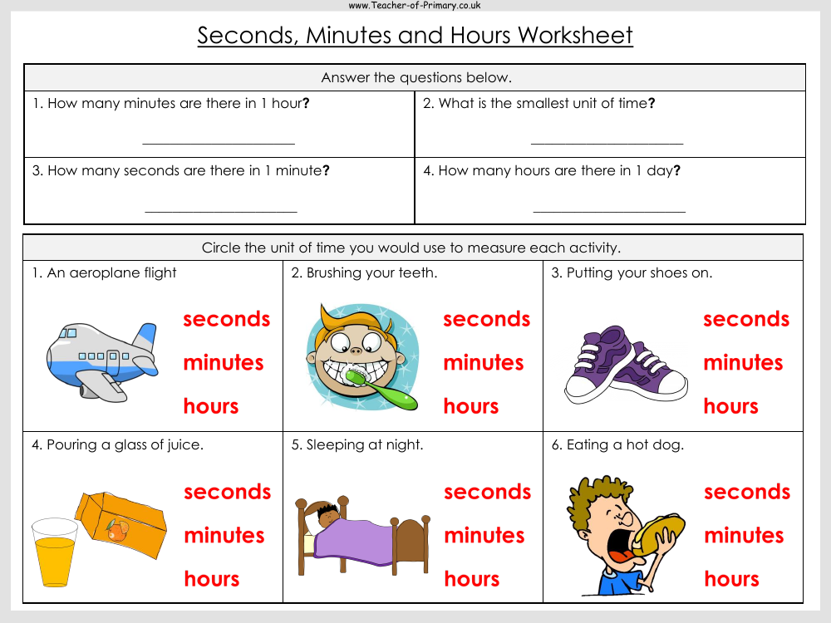
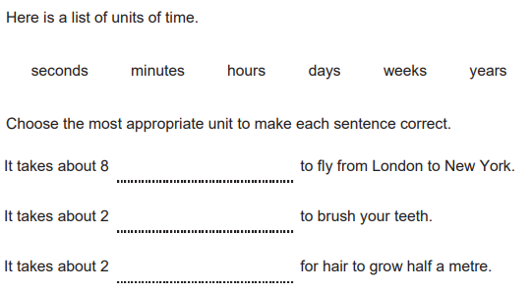

Draw a line to match each statement to how likely it is to happen.

The day before Sunday will be Friday. It will happen.
The day after Wednesday will be Thursday. It might happen.
first day of the month will be Monday It will not happen.

2D shapes
Objectives: -1- The student should recognize and name these 2D shapes: circles, triangles, squares, pentagons, hexagons, heptagons, octagons
2- Recognize the right angle.
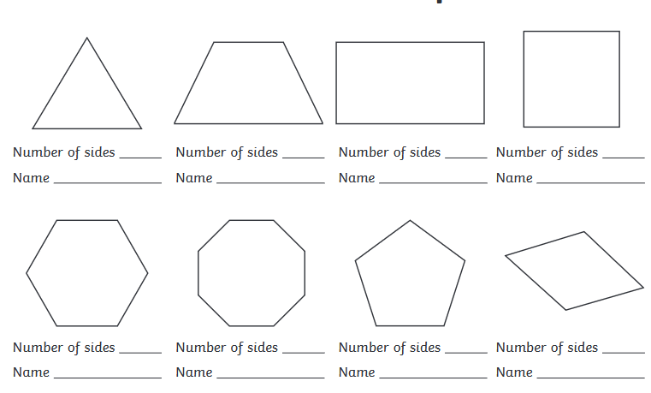

Fill in the blank with the correct shape name:
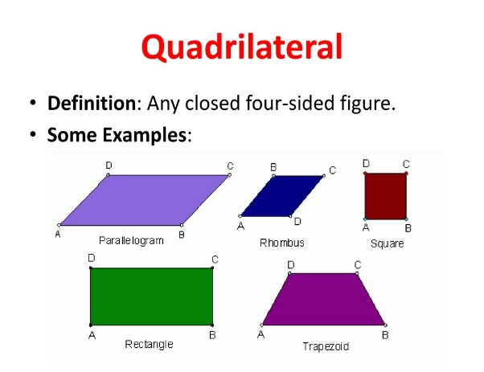
Any shape that has 5 sides is called ________________
Any shape that has 6 sides is called ________________
Any shape that has 7 sides is called ________________
Any shape that has 8 sides is called ________________
- Here is a tile.
The tile shows four different types of 2D shapes.

Mia counts the number of vertices on each of the 2D shapes. She records the information in a table.

Complete her table.
Some of it has been done for you.

Name of 2D shape | Number of vertices
circle | 0
triangle

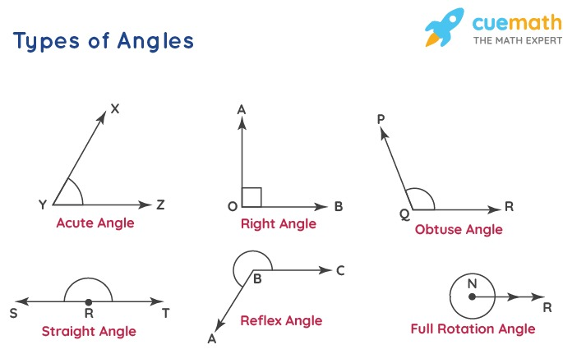
Types of angles
Draw a ring around all the angles that are smaller than a right angle (acute).
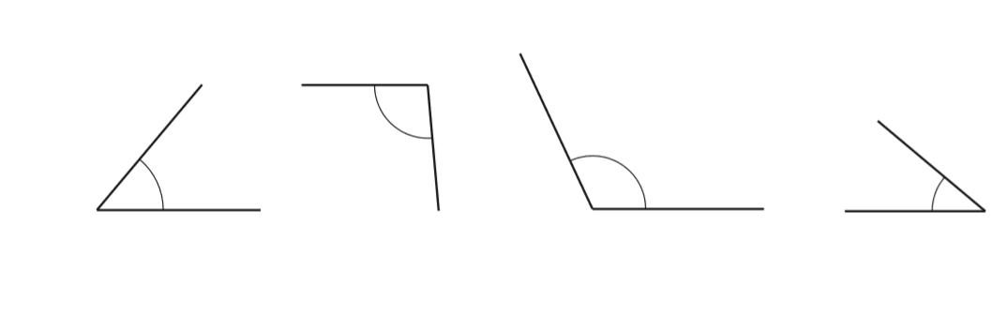
Draw a ring around all the angles that are greater than a right angle (obtuse).

Label each angle ( right, obtuse or acute)
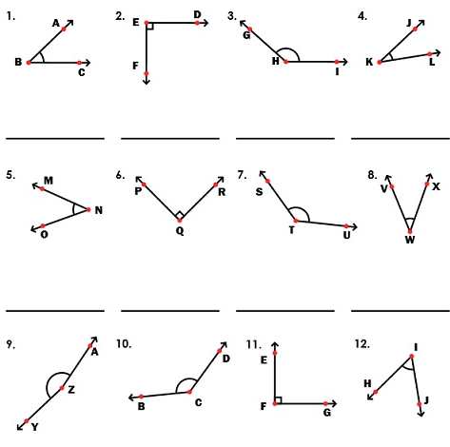
**If we joined two right angles together it will form a straight angle.

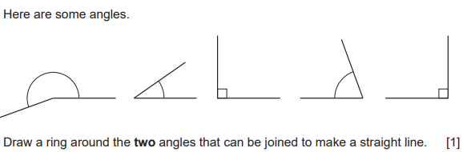

3D Shapes
Objectives: - The student should recognize and name these 3D shapes: sphere, cube, cuboids, cone, cylinder, triangular pyramid, square pyramid, pentagonal pyramid, hexagonal pyramid, prisms.

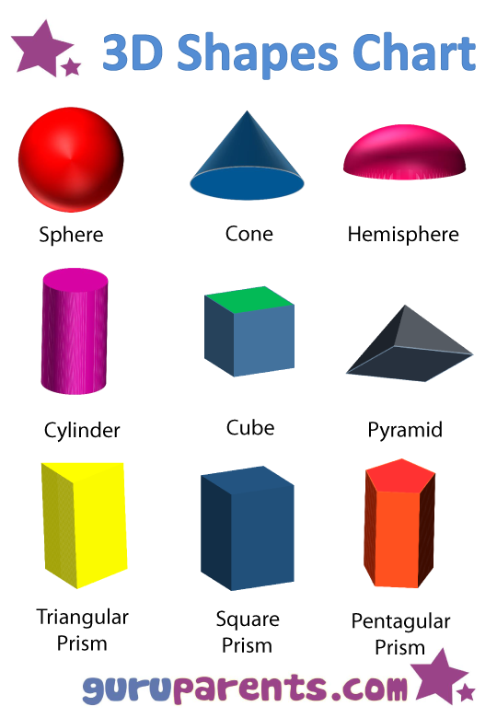

Match each shape with its name.
Pyramids are named based on their bases
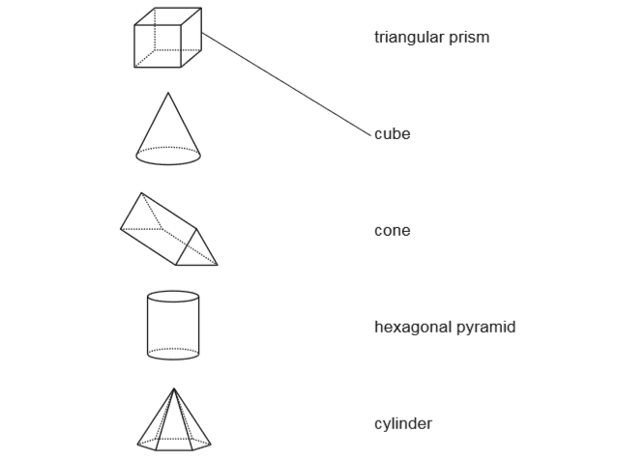
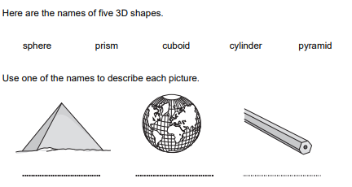
Prisms are called are named based on their base and top.

For each 3D shape, color the correct net. Then circle the correct name.
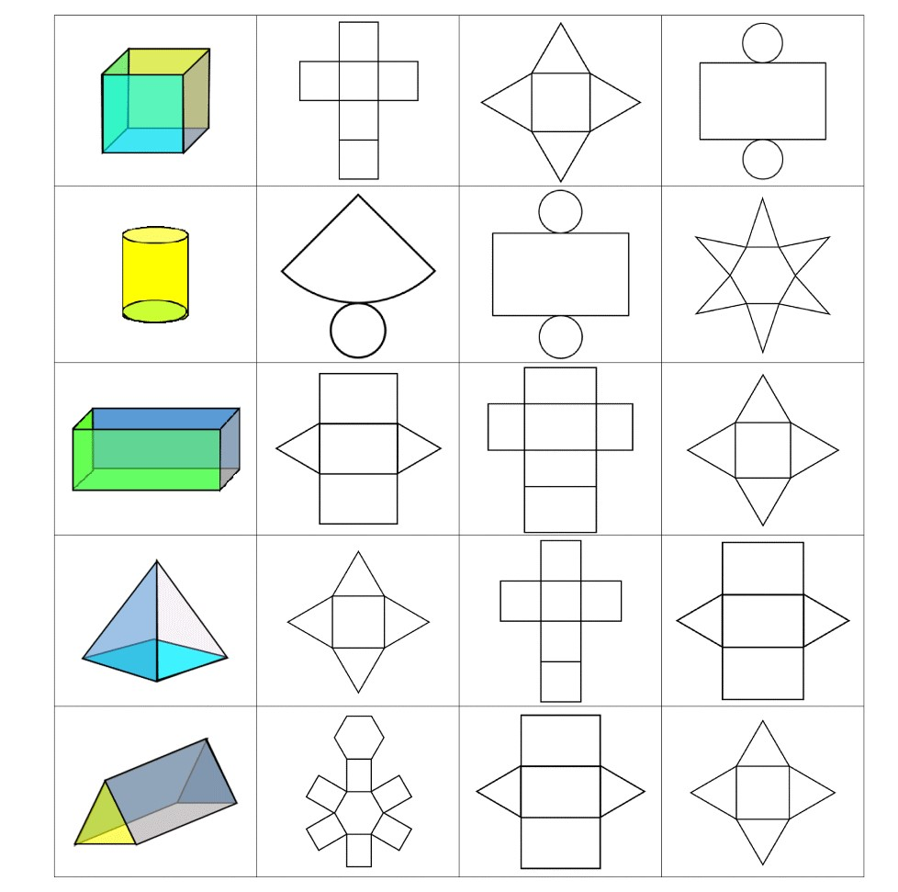
1- Square based pyramid
2- Triangular prism
3- Triangular pyramid
1- Pyramid
2- Cube
3- Cuboid
1- Sphere
2- Cube
3- Cuboid
1- Sphere
2- Cone
3- Cylinder
1- Square based pyramid
2- Triangular prism
3- Triangular pyramid

Lines of Symmetry
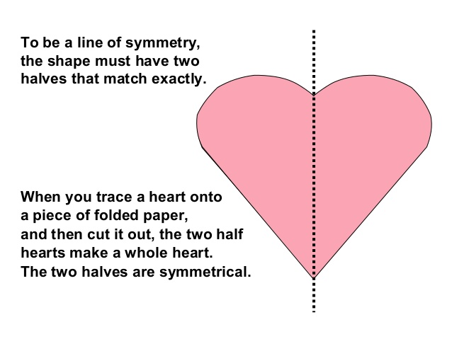
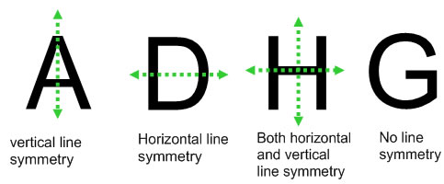

Can you draw a line to divide these shapes in evenly?
Some shapes can be divided two different ways.
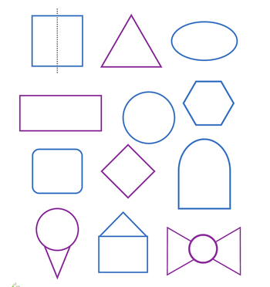

Draw the other half of these shapes.
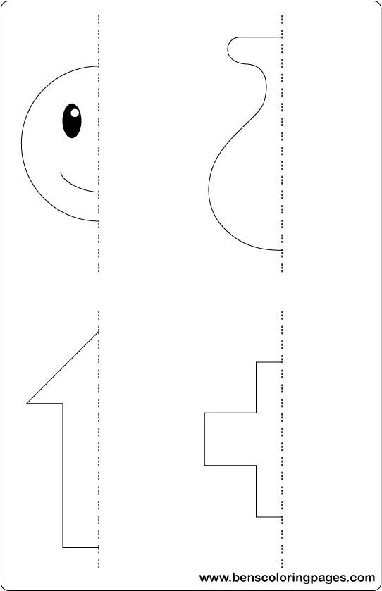

Reflect this shape in the mirror line.
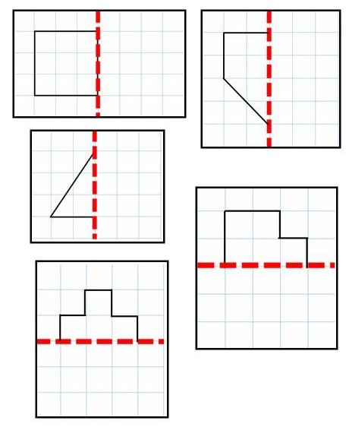

Location on a grid
Objective: Students should be able to find a point on a grid.
Here is a grid of squares. Square B3 is shaded.
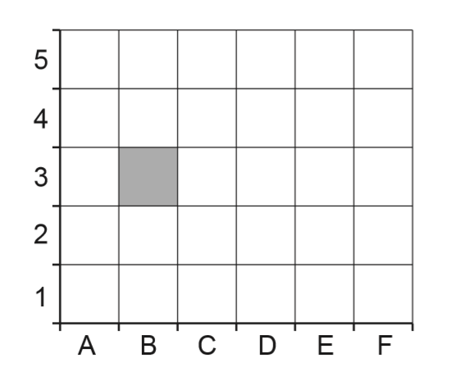
a- Put a cross (x) in square E2.
b- Color square F3 red.
c- Color square B4 yellow.
d- Color square D5 green.

Look at the following grid then write the position of the shapes.
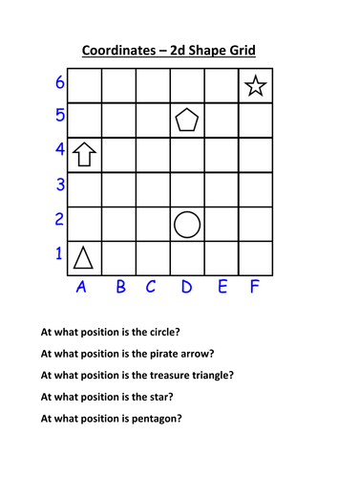
The position of the star is ( )

The position of the arrow is ( )

The position of the circle is ( )

The position of the triangle is ( )

The position of the pentagon is ( )
Position & Movement
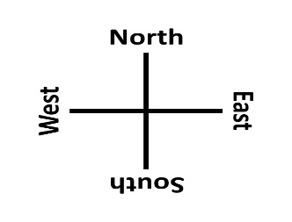
This is part of a town plan on a grid of squares.
A bus takes Sarah to the park.
Start
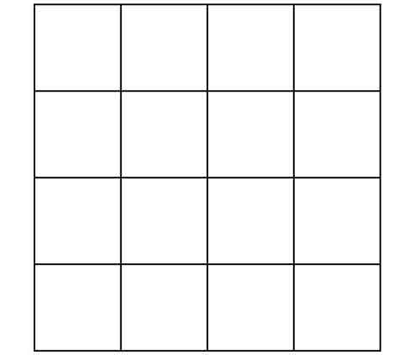
Finish
N
Fill this chart:

Start
Distance | Direction
Finish

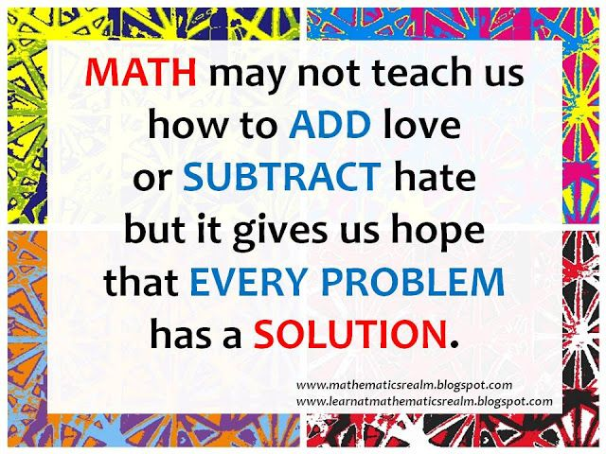
When we get this page it means our summer break has started so enjoy it 😊

