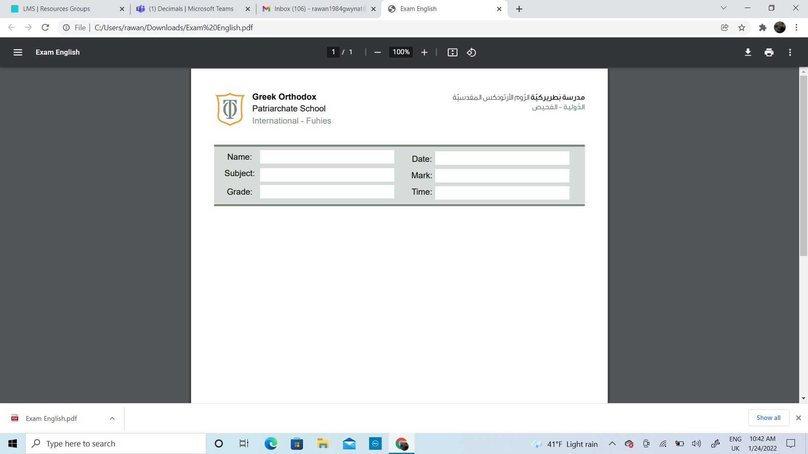
Math
Booklet
Name ____________________
Grade 1 ( A,B,C )
Teacher: Nancy Alfarah

Skip counting by 2s,5s and 10s
Learning objectives : Count on and count back in ones, twos, fives or tens, starting from any number (from 0 to 100).
Skip counting by 2's
Mr. Nabeel has 5 fish box. He has 2 fish in each box. Count by 2's to find the total number of fish.

Mrs. Nancy has 3 flowers pot. She has 2 flowers in each pot .count by 2's to find the total numbers of flowers.


- Count by 2's and colour the numbers you say starting from number 2.
1 | 2 | 3 | 4 | 5 | 6 | 7 | 8 | 9 | 10
11 | 12 | 13 | 14 | 15 | 16 | 17 | 18 | 19 | 20

- Count by 2's. How many wheels are there?

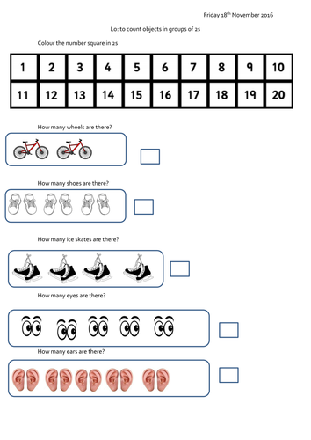

- Count by 2's. How many eyes are there ?

- Count by 2's. How many ears are there ?

Sequencing

Sequencing mind map

2 4 6 8

6
4
2

Skip counting by 5's .

- Count by 5's and write the missing numbers.

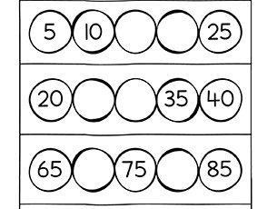

- Count the objects in each strip by 5's. Then write the total.
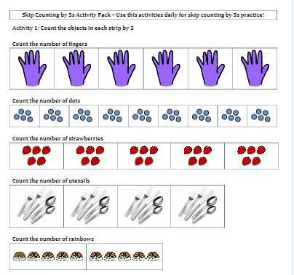

Skip counting by 10's .

- Count by 10's.
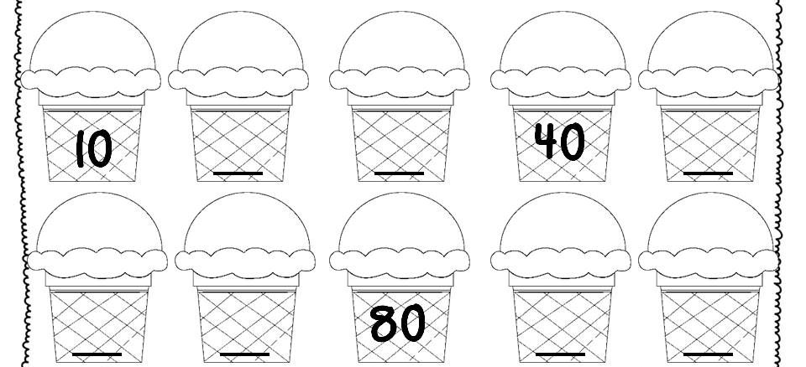

Rounding

Learning objectives : Round two-digit numbers to the nearest multiple of 10

Rounding poem

Circle your number
Look right next door
If it's 5 or greater
Add one more.
If it's 4 or less
There is no chore

Number to the right
Zero is your name.
Number to the left
Just stay the same

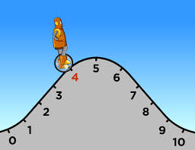

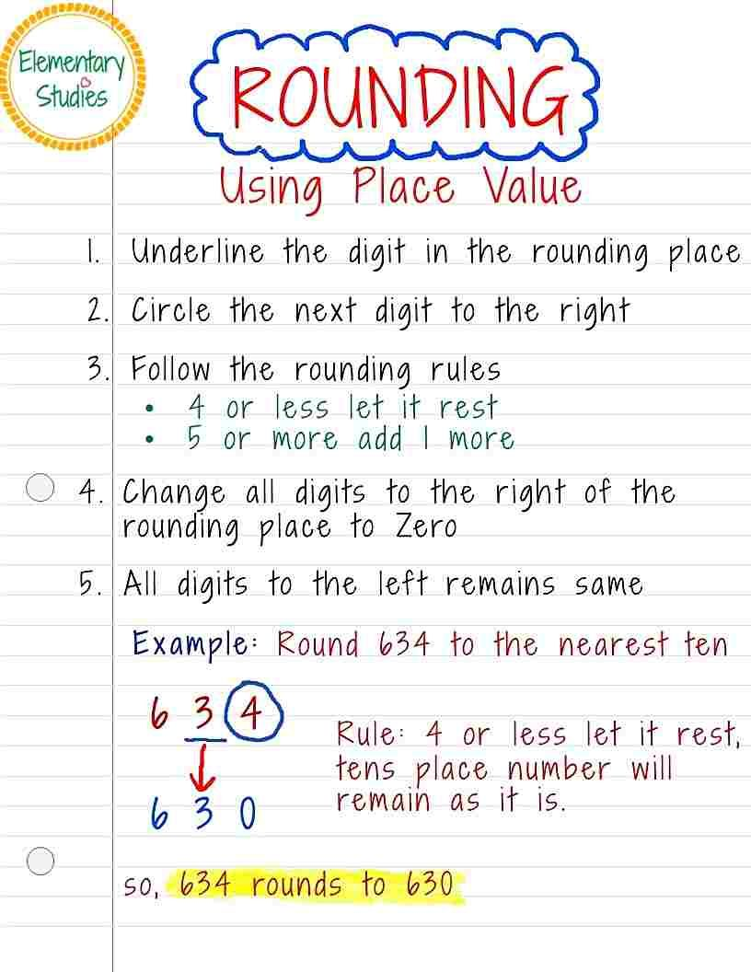

- Use a number line to help you round the numbers to the nearest ten.

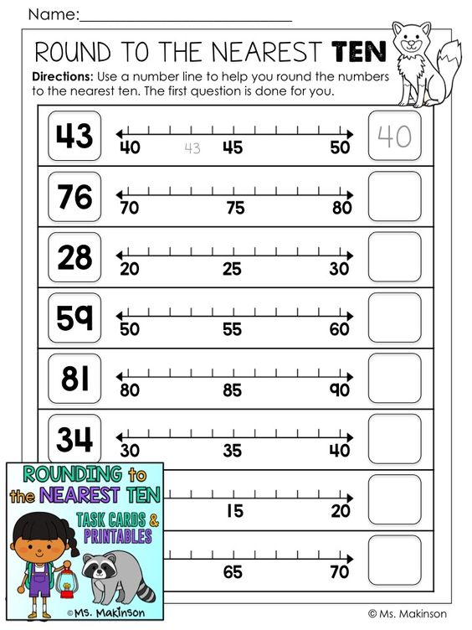

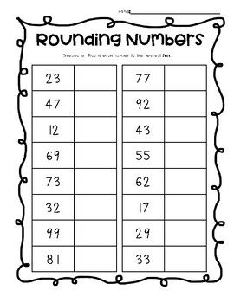

Challenge questions :
Write True or False for each statement.

27 rounds to 20.___________
8 rounds to 10._____________
94 rounds to 90.___________

Write 4 numbers that round to 20

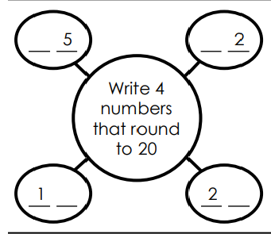

2D shapes
Learning objectives : The student should know the 2D shapes and its properties .

- Draw a line from each description to its matching shapes .
- Color all the .

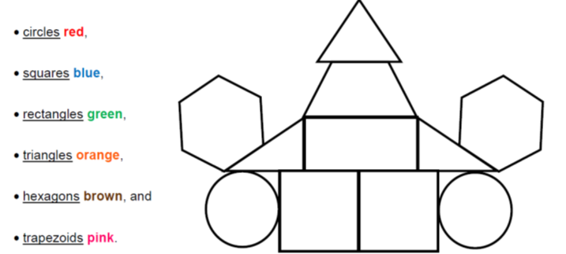
3D shapes
(solid shapes )
Learning objectives : The student should know the 3D shapes and its properties .

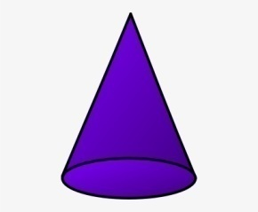  Cone  2 faces  1vertex  1 edge | 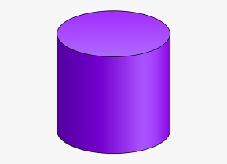  Cylinder  3 faces  0vertex  2 edges
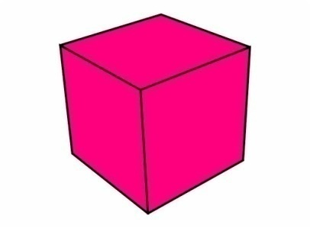  Cube  6 faces  8 vertices  12 edges | 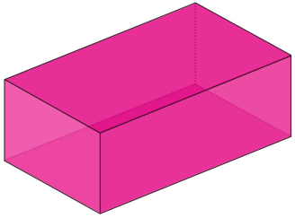  Cuboid  6 faces  8 vertices  12 edges

sphere
1 faces
0vertex
0 edge
- Fill in the blanks :
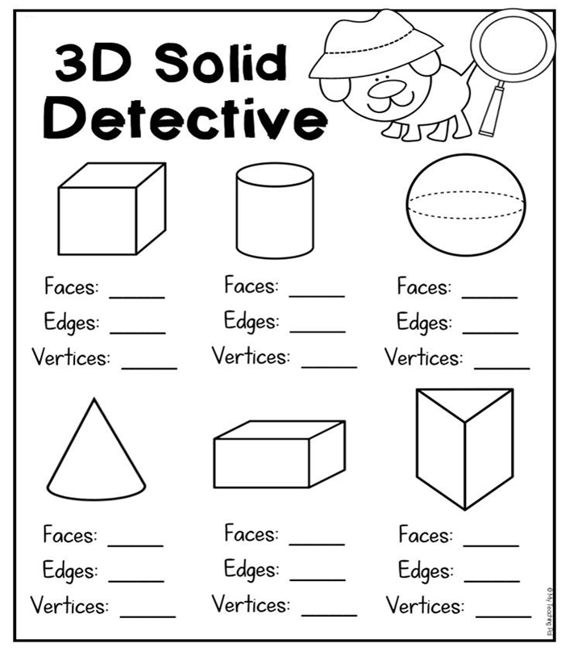

Missing number problems
Learning objectives : The student should know how to answer the addition and subtraction problems by finding the missing numbers.

Addition

- Find the missing numbers.

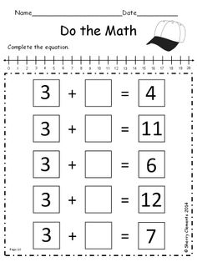

- Answer the following problem.

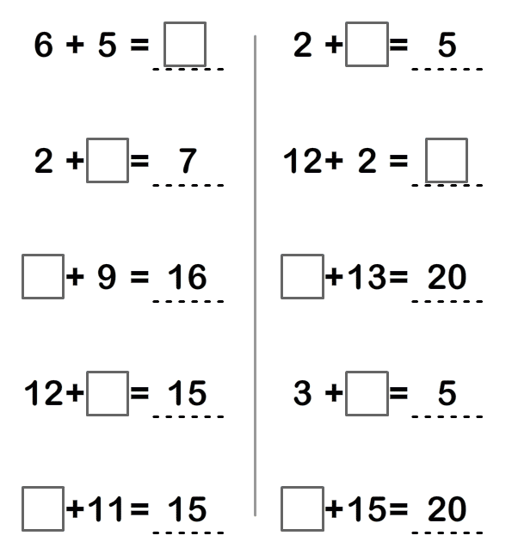

Missing number problems

Subtraction

- Answer the following problem.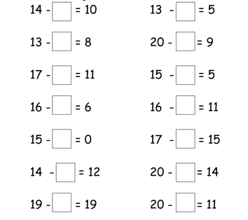
9+ = 14 | 14+ = 18
14 - =10 | 11 - =9
7 + 8 = | 7 + 12 =
- 1 =0 | - 5 = 0
5 + = 9 | 15 + = 19
15 - =5 | 15 - =9
7 + 8 = | 7 + 8 =
+ 3 =3 | + 3 =8

Multiplication
Learning objectives :
- learn and recognise multiples of 2, 5 and 10
- Understand multiplication as repeated addition and use the × sign
- Understand multiplication as describing an array

(Repeated addition) and (describing an array)

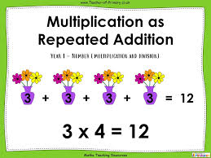
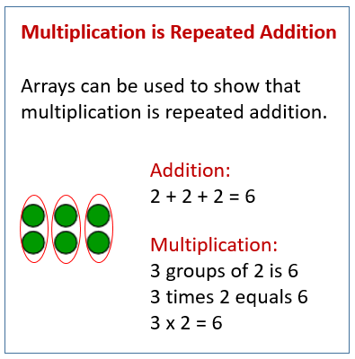

- Add and multiply.
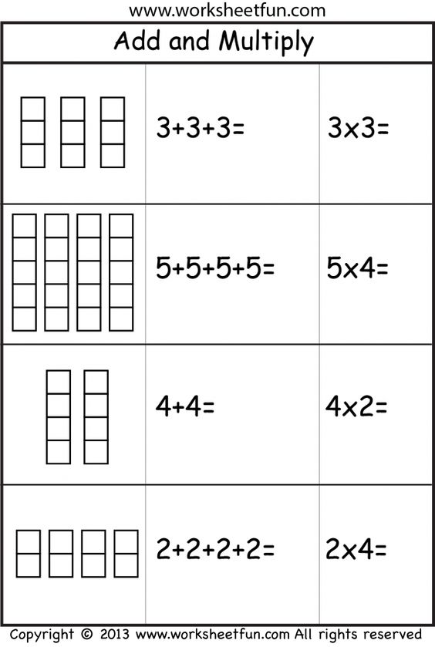
- If I have 5 groups of 2 stars, how can I write this using repeated addition?

- 2+2+2+2+2
- 5+2+2+2+2
- 2+2+5

- Which of the following shows repeated addition for 3 groups of 4 blocks?

- 3+4+4
- 4+4+4
- 4+3+3

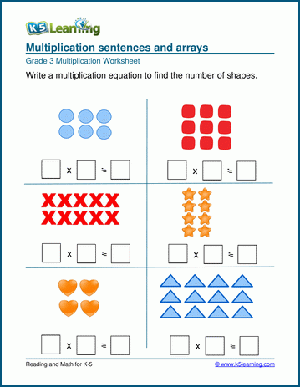

Multiples of 2

Multiples of 2 are all even numbers
(Counting in twos)

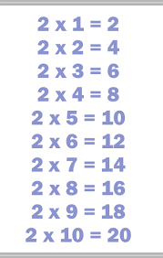

- Start at number 2 .join the dots by counting up in 2s.

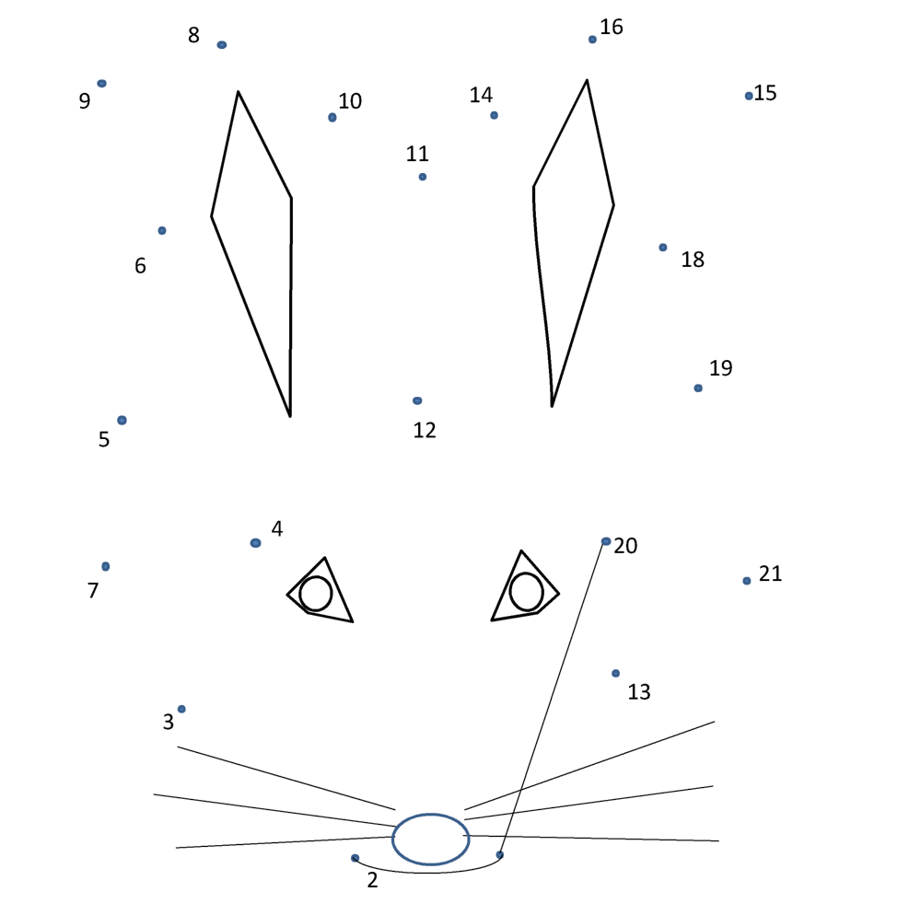

- Answer of the following problems.
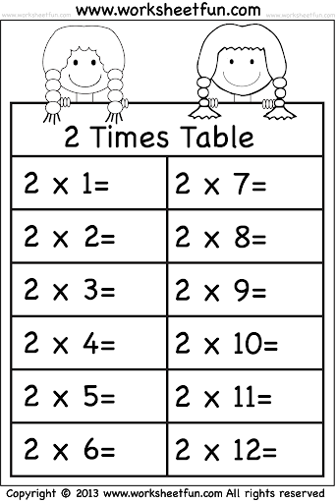

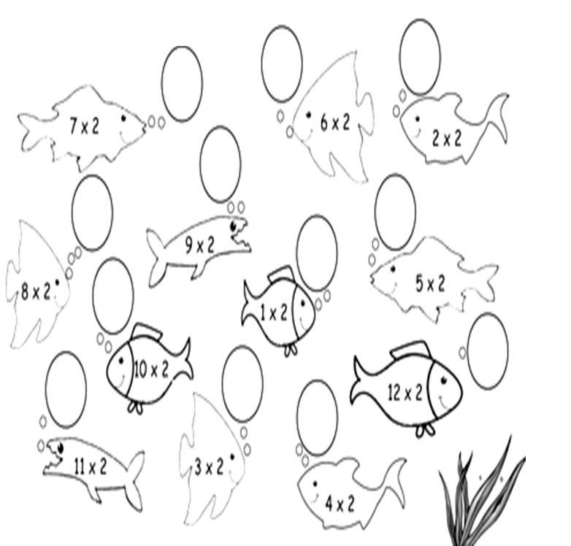

- Here are six digit cards.

Ahmed makes three 2-digit numbers that are all in the 2 times table.
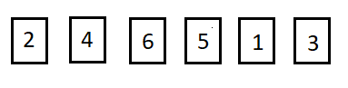
Complete the boxes to show the three numbers that Ahmed makes.

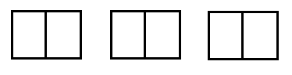
Use each of the digit cards once.

- Answer the following word problems .
- Sarah is collecting stickers for her album. Each page can hold 2 stickers. If Sarah has filled 4 pages completely, how many stickers does she have in total: ………………………………………………
- Tommy's pet fish has babies! Each day, 2 new baby fish are born. After 3 days, how many new baby fish does Tommy have: …………………………………………………
- Ms. Johnson gives out pencils to her students. She gives 2 pencils to each student. If she has 5 students in her reading group, how many pencils does she give out in total:...............................................................
- How many wheels are there on 7 bicycles?

____________ wheels

Draw some jumps on the number line to show how you could have found out.

Multiples of 5

Multiples of 5 end in the digit 5 or 0
(Counting in 5s)
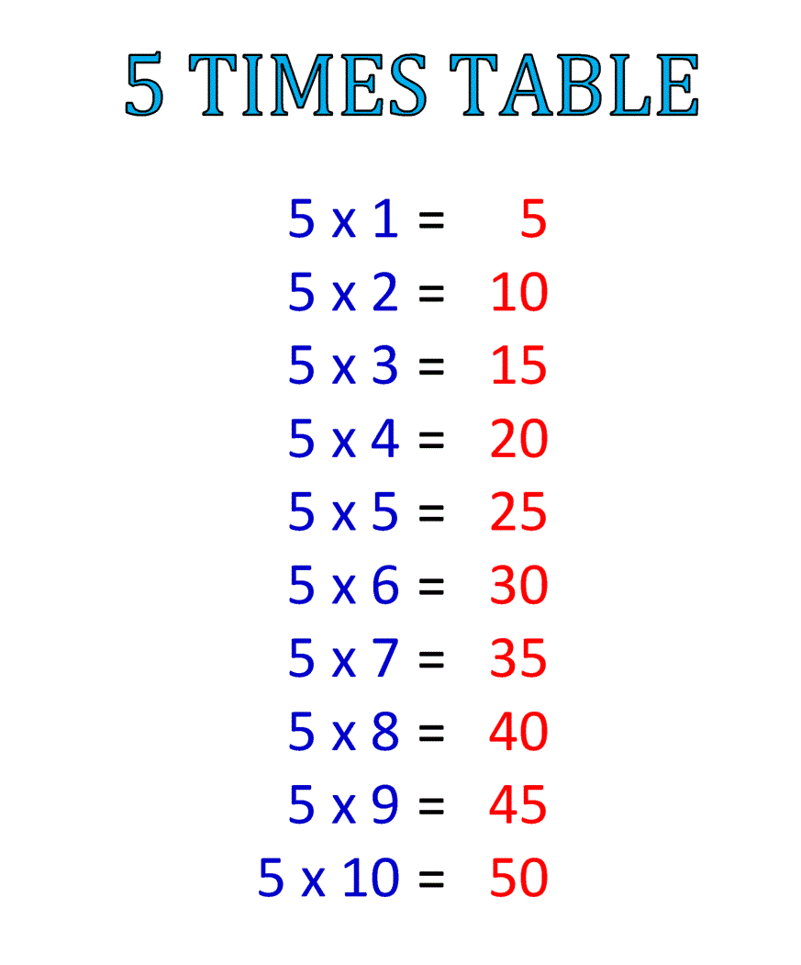

- Find the answer of each product.
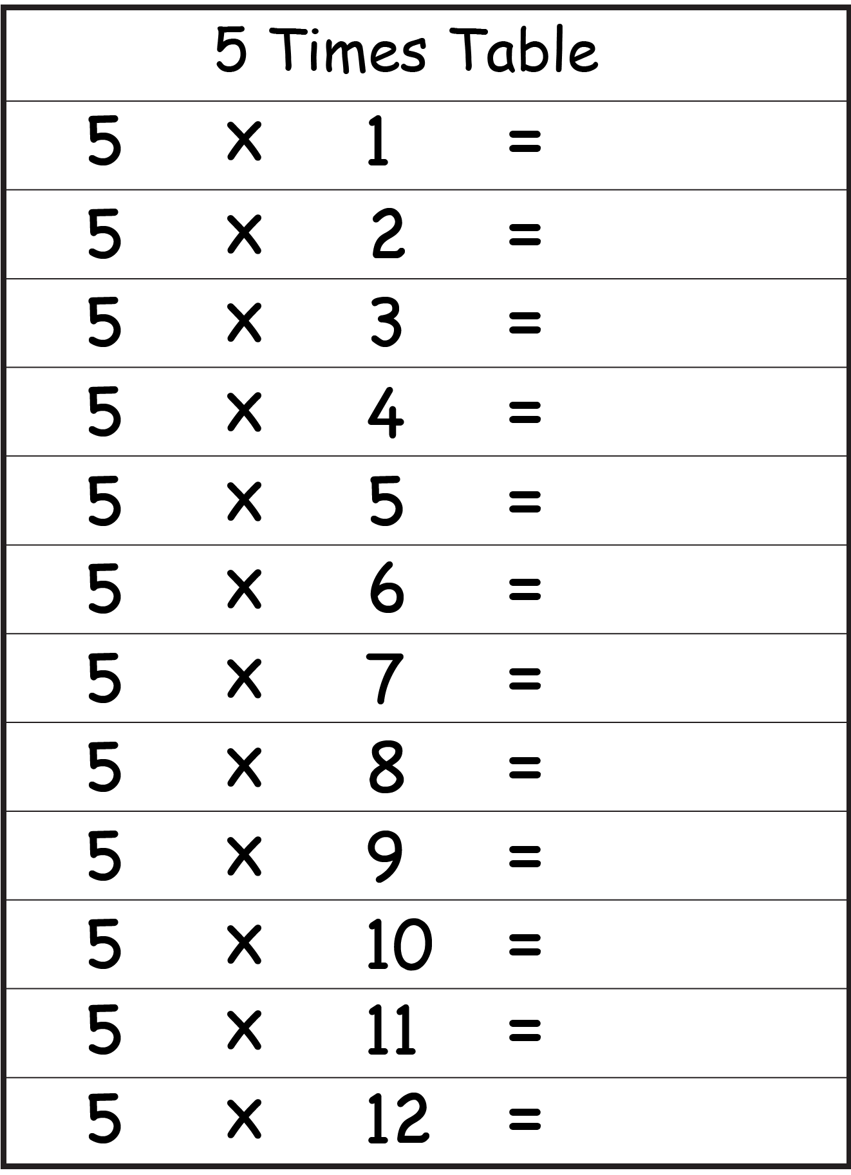

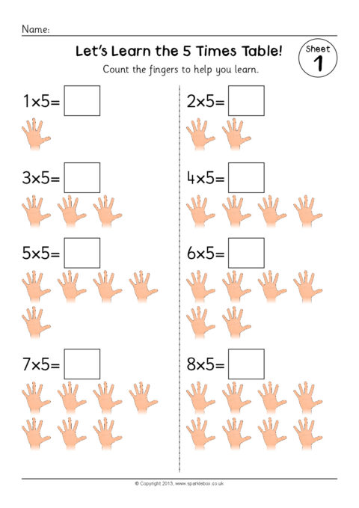

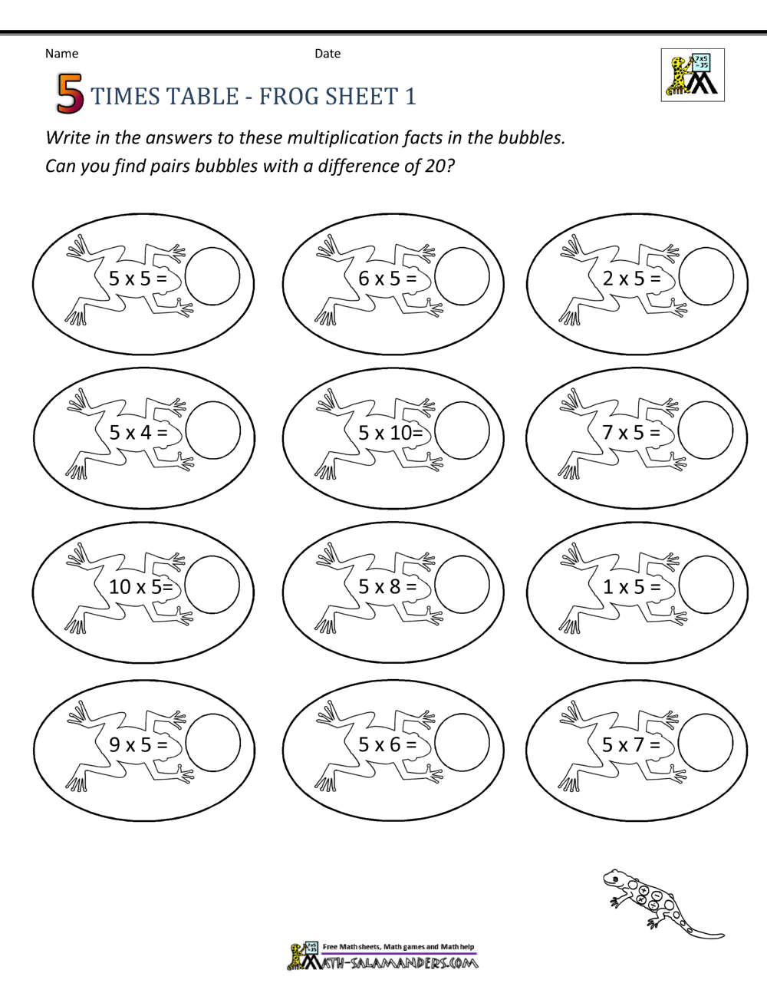

- Sort the numbers below by putting them in the correct bucket .( you can use the numbers more than once).

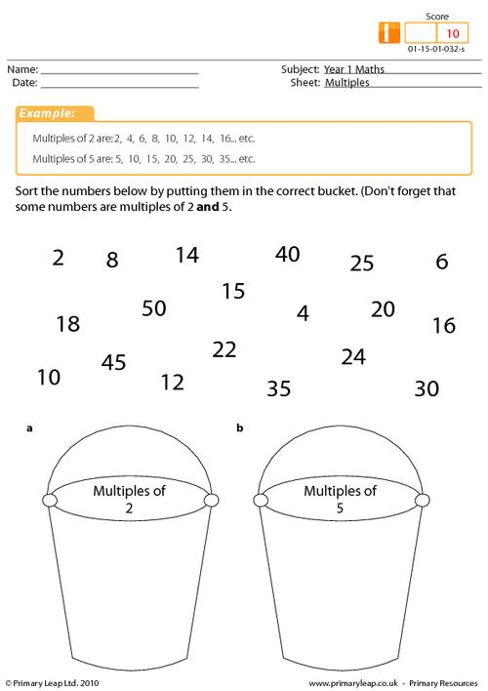

- Color the multiples of 5.
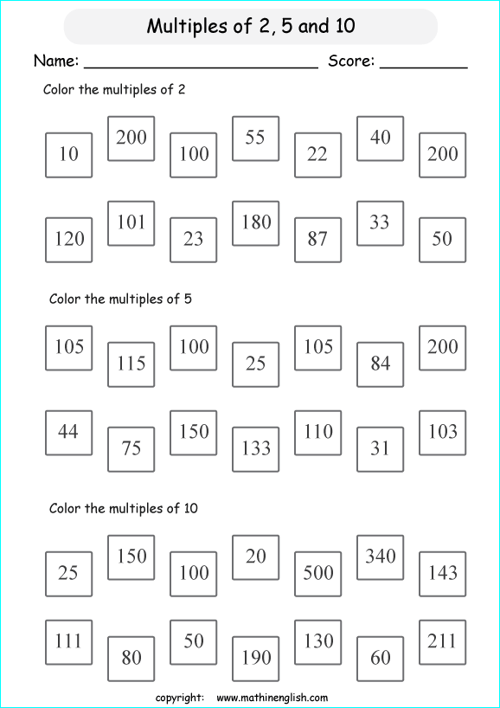

Multiples of 10

Multiples of 10 are all end in the digit 0
(Counting in 10s)

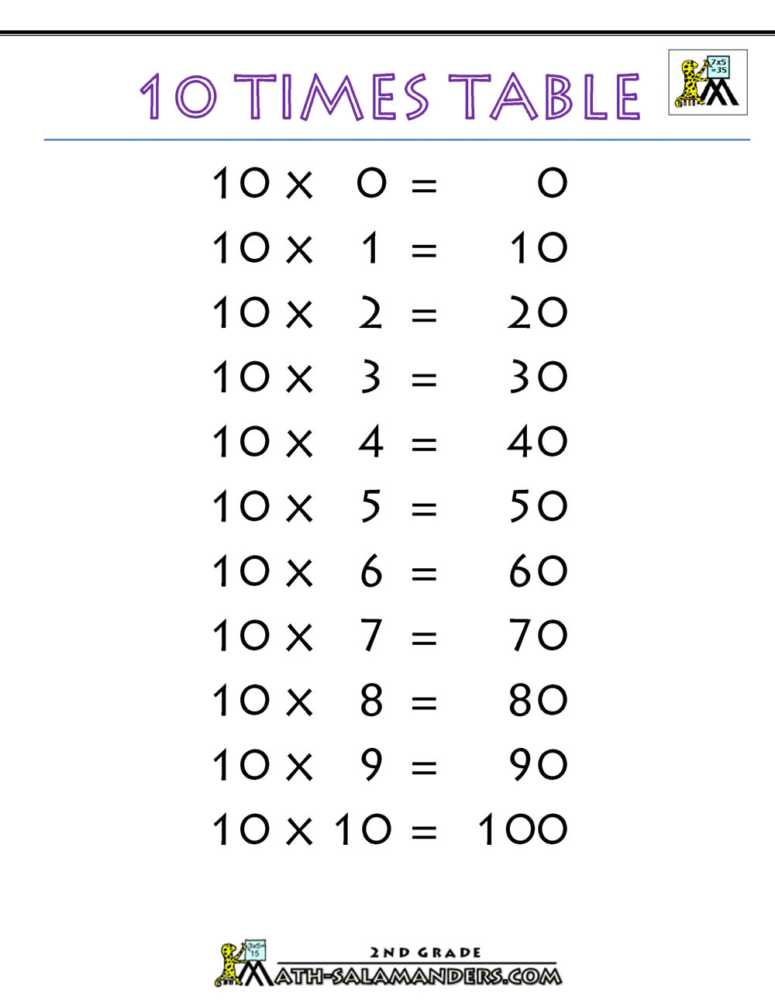

- Answer the following problems:

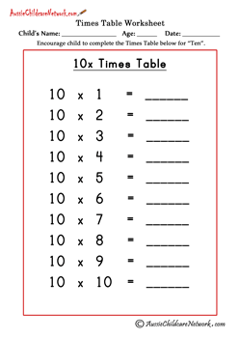

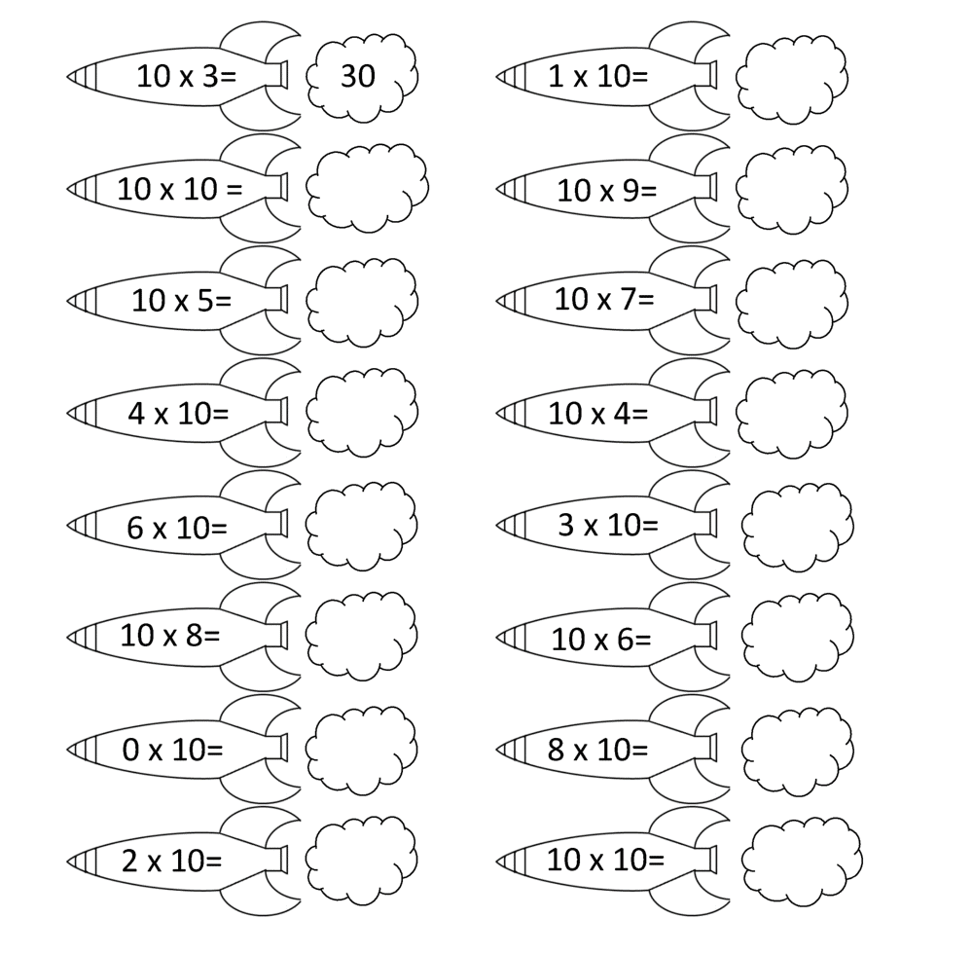

- Colour the multiples of 10.

- Circle the right answer.
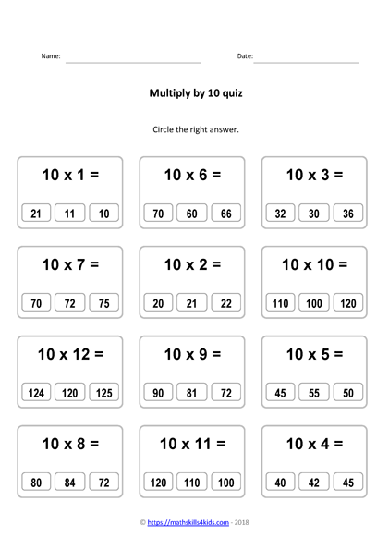

Division
As grouping
Learning objectives : Understand division as grouping and use the ÷ sign

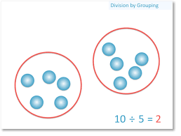

- Answer the following problems.

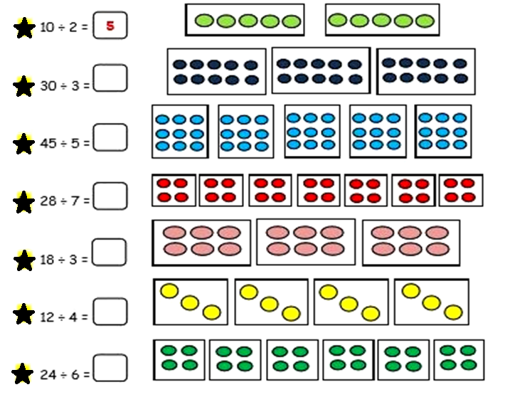

- How many cookies will each child get.
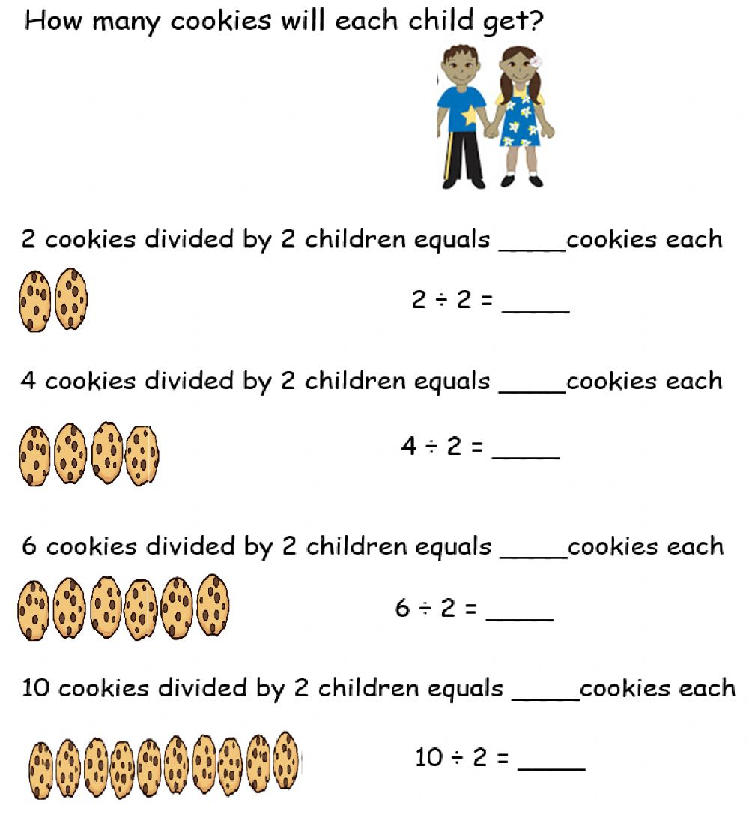

- Answer the following problems

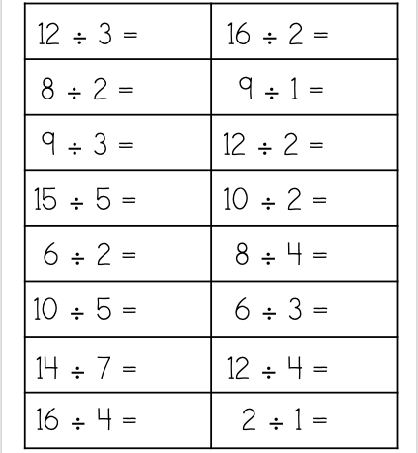

Double of numbers
Learning objectives : Double single and two-digit numbers

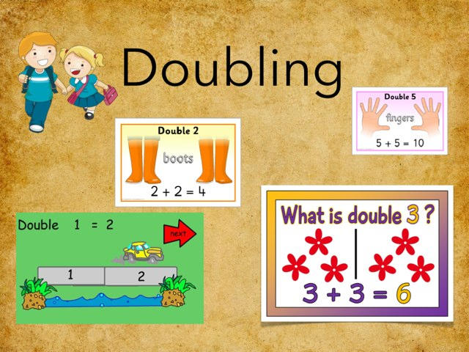
1 + 1
1 + 1

- Answer the following question about double.

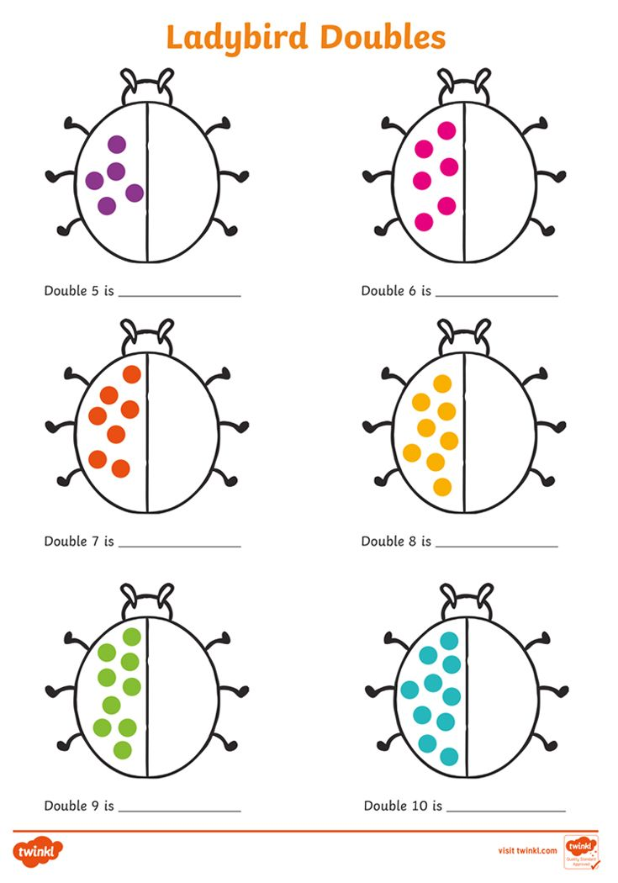

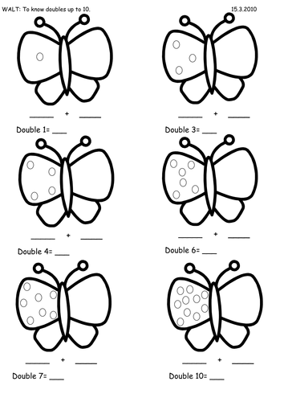

- Double the numbers on the dice and card.
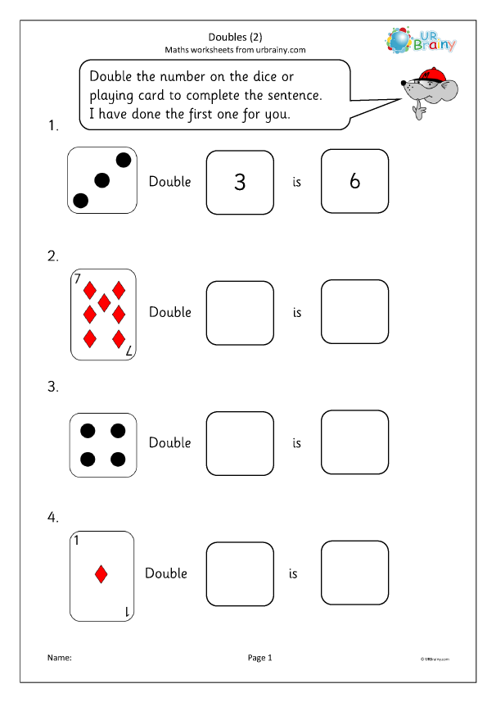

- Double the Fun Math Problems!
- Sarah has 8 toy cars in her collection. Her birthday is coming up, and her parents tell her they will give her double the amount of cars she already has. How many toy cars will Sarah have after her birthday:……………………………………………………….
- Tommy counted 6 butterflies in his garden this morning. In the afternoon, he saw double that amount. How many butterflies did Tommy see in the afternoon:………………………………………………

Half of numbers
Learning objectives : Find halves of small numbers of objects

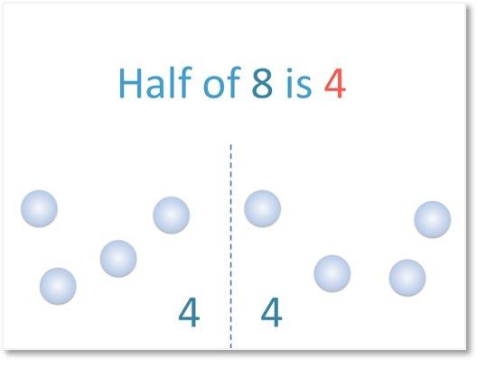

- Find the half of amounts.

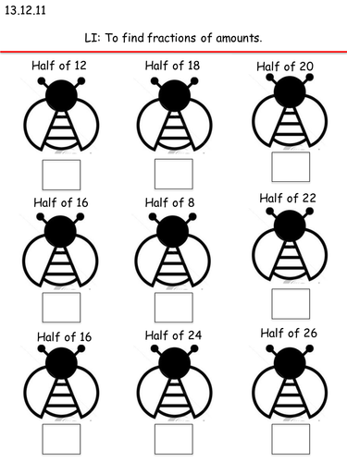

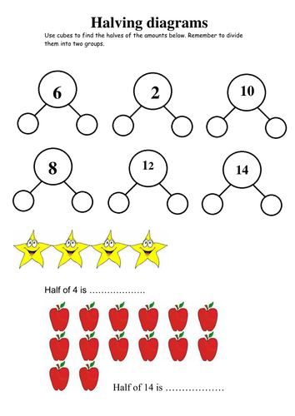

- Find the half of the following numbers. ( show your work )

half of 10 half of 12 half of 20

half of 4 half of 18 half of 14

Fraction
Learning objectives : Recognise that we write one half ½, one quarter ¼ and three quarters ¾

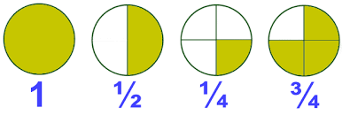
- Circle the correct answer.

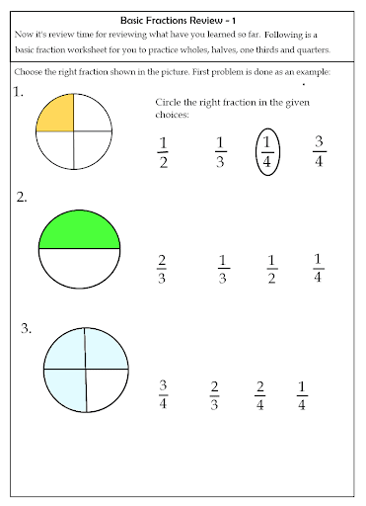

- Color the 1/2 of each shape written below it .

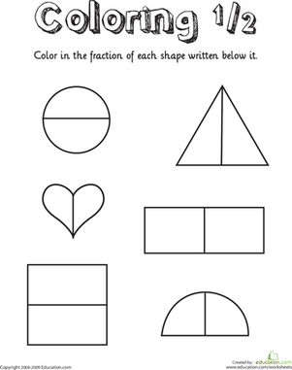

- Color the 1/4 of each shape written below it.

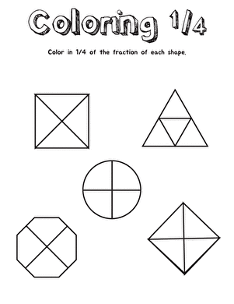

- Shade the correct fraction on the shape.

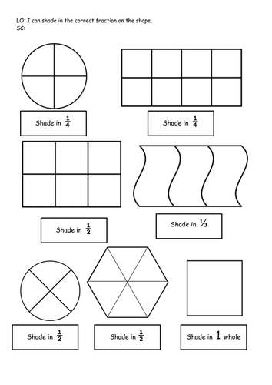

- Circle the shapes below that shows ¾ .

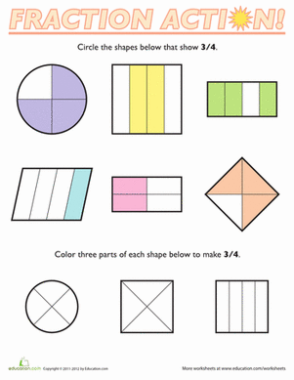

- Arun has 6 toy cars.

of the toy cars are red.

How many of the toy cars are red?

____________

Time
Learning objectives :
- Know the units of time (seconds, minutes, hours, days, weeks, months and years)
- Know and order the days of the week and the months of the year
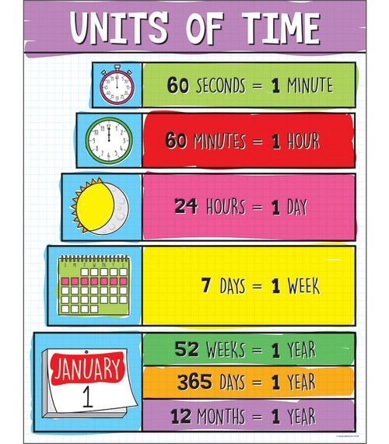

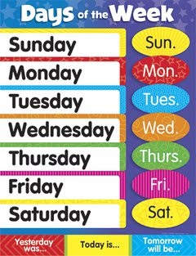

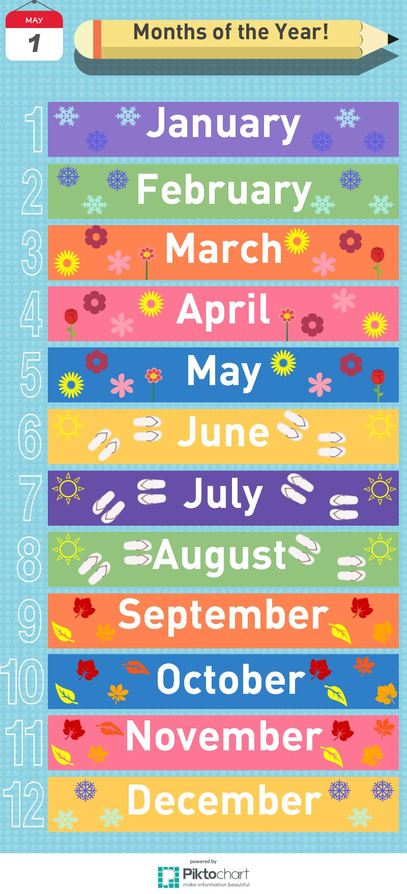
- Fill in each blank with the correct day .Don't forget to capitalize the first letter of the word .

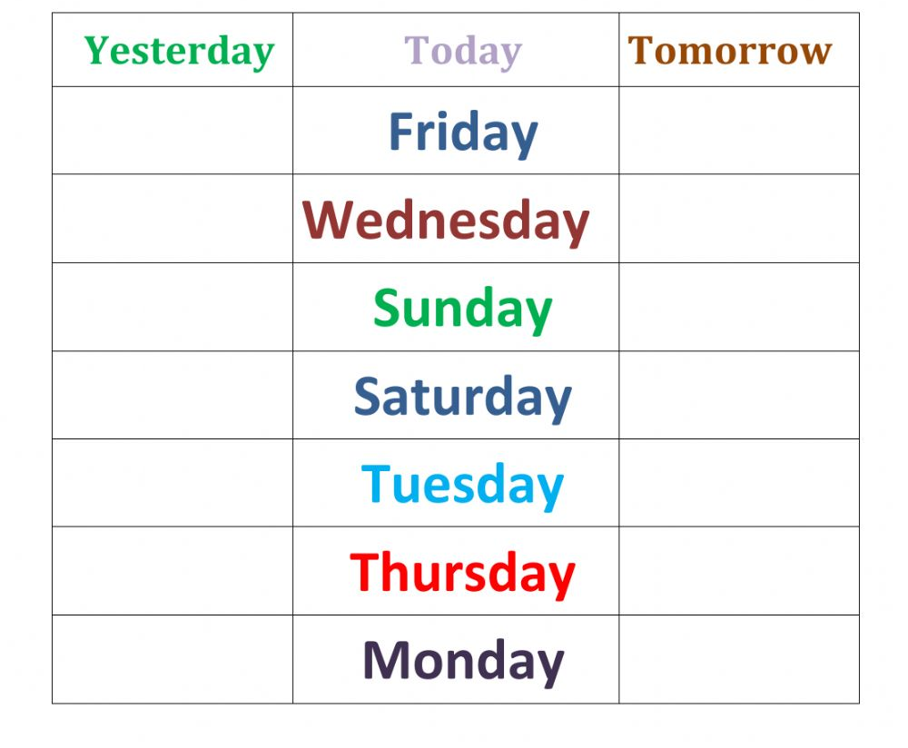
- Complete the sentence.

Today is Wednesday.

Yesterday was ________________ and tomorrow will be ________________.

- Fill in each blank with the correct year .Don't forget to capitalize the first letter of the word .

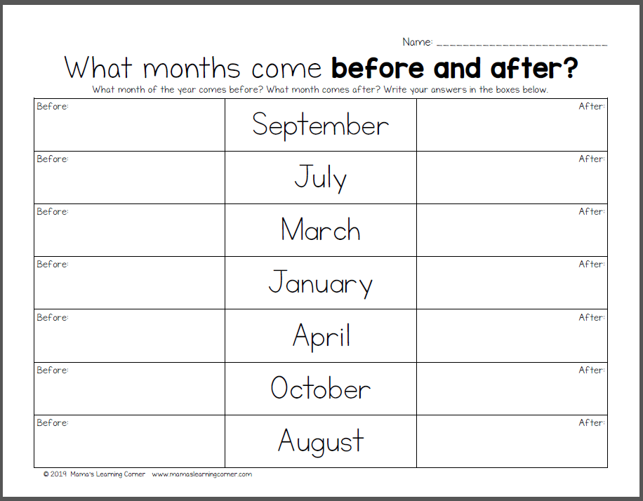

Mass and capacity

In the metric system of measurement, the most common units of mass are the gram( g ) and kilogram ( kg ).

How much is a gram?
A small paperclip has a mass of about 1 gram:


How much is a kilogram?
A wooden baseball bat has a mass of about 1 kilogram:
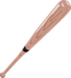

- Identify the most reasonable unit to measure the mass of the following.

( kg , g )
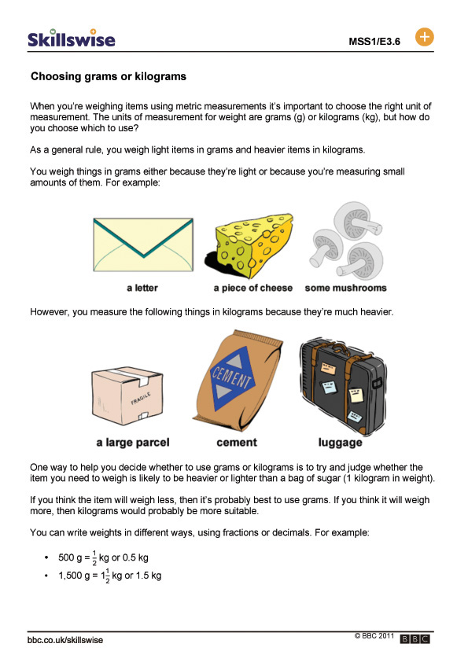

- Choose the correct mass for each of the following.

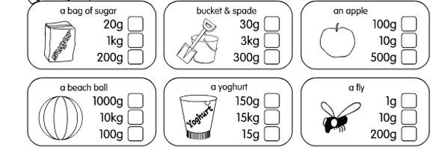

- Read the scales; write the mass of the vegetables.

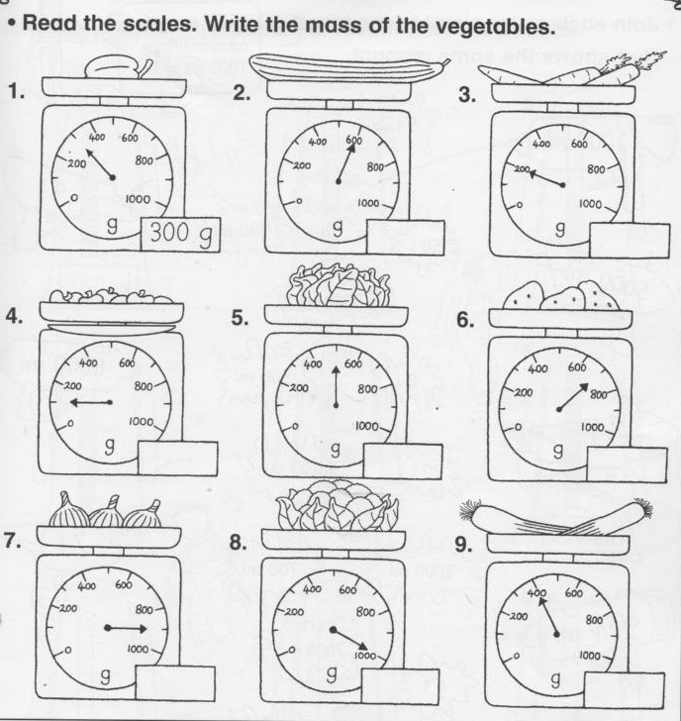

Length

- How many centimeters long is each pencil.

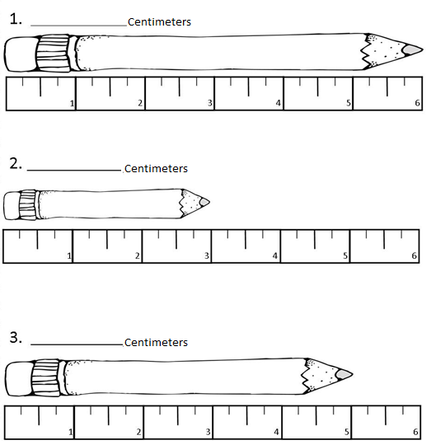

cm
cm
cm

- What unit of length you will use to measure the length of the following objects.

a) The destance between two cities.

b) The length of a rubber Km

c) The height of a man
m cm
d) Your little finger

e) The length of your pencil

how long is each object? Color and count the squares to show how long it is.
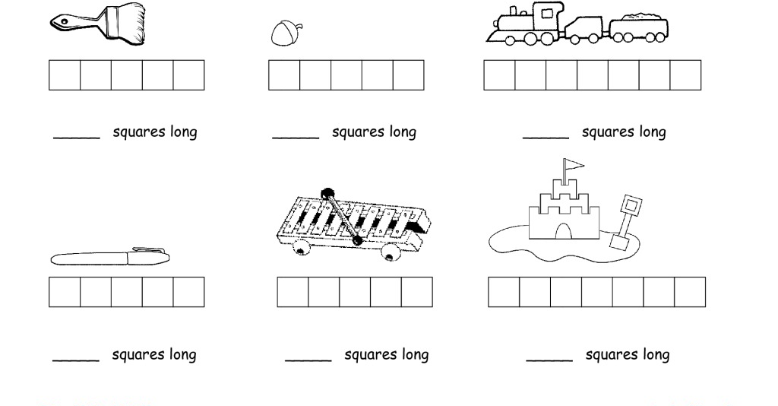

Position

Learning objectives : Follow and give instructions involving position.

- Where is the apple ,choose one from the box below.
In | Under | On | Near | Over | Close to | Far | behind
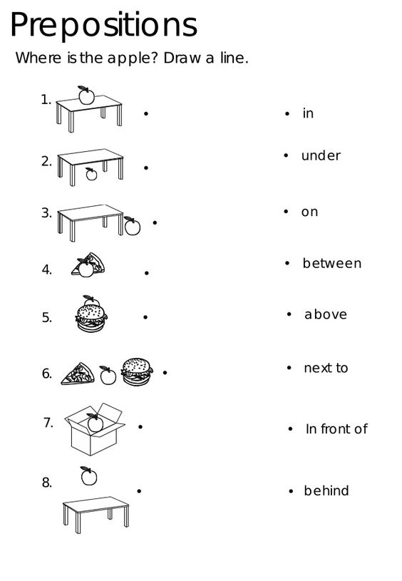

far
Close to

Money
Learning objectives : Recognise all coins and notes
- Draw lines to match the coins with totals.
5
5
10

18 C
13 C
9 C

- Draw coins to make each total.
Coins | Total
10 | 14c
5 | 10c
5  5 | 12c
1  10 | 15 c
1  1 | 5
10 | 18 c

