
Fifth Grade
Layers of the Earth
Study sheet #1
Unit 3

*The Earth is made up of four different layers.
*These layers are called the crust, the mantle, the outer core, and the inner core.
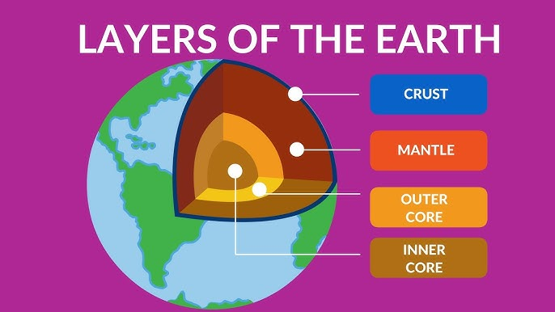

1-Crust:
-Crust is the thin outer layer of the Earth where we live.
-It is made of solid rock and minerals.
2-Mantle:
-Mantle is thicker than the crust.
-It is made of solid rocky material and magma.
*Magma: molten rock that is under the Earth’s surface.
*When this molten rock (magma) escapes to the Earth’s surface it is called lave.
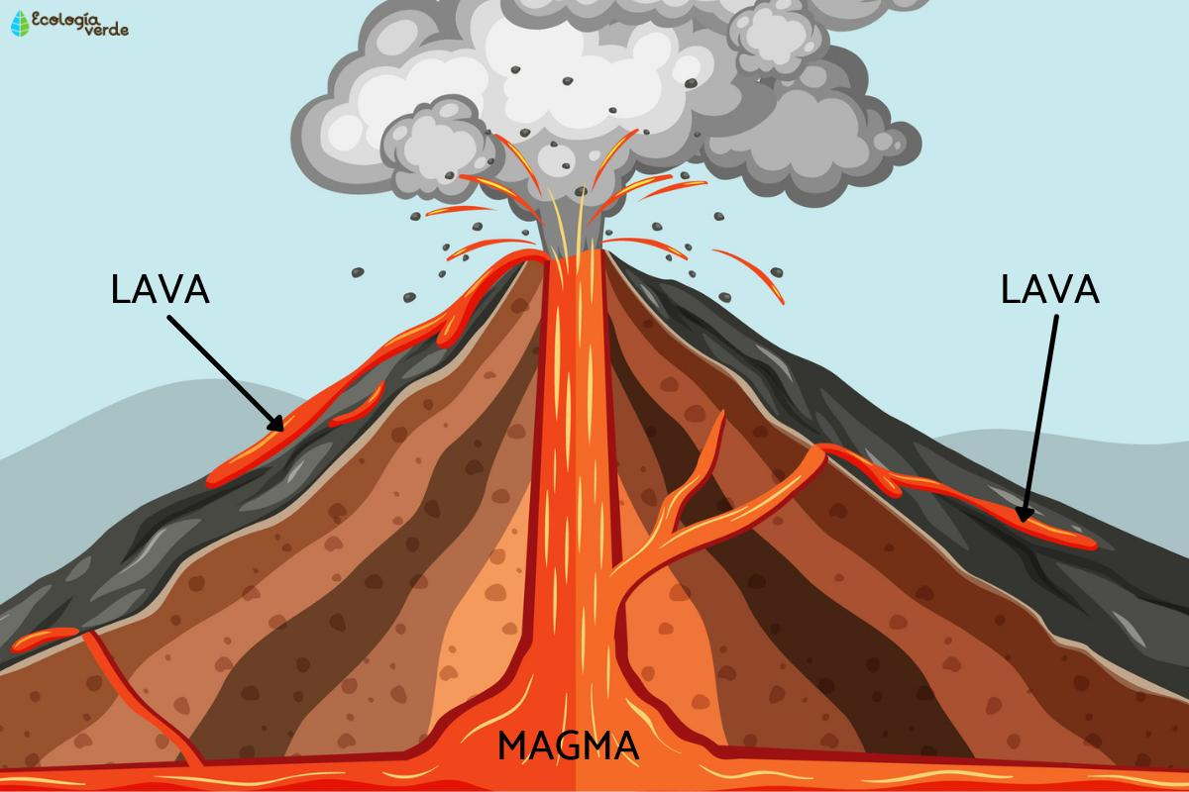

3-Outer core:
-Made up of hot liquid iron and nickel.
4-Inner core:
-Made up of solid iron and nickel.

