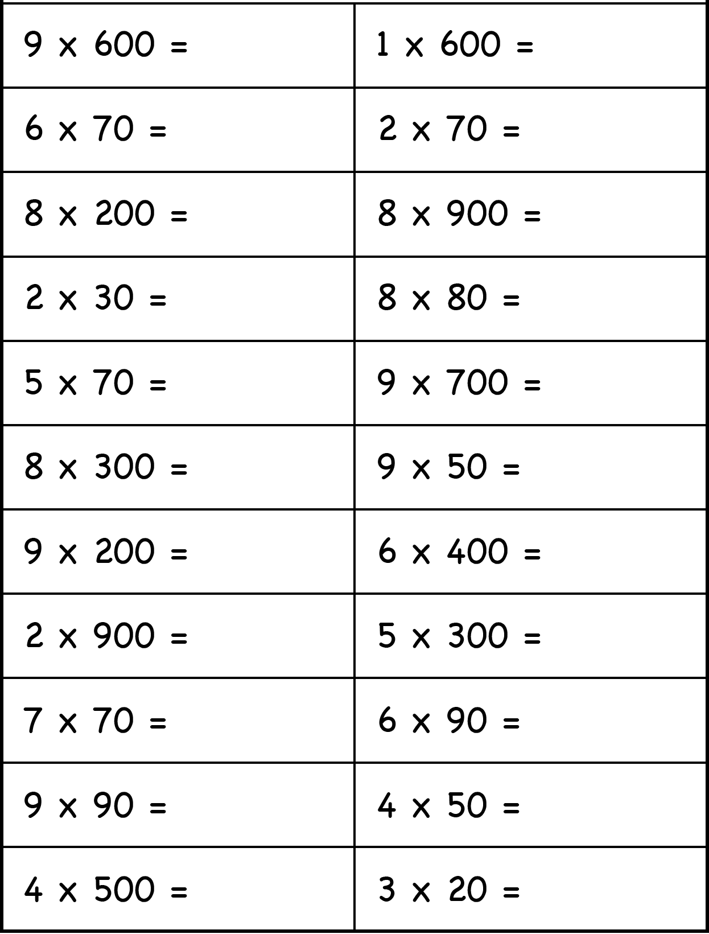

Q1) Calculate the answer of the following:
Math- Multiplication WS

Q2) Find the value of the following:
- 52 x 4 =

- 753 x 9 =

- 962 x 6 =

- 369 x 8 =

- 4527 x 3 =

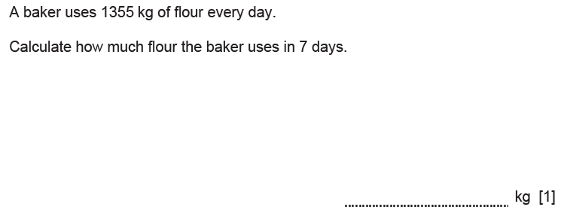
Q3)

Q4) Find the product of the following:
- 852 x 7 =

- 459 x 2 =

- 729 x 8 =

- 355 x 5 =

- 7512 x 2 =

- 2105 x 6 =

Q5) Calculate the following:
- 425x 15=

- 236 x 14 =

- 528 x 37 =

- 125 x 91=

- 257 x 63 =

- 233 x 48 =

- 525 x 22 =

Q6) Calculate the following:
- 614 x 35=

- 412 x 13 =

- 241 x 72 =

- 892 x 11=

- 722 x 23 =

- 846 x 45 =

- 369 x 33 =

Q7) Find the value of the following
- 216 x 16 = ____________

- 134 x 27 =____________

- 450 x 49 =___________

- 213 x 55= ___________

- 673 x 18 = __________

Q8) Calculate the value of the following:
- 7.2 x 2
- 1.25 x 5
- 34.5 x 3
- 1.44 x 2
- 85.4 x 23
f) 1.21 x 24
g) 1.83 x 15

Q9) Calculate the following:
- 24.3 x 3.6
- 15.6 x 1.3
- 1.28 x 4.1
- 25.2 x 6.5
- 18.9 x 3.2
- 27.5 x 5
- 30.6 x 1.9

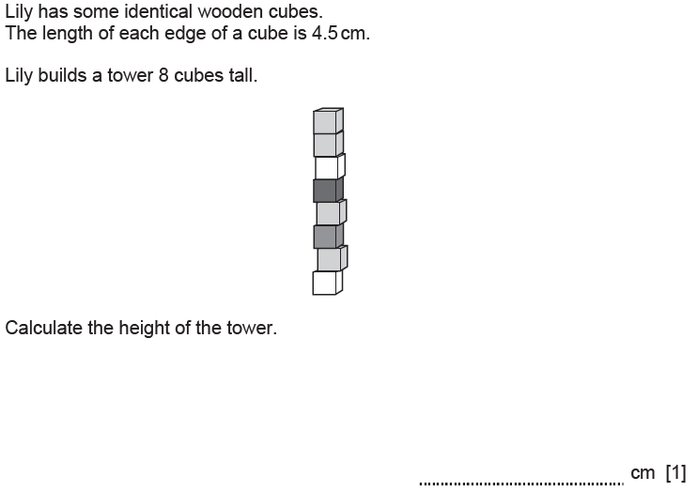
Q10)
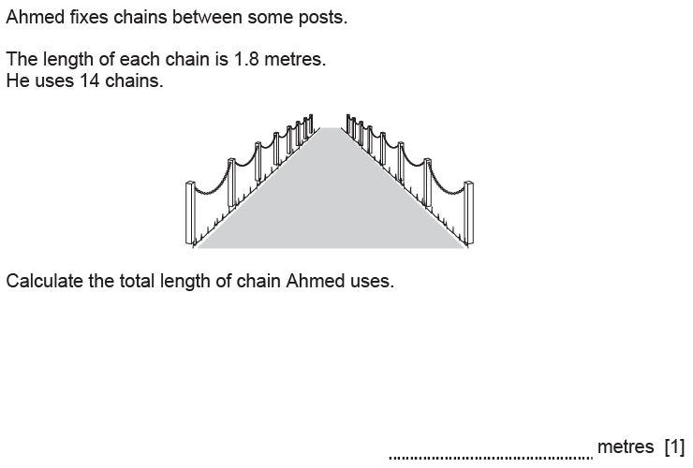
Q11)

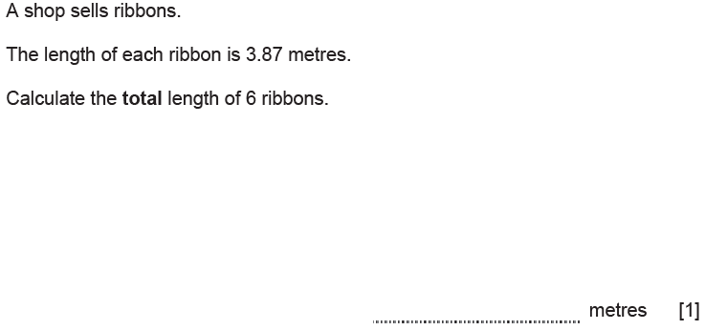
Q12)

