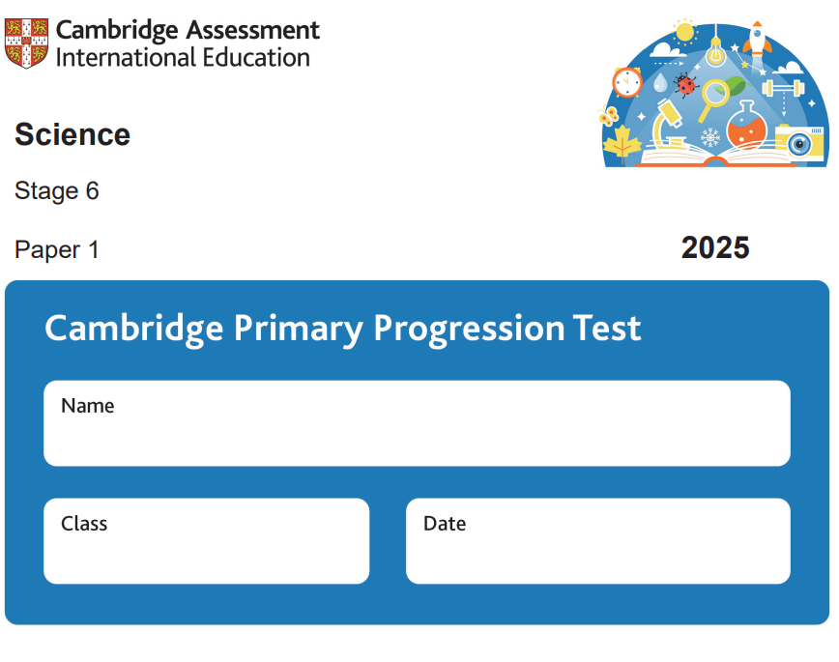

Revision booklet

Name:

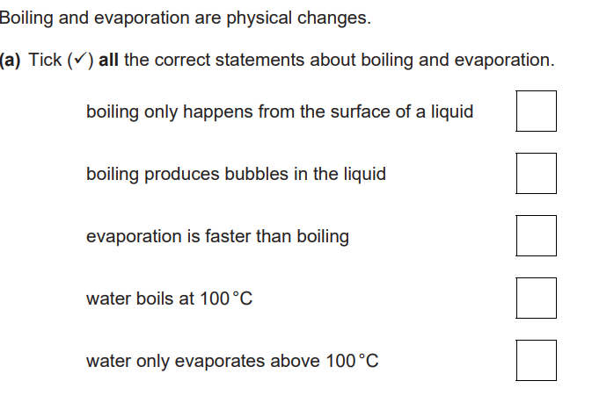
1-

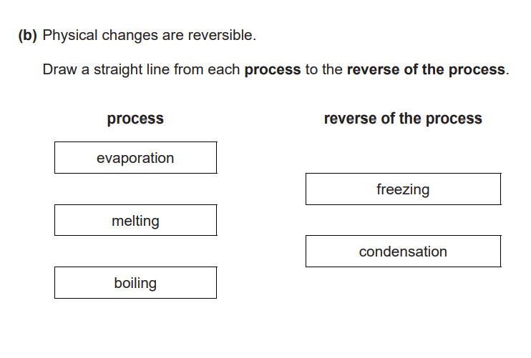

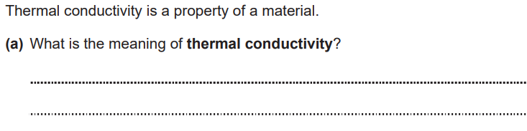
2-
The rate at which heat is conducted transferred or how fast heat conducted/transferred

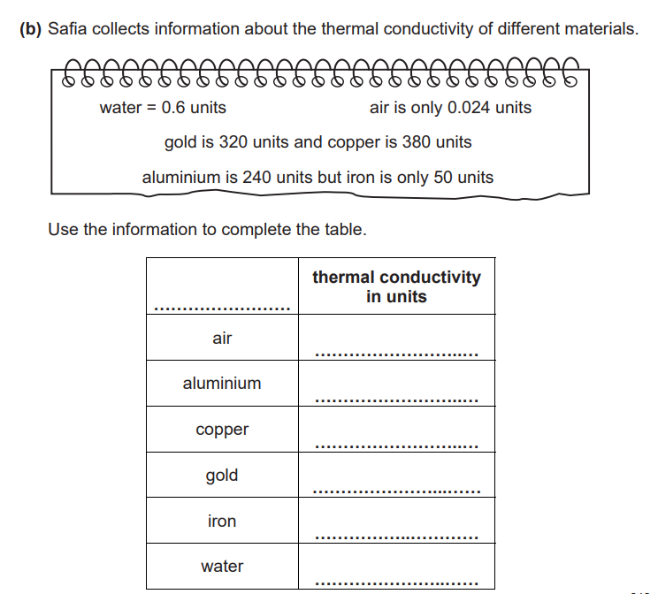

Materials

0.024
240
380
320
50
0.6

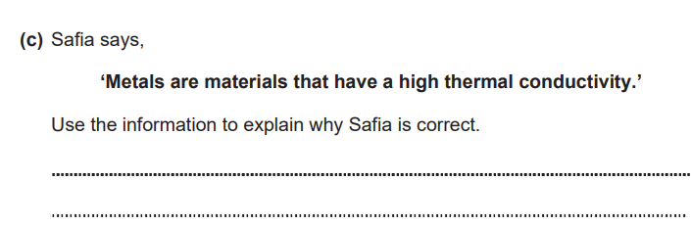

Metals have higher numbers than non-metal
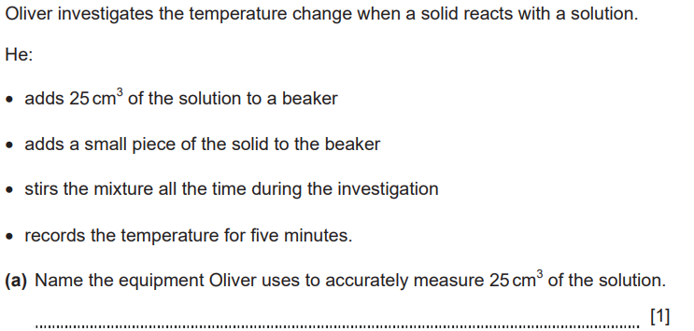
3-

Measuring cylinder
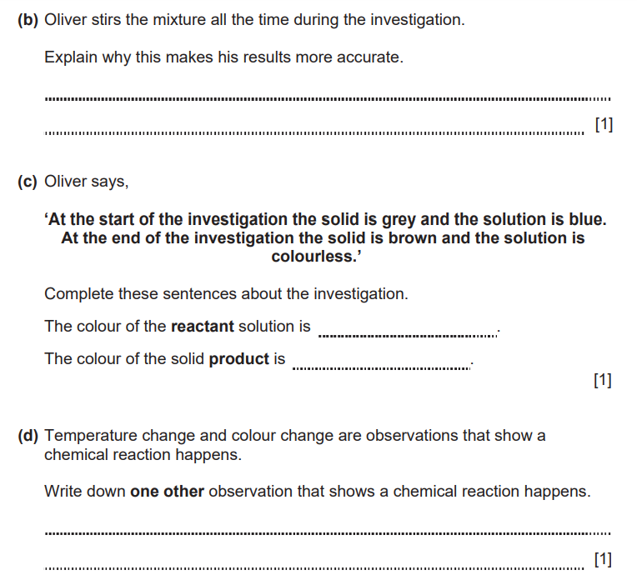
To make sure the temperature is the same.

blue
brown

Gas produced
