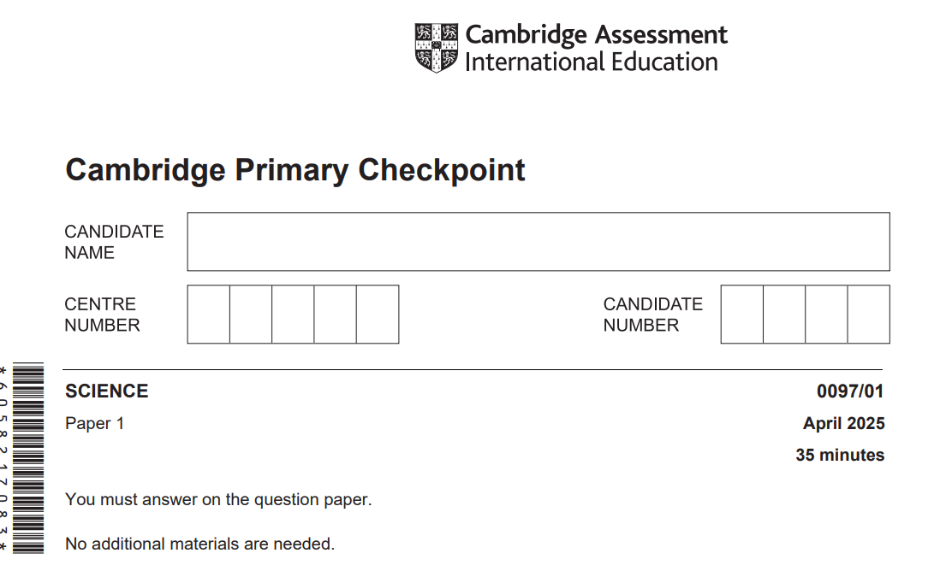

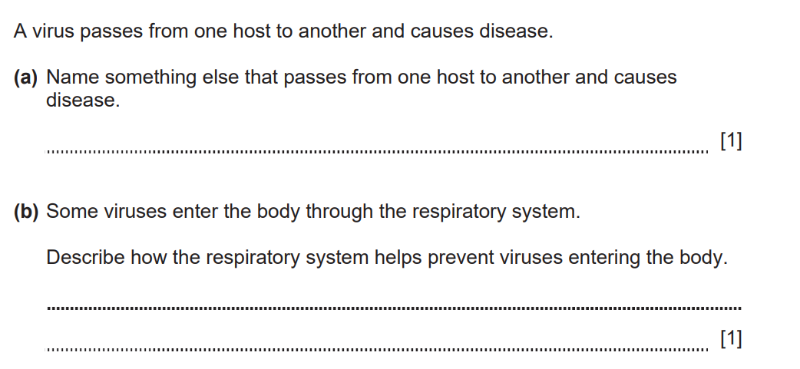
1-

Bacteria, parasites, fungi

Produces (mucus).

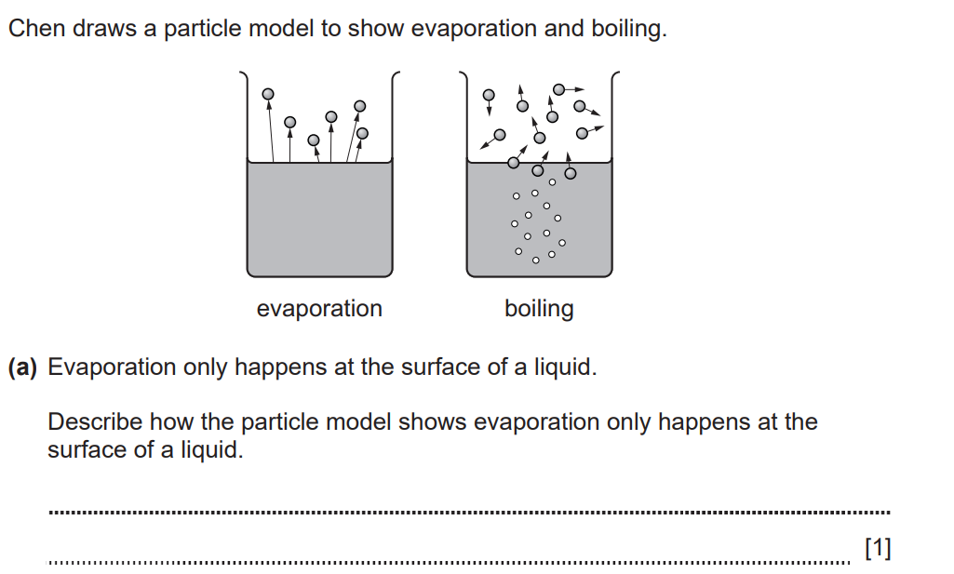
2-

Arrows only start from the surface or particles are only escaping from the surface.

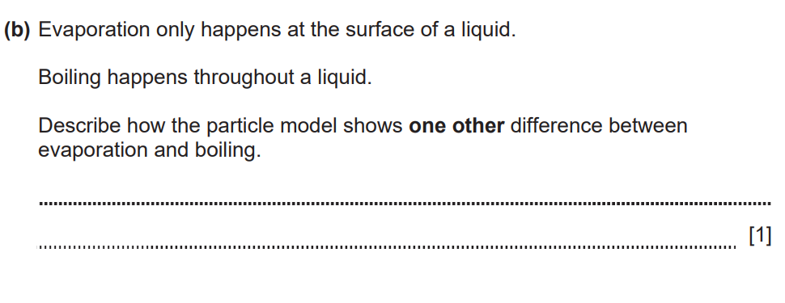

Boiling has bubbles or evaporation does not have
bubbles.


3-

Hips widen, development of breasts, start of menstruation, height increases ,body hair

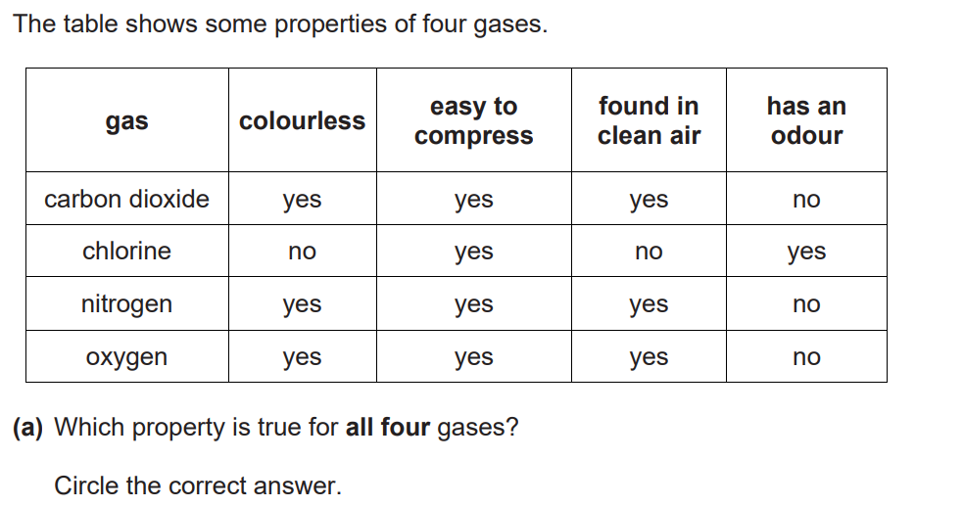
4-

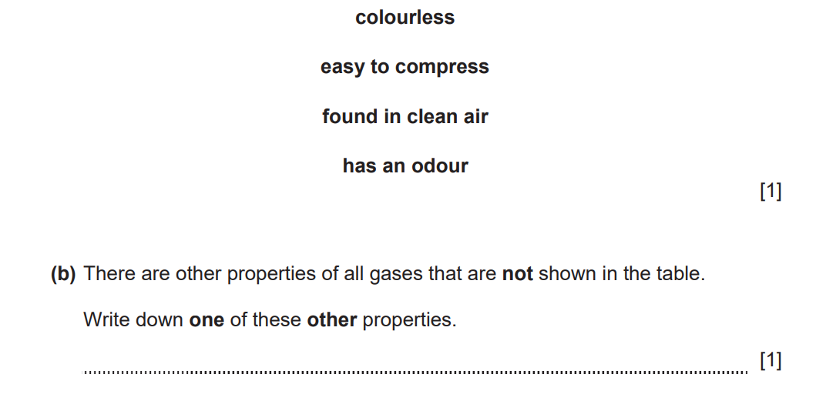

Mass ,does not have a fixed volume, flow easily

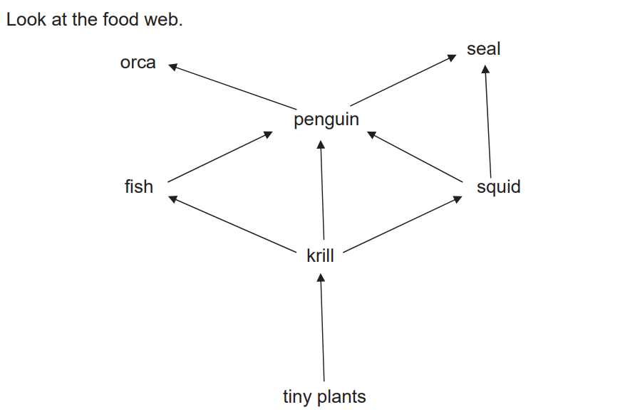
5-

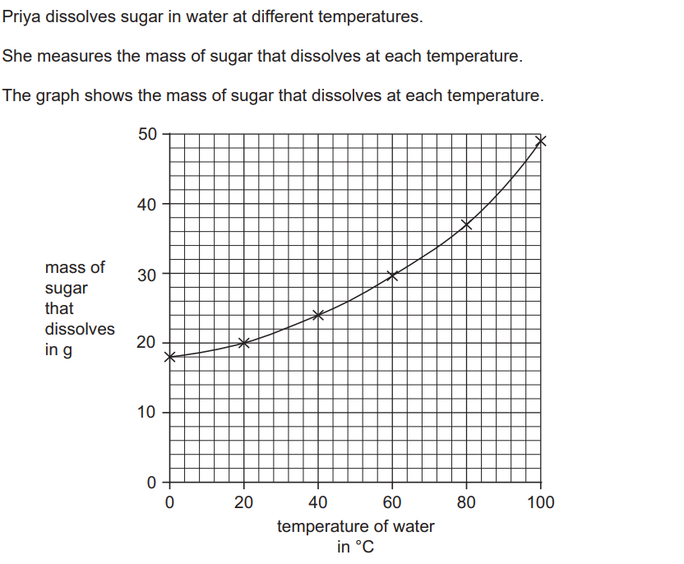
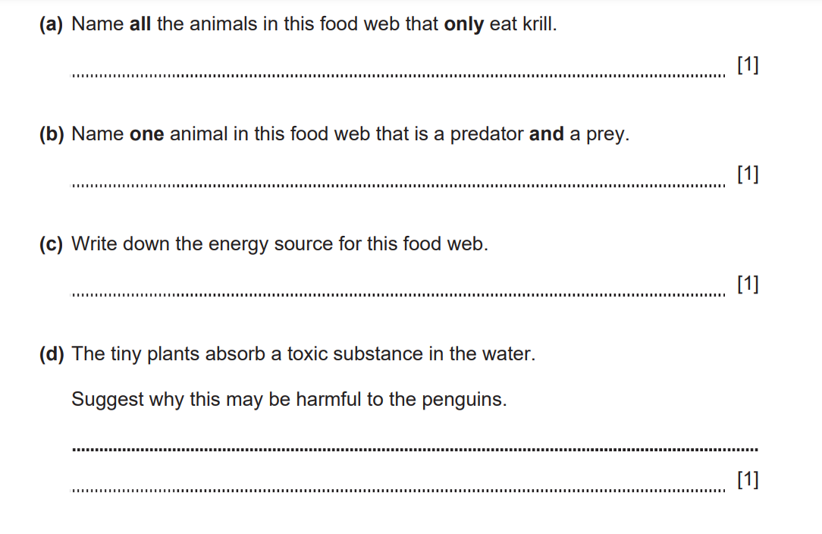
The penguin eats krill/animals that have eaten the tiny plants(which contain the toxic substance).
sun
Penguin fish squid
Fish and squid
6-

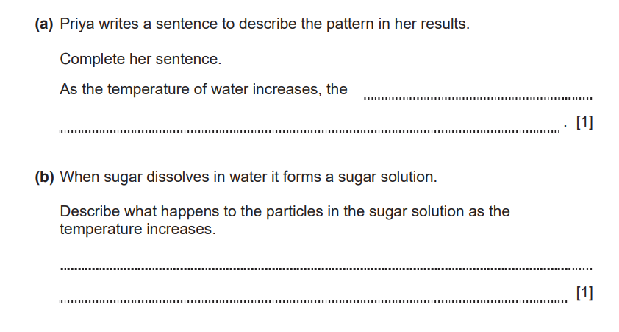

Mass of sugar dissolved increses

The particles have more energy ore move faster

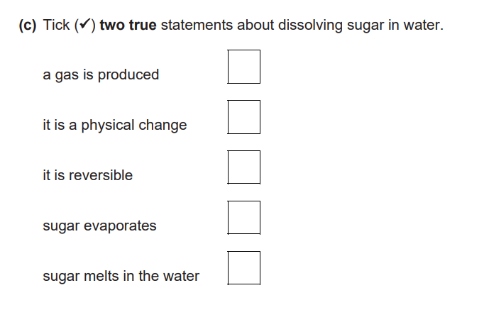

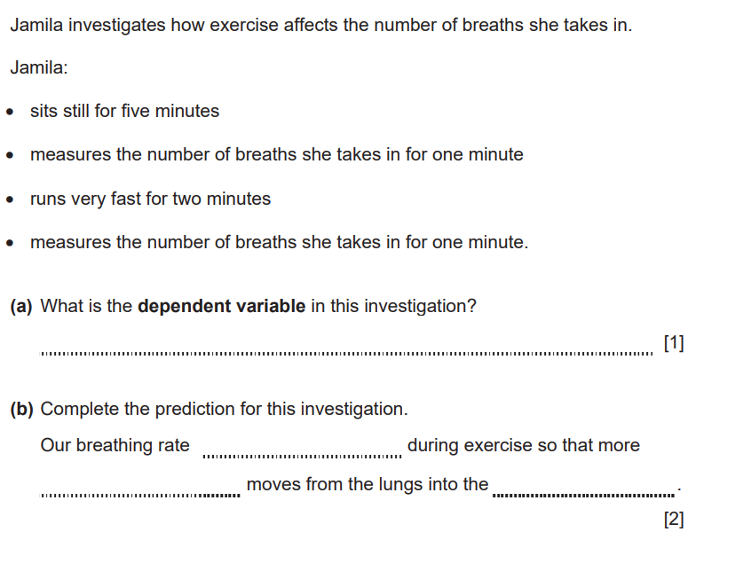
7-

The number of breathes(she takes in for one minutes)

increases
Oxygen blood

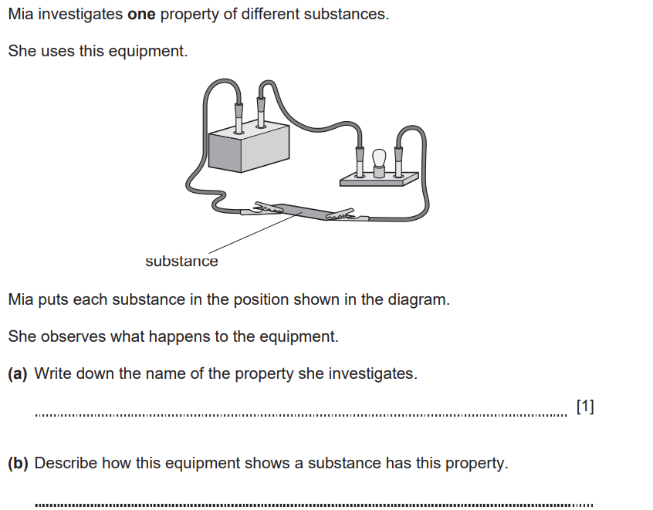
8-

Electrical conductivity
The lamp lights
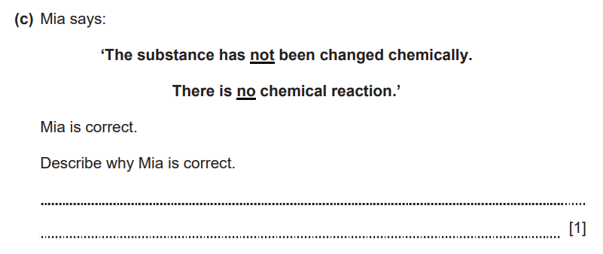
No bubbles produced or no gas produced
No colour changes
No new substance formed

