

Name: ……………………………. Class: 8th grade
Date: .…………………………….

Worksheet (9)
present perfect simple

1) Present perfect simple:
** Uses:
1- Actions that have just finished: (a very short time ago
- The museum has just closed.
- They have just eaten their breakfast.

2- Experiences (things you have done in your life (no specific time), and achievements (successes or important accomplishments):
- Linda has traveled to many countries.
- I have visited Petra twice.

3- Something that started in the past and has continued until now: (still happening now):
- They have lived in Amman for 10 years.
- He has worked at this school since 2020.

4- Something that happened in the past, but we don't know or we don't say exactly when: (we focus on the result, not the time):
- I have lost my keys.
- She has broken her arm.

5- Something that happened in the past and has a result that affects the present:
- I have broken my glasses.
- He has cut his finger.

** Key words:
- Already, ever, for, just, for a long time, for a long ages, never, once, twice, recently, so far, three times, until now, yet, since 2022, since June.

** Form:
1- Affirmative:
- Sub + have/has + P.P (V3):
- They have eaten lunch.
- He has cleaned his room.

2- Negative:
- Sub + have/has + not + P.P (V3):
- She hasn't visited Petra.
- They haven't eaten lunch.

3- Questions:
- Have/Has + sub + + P.P (V3)?
- Have you finished your homework? - Yes, I have. - No, I haven't.
- Has he cleaned his room? - Yes, he has. - No, he hasn't.

** Spelling:
1- Most verbs we add (ed):
- walk – walked.
- talk – talked.

2- If the verb ends with an (e) we only add (d):
- dance – danced.
- close – closed.

3- If the verb ends with (Y) preceded by a consonant we replaced the (Y) with (ied):
- tidy – tidied.
- study – studied.

4- If the verb ends with (Y) preceded by a vowel we keep the (Y) and only add (ed):
- play – played.
- stay – stayed.

5- If the verbs end with a consonant preceded by a vowel, we double the last letter and add (ed):
- travel – travelled.
- plan – planned.

** For the irregular verbs we don’t follow these rules:

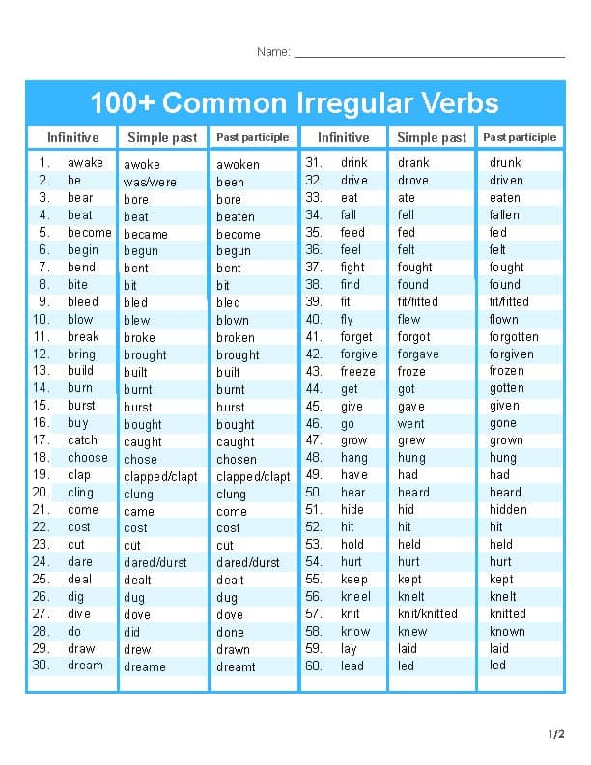
Teacher:
Maria Al Zuraikat

