Greek Orthodox Patriarchate schools
Science Summary
Name:………………………… … 6th grade
Date:………………………………………..

*Respiration: a process in which oxygen is breathed from air to reach cells and convert food into energy. Co2 is given out.
Animals respire into different ways:
*mammals have lungs
*insects have spiracles
*fishes have gills
* plants have stomata
**********************************************************
*Our body is made of flesh and blood built on a framework of bones.
*our body is composed of many separate bones all joined together by bands of muscles.
*Our bones protect very important organs inside :
Rib cage protects heart and lungs
Skull protects brain
Spinal column protects nerves and spinal cord
*************************************************************
Skelton system :
It is a hard framework of bones gives shape and strength to the body . it also protects the inner soft organs
*A child has 350 bones
*An adult has 206 bones
*each human has 600 muscles
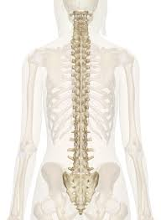
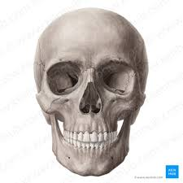
Skelton main parts:
Skull (bony structure )
spinal column
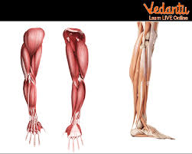
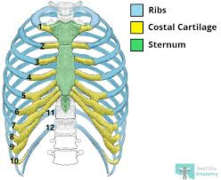
Rib cage limbs

*Skull is a bony structure with holes for mouth , ears , eyes , and nose
*Spine involves 33 vertebrae and it protects nerves / blood vessels and spinal cord
*limbs are hands, wrist, feet and ankles
*Rib cage is narrow curved bones and protects lungs and heart

Joints
*Joints occur when two bones meet, and They are strong enough.
*There are several joints:
1-hinge joints:
Move up and down , forward and backward
Ex: knees and elbow

2-ball and socket joints
Move any direction.
Ex: shoulder and hips

3-pivot joint
Move upward and downward
Ex : skull with spine

4-sliding joint
Move backward and forward
Ex: wrist and ankle
****************************************************

Muscular system
Muscles are bundles of fibers.
We have more than 650 muscles and each produces a different movement
Kinds of muscles :
1-skeltal muscles : voluntary movement such as hands and legs
2-smooth muscles : involuntary movement such as stomach
3-cardiac muscles : don’t stop moving or get tired such as heart
************************************************************

