
Greek Orthodox Patriarchate School / Karak
Final Exam for First Semester
Scholastic Year 2025/2026

Name: Subject: Science
Grade: 3rd grade Time Duration: 45 minutes
Total Marks: Day & Date: Monday 15/12/2025

Q1: True or False:
1- Inside the seeds, there are nutrients for a new plant ( T ).
2- Birds have light bodies ( T ).
3- The seeds of peaches and mangos are small ( F ).
4- Frogs always live in water, like fish ( F ).
5- The seeds of oranges and lemons are black ( F ).
6- If a tortoise sees danger, it hides inside its shell ( T ).

Q2: Fill in the blanks:
Sunlight  3 | Sharp teeth  6 | Oval  1 | The humps  4 | black  5 | Trunk  2

1- The seeds of watermelons are ________________.
2- An elephant uses its _________________ to grab leaves.
3- A seed starts growing when it gets water, air, and _________________.
4- It helps the camel to travel the desert for days without food_________________.
5- The seeds of papayas are _________________.
6- Animals that eat meat have claws and ________________.
Q3: Write (L) in the circle if the animal lives on the land, (A) if it lives in the air,
(W) if it swims in the water:
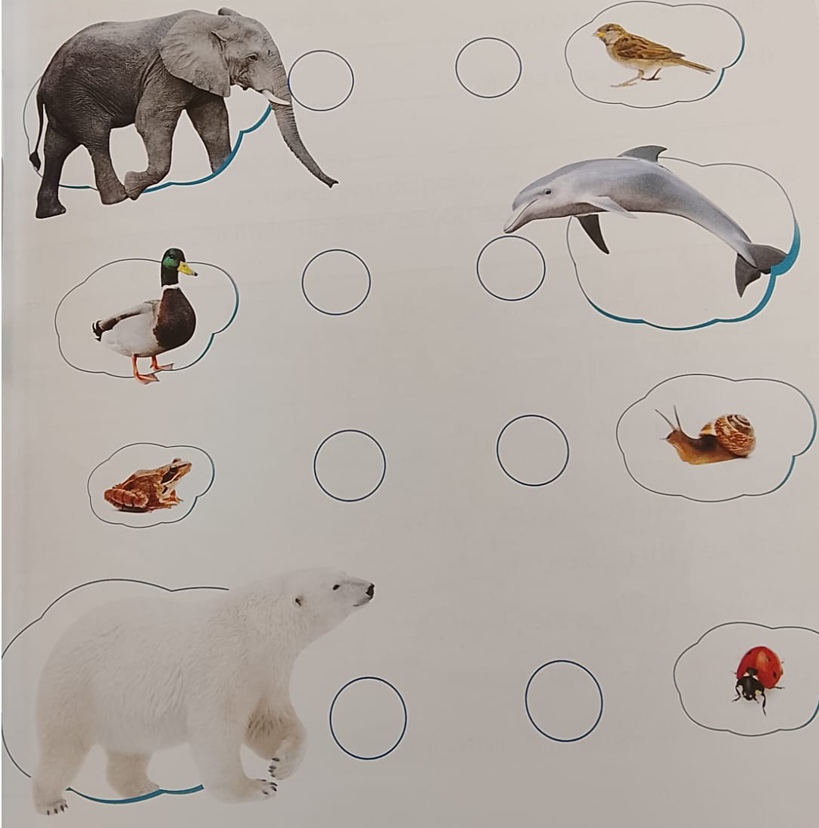

Good luck:
Teacher: Maria Zuraikat

