
Greek Orthodox Patriarchate School / Karak
Final Exam for First Semester
Scholastic Year 2025/2026

Name: Subject: ICT
Grade: 2nd grade Time Duration: 45 minutes
Total Mark: Day & Date: Thursday 18/12/2025
Q1: Color the square next to the application software:
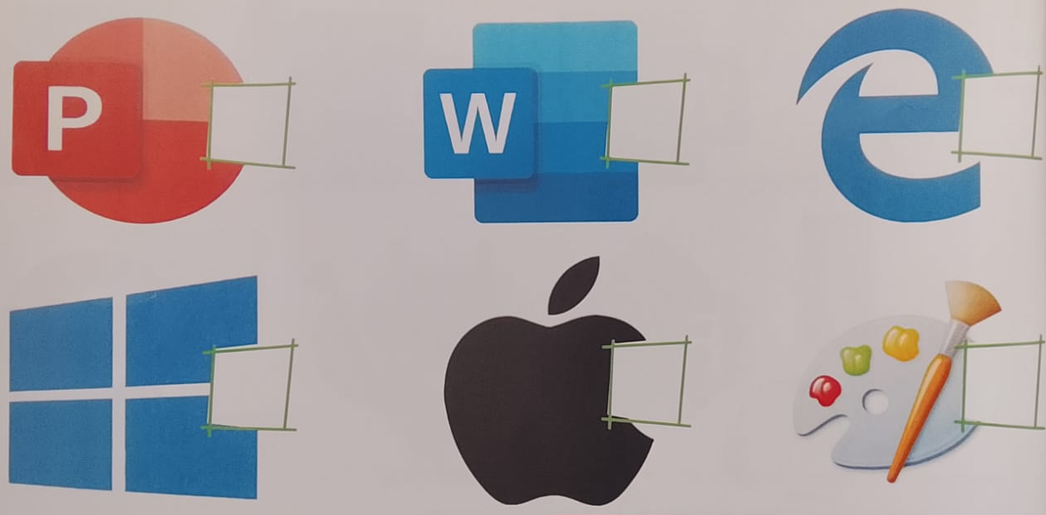

Q2: True or False:
1- Computer systems used at the hospital keep information for doctors ( ).
2- There are 4 shift keys on the keyboard ( ).

Q3: Write the missing key:
1- Shift + ( 1 ) = !
2- Shift + ( 2 ) = @
3- Shift + ( 3 ) = #
4- Shift + ( 4 ) = $
Q4: Match:
Input | 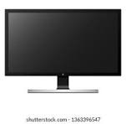
Output | 
Storage | 
CPU | 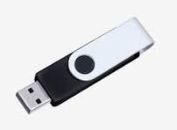

Good luck
Teacher: Maria Zuraikat

