
Greek Orthodox Patriarchate School / Karak
Final Exam for First Semester
Scholastic Year 2025/2026

Name: Subject: ICT
Grade: 1st grade Time Duration: 45 minutes
Total Mark: Day & Date: Thursday 18/12/2025

Q1: True (T) or False (F):
1- Startup means to turn off the computer ( F ).
2- A password keeps information safe ( T ).
3- Shutdown means to turn on the computer ( F ).

Q2: Tick or cross:
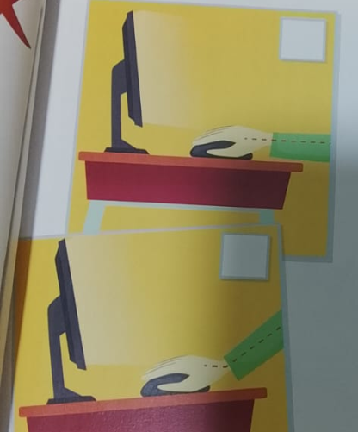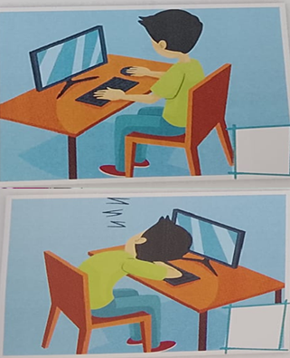

Q3: Match the word with the correct picture:
speaker | 
webcam | 
Monitor | 
headphones | 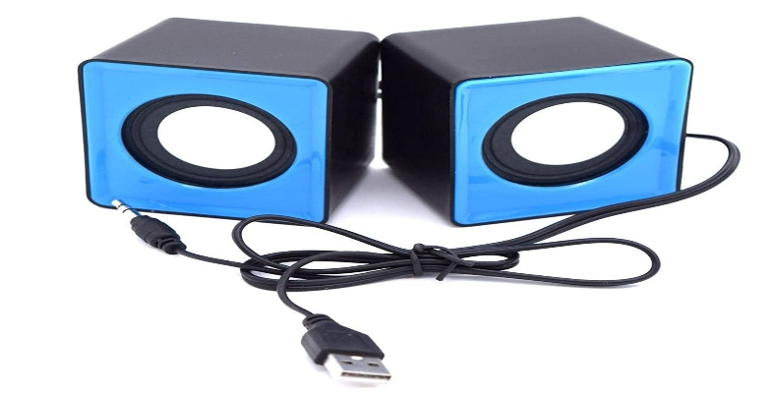

Q4: Solve:
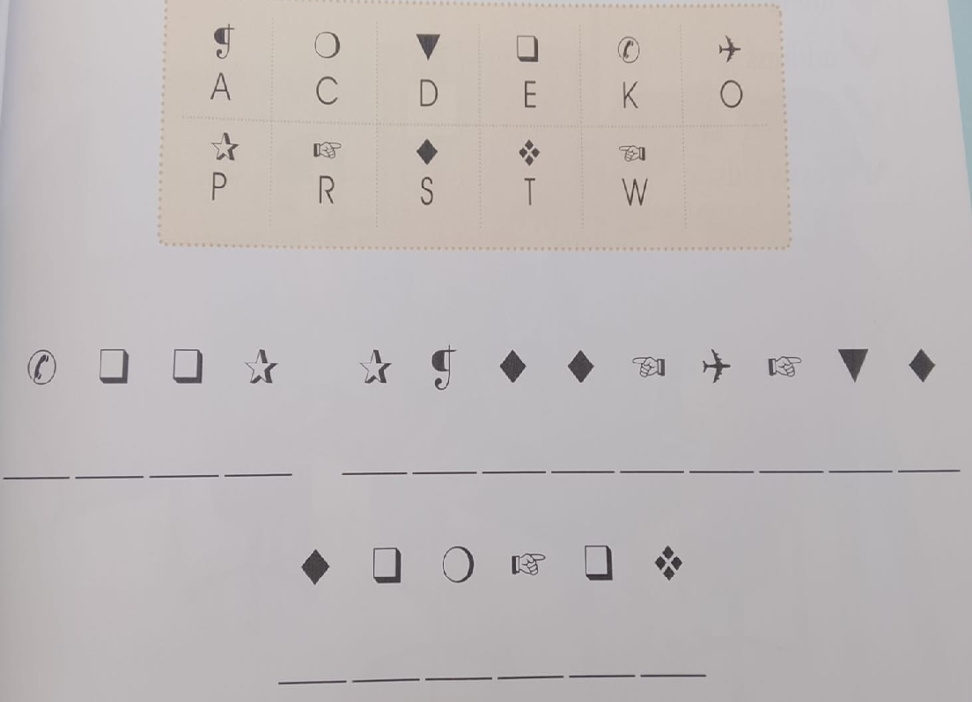

Good luck

Teacher:
Maria Zuraikat

