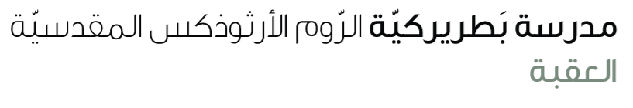
Name: Past continuous 5th grade

The Past Continuous Tense describes an action that was happening at a specific time in the past.
Affirmative | Negative | Question
S + was/were + verb + ing  Ex: She was reading a book. | S + wasn’t /weren’t + V(ing)  Ex: She was not reading a book. | Was/Were + V+ V(ing)?  Ex: Was she reading a book?
Used to describe an action happening at a specific time in the past. | Used to show an action that was not happening at a specific time. | Used to ask if an action was happening at a specific time.
Common words: while, when, at 7 o’clock yesterday

Exercises
A. Fill in the blanks with the correct form of the verb in Past Continuous:
1. He ______________ (play) football at 5 p.m. yesterday.
2. They _______________ (watch) a movie when it started to rain.
3. I _________________ (not sleep) at that time.
4. __________ you _____________ (study) for the test last night?

B. Choose the correct answer:
1. She (was / were) dancing at the party.
2. We (was / were) not listening to the teacher.
3. (Was / Were) they playing outside when it got dark?

C. Write 2 sentences of your own using Past Continuous tense:
1. ___________________________________________
2. ___________________________________________

