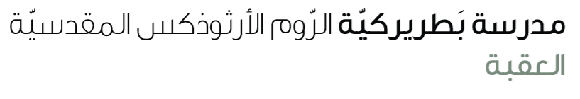
Name: Past continuous & simple 5th grade

Past Simple & Past Continuous – When / While

1. Explanation
We use the past continuous (was/were + verb-ing) for longer actions happening in the past.
We use the past simple (verb 2) for shorter actions that interrupt.

Using WHEN
✨ WHEN + past simple (V2) → interrupts the long action.
Example:
• I was cooking **when** the phone rang.

Using WHILE
✨ WHILE + past continuous (was/were + V-ing) → the longer action.
Example:
• She was studying **while** I was watching TV.

2. Examples
• He was driving when it started to rain.
• They were playing football when the bell rang.
• While I was walking home, I saw a cat.
• While we were eating, the lights went off.

3. Exercises

A. Complete the sentences with WHEN or WHILE:
1. I was sleeping __________________ the alarm went off.
2. _________________ she was talking, the door opened.
3. They were running ______________ it started to rain.
4. __________________ we were eating, my friend called.

B. Choose the correct form:
1. I (was watching / watched) TV when I (heard / was hearing) a noise.
2. She (was walking / walked) home when she (met / was meeting) her friend.
3. They (were playing / played) cards while we (were waiting / waited).

C. Complete the sentences with the correct form of the verbs.
1. He __________________ when the doorbell ________________ .( cook , ring )
2. They _____________________ when I __________________ them. (swim, call)
3. She ______________ the cat while she ______________________. (see, walk)
4. what _____________ you _______________ when I phoned you? (do)
5. What ____________ he ________________ when we went home? (play)
6. John __________________ the ball and ___________________ a goal. (kick, score)
7. We________________________ and ________________________ about our school project. (walk , talk)

