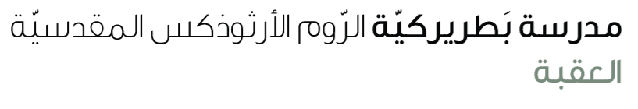
Name: Vocabulary 5th grade

Vocabulary:
Chess | A strategic board game played between two players.
Board | A flat surface, like the grid used to play chess.
Blind | Not able to see; can also mean unaware.
Pieces | Small individual parts of something; in chess, the units you move.
Childhood | The early stage of life when someone is a child.
Poor | Having little money or lacking something.
Engineer | A person who designs, builds, or solves problems using science.

