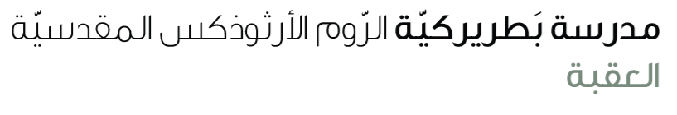
Name: Wh question Past simple (irregular verbs) 4th grade

1. Question Structure (Past Simple)
WH‑ + did + S + V(inf)?
Example: What did you eat?

2. complete the questions.
• What _______ you___________? ( see)
• When _______ you ___________the juice? (drink)
• Where _______ you ___________ the shoes? (buy)
• What _________ you __________ for breakfast? (eat)
• Why _________ you ___________ to school early? (go)
• What ________ you __________ in art class? (make)
• Who _________ you __________ lunch with? (have)
• Who _________ you __________ the gift to? (give )
• What ________ you ___________ yesterday? (wear)
• Why _________ you ___________ the ball? (throw)

3. Using BE in Past Simple (Was/Were) – Questions
Was/Were + S + comp…… ?
Example: Where were you yesterday? (be)
C. BE – Past Simple:
1. Who __________ you last night? (be)
2. Where __________ your teacher yesterday? (be)

