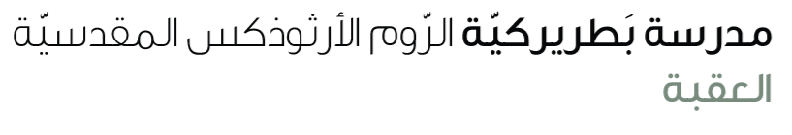
Name: Past simple (irregular verbs) 4th grade
We use the Past Simple Tense to talk about actions that happened in the past. Irregular verbs have special past forms that do not end in -ed.
Affirmative | Negative | Yes/No Question
S + V(2) | S + did not (didn't) + V(inf) | Did + S + V(inf)?
• I bought a new bag.  • She made a cake.  • They had breakfast.  • He gave me a gift.  • She wore a red dress.  • He threw the ball.  • We put up the tent.  • I went to the park.  • We saw a movie. | • I didn’t buy a bag.  • She didn’t make a cake.  • They didn’t have breakfast.  • He didn’t give me a gift.  • She didn’t wear a red dress.  • He didn’t throw the ball.  • We didn’t put up the tent.  • I didn’t go to the park.  • We didn’t see a movie. | • Did you buy a new bag?  • Did she make a cake?  • Did they have breakfast?  • Did he give you a gift?  • Did she wear a red dress?  • Did he throw the ball?  • Did you put up the tent?  • Did you go to the park?  • Did you see a movie?

Exercises
A. Fill in the blanks with the correct form of the verb in Past Simple:
1. She _______________ (buy) a beautiful dress yesterday.
2. We ________________ (make) a cake for Mom.
3. He __________________ (go) to school by bus.
4. I __________________ (see) my best friend last night.
5. They ________________ (have) lunch at 2 o’clock.

B. Change the sentences into the negative form:
1. He gave me a present. → _______________________________
2. We wore new shoes. → _______________________________
3. They put up the decorations. → _______________________________

C. Write Yes/No questions for these sentences:
1. She bought a bag. → _______________________________
2. He threw the ball. → _______________________________
3. We went to the zoo. → _______________________________

D. Write 2 sentences of your own using irregular verbs:
1. ___________________________________________
2. ___________________________________________

