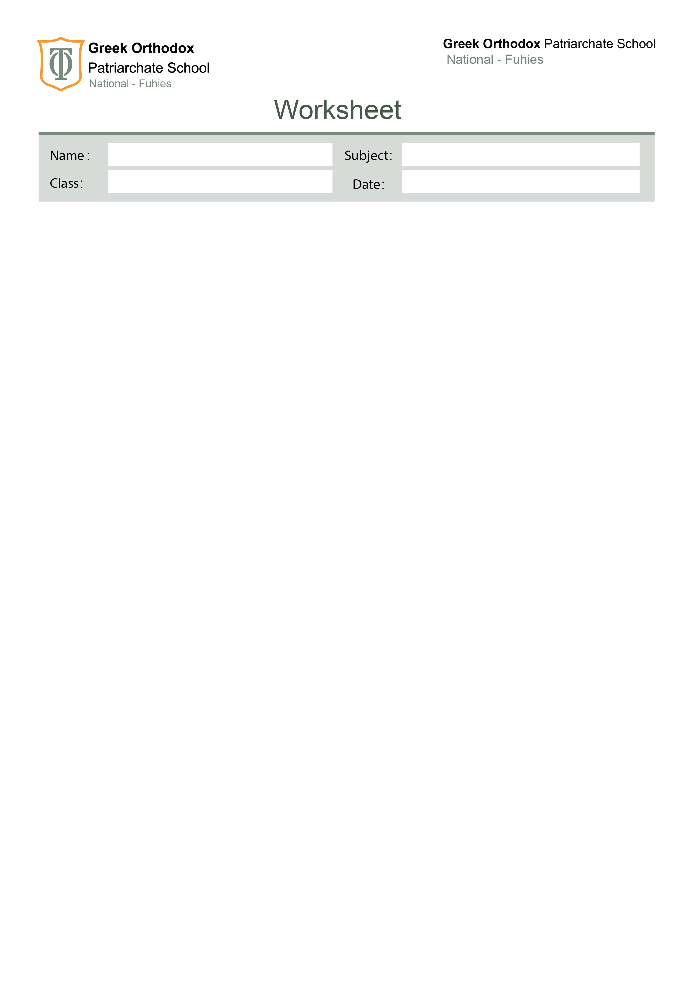

Grammar revision
Ten

A. Exercise A1 – Fill in the blanks
Use the correct past tense form of the verbs in brackets.

- When I _______________ (arrive) at the station, the train ___________________ (already/leave).
- She ______________ (cook) dinner when the lights suddenly ___________ (go) out.
- They ________________ (study) for two hours before they _______________ (take) a break.
- I ______________ (walk) home yesterday when I _____________ (see) an old friend.
- By the time the teacher came, the students _______________ (wait) for 15 minutes.
- He _______________ (not finish) his project even though he ___________________ (work) on it all week.
- While we _____________ (play) football, it _______________ (start) to rain heavily.
- She _________________ (never/visit) London before last summer.
- The children _______________ (build) a sandcastle when the wave ____________ (destroy) it.
- I _______________ (just/sit) down when someone __________________ (knock) on the door.

Exercise B1 – Choose the correct answer

- Look at those clouds! It (will rain / is going to rain) soon.
- I can’t come tonight. I (am meeting / will meet) my cousin at 7.
- By next July, they (will finish / will have finished) the new bridge.
- This time tomorrow, I (will fly / will be flying) to Paris.
- A: The phone is ringing!
B: I (am going to answer / will answer) it.
- She feels tired, so she (is going to take / will take) a nap.
- The company (is launching / will launch) a new product next month.
- I think students (will enjoy / are enjoying) the trip.
- We (are going to paint / will be painting) the house all weekend.
- By 2030, scientists (will discover / will have discovered) new treatments.

C. Exercise C1 – Change into reported speech

- “I can’t find my keys,” she said_____________________________________________
- “Do you like Italian food?” he asked me_____________________________________
- “Where did you put the documents?”
my boss asked____________________________________________
- “Don’t touch the wires,” the electrician warned us____________________________
- “Please help me with this project,” she asked me_____________________________
- “Let’s go for a walk,” he suggested_________________________________
- “I have never been to Spain,” she told us_________________________________
- “Why are you crying?” the teacher asked the child____________________________
- “Finish your homework before dinner,”
- his mother told him____________________________________________
- “Will you join us for the trip?”
- they asked us_________________________________________________

Your English teachers: Nayfeh Abu Hanna & Lara Bajjali

Education is the passport to the future, for tomorrow belongs to those who prepare for it today

