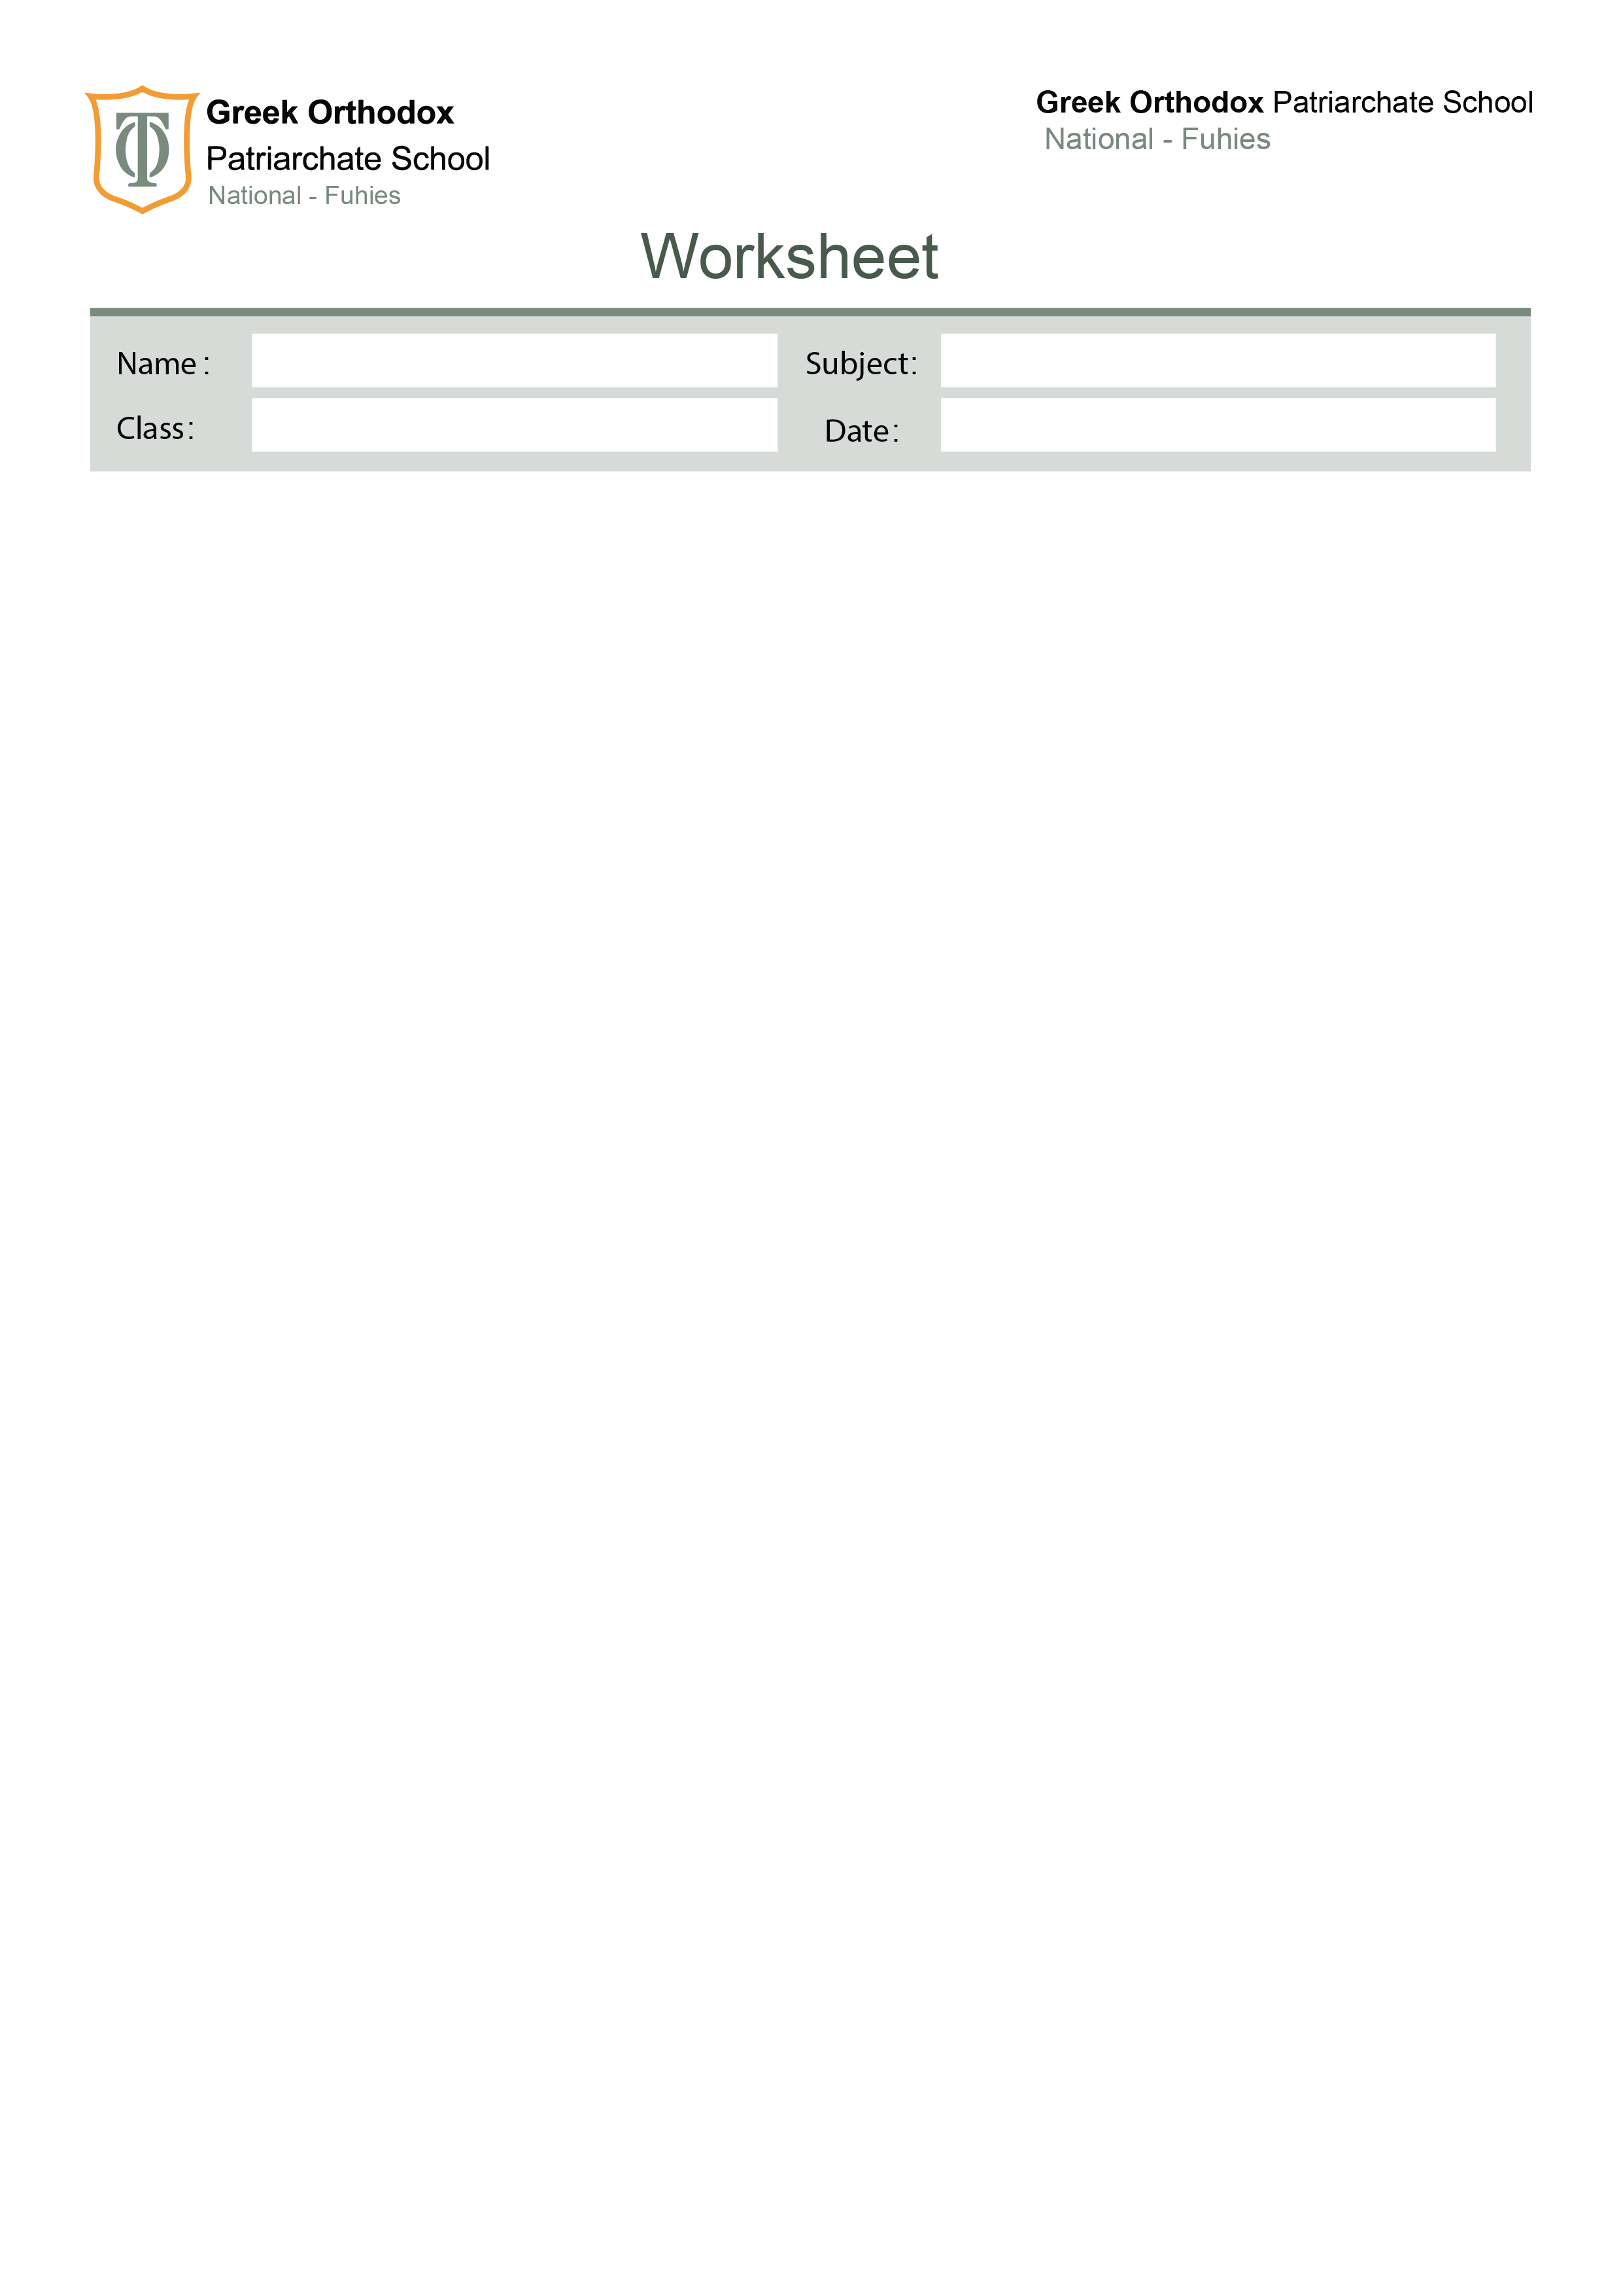

Grammar revision
Nine

Exercise A1 – Fill in the blanks.Use the correct past tense form of the verbs in brackets.

- When I ______________ (arrive) at the station, the train ____________________ (already/leave).
- She __________________ (cook) dinner when the lights suddenly _____________ (go) out.
- They _____________________ (study) for two hours before they ______________ (take) a break.
- I _______________ (walk) home yesterday when I ____________ (see) an old friend.
- By the time the teacher came, the students ______________________ (wait) for 15 minutes.
- He _____________ (not finish) his project even though he ________________ (work) on it all week.
- While we _____________ (play) football, it ______________ (start) to rain heavily.
- She _________________ (never/visit) London before last summer.
- The children ___________________ (build) a sandcastle when the wave _______________ (destroy) it.
- I ______________ (just/sit) down when someone ____________ (knock) on the door.

Exercise A1 – Choose the correct answer

- She (knows / is knowing) the answer.
- I (am thinking / think) about changing my job.
- This cake (tastes / is tasting) delicious.
- He (is having / has) a big family.
- I (am seeing / see) the doctor this afternoon.
- They usually (are going / go) to school by bus.
- She (has / is having) lunch right now.
- I (am loving / love) your new jacket!
- The students (have been working / work) on the project since morning.
- She (has lived / has been living) here for ten years.

Exercise A2 – Fill in the blanks with the correct present tense

- She _____________ (work) as a nurse and she ______________ (love) her job.
- I _____________ (look) for my keys. I can't find them anywhere.
- He _____________ (not understand) the question. Can you repeat it?
- We _______________ (study) English for three years.
- Listen! The neighbours ______________ (argue) again.
- She normally ____________ (wear) glasses, but today she ______________ (wear) contact lenses.
- I __________________ (not believe) you.
- They __________________ (wait) for the bus since 9 a.m.
- My father __________________ (own) a small shop in town.
- I __________________ (think) you should take a break.

Exercise A3 – Correct the mistakes
Each sentence has ONE mistake. Rewrite correctly.

- She is knowing the answer.
- They have waited here for two hours now.
- I am thinking this soup tastes bad.
- He is seeming tired today.
- I live here since 2015.
Exercise B1 – Insert the correct article (a, an, the, or leave blank)

- She bought ___ umbrella because it was raining.
- ___ Nile is one of the longest rivers in the world.
- I need ___ information about the new project.
- We visited ___ museum we talked about yesterday.
- He is ___ honest man.
- My sister plays ___ piano very well.
- They went to ___ school to meet the teachers.
- Have you ever been to ___ Europe?
- I had ___ idea that you were coming.
- ___ apples on the table are fresh.

Exercise B2 – Choose the correct answer

- She is ___ engineer.
a) a b) an c) the
- I saw ___ interesting movie yesterday.
a) a b) an c) the
- We had dinner in ___ best restaurant in the city.
a) a b) an c) the
- Can you pass me ___ salt?
a) a b) an c) the
- He goes to ___ university in Amman.
a) the b) ∅ c) a

Exercise B3 – Fill in the blanks in a short text. Insert a / an / the / ∅.
Yesterday, I visited ___ old town area in ___ city. First, I went to ___ small café near ___ river. I ordered ___ cup of tea and sat by ___ window. ___ view was beautiful. After that, I walked to ___ market and bought ___ few souvenirs for ___ friends.

Your English teachers: Nayfeh Abu Hanna & Lara Bajjali Education is the passport to the future, for tomorrow belongs to those who prepare for it today

