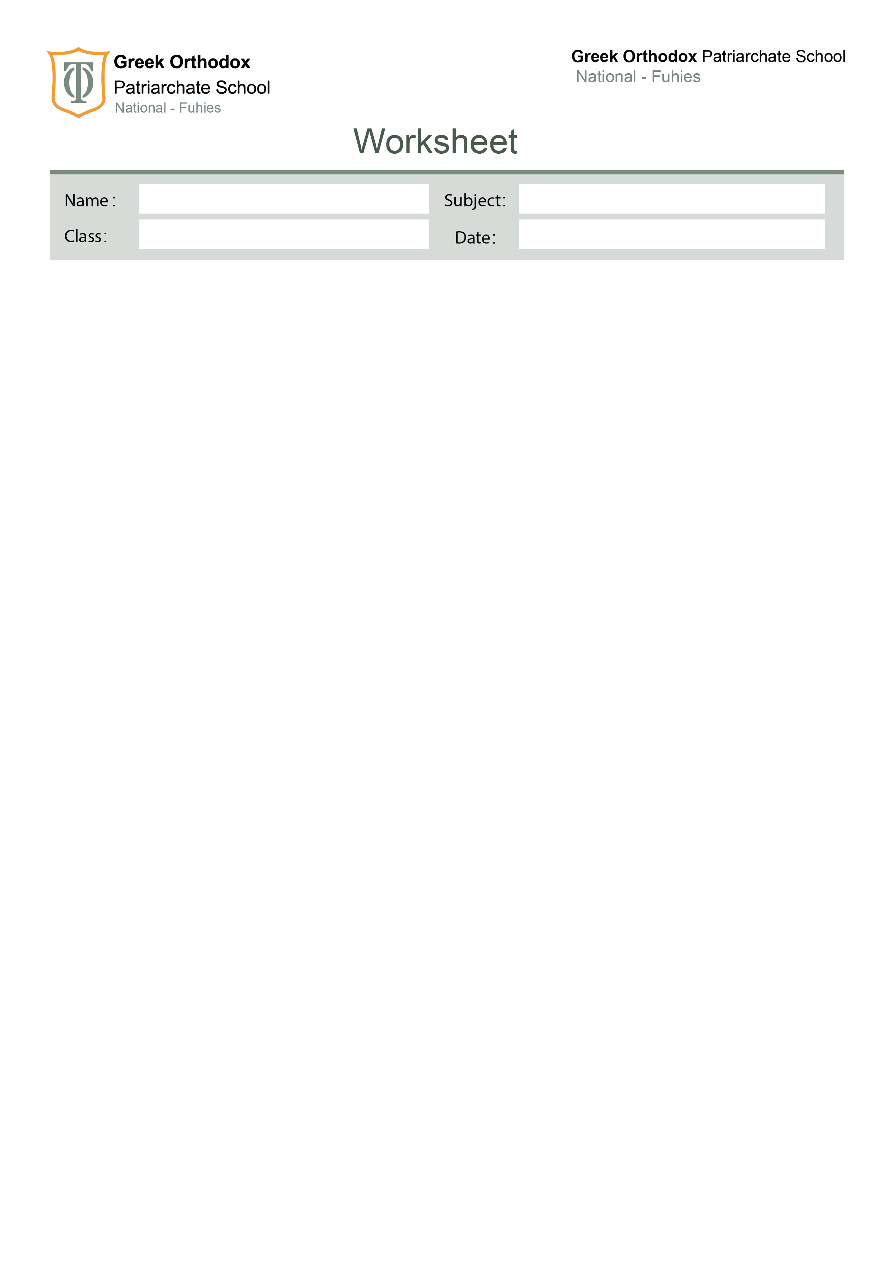

Grammar revision
Eight

Exercise A1 – Change into the passive.

- They built a new bridge last year.
____________________________________________________________
- The teacher is explaining the lesson.
____________________________________________________________
- Someone has stolen my bag.
__________________________________________________________
- They will announce the results tomorrow.
_______________________________________________________
- People speak Arabic in many countries.
_____________________________________________________
- They are repairing the car now.
______________________________________________________
- The committee will choose the winner next week.
_____________________________________________________________
- They had finished the work before we arrived.
______________________________________________________________
- They are holding a meeting at the moment.
______________________________________________________________
- They make these phones in Korea.
_____________________________________________________________

Exercise A2 Change into the active.

- The door was opened by Tom.
___________________________________________________--

- The cake was made by my mother.
_______________________________________________________-

- The homework was done by the students.
_________________________________________________________

- The letter was sent by Sara.
___________________________________________________________

- The window was broken by the boys.
___________________________________________________________

- The room is cleaned by the worker.
___________________________________________________________

- The song was sung by the singer.
________________________________________________________

- The plants were watered by the gardener.
_____________________________________________________

- The picture was drawn by Ali.
_________________________________________________

- The bags were carried by the children.
_____________________________________________

Exercise B1 – Add the correct question tag.

- She can swim well, ________?
- You haven’t called him yet, ________?
- Let’s start the meeting, ________?
- Somebody left the door open, ________?
- He never eats breakfast, ________?
- Your parents are coming tonight, ________?
- Don’t be late, ________?
- I’m your best friend, ________?
- They should help us, ________?
- Nothing is easy, ________?

Exercise B2 – Choose the correct question tag

- We’re leaving soon, (aren’t we / are we)?
- She doesn’t like coffee, (does she / doesn’t she)?
- He’s never been abroad, (has he / hasn’t he)?
- They were at school yesterday, (were they / weren’t they)?
- Let’s go for a walk, (shall we / will we)?

C. Exercise C1 – Choose if the noun is COUNTABLE or UNCOUNTABLE
- Advice → __________
- Furniture → __________
- Tomato → __________
- Water → __________
- Homework → __________
- Chair → __________
- Luggage → __________
- Bread → __________
- Idea → __________
- Milk → __________

Exercise C2 – Fill in the blanks with much, many, a few, a little
- There isn’t ________ sugar left.
- She has ________ friends in her new school.
- How ________ money do you need?
- I bought ________ apples for the picnic.
- He has ________ time today, so he can help.

Exercise D1 – Complete the sentences with the quantifiers (some, any, few, a few, little, a little, much, many, a lot of)

- I have ________ homework tonight, so I can’t go out.
- There are only ________ students in the classroom. It’s almost empty.
- She didn’t buy ________ bread.
- We have ________ water. We should bring more.
- Can I have ________ more tea, please?
- There were ________ people at the party — it was crowded.
- How ________ milk is left in the fridge?
- I know ________ about computers, so I can help you.
- He has ________ close friends, but they are very loyal.
- I didn’t see ________ mistakes in her essay.

Your English teachers: Nayfeh Abu Hanna & Lara Bajjali

Education is the passport to the future, for tomorrow belongs to those who prepare for it today

