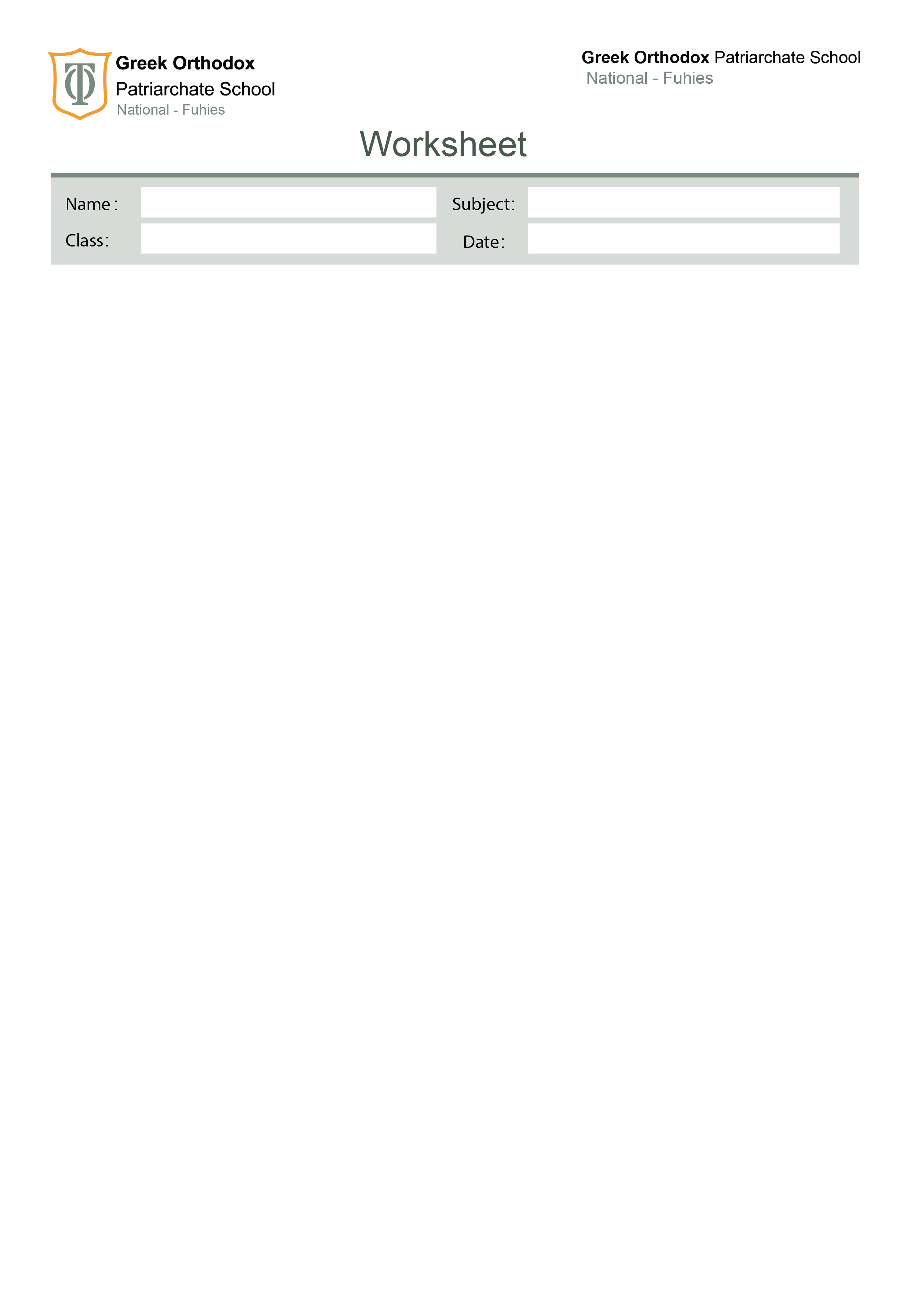

Grammar revision
Seven

A. Exercise A1 – Choose the correct pronoun
- This is my book. The blue one is ________. (mine / me)

- He hurt ________ while playing football. (himself / him)

- They invited ________ to the party. (us / we)

- Is this pen ________? (your / yours)

- She bought ________ a new dress. (herself / her)

- I can’t do this task by ________. (myself / me)

- _____ went to the library to return the book. ( she / her )

- My brother saw Lina and _____ at the mall. ( me / I )

- This jacket is not mine. It’s _____. ( hers / her )

- They enjoyed _____ at the party last night. ( themselves / them )

- Sara lost _____ keys in the classroom.( her / hers )

- That cat belongs to Omar. It is _____. ( his / him )

- My friends and I helped _____ clean the garden. ( us / ourselves )

- “Who broke the vase?” “I don’t know. It wasn’t _____.” ( mine / my )

Exercise B1 – Rewrite using possessive nouns (’s or ’)
- The car of my brother → ______________________
- The toys of the children → ______________________
- The office of Mr. Brown → ______________________
- The colours of the birds → ______________________
- The ideas of the students → ______________________
- The house of my parents → ______________________
- The phone of Sarah → ______________________
- The results of the teams → ______________________

Exercise B2 – Insert the correct possessive form
- This is my ________ (brother) laptop.
- The ________ (women) bags are expensive.
- We visited my ________ (grandparents) farm.
- All the ________ (players) uniforms were clean.
- I read the ________ (teacher) instructions carefully.

C. Exercise C1 – Fill in the blanks with the correct relative pronoun (who – which – whose – where – when )
- The girl ________ won the prize is my sister.
- This is the place ________ we first met.
- I know a man ________ car was stolen yesterday.
- 2010 was the year ________ I moved to Jordan.
- The book ________ you recommended was excellent.
- The restaurant ________ we had dinner was very crowded.
- The students ________ finished early can leave.
- That’s the teacher ________ I told you about.
- The bag ________ is on the table is mine.
- The film ________ we watched last night was boring.

Exercise C2 –Underline the relative clause AND circle the relative pronoun.
- The woman who lives next door is a doctor.
- The laptop which I bought last week is already broken.
- This is the shop where I found my jacket.
- The man whose dog you found is waiting outside.
- Sunday is the day when we usually visit my grandparents.
- I can’t forget the day when we started school.
- The city where I grew up was Amman.
- The old man who was in hospital died.
- The restaurant which serves seafood was burnt.
- The children whose father is a teacher are walking to school.

Exercise C3 – Define: Is the relative clause defining or non-defining?
Write D or ND and add the commas.

- My uncle who lives in Canada is visiting next month.
- The students who failed the test must retake it.
- London which is the capital of England is a busy city.
- The boy who helped me was very kind.
- My car which I bought last year is very fast.

Your English teachers: Nayfeh Abu Hanna & Lara Bajjali

Education is the passport to the future, for tomorrow belongs to those who prepare for it today

