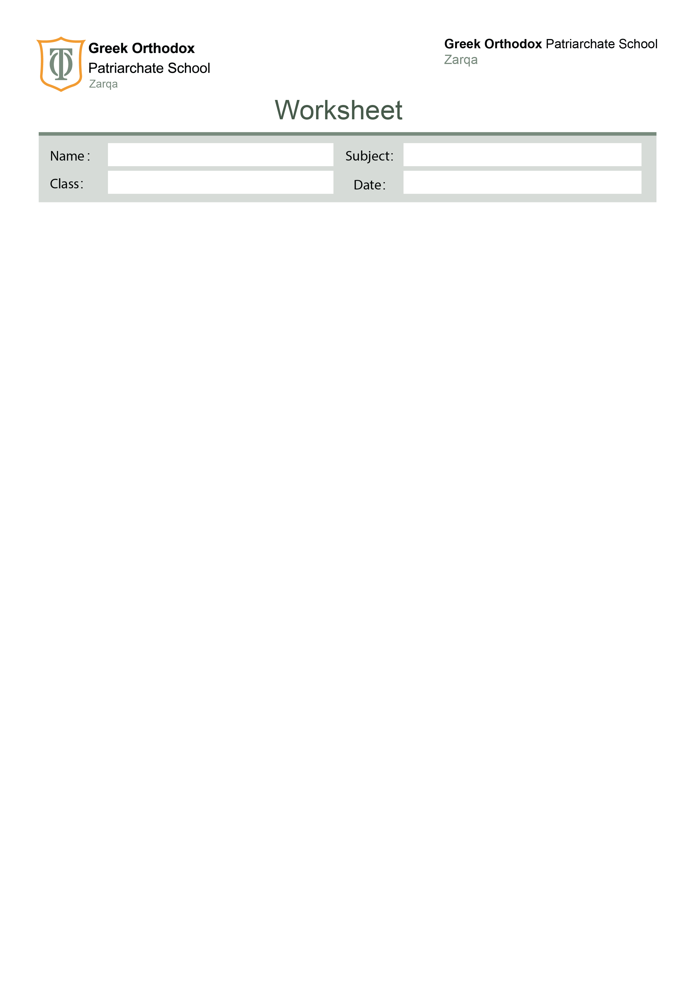

11th grade

Worksheet: Writing a Formal Email

A. Review: What Is a Formal Email?
A formal email is used when writing to an organization, company, or someone you don’t know personally. It follows a clear structure and uses polite, formal language.
We studied Farid’s email on page 22 about plastic packaging. Let’s review what we learned from it.

B. Structure of a Formal Email (Writing Box p.23)
Part | Function / What to Write | Example from Farid’s Email
Greeting | Begin politely | Dear Sir/Madam,
Introduction | Explain who you are and why you’re writing | I am a regular customer at your supermarket. I am writing to express my concern about plastic packaging.
Body | Give details, examples, or suggestions | Many vegetables are wrapped in plastic, which harms the environment. I suggest using paper bags instead.
Closing | Thank the reader or make a polite request | Thank you for your attention. I hope you will consider my suggestion.
Sign-off | End politely | Yours faithfully, Farid Ali

C. Useful Language from the Writing Box
- Beginning the email:
- I am writing to express my concern about...
- I am writing to inform you about...
- Making suggestions:
- I suggest (that) you...
- It would be better to...
- Polite requests:
- Could you please...?
- I would appreciate it if you could...
- Ending politely:
- Thank you for your attention.
- I look forward to your reply.

D. Example Email (From the Book)
Subject: Concern about Plastic Packaging
Dear Sir/Madam,
I am a regular customer at your supermarket, and I am writing to express my concern about the amount of plastic used in your packaging.
Many vegetables are wrapped in plastic, which harms the environment. I suggest using paper or reusable bags instead. This will help protect nature and make your store more environmentally friendly.
Thank you for your attention. I look forward to your reply.
Yours faithfully,
Farid Ali

E. Practice 1 – Identify the Parts (Ex. 6)
Read Farid’s email again. Match each part of the email with its correct label.
1. Dear Sir/Madam | ☐ Introduction ☐ Greeting ☐ Closing
2. I am a regular customer... | ☐ Closing ☐ Body ☐ Introduction
3. Many vegetables are wrapped in plastic... | ☐ Greeting ☐ Body ☐ Sign-off
4. Thank you for your attention... | ☐ Introduction ☐ Closing ☐ Body
5. Yours faithfully, | ☐ Greeting ☐ Body ☐ Sign-off

F. Practice 2 – Complete the Useful Phrases
Complete the sentences with the correct words.
1. I am writing to __________ my concern about plastic packaging.
2. I __________ using paper bags instead of plastic.
3. Could you please __________ using less plastic?
4. Thank you for your __________.
5. I look __________ to your reply.

G. Writing Task (p. 23)
Now it’s your turn! Write a formal email to a coffee shop chain about disposable cups. Follow the same structure as Farid’s email. Use polite and formal language.
Subject: ___________________________________________
Dear Sir/Madam,
I am a regular customer at your coffee shop, and I am writing to express my concern about ___________________________________________.
Many people throw away _______________________________. This harms the environment. I suggest ___________________________________________.
Thank you for your attention. I look forward to your reply.
Yours faithfully,
___________________________________________

Haneen Mazahreh

