Grammar U 3 Lesson 5A
11th grade

Relative Clauses Worksheet
We use who, whom, which, that, whose, where, and when in relative clauses.
They come after nouns or noun phrases to give more information about a person, thing, possession, place, or time.

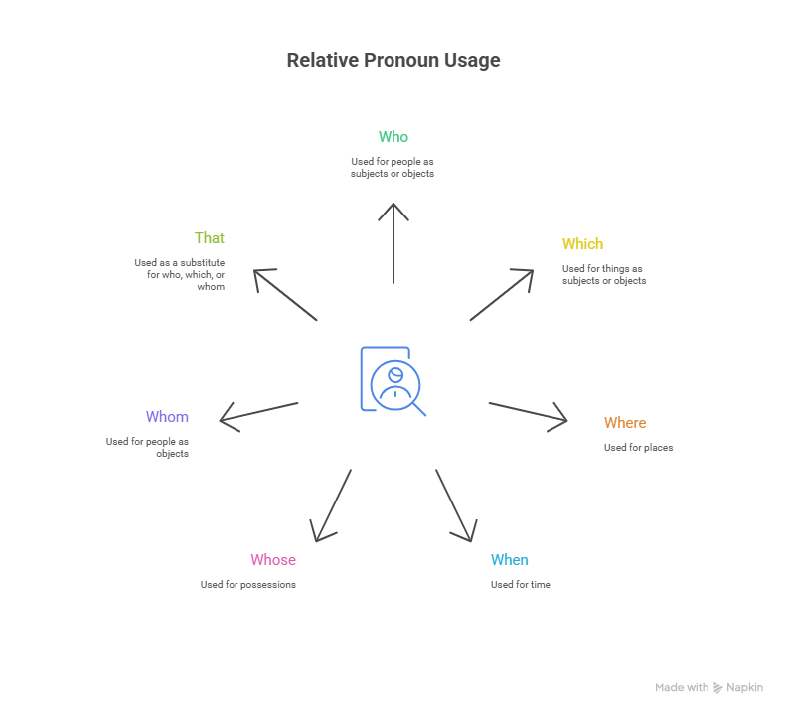

1. Who
We use who to talk about people (subject or object).
Examples:
- The boys who play football are children.
- The boys who I saw are clever.

2. Which
We use which to talk about things (subject or object).
Examples:
- The book, which contains three chapters, is boring.
- The book which you gave me is fascinating.

3. Where
We use where to talk about places.
Example:
- The café where we met each other is there.

4. When
We use when to talk about time.
Example:
- Last year when I arrived here was a difficult year.

5. Whose
We use whose to talk about possessions.
Example:
- This is the book whose title I couldn’t remember.

6. Whom
We use whom to talk about people (object).
Example:
- The cousin whom we met at the family reunion is coming to visit.

7. That
We can use that instead of who, which, or whom in defining clauses.
Examples:
- She ate the bread that was moldy.
- She accidentally ate the bread, which was moldy.

Exercise 1: Choose the correct relative pronoun
- A person ______ job is acting is an actor.
a) that b) where c) whom d) whose
- A video shop is a place ______ you can rent some films.
a) when b) that c) where d) which
- Dan’s sister, ______ lives in Hollywood, is an actress.
a) that b) who c) whom d) whose
- There’s one item on the agenda ______ hasn’t been dealt with yet.
a) where b) which c) whom d) when
- All the flights were cancelled, ______ was very annoying.
a) whom b) that c) which d) where
- Yesterday, I called my friend, ______ I hadn’t spoken to in years.
a) which b) who c) whose d) that
- That is the woman ______ daughter got 200 points on the test.
a) which b) who c) whose d) that
- The book, ______ was written in 1901, is one of the most popular books today.
a) which b) who c) whose d) that
- The man ______ lives next door is a doctor.
a) whose b) who c) where d) whom
- She is the one ______ helped me with my homework.
a) which b) that c) where d) whom
- The girl ______ won the race is my cousin.
a) whom b) who c) when d) whose
- The movie ______ we watched last night was fantastic.
a) whom b) that c) when d) whose
- She’s the girl ______ lives in the next neighborhood.
a) where b) which c) whom d) who
- The book ______ I borrowed from the library was informative.
a) where b) whom c) which d) whose
- My father’s car, ______ he bought in 1991, is still working.
a) that b) whose c) whom d) which

Defining Relative Clauses
Function:
Defining clauses give essential information about the person or thing being talked about.
They cannot be omitted and do not use commas.
You can use that instead of who or which in defining clauses.
Examples:
- The person who designed the house is a world-famous architect.
- The land where the house is built is beautiful.
When can we omit the pronoun?
If the relative pronoun is the object, you can omit it.
✅ The house (which/that) the family built is unique.
✅ The merchant (who/whom) I saw is rich.
✅ The merchant I saw is rich.
If the relative pronoun is the subject, you cannot omit it.
🚫 The woman arrived earlier was my teacher.
✅ The woman who arrived earlier was my teacher.

Non-Defining Relative Clauses
Non-defining clauses give extra, non-essential information.
They are always written with commas and can be omitted.
We never use “that” in non-defining clauses.
Examples:
- My brother, who lives in New York, is a doctor.
- The building, which many considered ugly at first, is now famous.
- They didn’t give me my money, which was very annoying.

Prepositions in Relative Clauses
Prepositions usually go at the end of the clause in everyday English.
In formal English, they can go before the relative pronoun.
Examples:
- This is the house which/that they lived in.
(Formal: This is the house in which they lived.)
- The architect knew the couple who he designed the house for.
(Formal: The architect knew the couple for whom he designed the house.)

Exercise 2: Choose the correct relative pronoun
- His brother, ______ works at the supermarket, is a friend of mine.
a) which b) where c) who d) that
- She’s playing a woman ______ son was killed in the war.
a) who b) whose c) where d) when
- Do you remember the summer ______ Jack came home by surprise?
a) where b) when c) who d) whom
- Here are some cells ______ have been affected.
a) when b) which c) who d) whose
- The painting, ______ was finished in 1850, is famous.
a) that b) whose c) which d) where
- I’ve just come back from London, ______ John lives.
a) whose b) whom c) who d) where
- This is the person ______ I met a few weeks ago.
a) where b) whom c) which d) whose
- My sister, ______ is now living in New York, has just had a baby.
a) which b) that c) whose d) who
- I’ll always remember the day ______ we met.
a) where b) when c) who d) which
- Is that the man ______ house was destroyed by the hurricane?
a) whom b) who c) whose d) which
- The City Park, ______ we used to go, has been closed down.
a) who b) where c) whom d) whose
- Is that the man ______ she arrived?
a) in when b) to where c) with whom d) on which
- The tree ______ they had their picnic was the largest in the park.
a) to who b) with whose c) under which d) on when
- To the east of the city was a lake ______ many people went ______ on weekends.
a) when - with b) that - to c) whose - in d) whom - under

Exercise 3: Choose the correct answer
- That boy’s mum is Japanese. He’s fluent in five languages.
a) That boy, who mum is Japanese, is fluent in five languages.
b) That boy, whose mum is Japanese, is fluent in five languages.
c) That boy, which mum is Japanese, is fluent in five languages.
d) That boy, that mum is Japanese, is fluent in five languages.
- My grandma’s house has no wi-fi. It’s very annoying.
a) My grandma’s house has no wi-fi, whose is very annoying.
b) My grandma’s house has no wi-fi, where is very annoying.
c) My grandma’s house has no wi-fi, that is very annoying.
d) My grandma’s house has no wi-fi, which is very annoying.
- They go to that beach in summer. It’s their favourite place.
a) The beach where they go in summer is their favourite place.
b) The beach when they go in summer is their favourite place.
c) The beach whose they go in summer is their favourite place.
d) The beach whom they go in summer is their favourite place.
Haneen Mazahreh

Answer Key

Exercise 1
- d 2. c 3. b 4. b 5. c 6. b 7. c 8. a 9. b 10. b 11. b 12. b 13. d 14. c 15. d

Exercise 2
- c 2. b 3. b 4. b 5. c 6. d 7. b 8. d 9. b 10. c 11. b 12. c 13. c 14. b

Exercise 3
- b 2. d 3. a

