Reading Comprehension Lesson 4A
11th grade
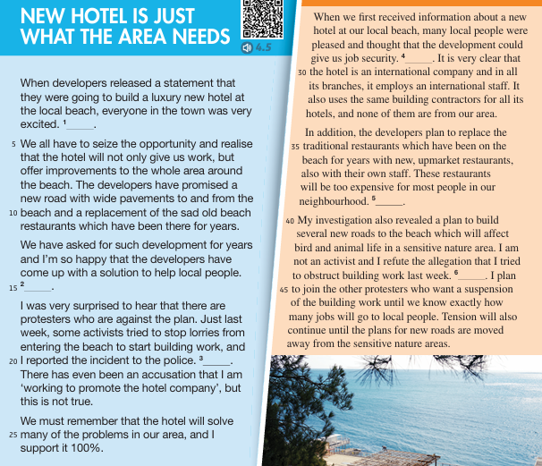

Vocabulary Table
Word | Arabic Meaning | Example from the Text
released | أصدر / نشر | When developers released a statement…
opportunity | فرصة | We all have to seize the opportunity…
improve | يحسّن / يطوّر | …and realise that the hotel will not only give us work, but offer improvements…
pavement | رصيف | …a new road with wide pavements…
protesters | محتجون | …there are protesters who are against the plan.
activists | نشطاء | Some activists tried to stop lorries from entering the beach…
allegation | اتهام / ادعاء | There has even been an accusation that I am working to promote the company…
employment | توظيف / تشغيل | …the hotel…employs an international staff.
unmarket | غير مُسوّق / غير معروف | …replace the old restaurants with new, unmarket restaurants…
investigation | تحقيق | My investigation revealed a plan to build several new roads…
sensitive | حسّاس | …bird and animal life in a sensitive nature area.
refute | يدحض / ينكر | I am not an activist and I refute the allegation…
suspension | تعليق / إيقاف مؤقت | …protesters who want a suspension of the building work…
tension | توتر | Tension will also continue until the plans…are moved away.
neighbourhood | الحي / المنطقة | These restaurants will be too expensive for most people in our neighbourhood.

Reading Comprehension
Read the text then answer the following questions
1. What did the developers announce?
A. A road expansion project
B. A plan to build a luxury hotel
C. The closing of old restaurants
D. A beach clean-up campaign
Correct answer: B
2. Who tried to stop lorries from entering the beach?
A. Developers
B. Local families
C. Activists
D. Hotel staff
Correct answer: C
3. Why were many people excited about the hotel?
A. It would create jobs and improve the area
B. It would protect wildlife
C. It would reduce tourism
D. It would stop traffic
Correct answer: A
4. What is the writer’s opinion about the hotel?
A. He dislikes it
B. He is unsure
C. He supports it
D. He prefers a different project
Correct answer: C

5. Which sentence shows direct support for local workers?
A. “The restaurants will be too expensive.”
B. “The hotel employs an international staff.”
C. “We have all asked for such development for years.”
D. “Many jobs will go to local people.”
Correct answer: D
6. If you were a local community member, which detail from the text would help you decide to support the project?
A. It will replace traditional restaurants
B. It will bring job security
C. It might cause tension
D. Roads will affect animal life
Correct answer: B
7. Which argument is used by the protesters?
A. The hotel will improve pavements
B. The project will harm a sensitive nature area
C. The hotel will bring tourists
D. The hotel will cost too much
Correct answer: B
8. How does the second writer try to defend himself?
A. He agrees with all accusations
B. He demands more hotels
C. He refutes the allegation of obstruction
D. He supports destroying the nature area
Correct answer: C
9. Which opinion is best supported by evidence from the text?
A. The project has no environmental effects
B. Everyone in town supports the project
C. The project has both benefits and risks
D. The hotel will not create jobs
Correct answer: C
10. Imagine you are a journalist. Based on the two opinions, which headline best fits?
A. “Hotel Brings Only Problems to Town”
B. “Developers Cancel Beach Construction”
C. “Community Divided Over New Hotel Project”
D. “Nature Area Declared Wildlife Sanctuary”
Correct answer: C
Haneen Mazahreh

