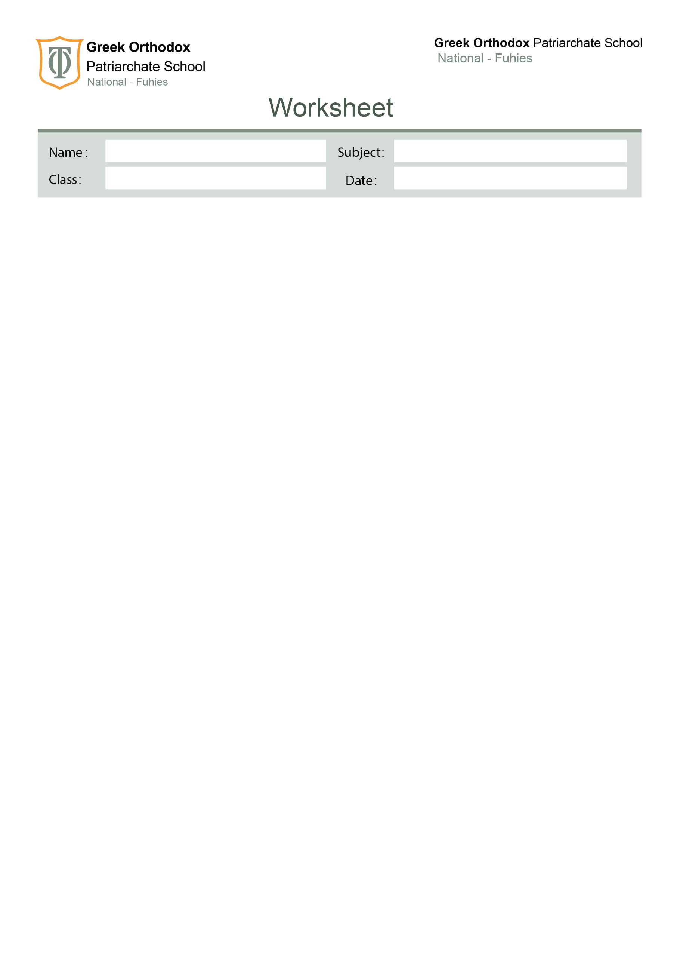

No. ( )

The Articles
Nine

The Articles

The | Zero article
1. A singular or plural noun when it is clear/obvious which person or thing we are talking about.  There is a lamp in my bedroom. (we mention the lamp for the first time)  The lamp is next to the desk.  2. Anything which we identify immediately.  We watched the new Brad Pitt movie last night.  3. Musical instruments (the violin, the guitar, the drums, the flute, the piccolo).  She plays the piano.  4. Something that is unique or there is only one.  the sun  the moon  the internet.  5. Names of rivers, seas, oceans, mountain ranges and deserts (always in capitals).  The Mississippi River  The Black Sea  The Andes  The Sahara Desert  6. Directions (cardinal points).  the west  the south-east  the north-west  7. Superlative adjectives:  He is the tallest boy in the class.  It is the oldest building in the town  8. When we have already mentioned the noun:  A woman who fell 10 metres from High Peak was lifted to safety by a helicopter. The woman fell while climbing  9. With adjectives like rich, poor, elderly, unemployed to talk about groups of people:  Life can be very hard for the poor.  I think the rich should pay more taxes.  She works for a group to help the disabled.  10. newspapers:  The Times; The Washington Post  11. well known buildings or works of art:  the Empire State Building; the Taj Mahal; the Mona Lisa; the Sunflowers  12. organisations:  the United Nations; the Seamen’s Union  13. hotels, pubs and restaurants:  the Ritz; the Ritz Hotel; the King’s Head; the Hilton  *Note: We do not use the definite article if the name of the hotel or restaurant is the name of the owner, e.g.,Brown’s; Brown’s Hotel; Morel’s; Morel’s Restaurant, etc  14. families:  the Obamas; the Jacksons  15.Titles without names.  The president – the king…….  Note: if the name was included, we use zero article.  I met the king.  I met King Abdallah. | 1. When we refer to general ideas, plurals or uncountable nouns we do not use THE.  Religion is an important issue. (NOT The religion is an important issue)  Mexican food is spicy. (NOT The Mexican food is spicy).  2. Names of people, books and plays (unless it is part of the title).  I have read Romeo and Juliet.  3. Towns, cities, states and countries.  Cape Town  Montana  Vietnam  (Exceptions – The USA, The UK, The Netherlands, The Czech Republic, The Philippines).  4. Lakes, single islands, continents or mountains.  Lake Victoria- Jamaica -Asia -Mt Fuji  5. Planets  Mars  Jupiter  Saturn  6. Sports or games  soccer  tennis  skiing  monopoly  7. Meals  breakfast  lunch  dinner  supper  8.Names  People: Mary, Bill, Josef  Places: Russia, Bangkok, Heathrow Airport, Cambridge University, Waterloo Station  Streets: Oxford Street, Wall Street, Picadilly Circus  9.Languages: English, Russian  Note: we use the definite article if the word language is included.  I speak Chinese.  I speak the Chinese language.  10.Academic subjects: History, Law, Physics  11.Days, months: Monday, November  12. Routine Places  in bed, at home, to school, to work  Note:If we are going to the place for other purposes, we use the definite article.  He was sent to hospital after the accident.  He went to the hospital to visit his friend.  14.Means of Transport  on foot, by car, by bus, by air

Exercises
1.Fill in with : the or × ( for zero article)

1. I have just had ______the__ greatest idea.
2. Columbus was one of ______the__ first people to cross _____the___ Atlantic.
3. _____The___ British drink too much tea.
4. _____The___ Thames River flows into _______the___ North Sea.
5. ______The__ Earth revolves around ____the___Sun.
6. ____The___ Chinese language is more difficult than ____*_____ French.
7. ___The_ people we met on holiday in __the__north of England came from ___the__ USA.
8. The people who live in ______the____ Netherlands are called ______the____ Dutch.
9._____*_____ Football is his whole life.
10. Did you read _____the_____ book I gave you?
11. Sally went to ____the______ prison to visit her husband.
12.Do you go to ______*____ church on Sundays?
13. I usually have ____*____coffee in _____the___ morning.
14. I am going to _____the_____ hospital to visit my sick friend.
15. I can’t play ______the____ piano but I can play _____the_____ guitar.
16. _______The___ Prime Minister will give a speech this afternoon.
17.___The_ Tower of London is one of ___the_____ main attractions of ___*___London.
18._____*____ Neil Armstrong made _____the____ first footprint on ____the____ moon.
19. I go to _____*_____ school by___*_______ bus.
20.We went to ___the_____ Dead Sea and stayed at _____the_____ Four Seasons.
21. He eats a lot of _____*_____ meat.
22. _______The___ food that you cooked was very good!
23. ______*____ cell phones do not cause _____*___cancer.
24. Let's play ______*____ volleyball.
25. What would you like for ______*____ breakfast?
2. Fill with correct articles (a, an , the , x for zero article)
1-Have you ever been to____*___ Madrid?
2-I think __*____ Paris is ___the___ prettiest city in ___the___world.
3-What did you have for ___*___ lunch today? I had __*___ meat with__*___ rice.
4-Do you buy __*__ newspapers?
5-Danny plays __*___ golf every Saturday but he can’t play __the____ violin.
6-I need ___a__paper and __a__ pen to write __a___letter.
7-___*___French is very difficult but __the__Chinese Language is ___the__most difficult.
8-That’s ___a__ beautiful dress. I need to buy it and I need to buy __an___umbrella.
9-___*___ students must wear ___a__ uniform at___*__ school.
10-We travelled to ___*__London by____*__ train.
11-__The___tallest man in __the___world was born in ___the__USA.
12-___The___Queen is going to visit__*____ Aqaba in___the__ afternoon.
13-I like to drink___*__ tea with _*___ milk in __*___evening.
14-We saw ___a__ giraffe and __an__alligator at __the__zoo.
15-__*__Jim is _an___engineer. He works at __the___UNESCO.
16-__The___Sims are staying at ____the__Marriot in___the___ Dead Sea.
17-___*___Asia is ___the___largest continent in the world.
18-___The__Nile is longer than __the___Amazon.
19-The tourists visited ___the___Taj Mahal in ___*__India.
20-____The__Sun is a star but __the____Earth is a planet.
21-After committing the crime, the murderer was sent to ___*____jail.
22-Please go to ___the___ bed and clean it.
23-___*__President Obama is travelling to __the___Middle East to talk with___the__ kings.
24-___*__Maths is very complicated .I prefer__*___ English.
25-____*__ Everest is _the____highest mountain of____the_ Himalayas.
26._____*____ King Abdallah is the ruler of ___the_____Hashemite Kingdom of Jordan.
37.____*____ December is ____the_____ last month of ____the_____ year.

Your English teachers: Nayfeh Abu Hanna & Lara Bajjali

Education is the passport to the future, for tomorrow belongs to those who prepare for it today

