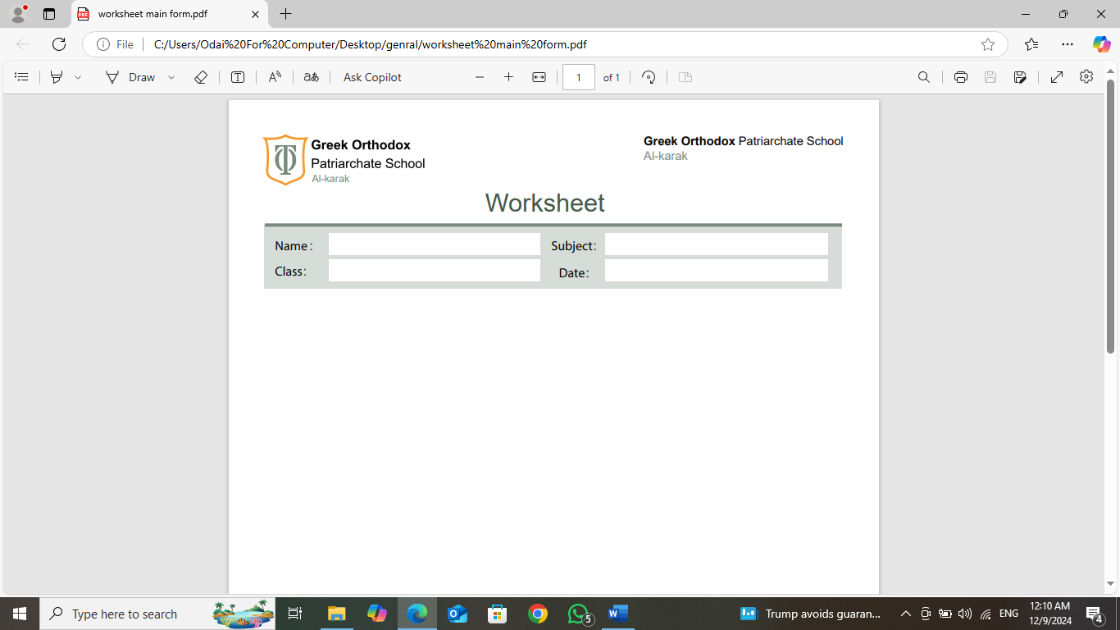
Read the article (How would like to be), then answer the questions below:
1-What do the rhino keepers do?
………………………………………………………………………………………………………………………………………………………………………………………………………………………………………….
2-Why do you think the rhino keepers protect rhinos?
………………………………………………………………………………………………………………..
3-What do the mural painter do?
………………………………………………………………………………………………………………………………………………………………………………………………………………………………………………………….
4-What does the concept (grey) indicate?
…………………………………………………………………………………………………………………
5-Why do you think mural painters have a great job?
…………………………………………………………………………………………………………………………………………………………………………………………………………………………………………………………………..
6-What do cool hunters do?
…………………………………………………………………………………………………………………………………………………………………………………………………………………………………………………………………………………………………………………………………………………………………………………………………..

7-What are the main qualifications that you need to be a cool hunter?
………………………………………………………………………………………………………………………………………………………………………………………………………………………………………………………
8-What might be difficult about being a cool hunter?
……………………………………………………………………………………………………………
8-Find out:
1-An opposite ………………………………………….
2-A synonym ………………………….
3-A word means (no longer existing)………………………………..
4-A plural noun ……………………….
5-An adjective……………………
6-A phrasal verb……………………………………..
7-A word gives reasons ………………………………………..
**************************************************************
English -English Meanings:
Wonder: verb , to feel a great surprise
Fashion: noun , a style that is popular
Gardener: noun, looks after plants and flowers.
Mural: noun, a large picture painted on a wall
Lifeguard: noun, checks that people on the beach are safe
