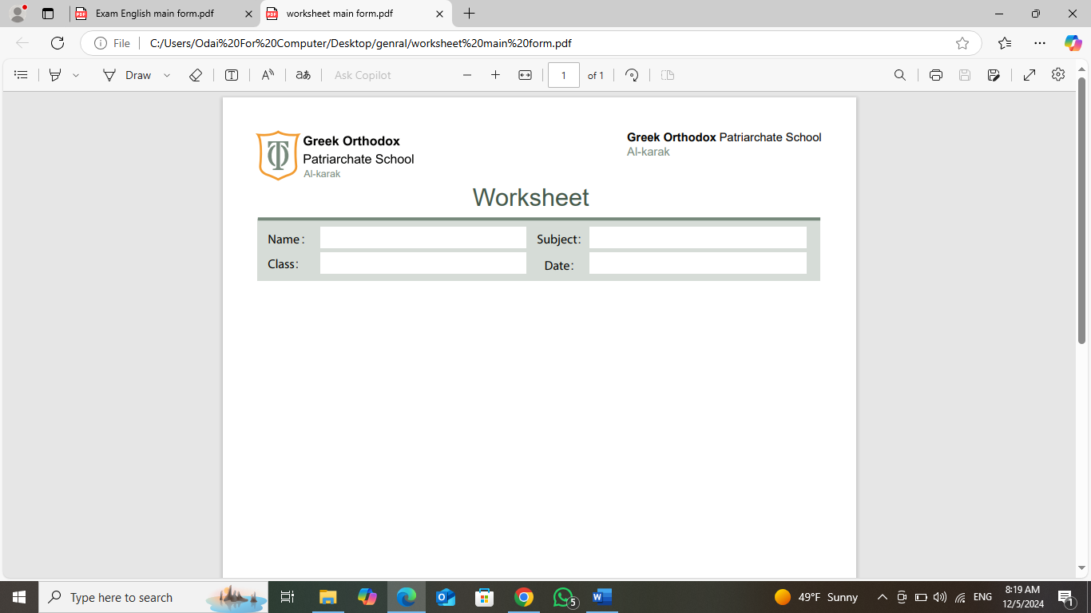
Write sentences into past time: (Homework)
invite her friend | Last Sunday (yes)
write a letter | Last week (no)
make a project | Yesterday (no)
buy a shirt | Yesterday ( yes)
see a parade | Last winter (yes )

Sami,

…………………………………………………………………………………………………………………………………………………………………

………………………………………………………………………………………………………………………………………………………………

…………………………………………………………………………………………………………………………………………………………

……………………………………………………………………………………………………………………………………………………………

……………………………………………………………………………………………………………………………………………………………..

MRS: Wala Almajali

