
Final worksheet for fourth grade
Name: Monday
24/11/2025

1) What are the main differences between postal letters and e-mails?
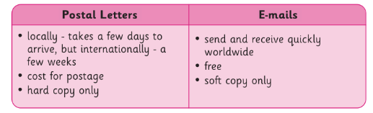

2) What devices can you use to gain access to online media?
1.smartphone 2.laptop 3.tablet

3) What are selfies?
A selfie is a photo that is individually taken of yourself with a smartphone, tablet, or webcam. Some people take selfies so they can post them online.

4) What things do you do online?
1.Send e-mails 2. play games 3.learn

5) What types of online communication ?
1.Voice and video calling 2. sending e-mails

6) What is the Recycle Bin?
It holds all of the deleted files and folders, so they can be recovered if needed.

7) What kinds of things can you attach in an e-mail?
1. images 2. sound 3. text 4. Videos

8) What is online media?
Any type of information that can be accessed via the internet.

