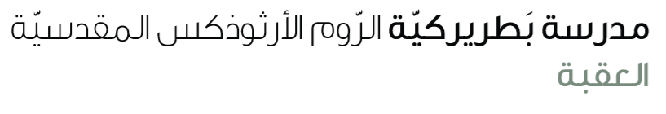
Name: Study guide 6th grade

Dear students and students,
Please be informed that the Final English Exam will take place on Monday, 15th. To help you prepare effectively, please study the following pages and exercises from your pupil’s book and workbook.
Reading comprehension & vocabulary
S.B
Page 32 study the paragraph ( How would you like to be a … ?)
(vocabulary English – English: (keeper / mural / fashion / wonder/ skill )
W.B ------ Page 26 ex 3
S.B page 30 ex 2 page 84 ex 1
W.B page 24 ex 1

Grammar
Indefinite pronouns
W.B page 25 ex 1,2
Question tag
S.B page 33 ex 2,3 page 48 ex 4
W.B ----- page 27 ex 1,2
Study the worksheet

Writing
Describe a job

