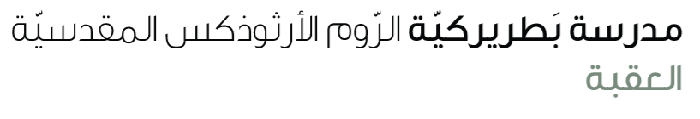
Name: Study guide 4th grade

Dear students and students
Please be informed that the Final English Exam will take place on Monday, 15th
To help you prepare effectively, please study the following pages and exercises from your pupil’s book and workbook

Reading comprehension & vocabulary
S.B
Page 32 study the paragraph (wonderful food festival in Italy) Ex 3
Page 48 ex 1
W.B
Page 24 ex 1 Page 26 ex 1,3

Grammar
Past simple irregular verbs
S.B ------ page 31 ex 2 page 33 ex 2 page 48 ex 3
W.B------ page 25 ex 1,2,3 page 27 ex 2
Study the worksheet

Writing
S.B page 35 ex 3.b
W.B page 28 ex 2

