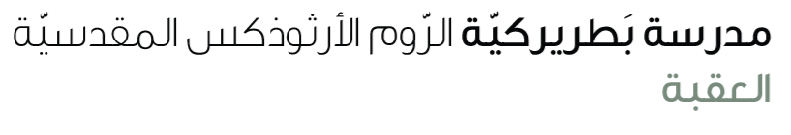
Name: Study guide 5th grade

Dear students and students,
Please be informed that the Final English Exam will take place on Monday, 15th. To help you prepare effectively, please study the following pages and exercises from your pupil’s book and workbook

Reading comprehension & vocabulary
W.B
Page 26 study the paragraph (how chess can change lives) ex 2,3
(vocabulary English – English : childhood/ poor/ engineer / chess / board / blind / piece)
W.B page 28 ex 2
S.B
Page 30 ex 2,4 page 35 ex 3.b page 48 ex 1

Grammar
Past continuous
S.B ____ page 31 ex 2 page 48 ex 3
W.B _____page 25 ex 1
****************************************************
Past simple & past continuous
S.B ----- page 33 ex 2
W.B ----- page27 ex 2 page 122 ex 1,2
Study the worksheet

