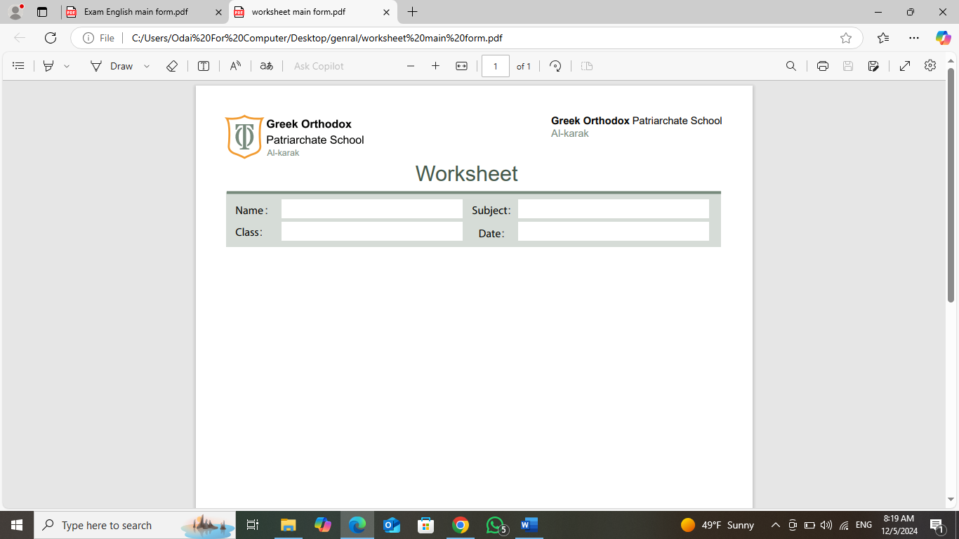
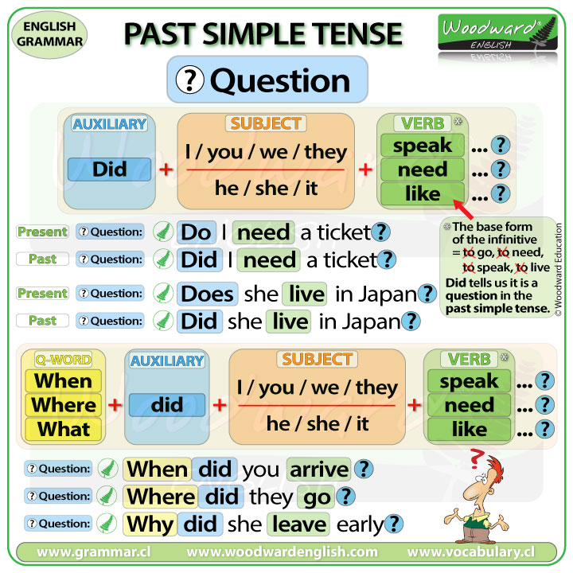

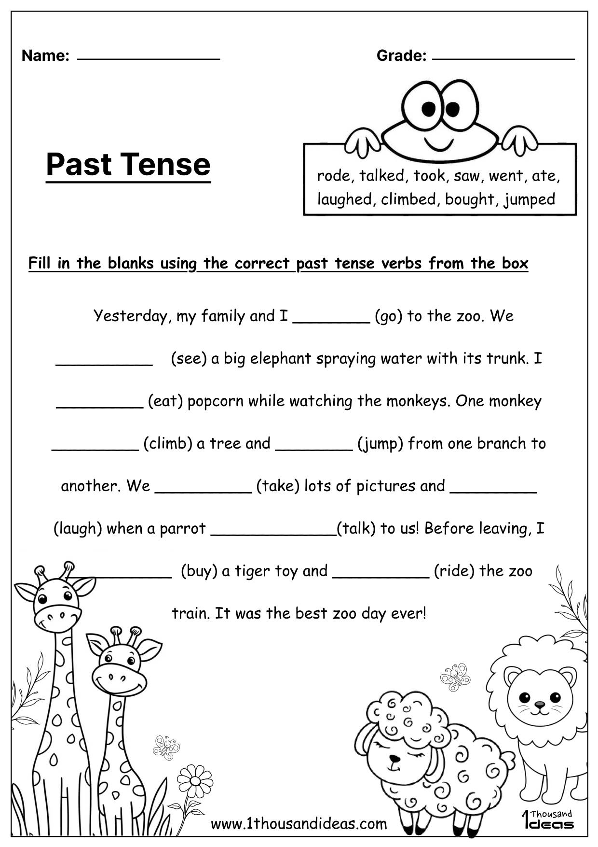
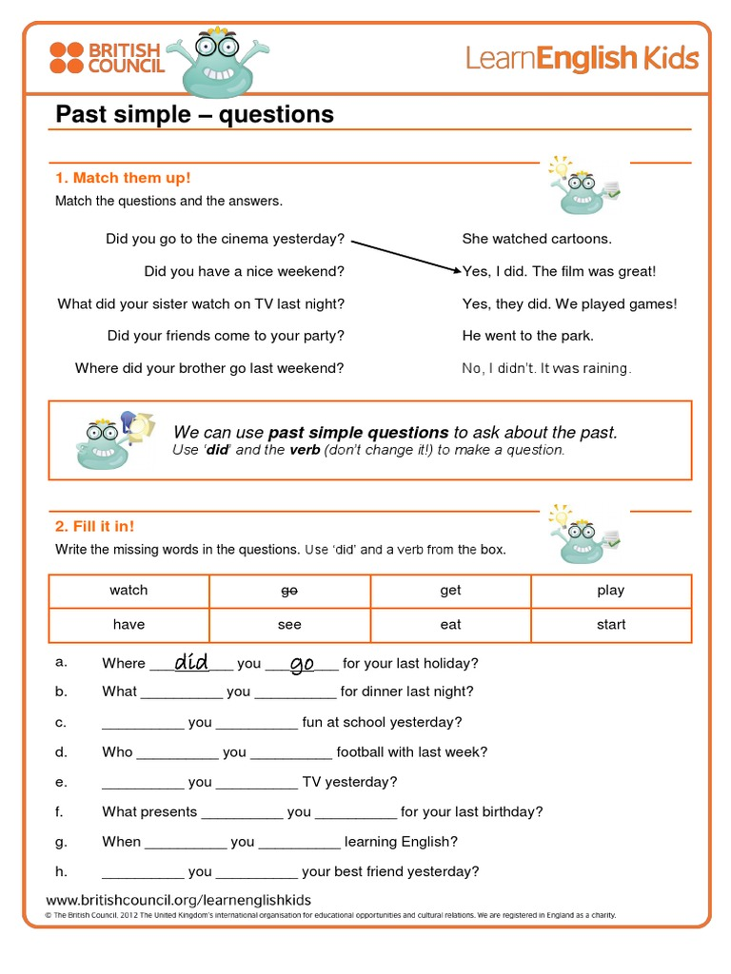

Rewrite the following into questions using (did)?
Buy - bought drink – drank
Take -took choose -chose
learn - learnt

1-She bought a new car.
Why…………………………………………………………………………………………………………………………
2-They climbed a high mountain.
When ……………………………………………………………………………………………………………………..
3-He helped his friend.
Why ……………………………………………………………………………………………………………..
4-She made a nice project.
How…………………………………………………………………………………………………………………………
5-She ate her breakfast yesterday.
Where……………………………………………………………………………………………………………..
6-She learnt about Dinosaurs last week.
What …………………………………………………………………………………
7-Sara went to Amman last Friday.
Why …………………………………………………………………………………………………………

The end

