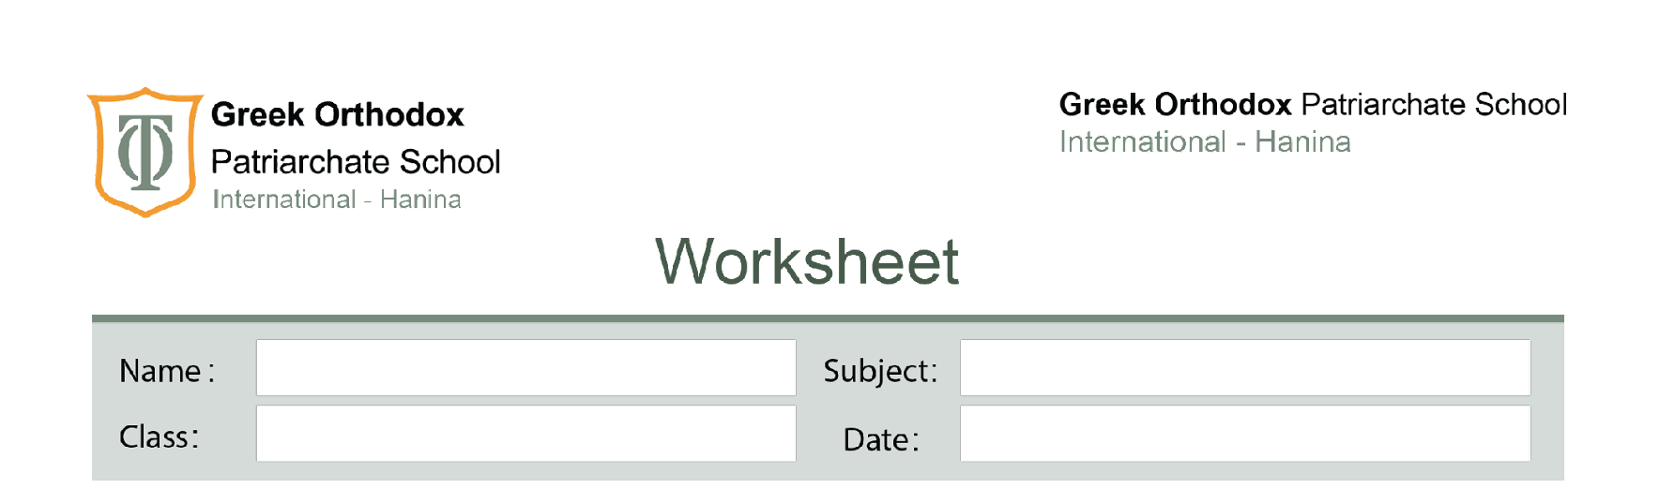
Seventh Grade
7.2 A balanced diet
Diet and growth study sheet
Unit 7

*Your lifestyle is the way in which you live.
*A healthy lifestyle is the way in which you live to keep your body as healthy as possible.
*The key features of a lifestyle to encourage your healthy growth and development are:
1-Diet 2-keeping a healthy heart 3-Taking exercise 4-Avoid smoking
*Everyone needs a balanced diet from birth for healthy growth and development.
*Here are some ways in which an unbalanced diet can affect human growth and development.
A- Anorexia nervosa: is a treatable eating disorder in which people have low body weight based on personal weight history.
B-Obesity: Is a condition which develops in children (and adults) who have a very high-energy diet.
Q: What will happen if the person uses less energy than before but continues to eat the high-energy diet?
Even more body fat is produced. This can affect the:
1-The working of the heart and increase in the body mass.
2-Puts extra strain on the bones and joints.
3-Obesity can lead to a form of diabetes called type 2 diabetes which can lead to insulin resistance.
*Insulin helps the body to take extra sugar out of the blood and store it in the liver.
In type 2 diabetes, the body no longer responds to insulin, and blood with a high sugar content flows around the body.

Q: What will happen if the body no longer responds to insulin?
1-Blindness.
2-Damage to the nerves and blood vessels in the feet. Which can only be treated by amputation.
3-Kidny damage which can be fatal.

