How do things change
Grade 2

*Learning Objective: to recognize the vocabulary of the lesson page 28.

Q1: Check the correct picture.
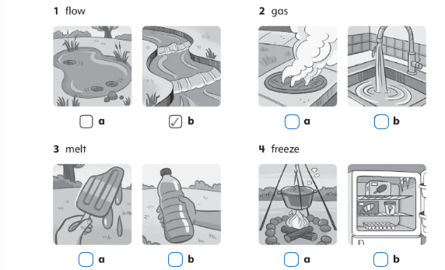

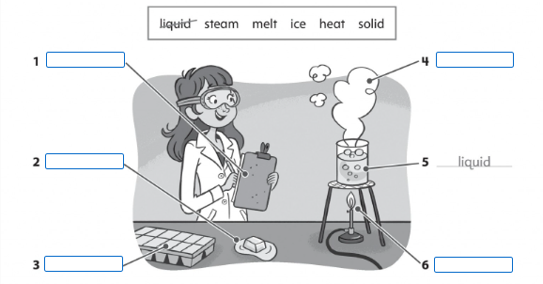
Q2: Look at the picture and write the words.

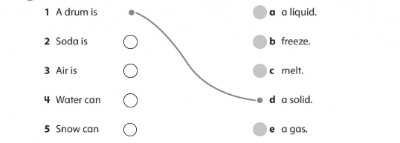
Q3: Match the beginnings of the sentences to the ends.

Q3: Complete the sentences.
- I make something hot. I ____________it.
- We make ________________ by heating water.
- Steam is a ________________.
- I ______________ water. It is now ice.

Teacher Nadeen

2

