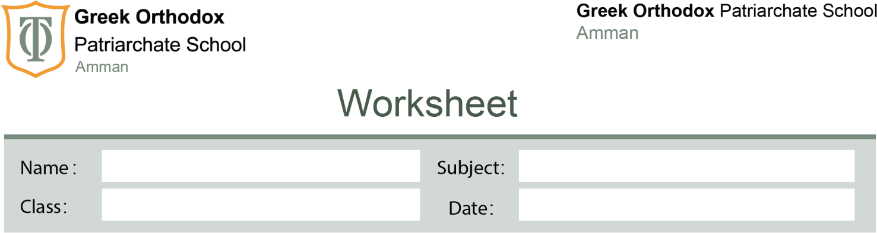

Grammar unit 3

Grade

7

18/11/2025

4

#
Answer Key

Practice 1
- I am meeting my cousin tomorrow.
- They are traveling to Amman next Monday.
- She is having lunch this afternoon.
- We are studying for the test tonight.
- My parents are visiting my aunt this weekend.

Practice 2 – Rewrite using Present Continuous
- I am playing football on Friday.
- She is going to the dentist tomorrow.
- They are watching a movie tonight.

Prepositions of Time & Place

Practice 3 – Choose the correct preposition
- My exam is on Monday.
- We will travel in summer.
- The keys are on the table.
- She is waiting at the bus stop.
- My birthday is in February.

Practice 4 – Fill in the blank
- The meeting starts at 6:00 p.m.
- They live in Amman.
- The festival is on July 18th.
- She is in the kitchen.
- We are leaving on the weekend.
(“At the weekend” is also acceptable depending on dialect.)

Challenge – Sample answers
(Any correct answers accepted)
- We are meeting my uncle on Friday.
- She is traveling to Dubai in winter.
- They are having dinner at the restaurant tonight.

