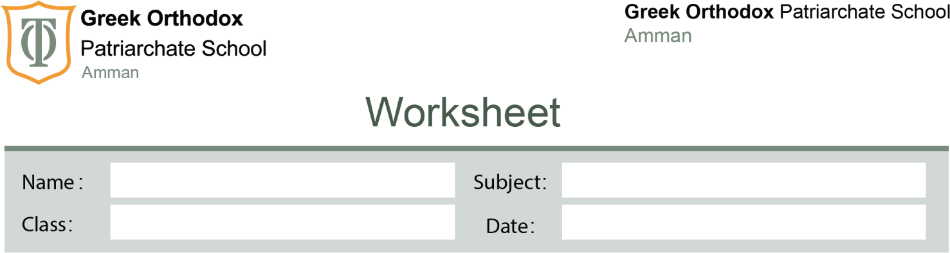

Vocabulary unit 3

Grade

7

18/11/2025

3

#
Answer Key

Part 3 – Exercise 1: Match the Words to Their Meanings
- printer → d
- text → b
- password → c
- laptop → a
- download → e
- digital camera → f

Part 4 – Exercise 2: Fill in the Blanks
- I forgot my password, so I couldn’t open my email.
- I always text my friends when I arrive home.
- My dad bought a new digital camera because he likes taking photos.
- Can you download the new movie from the internet?
- Teenagers spend hours on social media sharing photos.
- Don’t forget to send me an email about the project.
- My laptop has a large screen and I can take it anywhere.
- My mum’s phone is very easy to use; even my grandma can use it.
- The new video game is unusual – it’s not like any I’ve played before.
- My old phone is really old. I need a new one!
(If you prefer an adjective from the list: “terrible” also fits.)

Part 6 – Exercise 4: Sample Answers
(Any correct sentence is acceptable.)
- Modern: My new tablet is very modern and works really fast.
- Boring: That computer lesson was boring today.
- Excellent: This laptop has excellent battery life.
- Old: My printer is old and prints very slowly.
- Interesting: Social media can be very interesting sometimes

