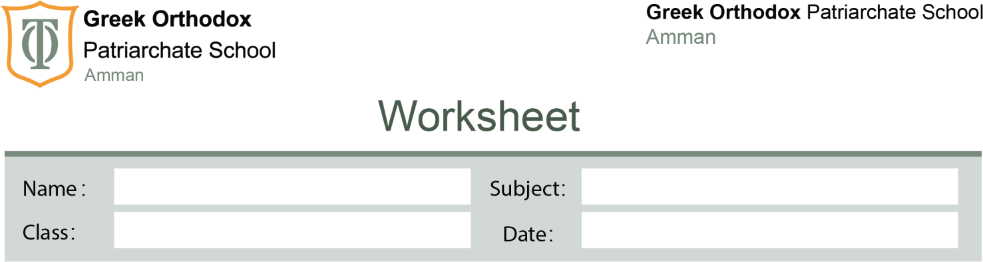

Present perfect and present continuous

Grade

9

5/11/2025

3

#
Answer Key

KEY ANSWERS – Present Perfect Simple & Continuous Worksheet

Practice A – Choose the correct tense
- She has been writing emails all morning; she still isn’t done.
- We have finished the report; you can check it now.
- They have been waiting for the bus since 7 a.m.
- I have never tried sushi.
- Why are you tired? Have you been running?

Practice B – Correct the mistake
- He has been eating three sandwiches.
- We have lived here for two hours.
- Have you ever visited Turkey?
- She hasn’t been studying for the exam.
- They have finished the project already.

Practice C – For / Since
- for
- since
- since
- for
- for

Practice D – Sample Answers
(Other correct answers are acceptable.)

1. study English
- Simple: I have studied English for many years.
- Continuous: I have been studying English since morning.

2. clean the house
- Simple: She has cleaned the house.
- Continuous: She has been cleaning the house for an hour.

