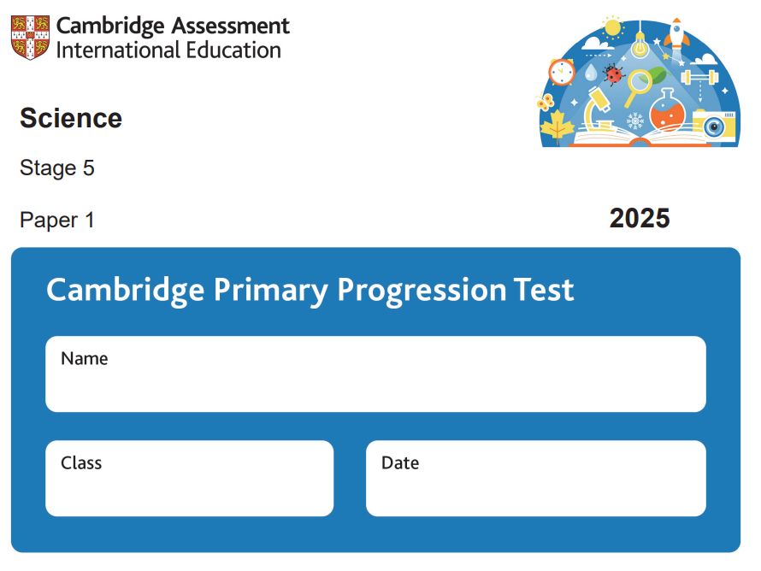

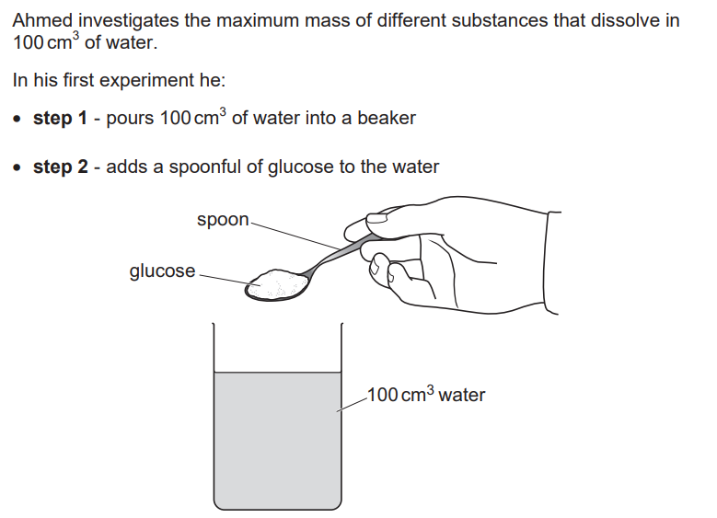
1-

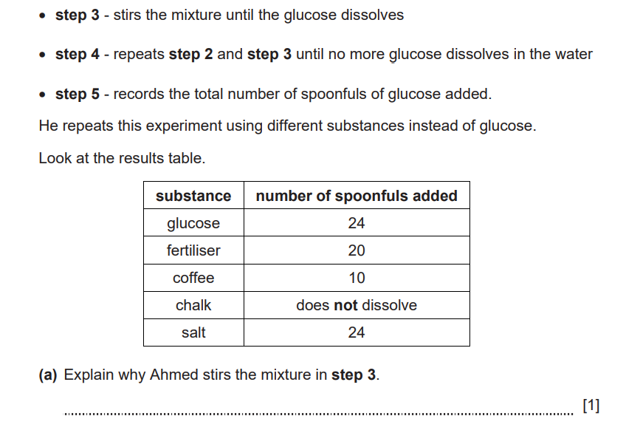

It will speed up dissolving
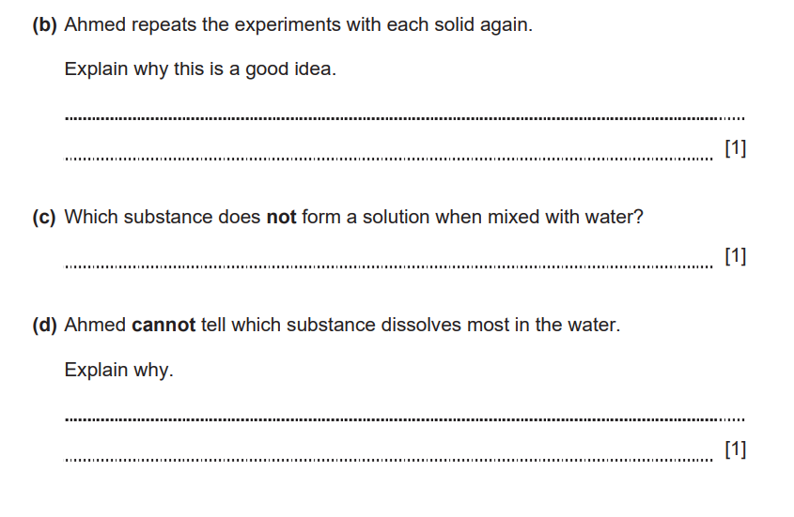

Result will be more reliable or to check result or identify anomalous results

Chalk

Both glucose and salt have the same number of spoonful

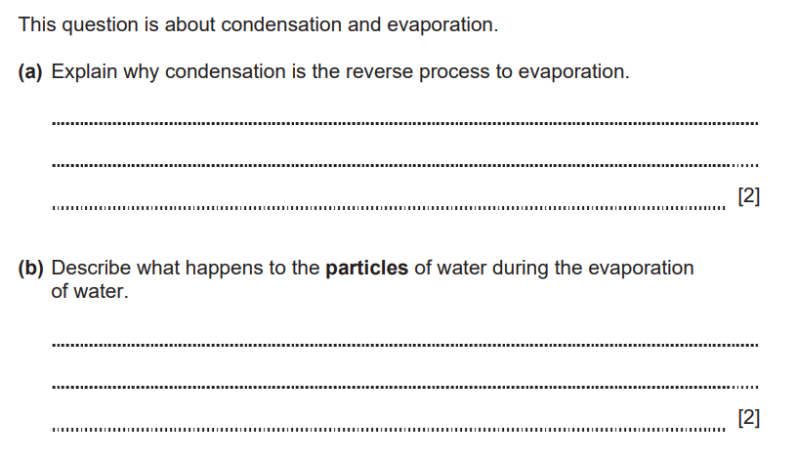
2-

Condensation is gas to liquid
Evaporation is liquid to gas

Particles move faster
Particles have more energy
Particles move further apart

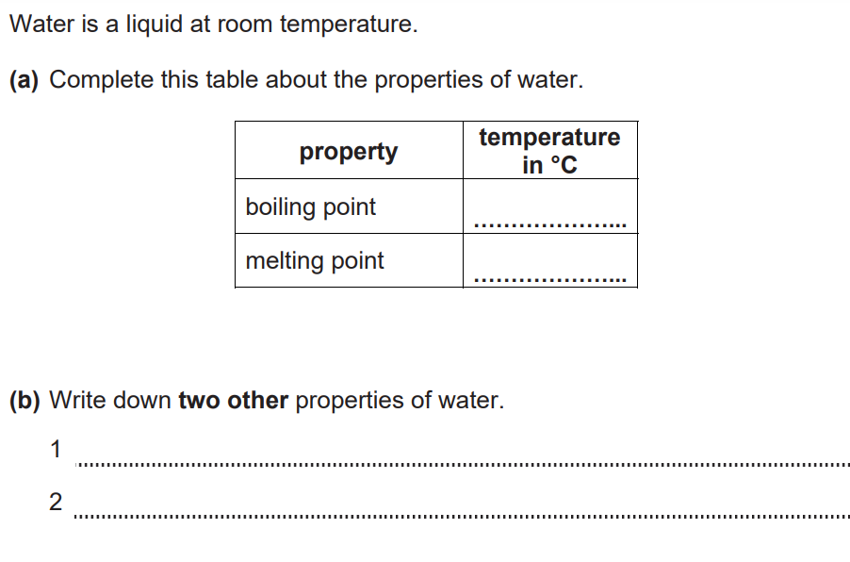
3-

100
0

Expand on solidifying
Dissolves substances or is a solvent

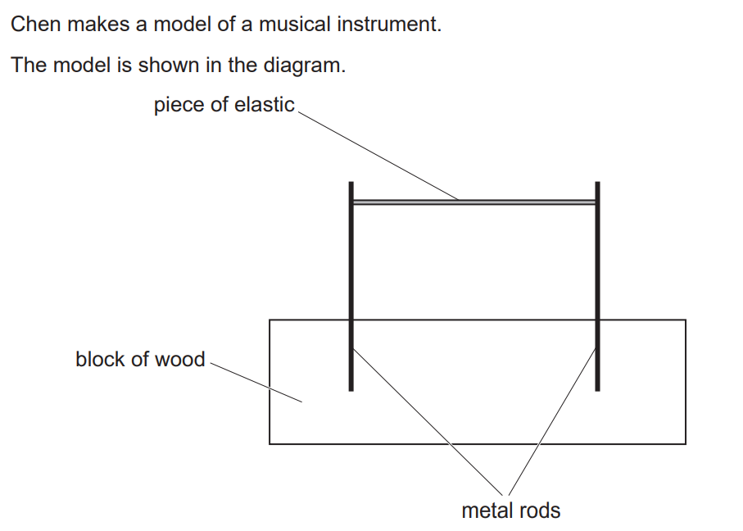
4-

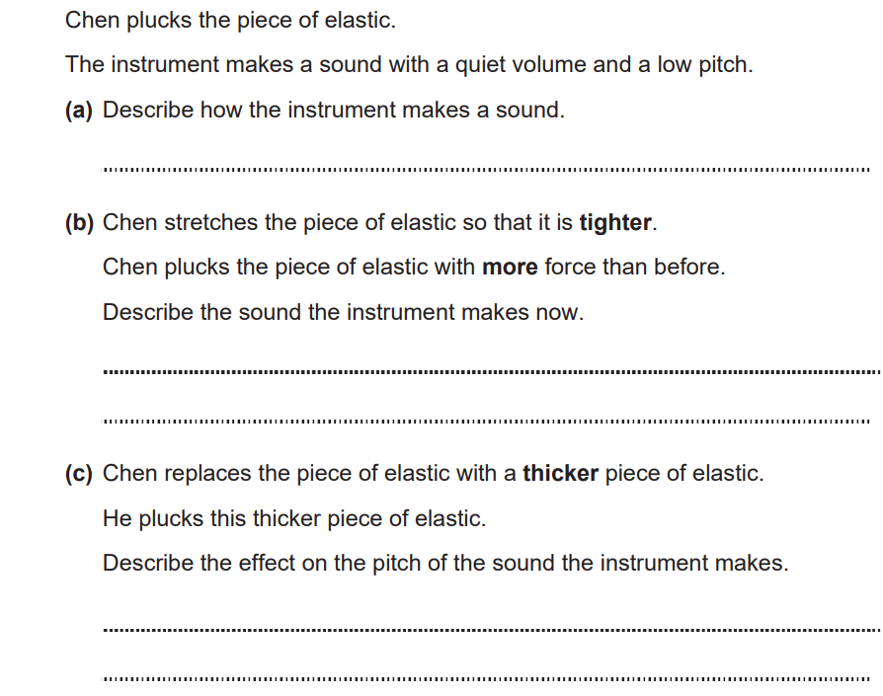
Elastic vibrates

Louder higher pitch

Becomes lower pitch

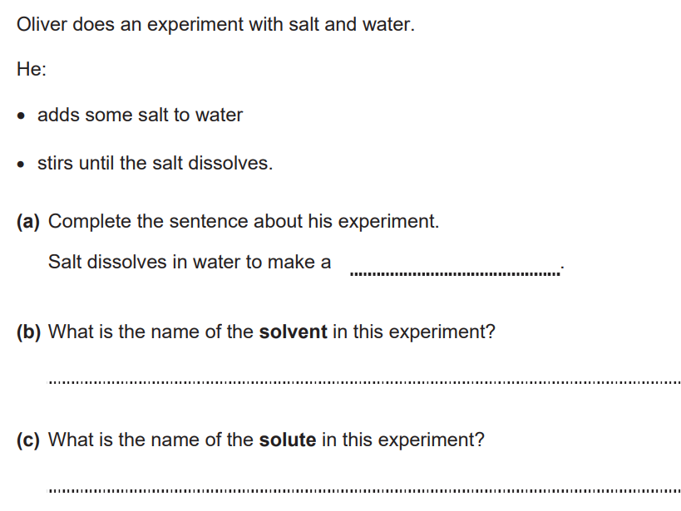
5-

solution

Water

salt
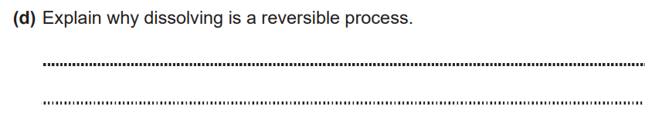
Because you can evaporate it to get the salt and water

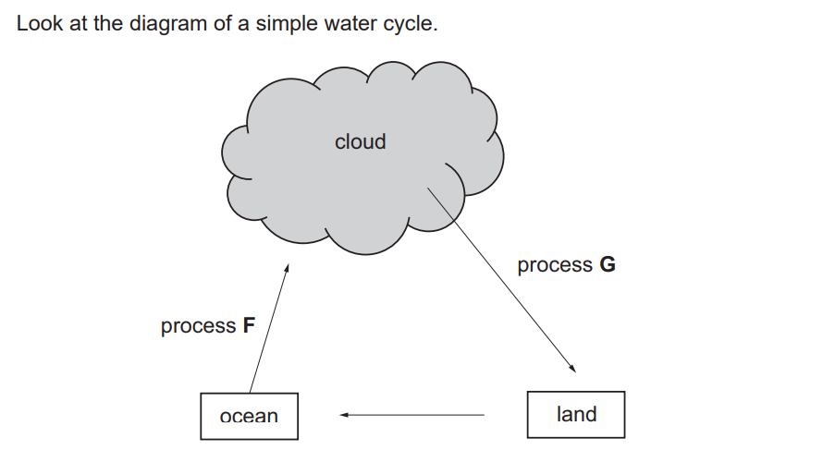
6-

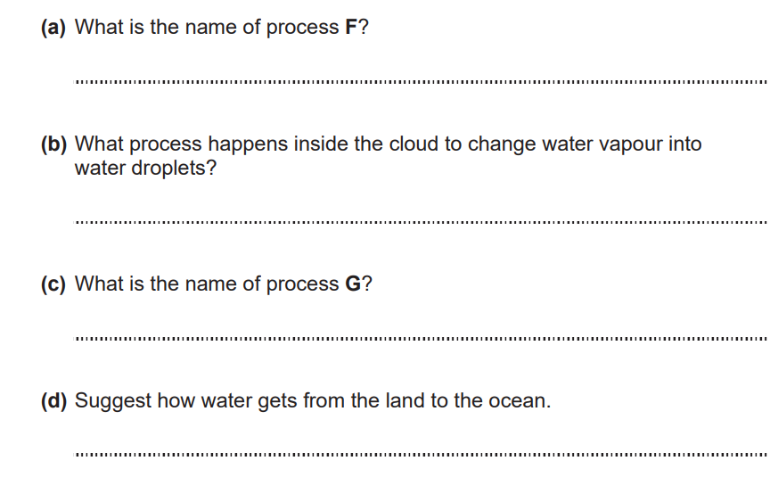

Evaporation
Via rivers or lakes
Precipitation
Condensation

