MOLD ATTACK

.DANIELTWAL

Mold grows on food when microscopic spores in the air land on a moist surface, like damp food. These spores then use the food's nutrients to grow, forming root-like structures that spread and break down the food as they multiply. This process is facilitated by moisture and warmth and can cause the food to rot and change color.

. Mold grows in bread, cheese, and fruit when mold spores land on moist surfaces in warm conditions and have a food source. Bread provides carbohydrates, fruit has high water and sugar content, and soft cheeses have high moisture, all of which are ideal for mold growth. Hard cheeses are more resistant to mold due to higher salt content and lower moisture, but can still mold if conditions are righT

.WHICH FOOD GROWS MOLD FASTER?

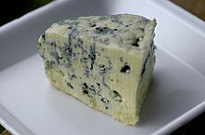
This Photo by Unknown Author is licensed under CC BY-SA

Mold grows on cheese when airborne spores land on the surface and find a suitable environment, which is especially likely with moist, warm, and oxygen-rich conditions.

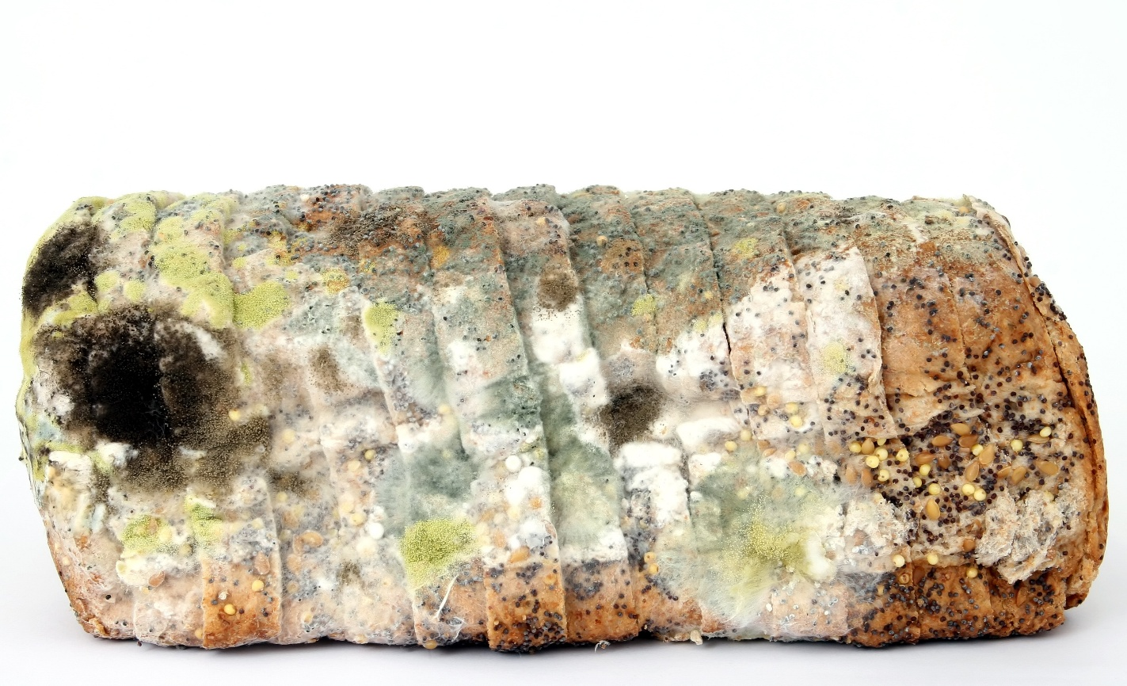

Mold grows on bread because it's a nutritious food for mold, and the right conditions of moisture, temperature, and air circulation allow it to thrive. Bread is a source of carbohydrates, proteins,

Mold grows on fruit when microscopic spores from the air land on a fruit's surface and find a hospitable environment.

