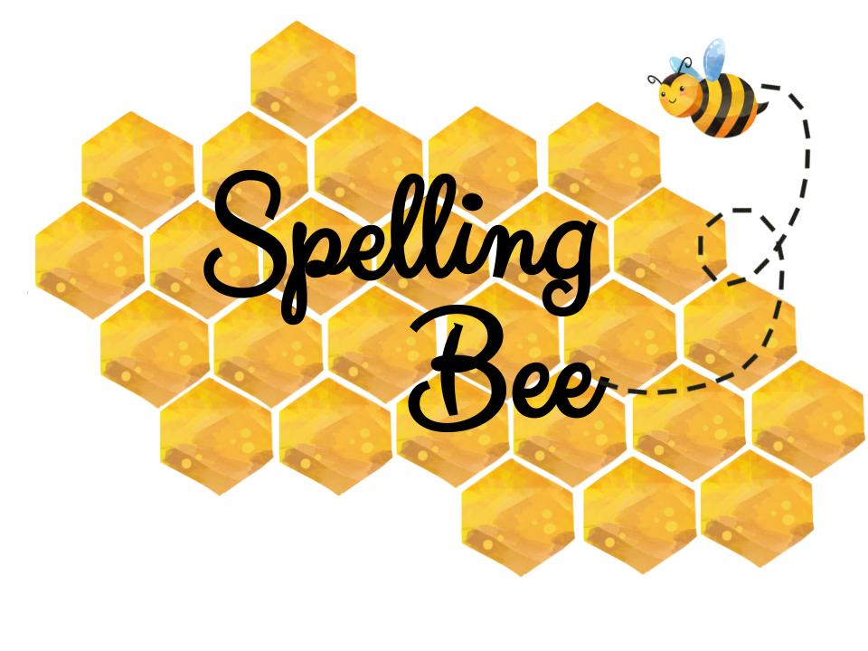
Grade 3
Beginner |  | Intermediate |  | Advanced
Son  1 | Old  2 | Beard  27 | Thin  28 | Cough  53 | Cycle  54
Name  3 | Nine  4 | Round  29 | Young  30 | Laugh  55 | Square  56
Game  5 | Play  6 | Loud  31 | Mother  32 | Outside  57 | Explorer  58
Snow  7 | Farm  8 | Rubber  33 | Pencil  34 | Ancient  59 | Sculpture  60
Cake  9 | Tree  10 | Dirty  35 | Leave  36 | Adventure  61 | Decide  62
Lake  11 | Swim  12 | Walk  37 | Smile  38 | Funfair  63 | Motorbike  64
Bike  13 | Cool  14 | Sore  39 | Down  40 | Hospital  65 | Machine  66
Kite  15 | Bake  16 | Calm  41 | Worry  42 | Supermarket  67 | Stomach  68
Ride  17 | Make  18 | Tennis  43 | Next  44 | Straight  69 | Watermelon  70
Jump  19 | Sky  20 | Light  45 | Every  46 | Milkshake  71 | Vegetables  72
Fish  21 | Blue  22 | Same  47 | Clean  48 | Teenager  73 | Horrible  74
Shark  23 | Safe  24 | Park  49 | Burger  50 | Subway  75 | Exercise  76
Fat  25 | Dark  26 | Party  51 | Sail  52 | Village  77 | Daughter  78

English Department : Raneem Alashaa’l

