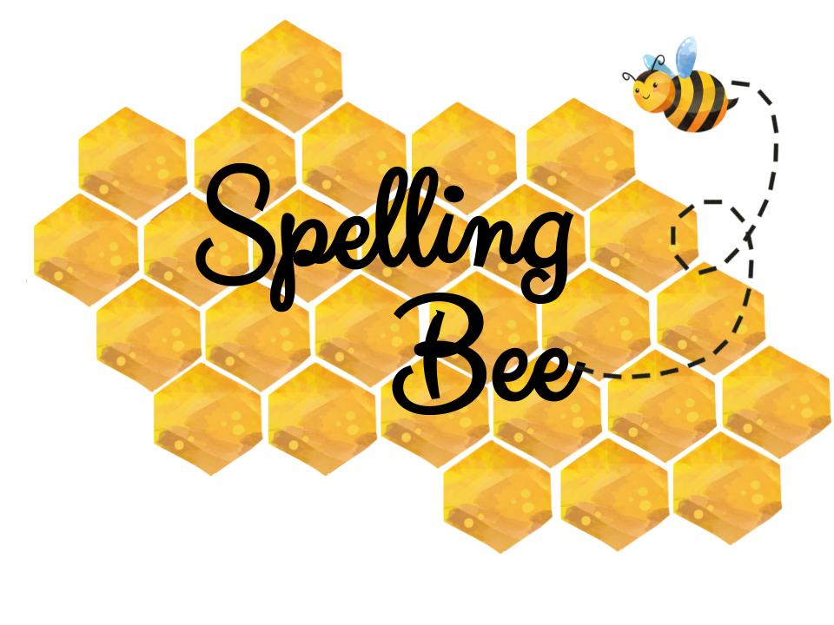
Grade 2
Beginner |  | Intermediate |  | Advanced
Mask  1 | Fish  2 | Hurt  27 | Think  28 | Juice  53 | Money  54
Rug  3 | Floor  4 | Sofa  29 | Hair  30 | Classmate  55 | Festival  56
Park  5 | Mum  6 | Face  31 | Head  32 | Birthday  57 | Kitchen  58
Dad  7 | Day  8 | Clock  33 | Wait  34 | Armchair  59 | Chicken  60
Room  9 | Sofa  10 | Spoon  35 | Small  36 | Crocodile  61 | Rainbow  62
Name  11 | Book  12 | Skirt  37 | Young  38 | Outside  63 | Penguin  64
Nose  13 | Love  14 | Driver  39 | Build  40 | Elephant  65 | Cousin  66
Art  15 | Time  16 | Sink  41 | Kick  42 | Get up  67 | National  68
Cool  17 | Have  18 | Maths  43 | Team  44 | Library  69 | Change  70
This  19 | There  20 | Jump  45 | Catch  46 | Healthy  71 | Classroom  72
Tank  21 | Hit  22 | Window  47 | Mirror  48 | Motorbike  73 | Naughty  74
Arm  23 | Tree  24 | Guitar  49 | English  50 | Tube  75 | Europe  76
Bed  25 | Soon  26 | Robot  51 | Camera  52 | Famous  77 | Octopus  78

English Department : Raneem Alashaa’l

