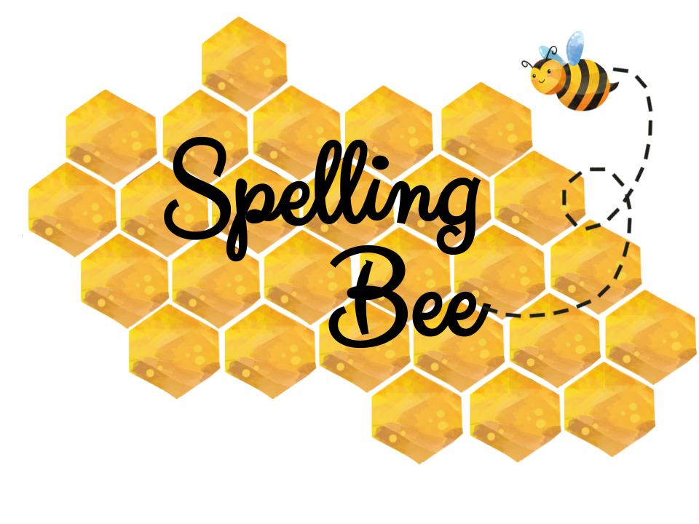
Grade 1
Beginner |  | Intermediate |  | Advanced
Big  1 | Old  2 | Desk  27 | This  28 | Student  53 | Marble  54
Door  3 | Bag  4 | Sofa  29 | Hair  30 | Classmate  55 | House  56
Tall  5 | Bat  6 | Face  31 | Head  32 | Please  57 | Kitchen  58
Toy  7 | One  8 | Nose  33 | Kiwi  34 | Flower  59 | Chicken  60
Pen  9 | Doll  10 | Lamp  35 | Trip  36 | Friend  61 | Breathe  62
Map  11 | Sad  12 | Woman  37 | Horse  38 | Middle  63 | Penguin  64
You  13 | Love  14 | Shop  39 | Sheep  40 | Mouse  65 | Cousin  66
New  15 | Fun  16 | Dress  41 | Black  42 | Umbrella  67 | Violin  68
Man  17 | Mum  18 | Water  43 | Sweet  44 | Library  69 | Model  70
Leg  19 | Sky  20 | Great  45 | Shell  46 | Butter  71 | Classroom  72
She  21 | We  22 | Read  47 | Kite  48 | Gloves  73 | Horrible  74
Arm  23 | Girl  24 | Blue  49 | Brown  50 | Hungry  75 | Castel  76
Bed  25 | Box  26 | Small  51 | Light  52 | Picture  77 | Octopus  78

English Department : Raneem Alashaa’l

